FTPS-Gateway
Client User Guide

V1.2

Platforme og DUC

22. februar 2021

This document describes the client side of the FTPS-Gateway solution, i.e. how you as a user can upload files to SKAT or receive files from SKAT using FTPS-Gateway’s facilities for secure and managed file transport via the FTPS protocol.
Client Connection

FTPS Gateway TFE
Address: secureftpgatewaytest.skat.dk
Port: 6381
High Ports: 36000-39999

FTPS Gateway Prod
Address: secureftpgateway.skat.dk
Port: 6381
High Ports: 36000-39999

Use an FTP Client that support the FTPS protocol (TLS/SSL Explicit).
We will use WinSCP for illustrations.

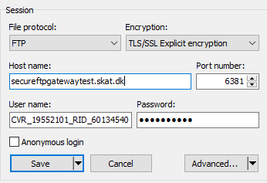

You need both an OCES certificate and Username for login.

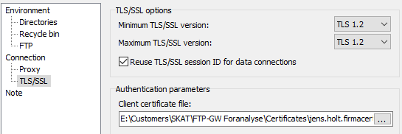
Specify your OCES Certificate file (private p12 or pfx). You will be prompted for your PassPhrase when you logon.
Only TLS 1.2 or higher is supported.

Username is constructed from the CVR-number and UID/RID-number in the OCES certificate (Subject):
Company certificate (VOCES): CVR_xxxxxxxx_UID_yyyy…y
Employee certificate (MOCES): CVR_xxxxxxxx_RID_yyyy…y
Functional certificate (FOCES): Is not supported

Ex.: CVR_19552101_RID_60134540

Your certificate must be pre-registered in FTPS-Gateway before you are able to login. During pre-registration the password for your username is generated.

Connection problems

If you are unable to connect successfully and are rejected with TLS/SSL error, you should enable debug in your FTPS Client software. This will allow you to see more details on why you are unable to connect, ex. unregistrered/expired/revoked certificate, username/password incorrect etc.

FTP Structure

The upload structure reflect the authorizations (Groups/Roles) currently applicable for your OCES certificate, and you can only upload files to the Business Services available.

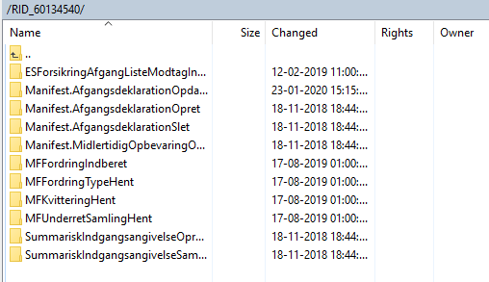

Uploaded files must be uniquely named. An uploaded file with a named previously used will be rejected with a status_0 with the following error text:
FILENAME_CANNOT_BE_REUSED_FOR_TRANSACTION

Uploaded files are processed (removed) immediately after upload. If you suspect your file is not fully processed, do not send it again (with a new name), instead contact jp-driftscenter@ufst.dk .

The download structure (/out) hold response and status files for download.

Note: To avoid excessive use of system resources it is strongly recommended to login to check for responses and status updates at most once per minute.

Status files

The purpose of the status file is to inform what has occurred to the uploaded file. Status files are named

status_<requested service>_<FTPTransactionID>_<statuscode>.xml

where
- <requested service> is the service (folder) that the file was uploaded to.
- <FTPTransactionID> is the filename of the uploaded file or a generated sequence number (unrelated outbound).
- <statuscode> is either 0, 1, 2 or 3.

There are four possible status codes:

- Status 1 (File delivered) This file is generated when the file has been sent to the Backend System. If you do not receive this almost immediately, the reason could be that the backend system is temporarily unavailable (planned or unplanned).
- Status 2 (File Accepted) This file is generated when the file has been accepted by the Backend System.
- Status 3 (File exposed) This file is generated when a file has been sent from the Backend System to the client. A file is sent either as a response to a file sent from the client or as an unrelated outbound file.
- Status 0 (Error) This file is generated when an error during processing of the file either in FTPS Gateway or the Backend system.

Certificate Portal

The Certificate Portal provides self-service for pre-registration of certificates.

TFE: https://secureftpgatewaytest.skat.dk
PROD: https://secureftpgateway.skat.dk

You are required to use the same certificate as you would use for the FTPS Gateway.

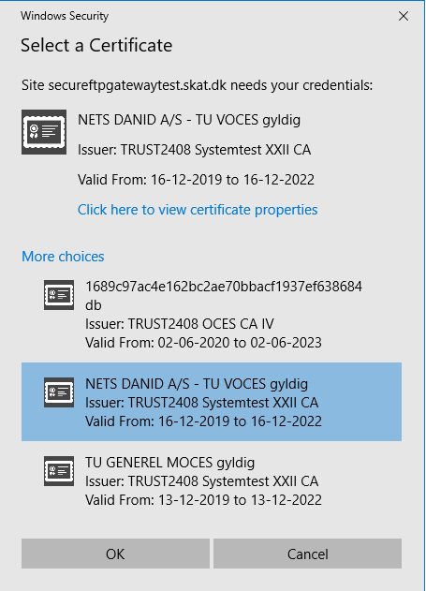

In above example you can select from the certificates, which have been imported to the browser. Here we select a NETS test certificate and enter the logon page of the Certificate Portal. The CVR and UID/RID information is extracted from the certificate and you are identified as user: CVR_30808460_UID_25351738.

The first time you logon the default password is your user identification, and you may thus simply copy/paste and proceed with logon.

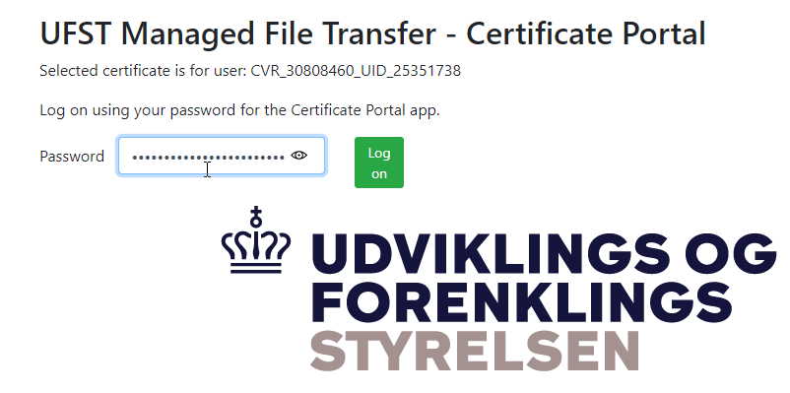

The first time you login you are requested to change password. You may use the passphrase for your certificate or any other password, which will thus be required for subsequently logon.

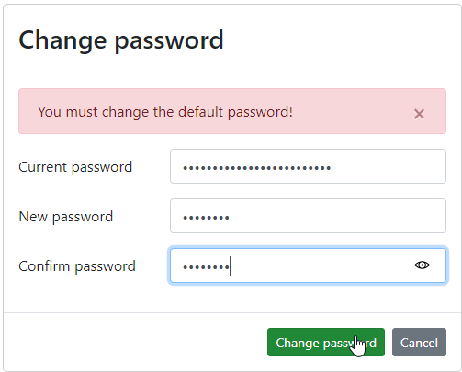

In this example FTPS Gateway has no previously knowledge of this certificate and would reject any logon attempt. So now you want to “Register Certificate”.

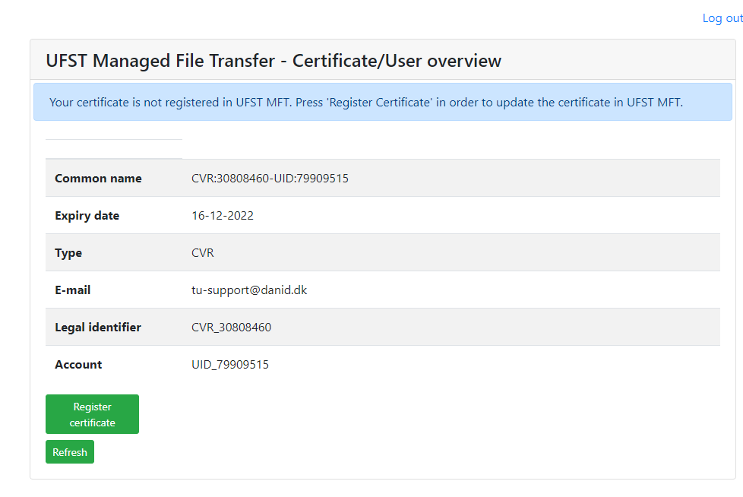

The registration process will be initiated and should be completed within a few minutes. Use the “Refresh” to verify when the registration has been completed.

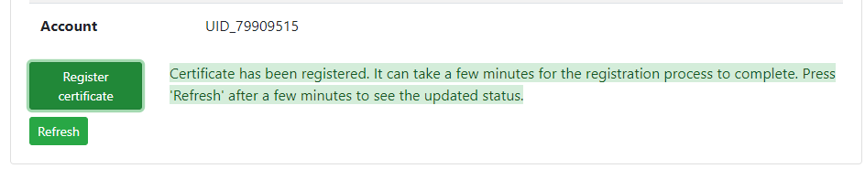

Your certificate is now registered and you see both your FTPS Gateway User name and assigned password, which you should record for setup of your FTPS session.

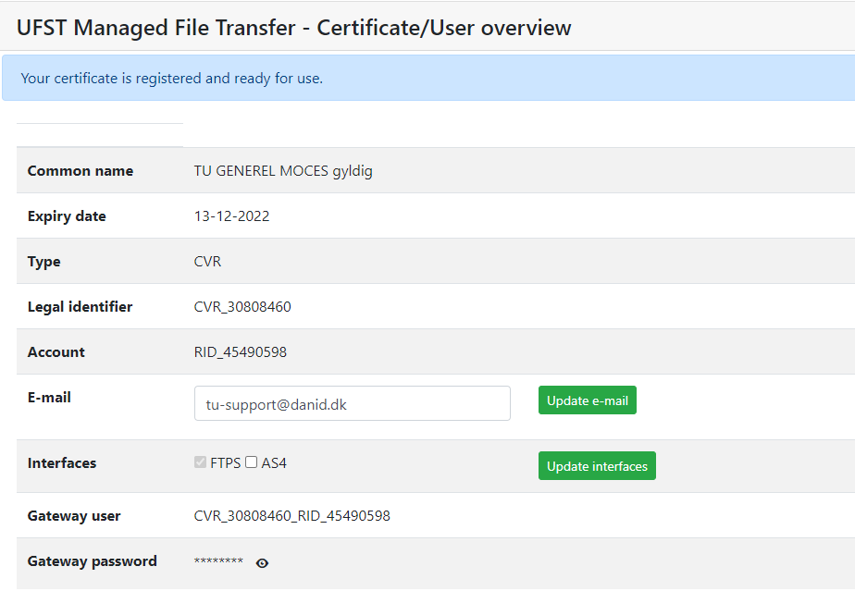

Note: Your email address is extracted from the certificate (if present). Please make sure you have a valid and relevant email address for your certificate as this could be used to contact you later.

Note: By default new certificates are setup with FTPS interface. You are able to select AS4 interface (and update), however this should ONLY be done if you use the same certificate for B2B exchange with the new Custom System(s) ex. DMS.Import.

Finish by selecting “Log out”. Your FTPS Gateway login will be established within 15 minutes from your pre-registration and you are then ready to upload to the services you have access to (verified with your DCS roles for certificate).

Certificate Renewal

Whenever you renew a certificate (keeping the same UID/RID) you can use the Certificate Portal to update the certificate in FTPS Gateway. Logon again using your new certificate and the password you assigned during your first logon.

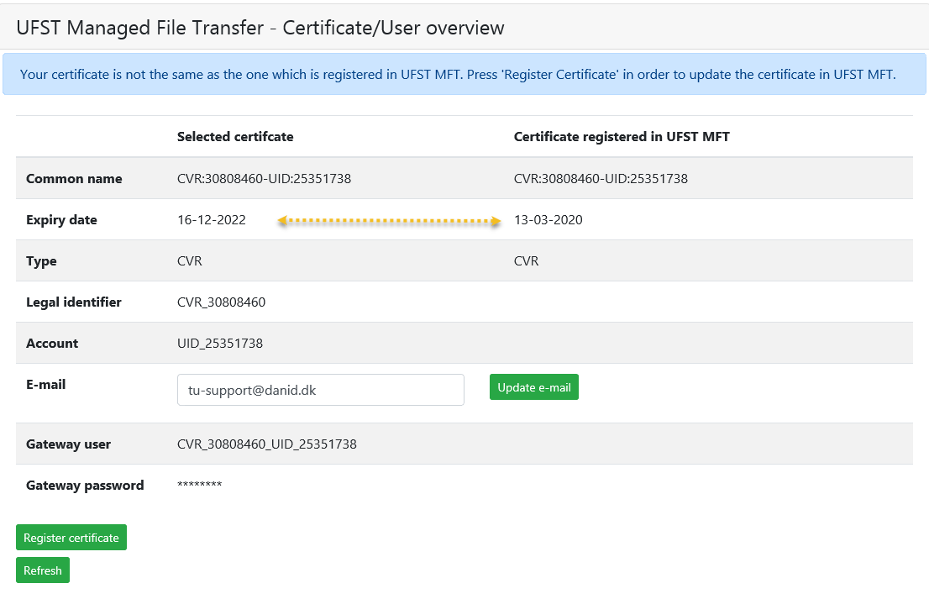

Use “Register Certificate” to update the certificate in FTPS Gateway.

Note: The procedure is the same as with a new certificate, except the assigned FTPS Gateway password will NOT change.

Certificate validity

You are able to import certificates that are “Expired” or “Retracted” you’re your browser, however expired certificates cannot be used to logon to Certificate Portal (will not be shown in logon list). You are able to logon and register a retracted certificate, however when you later try use the certificate with FTPS Gateway it will be rejected (CRL checking only takes place during login to FTPS Gateway).

FTPS Gateway only support VOCES (Virksomhedscertifikat) and MOCES (Medarbejdercertifikat), so although you can import FOCES (Funktionscertifikat) into your browser and select this from the logon list:

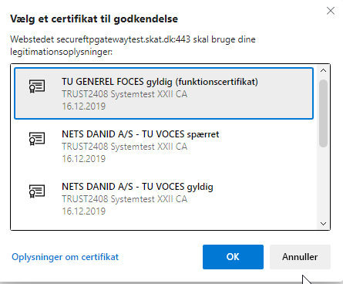

It will be rejected by Certificate Portal as follows:

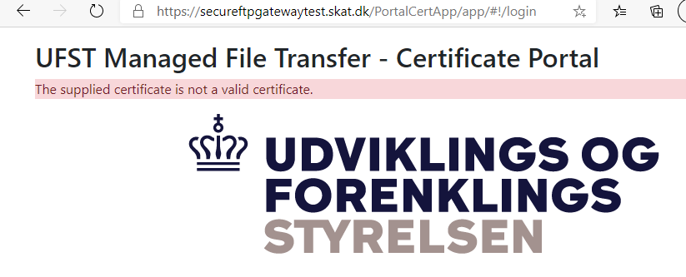

Browser Setup

In above examples we have used Microsoft Edge and Chrome browser and each of these have different ways of importing certificates.

If no valid certificates have been imported when you try to use the Certificate Portal you would see an error screen like the following:

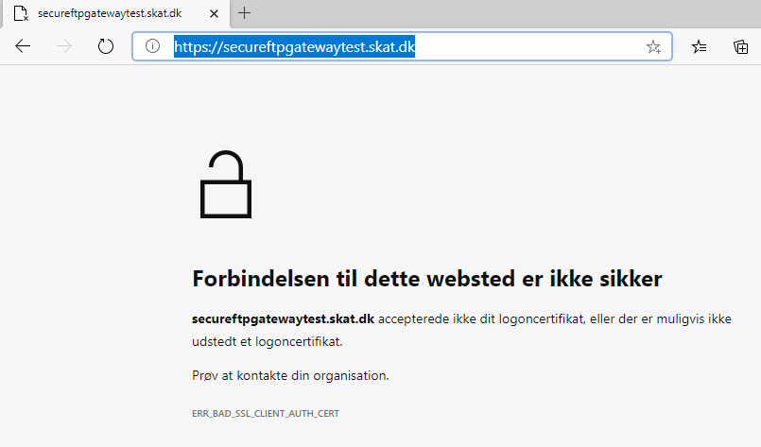

Use “Certificate Manager” feature of your browser to import your OCES certificate. In this example I already have multiple certificates imported, and thus request another import.

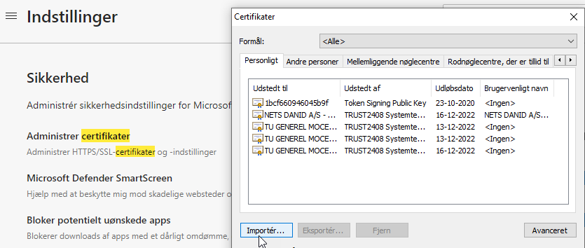

Following illustrates import of a certificate in your browser:

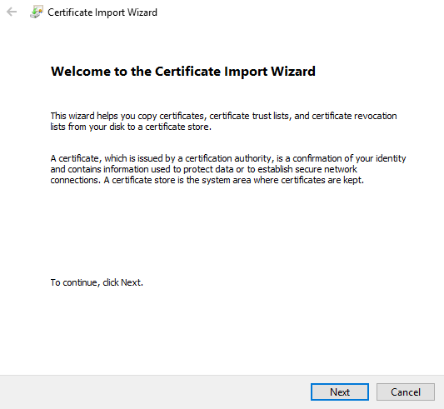

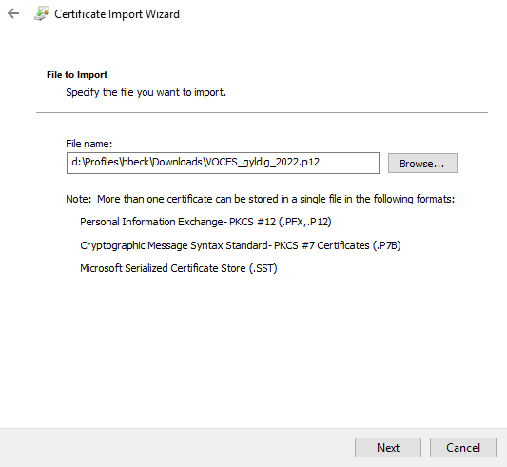

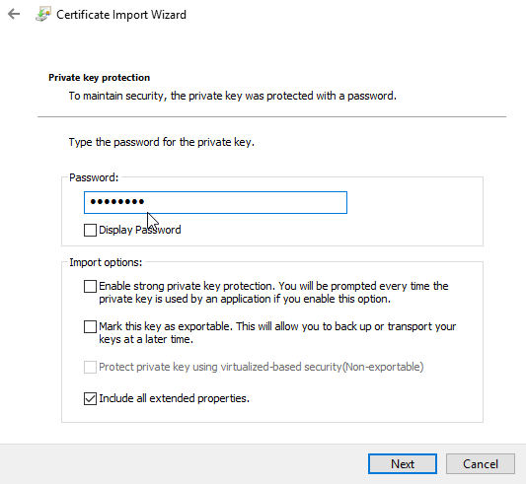

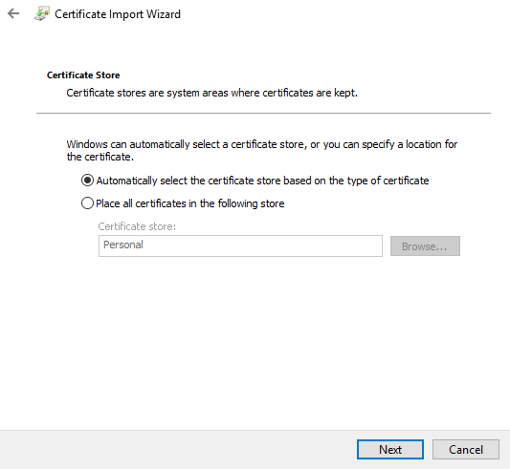

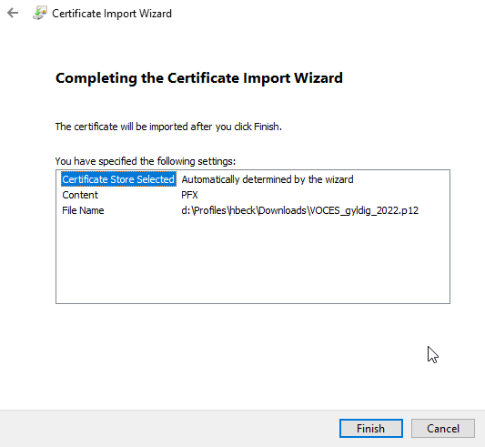

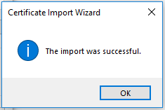

Special for eKapital Classic

New certificates must also be registered via a form on skat.dk, likewise changes to registration must also be done via this form.
Link to form
https://www.skat.dk/skat.aspx?oid=2272245&chk=216849

Status file format

Status files are XML files with following elements:

Filename |  | Name of the uploaded file by the client.  If unrelated outbound file (not a response) the value is empty.
FTPTransaktionsId |  | Unique transaction ID as specified by the client (uploaded filename)
SKATTransaktionsId |  | Unique transaction ID generated by the system
Timestamp |  | Timestamp of the status file
status.code |  | Status code. Can either be OK or ERROR
Service |  | Requested backend system
response | Filename | Filename for file exposed to the client.
error | error.code | Unique code for a specific error
 | error.message | Description of the error
 | error.resolution | Description of a possible solution

Example status -1 file:

<?xml version="1.0" encoding="UTF-8" standalone="no"?>
<status>
<file>
<filename>/CVR_19552101/RID_60134540/FTPSGW.Heartbeat/ping20201210143002441-hb01.xml</filename>
<FTPTransaktionsId>ping20201210143002441-hb01.xml</FTPTransaktionsId>
<SKATTransactionId>ci1607607002916_31616756_1</SKATTransactionId>
<timestamp>20201210143017</timestamp>
<status.code>File delivered to requested Backend System</status.code>
<service>FTPSGW.Heartbeat</service>
</file>
</status>

Example status_2 file:

<?xml version="1.0" encoding="UTF-8" standalone="no"?>
<status>
<file>
<filename>/CVR_19552101/RID_60134540/FTPSGW.Heartbeat/ping20201210143002441-hb01.xml</filename>
<FTPTransaktionsId>ping20201210143002441-hb01.xml</FTPTransaktionsId>
<SKATTransactionId>ci1607607002916_31616756_1</SKATTransactionId>
<timestamp>20201210143017</timestamp>
<status.code>File accepted by FTPSGW.Heartbeat</status.code>
<service>FTPSGW.Heartbeat</service>
</file>
</status>

Example status_3 file (response):

<?xml version="1.0" encoding="UTF-8" standalone="no"?>
<status>
<file>
<filename>/CVR_19552101/RID_60134540/FTPSGW.Heartbeat/ping20201210143002441-hb01.xml</filename>
<FTPTransaktionsId>ping20201210143002441-hb01.xml</FTPTransaktionsId>
<SKATTransactionId>ci1607607002916_31616756_1</SKATTransactionId>
<timestamp>20201210143018</timestamp>
<status.code>File exposed</status.code>
<service>FTPSGW.Heartbeat</service>
<response>
<filename>/out/FTPSGW.Heartbeat_in_ping20201210143002441-hb01.xml_response.txt</filename>
</response>
</file>
</status>

Example status_3 file (unrelated):

<?xml version="1.0" encoding="UTF-8" standalone="no"?>
<status>
<file>
<filename/>
<FTPTransaktionsId>Manifest.MidlertidigOpbevaringOpdater_MAN_DKA54A_eda73f9d-0215-4849-9e0b-275c91c62624.notify.xml</FTPTransaktionsId>
<SKATTransactionId>MAN_1607577057900</SKATTransactionId>
<timestamp>20201210061159</timestamp>
<status.code>File exposed</status.code>
<service>Manifest.MidlertidigOpbevaringOpdater</service>
<response>
<filename>/out/Manifest.MidlertidigOpbevaringOpdater_MAN_DKA54A_eda73f9d-0215-4849-9e0b-275c91c62624.notify.xml</filename>
</response>
</file>
</status>

Example status_0 file:

<?xml version="1.0" encoding="UTF-8" standalone="no"?>
<status>
<file>
<filename>RID_60134540/FTPSGW.Heartbeat/empty.xml</filename>
<FTPTransaktionsId>empty.xml</FTPTransaktionsId>
<timestamp>1607615347963</timestamp>
<status.code>ERROR</status.code>
<service>FTPSGW.Heartbeat</service>
<error>
<error.code>FILENAME_CANNOT_BE_REUSED_FOR_TRANSACTION</error.code>
<error.message>The filename provided has already been used for previous transaction</error.message>
<error.resolution>Resubmit the file with a new filename</error.resolution>
</error>
</file>
</status>

Error Codes

The error information in status_0 may originate either from FTPS Gateway or the Backend system.

Error code: FILENAME_CANNOT_BE_REUSED_FOR_TRANSACTION
Error message: The filename provided has already been used for previous transaction
Error resolution: Resubmit the file with a new filename

Following are only relevant for eKapital Classic:

Error code: FILE_NOT_UPLOADED_IN_ASCII_MODE
Error message: Files to the requested Backend System must be uploaded in ASCII mode
Error resolution: Upload file in ASCII mode
The backend System only support files uploaded in ASCII mode. Please upload the file in ASCII mode or contact customer service for further instructions.

Error code: RECORD_LENGTH_INCORRECT
Error message: The file does not conform with required format due to incorrect record length. Please see www.skat.dk/eKapital
Error resolution: Fix record length and upload file again
This error will occur to ensure that the record length has the correct length. Fix the record length and try to upload again. Please contact SKAT customer service if the problem continues.

Error code: FIRST_RECORD_INCORRECT
Error message: The file does not conform with required format due to incorrect start of first record. Please see www.skat.dk/eKapital
Error resolution: Fix first line and upload file again
This error will occur to ensure that the record length has the correct length. Fix the record length and try to upload again. Please contact SKAT customer service if the problem continues.

Error code: LAST_RECORD_INCORRECT
Error message: The file does not conform with required format due to incorrect start of last record. Please see www.skat.dk/eKapital
Error resolution: Fix last line and upload file again
This error will occur to ensure that the record length has the correct length. Fix the record length and try to upload again. Please contact SKAT customer service if the problem continues.

Support

If you experience problems with connection or other problems in relation to migration to the FTPS Gateway and or Certificate Portal, you can request help through jp-driftscenter@ufst.dk.

List of systems/services
Bilag

System: eKapital

FATCA
CRS
Udlaan
Prioritetslaan
Pensiondiverse
Pantebreve
Indlaan
CBC

System: eKapital (Classic)

AKFA
AKSA
ANPA
ATP
BHOL
CPS
FINK
GI
IFPA
IRTE
OBLG
PADE
PANT
SFS
UDBY
URTE
KTR

System: PSRM

INDBetalingsoplysningerTraekListeModtagService
INDBetalingsaftalerTraekListeModtagService
INDBetalingsanmodningerTraekListeSendService
INDIndbetalingsKortStatusListeModtagService
INDBetalingTilAfmeldingerTraekListeSendService
INDIndbetalingOplysningListeModtagService
INDKontoudtogOplysningListeModtagService
INDUdbetalingOplysningListeModtagService
INDMFFordringIndberetService
INDMFKvitteringHentService
INDMFUnderretSamlingHentService
INDMFFordringTypeHentService
INDMUdbetalingOplysningListeModtagService
INDMKontoudtogOplysningListeModtagService

System: MiniMF (ICI)

MFFordringIndberet
MFFordringTypeHent
MFKvitteringHent
MFUnderretSamlingHent

System: DMI

BetalingsanmodningerTrækListeSend
DMIBetalingsaftalerTrækListeModtagService
DMIBetalingsanmodningerTrækListeSendService
DMIBetalingsoplysningerTrækListeModtagService
DMIBetalingTilAfmeldingerTrækListeSendService
DMIIndbetalingOplysningListeModtagService
DMIKontoudtogOplysningListeModtagService
DMIUdbetalingOplysningListeModtagService
DMIValutaKurserOverførService

System: ICS

SummariskIndgangsangivelseOpdaterService
SummariskIndgangsangivelseOpretService
SummariskIndgangsangivelseSamlingOmdirigerService

System: Manifest

Manifest.AfgangsdeklarationOpdater
Manifest.AfgangsdeklarationOpret
Manifest.AfgangsdeklarationSlet
Manifest.AnkomstdeklarationOpdater
Manifest.AnkomstdeklarationOpret
Manifest.AnkomstdeklarationSlet
Manifest.EksternAnkomstOgAfgangsIndberetningOpret
Manifest.MidlertidigOpbevaringOpdater
Manifest.MidlertidigOpbevaringOpret
Manifest.MidlertidigOpbevaringOpsplitOpret
Manifest.MidlertidigOpbevaringSlet
Manifest.TolddokumentSamlingHent

