# Notification guidelines

Danish businesses that are part of a multinational group with a consolidated revenue of DKK 5.6 billion or more in one fiscal period must inform the Danish Tax Agency (Skattestyrelsen), which group entity (company, foundation, aassociation or permanent establishment, etc.) that is liable to submit a Country-by-Country Report for the following fiscal period.

These guidelines deal with the liability to submit a notification about Country-by-Country Reporting. You will be guided through how to complete and submit the notification form via E-tax for businesses (TastSelv Erhverv). You will also find information on establishing a function with assigned rights and assigning this function to an employee certificate.

By default, companies are assigned the right to submit CbCR notifications. This means that you can complete the notification form and submit it to the Danish Tax Agency by logging on to E-tax for businesses. There, an administrator of rights can assign notification rights to the relevant certificates. Please read more about this in section 3.

# Submitting the notification

Please log on to E-tax for businesses to submit a notification.

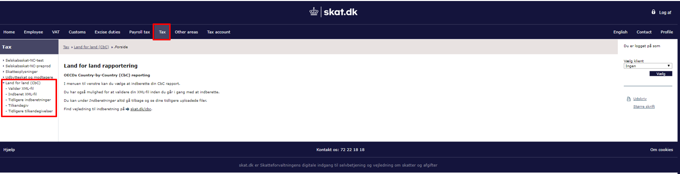

Figure 1 Select Tilkendegiv (Notification)

Once you have logged on, you select ‘Skat’ (Tax) in the top menu, and then you select ‘Land for land (CBC) ‘ (Country-by-country (CBC)) from the menu items in the left-hand side of your screen.

Select menu item ‘Tilkendegiv’ (Notification) to complete the notification form.

Please note that the screen dump above also shows menu items for submitting the country-by-country report. You will not be able to see these menu items, unless the Danish company is responsible for reporting on behalf on your entire group and has been assigned this particular right as a result of this.

## 2.1 Country-by-country notification

When submitting the notification, you will be advised that the accounting year preceding the current accounting year of your group is the relevant year for the notification.

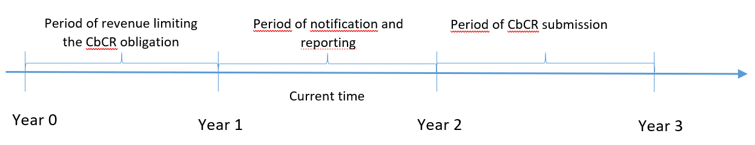

The above illustrates three periods: Period of revenue, period of notification and period of reporting.

* ***Period of revenue limiting the CbCR obligation***

This is the fiscal period preceding the fiscal period relevant for the notification.

* ***Period of notification and reporting***

This is the fiscal period for which notification is given about the revenue of the preceding fiscal period, and for which the CbC Report should be prepared.

* ***Period of CbCR submission***

This is the fiscal period when the ultimate parent company submits the country-by-country report containing the numbers for the *period of notification and reporting*.

If Denmark is the tax jurisdiction of the ultimate parent company, the country-by-country report should be submitted to the Danish Tax Agency (Skattestyrelsen). [Please read more at www.skat.dk/country-by-country](https://www.skat.dk/skat.aspx?oid=2230454) under Submitting CBC Reports.

2.1.1 Declaration of the revenue for the fiscal period preceding the reporting period.

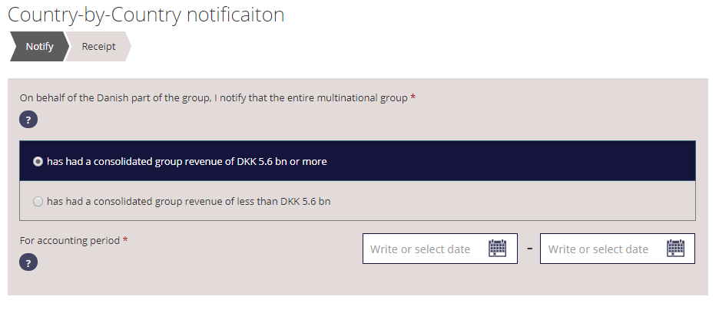  
Figure 2 Select the consolidated revenue of the entire group for the period of revenue limiting the CbCR obligation

Select whether the consolidated revenue of the entire group was more or less than DKK 5.6 billion (= 750 million Euro) and state the dates of the relevant fiscal period. Here, the fiscal period is the same as the *period of revenue* limiting the CbCR obligaction (see timeline under 2.1), and a revenue of more than DKK 5.6 billion results in a notification liability of the ultimate parent company to submit a country-by-country report for the following fiscal period. When you have entered the starting and closing dates of the fiscal period, the starting date of the following accounting year will automatically be entered (meaning the day after the closing date you have entered).

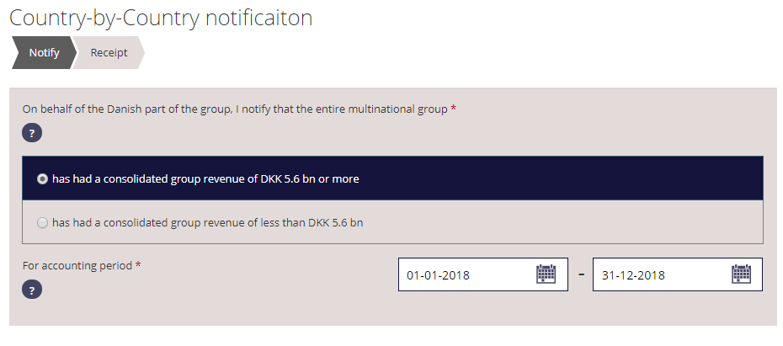 Coun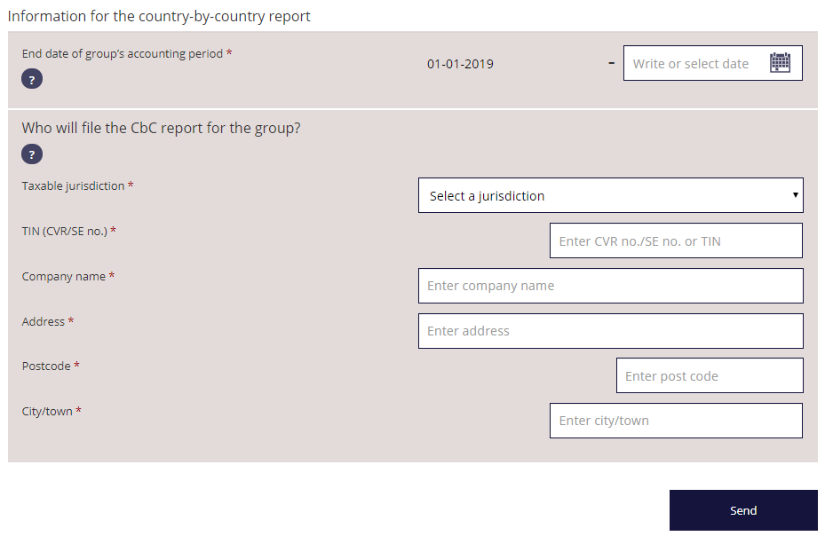

Figure 3 State who will be submitting the country-by-country report and to which tax jurisdiction’s authority.

If you state that the group’s consolidated revenue exceeded DKK 5.6 billion, you should state who will be submitting the country-by-country report and to which tax jurisdiction’s authority.

A group with a consolidated revenue of more than DKK 5.6 billion for a given fiscal period is liable to submit the country-by-country report for the following fiscal period, which we call *the period of notification* in our timeline. Please state the closing date for the group’s accounting period for the accounting year which will be covered by the country-by-country report.

Once you have completed the other fields, you can submit the notification.

# 3. Right of notification

By default, all companies are assigned the right of notification, and you can complete the notification information and submit it to the Tax Agency by logging on to E-tax for businesses. In E-tax for businesses, an administrator of rights can assign the notification right to the relevant employee certificates.

In this section, you can read how to assign an employee the right to prepare a country-by-country report notification. When you want to assign the right of notification to an employee certificate, the right should first be grouped into a function which may contain several rights (this could also be the right to submit the country-by-country report.

### 3.3.1 Registration of employee certificate (RID)

The employee certificate should be registered before you can assign it to a function with rights. Please make sure you have the following information available:

* RID no.:
* Name of employee
* Email of employee

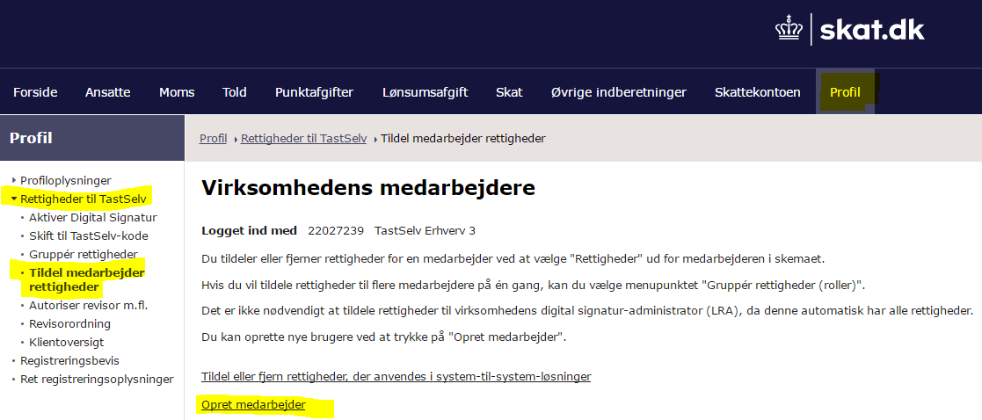  
Figure Opret medarbejder (Register employee)

Select *‘*Profil’ (Profile) from the top menu and then ‘Rettigheder til TastSelv> Tildel medarbejder rettigheder > Opret medarbejder’ (Rights to E-tax > Assign rights to employee > Register employee).

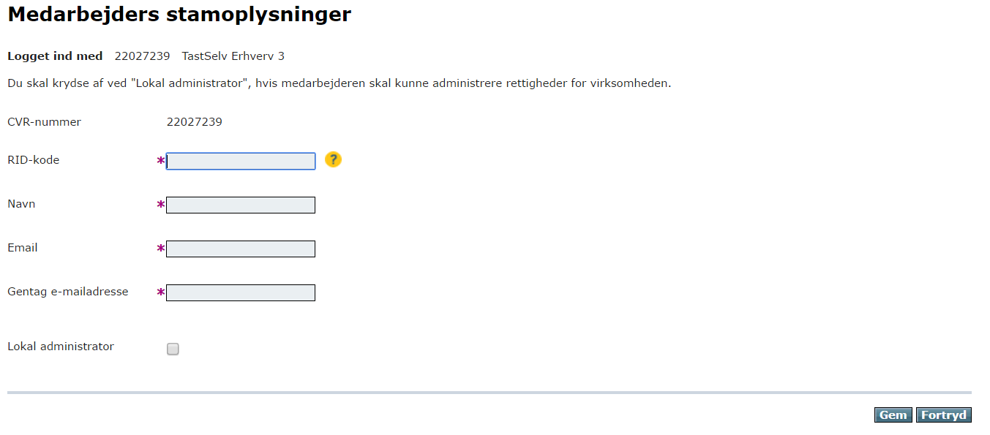

Figure 5 Complete ”Medarbejders stamoplysninger” (Employee information)

Please complete the fields RID, Name of employee and Email of employee and click ‘Gem’ (Save). The employee is now registered.

You can assign the function of local administrator to an employee, if the employee will be administrating the rights of the business.

### 3.3.2 Registration of business certificate (UID)

In order to set up a function with notification rights, you will have to register the business certificate to connect it to the function. Please register the business certificate by creating a new system user by means of the certificate UID code.

Ony 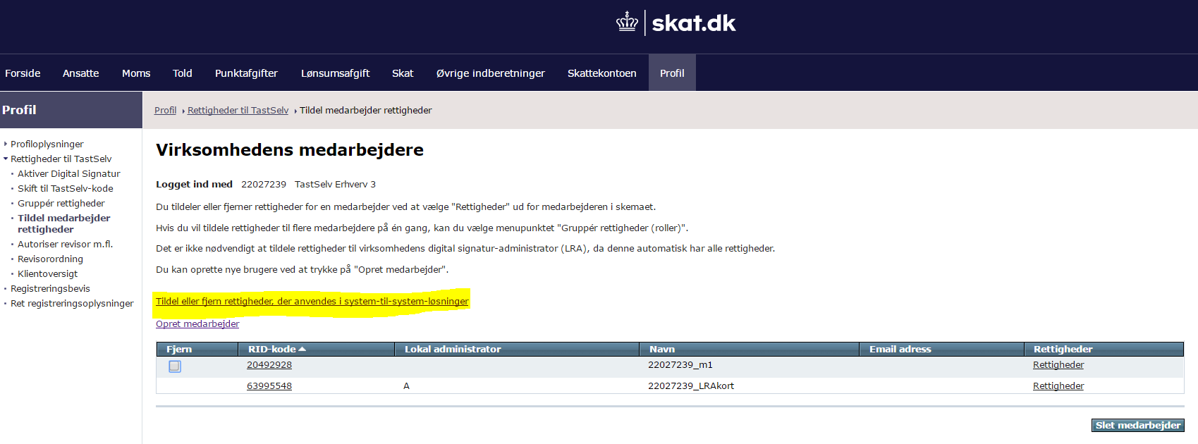

Figure 6 Assign employee rights

Click ‘Tildel medarbejder rettigheder’ (Assign employee rights) in the left-hand menu and select ‘Tildel/fjern rettigheder der anvendes i system-til-system-løsninger’ (Assign/remove rights used for system-to-system solutions) which you will find in the middle column.

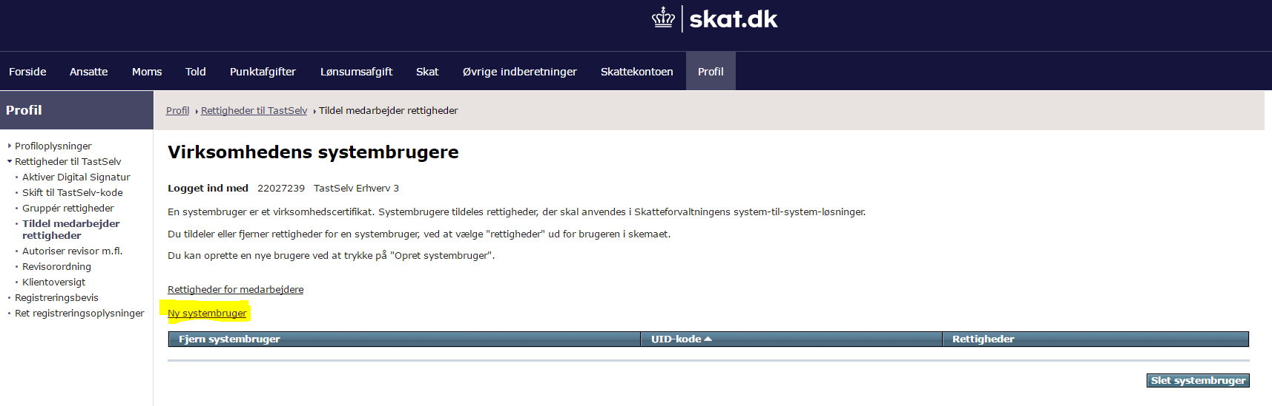

Figure 7 Create new system user

Select ‘Ny systembruger’ (New system user)

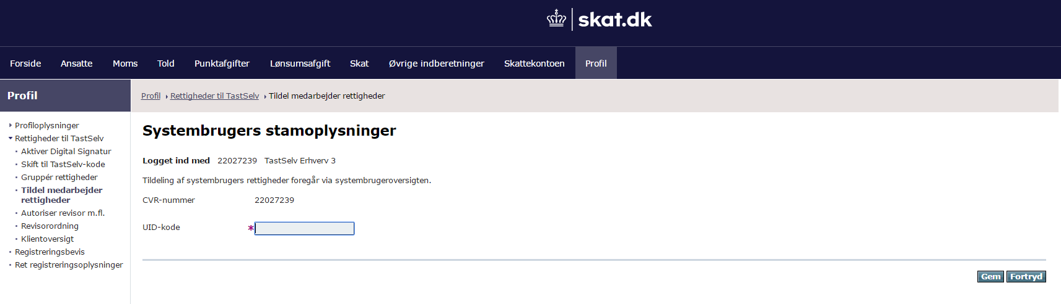

Figure 8 System user UID code

Enter the UID code and select ‘Gem’ (Save). The system user is now registered.

### 3.3.3 Setting up groups of rights

When the system user is registered with the correct UID or RID code, the user should be assigned a function with the relevant rights.

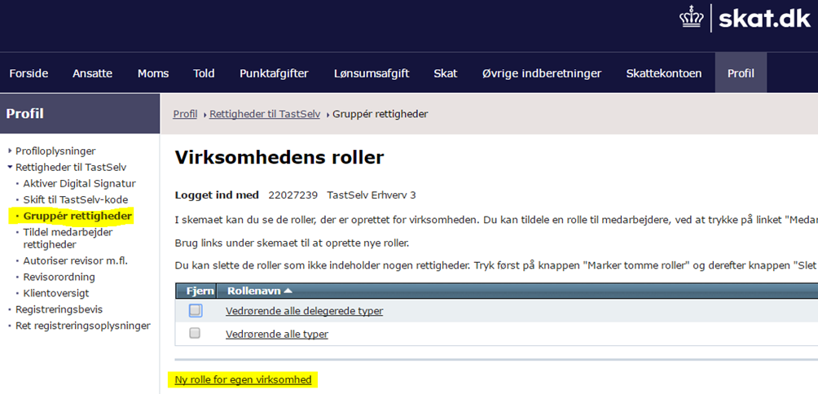

Figure 9 New function for own business

Select ‘Gruppér Rettigheder’ (Group Rights) and then ‘Ny rolle for egen virksomhed’ (New function for own business) to set up a new function with the right of notification.

If the right to submit CbC reports already exists, you may consider to assign the right to make CbC notifications to the same function

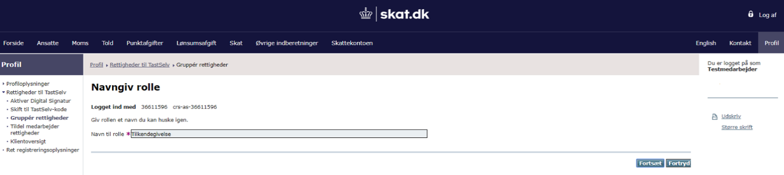

Figure 10 Name role

When you set up a new function, you should name it. Choose a meaningful name that makes sense to you and then click ‘Fortsæt’ (Next). The relevant notification right for county-by-country reporting is **‘Tilkendegiv Land for land-rapport’ (Notification of county-by-country report)**.

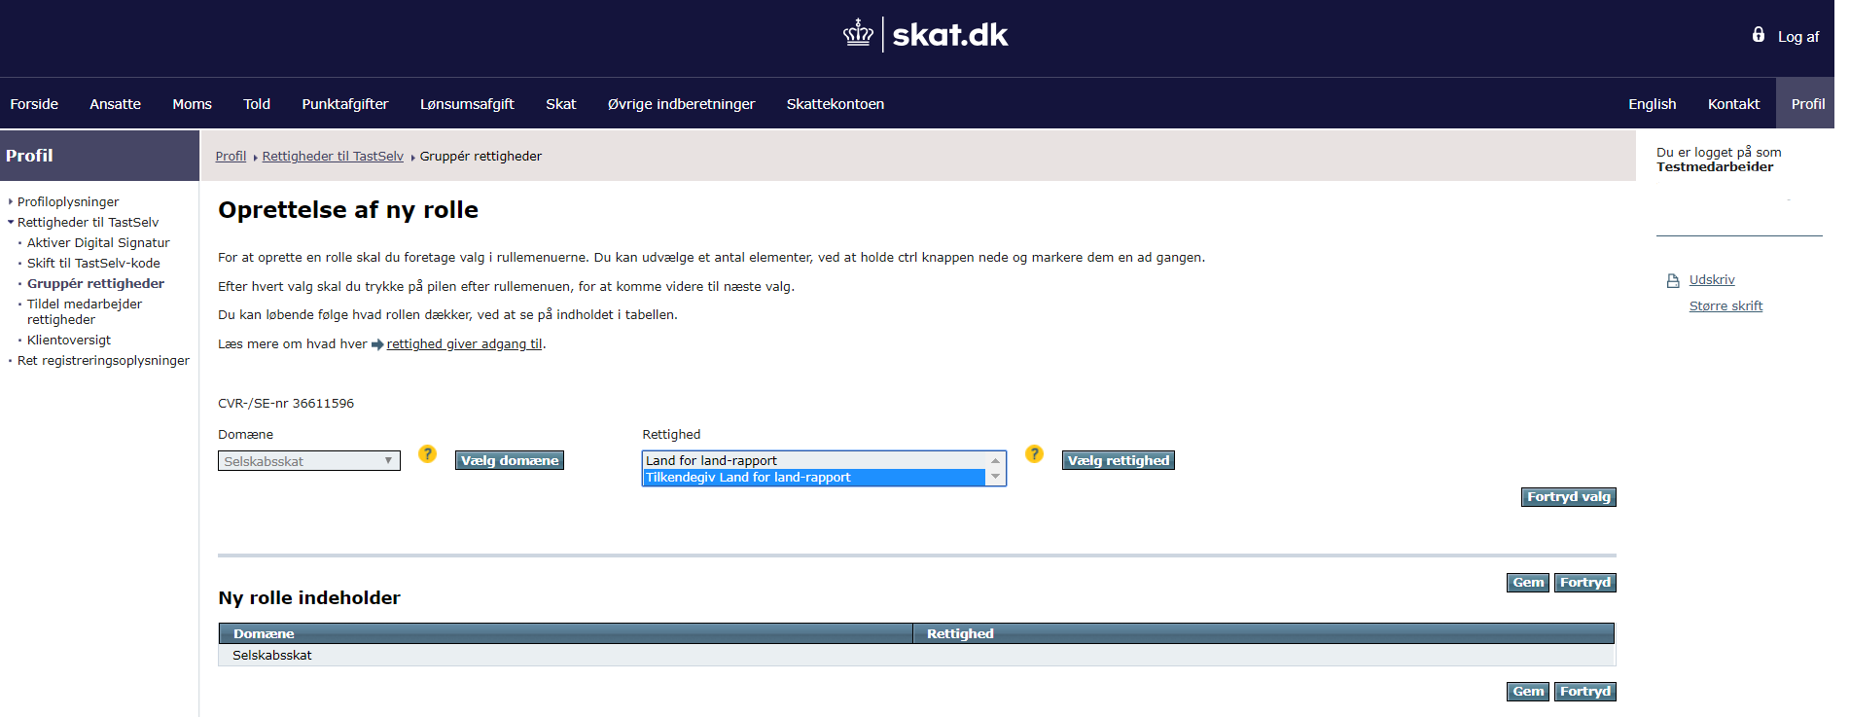

Figure 11 Assign rights

When you assign rights to a function, please select the domain ‘Selskabsskat’ (Corporation tax) and then click ‘Vælg domæne’ (Choose domain). Under ‘Rettigheder’ (Rights), you select ‘Tilkendegiv Land for land-rapport’ (Notification of country-by-country report) and click ‘Vælg rettighed’ (Select right). Next, you click ‘Gem’ (Save) and the group of rights is now set up.

Receipt 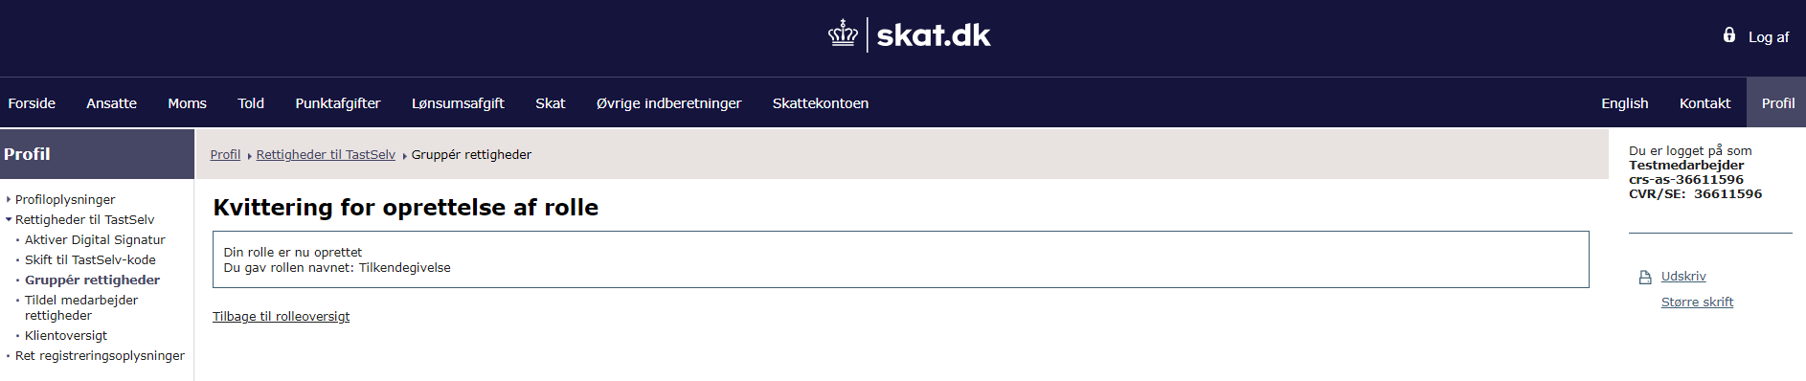

Figure 12 Receipt for creation of CBC notification role

When the notification function is set up and the right has been saved, the receipt will appear on the screen.

### 3.3.4 Assigning groups of rights

After the notification function has been set up, it can be assigned an employee certificate, which will associate an employee with the function.

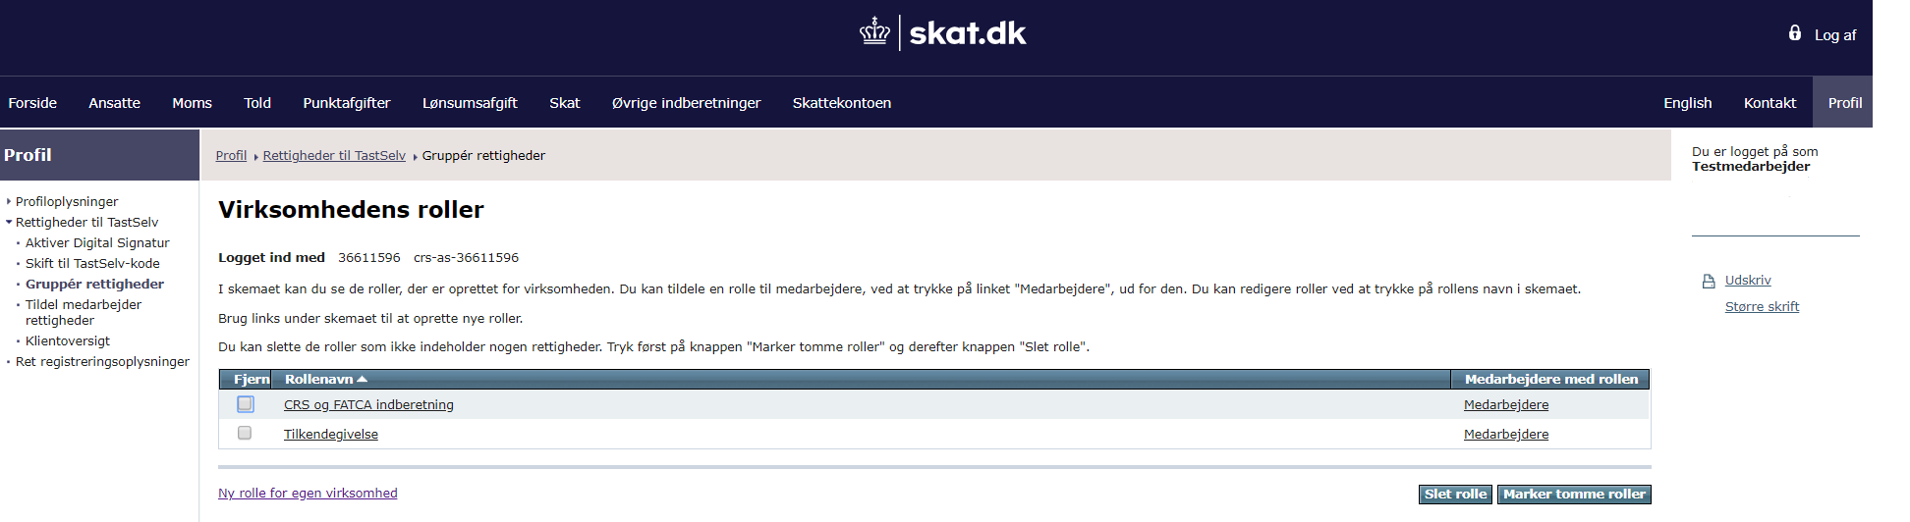

Figure 13 Gruppér rettigheder (Group rights)

For you to assign the notification function to an employee certificate please select the menu item ‘Gruppér rettigheder’ (Group rights). Then click ‘Medarbejdere’ (Employees) next to the desired function name, which in this example is ‘Tilkendegivelse’ (Notification).

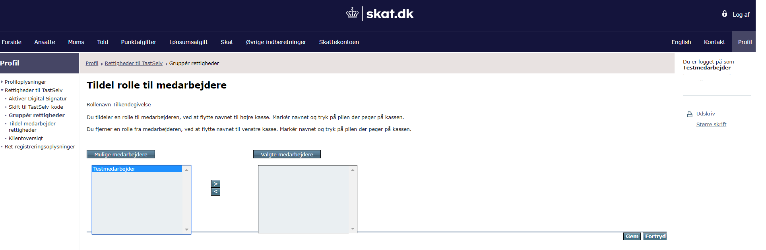

Figure 14 Assign role to employee

You will then be presented with a list of possible employees to accept the function. Mark the employee(s) and use the arrow tab to move them to ‘Valgte medarbejdere’ (Selected employees). Click ‘Gem’ (Save) to save the changes.

The procedure for assigning rights to business certificates, is very similar to the above description of employee certificates, please see 3.3.5

### 3.3.5 Assigning employee rights

You can also assign rights to an employee by selecting ‘Tildel medarbejder rettigheder’ (Assigning employee rights). Here, you can also see which functions are assigned to the individual employees.

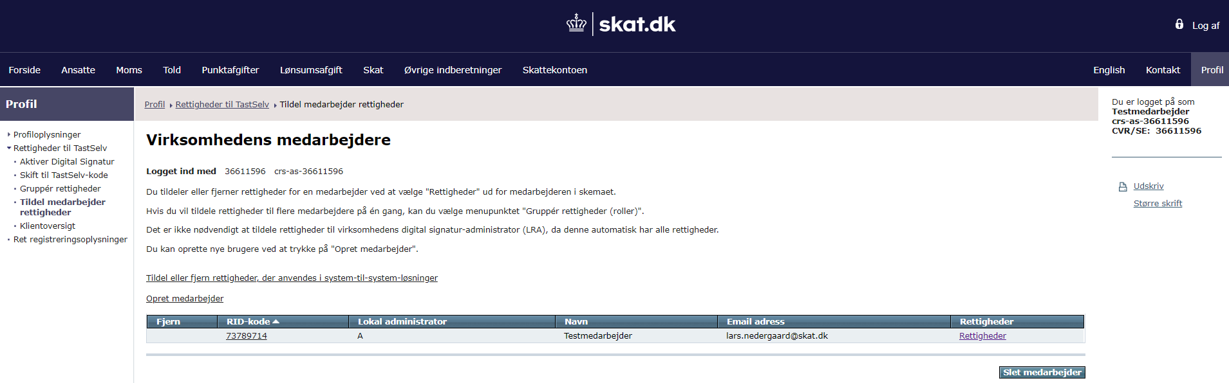

Figure 15 Select employee

Click ‘Rettigheder’ (Rights) next to the relevant employee.

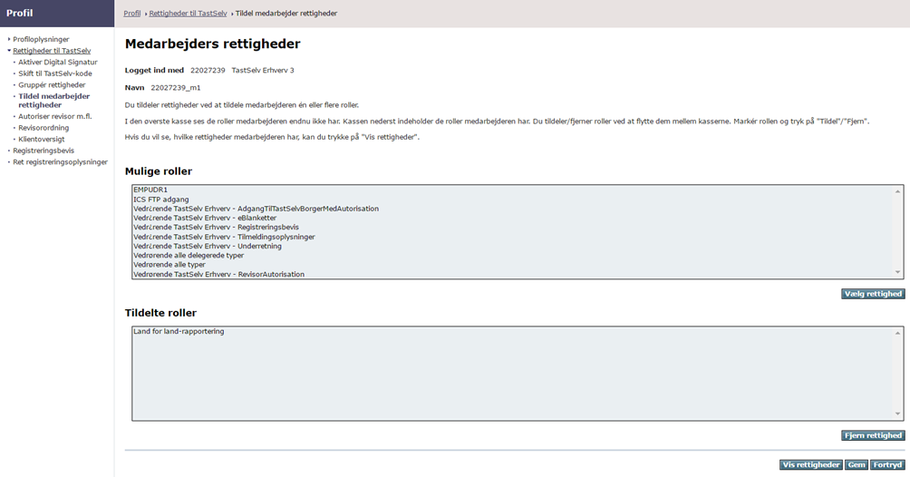  
Figure 16 Assign rights to an employee

You will then be shown a list of the functions you can assign to the employee and any functions the employee already has. Here, you can assign or remove employee functions. When you have assigned a function to an employee, the employee can log on to E-tax for businesses and submit a notification.

### 3.3.6 The accountant scheme (revisorordningen)

The company can also delegate the right to submit notifications on behalf of the company to a third party.

It is important that the third party intended to submit notifications on behalf of the company has signed up for the accountant scheme as this is the only way to obtain this function.

### 3.3.6.1 Signing up for the accountant scheme (revisorordningen)

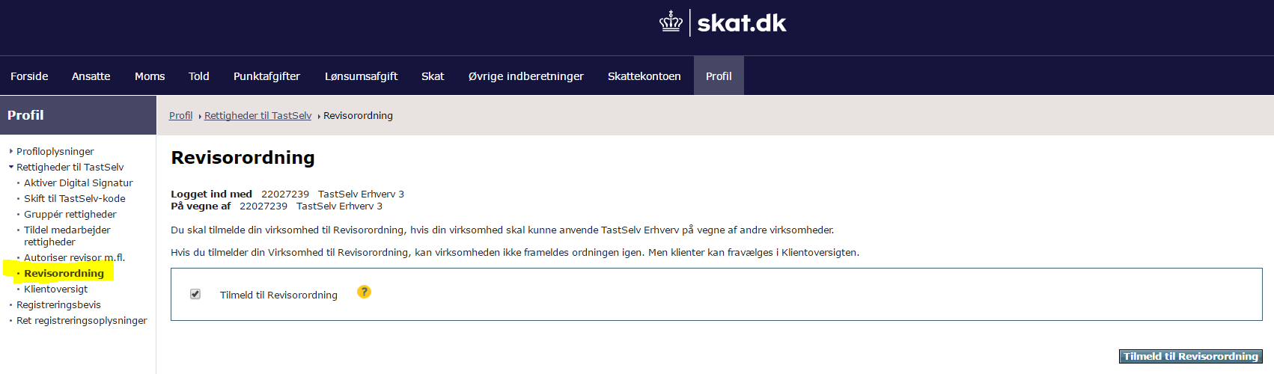

Figure 17 The accountant scheme (revisorordningen)

A business can sign up for the accountant scheme under ‘Revisorordning’ (Accountant scheme) in the left-hand menu. Tick off the box ‘Tilmeld til Revisorordning’ (Sign up for the accountant scheme) and finally click ‘Tilmeld til Revisorordning’ (Sign up for accountant scheme).

### 3.3.6.2 Authorise accountant etc.

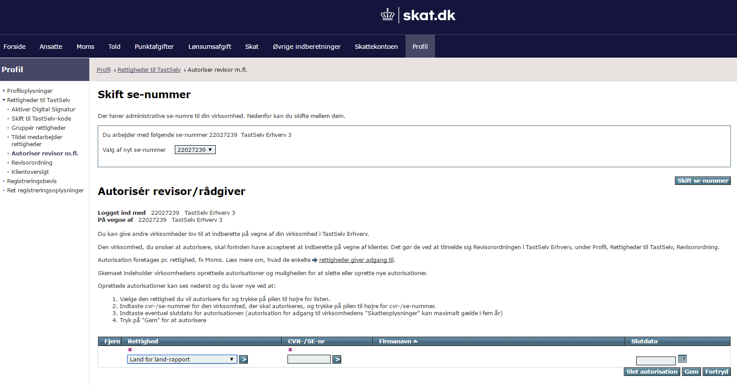

Figure 18 Authorise accountant

You delegate rights under menu item ‘Autoriser revisor m.fl.’ (Authorise accountant etc.) in the left-hand menu.

Please select the right you want to assign to others and click on the arrow on the right.

Enter CVR/SE no. of the business you want to authorise and click on the arrow on the right.

Enter a possible authorisation expiry date. You can delegate the country-by-country reporting right for a maximum of five years.

Click ‘Gem’ (Save) to save the complete the authorisation.