

DK-EMCS

User Manual - Trader Portal Guide

Table of Contents
1 Introduction 9
1.1 Purpose 9
1.2 Minimum System Requirements 9
1.3 Document Structure 10
2 Basic Concepts and Terms 11
2.1 Movement 11
2.2 Movement Actions 11
3 User Interface 12
3.1 Create New Movement (Create IE815) 13
3.1.1 Required and Validated data elements 14
3.1.2 Consignee 18
3.1.3 Delivery Place 21
3.2 Overview 24
3.2.1 Open Movements 24
3.2.2 Movements Overview 26
3.2.3 Messages Overview 33
3.2.4 Pending Actions 34
3.3 Unknown ARC 36
3.3.1 Overview 36
3.3.2 Create Report of Receipt 38
3.4 Draft Declarations 40
3.5 Import 41
3.5.1 Pending Messages 41
3.5.2 Rejected Messages 44
3.6 Reference Data 47
3.6.1 View Reference Data 47
3.6.2 Reference Data Requests 49
3.7 SEED Authorisation 51
3.8 Business-related Actions on Movements 53
3.9 Change of destination (IE813) 53
3.9.1 Destination Change 53
3.10 Cancelation of declaration (IE810) 54
3.11 Report of Receipt (IE818) 55
3.12 Alert or Rejection of an E-AD (IE819) 56
3.13 Explanations on Delay (IE837) 57
3.14 Submitted Draft of Splitting Operation (IE825) 58
3.14.1 IE825 Submission Guide 60
3.14.2 New Consignee and Delivery Place 63
3.15 Explanations on Reason for Shortage (IE871) 64
4 Common User Interface Components 66
4.1 Logging-in 66
4.2 Basic Screen Elements 68
4.3 Data Field indicators 68
4.4 Advanced Search Facility 69
4.4.1 Adding a search criterion (Rule) 71
4.4.2 Configuring the search “Sort Order” 72
4.4.3 Saving configured search criteria 72
4.4.4 Search Results 73
4.5 Grid Footer 73
4.6 Export Functionality 75
4.7 Form Tab 76
4.8 Overview Button 77
4.9 Long Search lists 79
4.10 Short Search lists 80
4.11 Date Selector 81
4.12 Interface Scaling (Adaptive Behaviour) 81
4.12.1 Full (expanded) size 82
4.12.2 Compact size 83
4.12.3 Condensed size 85
5 Appendices 87
5.1 Appendix A – Movement Statuses 87
5.2 Appendix B – Message Types and Descriptions 88

Table of Figures
Figure 1: Trader Portal - Main left-menu 12
Figure 2: IE815 Message Menu Button 13
Figure 3: Screen Submission of an IE815 Message 14
Figure 4: Declaration drafting - marking of missing required fields 15
Figure 5: Validation errors - example 16
Figure 6: Validation errors - popup window with business rule 17
Figure 7: Validation errors - markup on the screen 17
Figure 8: Consignee – Destination Type Code 18
Figure 9: Consignee – Excise Number 19
Figure 10: Consignee – Consignee Details 19
Figure 11: Consignee – Consignee Error 20
Figure 12: Consignee – Trader ID 20
Figure 13: Delivery Place – Destination Type Code 21
Figure 14: Delivery Place – Consignee Details 21
Figure 15: Delivery Place – Tax Warehouse 22
Figure 16: Delivery Place – Tax Warehouse Details 22
Figure 17: Delivery Place – Search 23
Figure 18: Delivery Place – Consignee Error 23
Figure 19: Delivery Place – Trader ID 24
Figure 20: Open Movements grid 25
Figure 21: Open Movements Actions 26
Figure 22: Open Movements View 26
Figure 23: Movement Overview grid – example 27
Figure 24: "Actions" menu - examples 28
Figure 25: Movement Details screen 29
Figure 26: Movement details header 29
Figure 27: Movement messages grid 30
Figure 28: Movement messages grid View 31
Figure 29: Movement messages grid Download XML 31
Figure 30: Movement messages grid Download PDF 32
Figure 31: View Declaration screen - example 32
Figure 32: Message Overview grid – example 34
Figure 33: Pending Actions – example 34
Figure 34: Unknown ARC – Overview button 36
Figure 35: Unknown ARC – Overview 36
Figure 36: Unknown ARC – Overview Actions 37
Figure 37: IE818 Message Menu Button 38
Figure 38: Screen Submission of an IE818 Message 39
Figure 39: Drafting Process 40
Figure 40: Draft Declarations overview 40
Figure 41: Import – Pending Messages Button 41
Figure 42: Import – Pending Messages Screen 42
Figure 43: Import – Pending Messages LRN Search 42
Figure 44: Import – Pending Messages Actions 43
Figure 45: Import – Pending Messages Submitted form 43
Figure 46: Import – Rejected Messages Button 44
Figure 47: Import – Rejected Messages Screen 44
Figure 48: Import – Rejected Messages LRN Search 45
Figure 49: Import – Rejected Messages Actions 45
Figure 50: Import – Rejected Messages Submitted IE815 46
Figure 51: Import – Rejected Messages Rejection 46
Figure 52: View Reference Data Button 47
Figure 53: View Reference Data Screen 47
Figure 54: View Reference Data Results 48
Figure 55: Reference Data Requests Button 49
Figure 56: Reference Data Requests Screen 49
Figure 57: View Reference Data New Request 50
Figure 58: View Reference Data Request actions 51
Figure 59: View Reference Data Request form 51
Figure 60: SEED Authorisation Button 52
Figure 61: SEED Authorisation Screen 52
Figure 62: Change of destination (IE813) 53
Figure 63: Screen Submission of an IE813 Message 53
Figure 64: Destination Change 54
Figure 65: Cancelation of declaration (IE810) 55
Figure 66: Screen Submission of an IE810 Message 55
Figure 67: Report of Receipt (IE818) 56
Figure 68: Screen Submission of an IE818 Message 56
Figure 69: Alert or Rejection of an E-AD (IE819) 57
Figure 70: Screen Submission of an IE819 Message 57
Figure 71: Explanations on Delay (IE837) 58
Figure 72: Screen Submission of an IE837 Message 58
Figure 73: Submitted Draft of Splitting Operation (IE825) 59
Figure 74: Screen Submission of an IE825 Message 1 59
Figure 75: Screen Submission of an IE825 Message 2 59
Figure 76: Splitting operation IE815 Message 60
Figure 77: Splitting operation IE825 Message E-AD 1 61
Figure 78: Splitting operation IE825 Message E-AD 2 62
Figure 79: Splitting operation Original Movement 62
Figure 80: Splitting operation New Movements 62
Figure 81: Splitting operation New Movement 1 63
Figure 82: Destination Change 63
Figure 83: Explanations on Reason for Shortage (IE871) 64
Figure 84: Screen Submission of an IE871 Message 65
Figure 85: EMCS License Selection Screen 66
Figure 86: EMCS Movement Overview Screen 67
Figure 87: EMCS Switch Excise Number Button 67
Figure 88: Common screen elements 68
Figure 89: Advanced filter component 70
Figure 90: Advanced Search facility - The filtering component 71
Figure 91: Advanced Search facility - The sorting component 72
Figure 78: Save search criteria dialog 72
Figure 93: Use saved search criteria 72
Figure 94: Search results 73
Figure 95: Grid footer 73
Figure 96: Selection of shown results 74
Figure 97: Page navigation controls 74
Figure 98: Export Functionality 75
Figure 99: Export record limit 76
Figure 100: Form tabs 76
Figure 101: Overview Button 77
Figure 102: List items Overview 78
Figure 103: Go to Item 78
Figure 104: Long search list - example 79
Figure 105: Short search list – example 80
Figure 106: Date selector - example 81
Figure 107: Interface scaling - Full size screen example 82
Figure 108: Interface scaling - compact screen example 83
Figure 109: Interface scaling - Select section example 84
Figure 110: Interface scaling - condensed screen example 85
Figure 111: Interface scaling – show menu in condensed screen size 86
Table of Tables
Table 1: Movement Overview grid - fields 27
Table 2: View Declaration Message - sections 33
Table 3: Message Overview grid - fields 34
Table 4: Pending Actions grid – fields 35
Table 5: Unknown ARC - Overview grid - fields 37
Table 6: View Reference Data Results grid - fields 48
Table 7: Movement statuses 87
Table 8: Messages Codes and Descriptions 88

Introduction

Purpose
The purpose of this document is to describe the Trader functions of the EMCS IT system. It describes the user interface through which Economic Operators will be exchanging information with Customs Authorities to conclude end-to-end business processes for the Goods Under Duties Suspension.
The Excise Movement and Control System (EMCS) is a computerised system for recording and monitoring the movement of excise goods (alcohol, tobacco and energy).
The system allows Member States to monitor consignments of excise goods in real time and to carry out the necessary checks. The procedures are intended to facilitate the secure collection of duties set by Member States in the internal market and to reduce the risk of fraud in this area.
The user manual does not describe the business logic of the system but contains detailed instructions that allow users to perform all the functions of the system.

Minimum System Requirements
- One of the following browsers must be installed
  - Google Chrome 85+
  - Mozilla Firefox 78+
  - Microsoft Edge 85+
  - Safari 13+
- Javascript must be enabled
- Cookies must be enabled
- Display resolution: Application is responsive and supports mobile devices. For optimal experience a minimum 1024×768 resolution is recommended.

Note: This guide is not intended for and does not describe the B2B (Business to Business) communication between Traders, their agents or representatives and Customs Authorities. However, any messages submitted via the B2B interface will be visible in the Trader Portal as well.
This document is not the Trader EMCS Technical Specification and as such it does not contain any technical related information e.g. authorisation, authentication, end points, etc.

Document Structure
This document is divided into the following sections:
- Basic Concepts and Terms
- User Interface
- Business-related Actions on Movements

Basic Concepts and Terms

Movement
A Movement starts with the submission of an initial declaration (IE815).
Note: All messages exchanged within the system are noted as “IE” (Information Exchange).
Within the context of the EMCS, the e-AD/e-SAD (duty suspension/duty paid) is a message containing information about the movement; namely the origin, the destination, the Economic Operators that are involved in the movement and the product codes along with their quantities being moved.
The declaration is validated, processed and an ARC (Administrative Reference Code), is generated. This ARC is common to all messages exchanged for that particular movement.
For example, when a declaration has been successfully submitted and validated, it acquires the status ACCEPTED which, in turn, is communicated to the EMCS system (and becomes visible in the Trader Portal) as message IE801.
The possible status for a movement is detailed in Appendix A – Movement Statuses. Their transitions are triggered by exchanged messages.

Movement Actions
Depending on the status of the movement and other factors, a number of actions are available for the Traders.
For a complete list of available actions that a trader can perform on a movement please see Business-related Actions on Movements.

User Interface
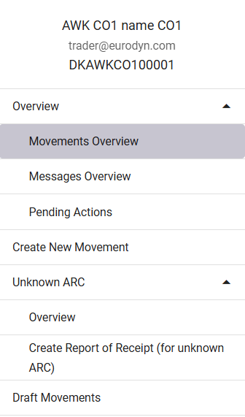
The left-menu user interface is shown in the image below:
Figure 1: Trader Portal - Main left-menu
Each section is further explained in more details in the paragraphs that follow.

Create New Movement (Create IE815)
Please note that only an authorized Consignor can create an e-SAD shipment for an authorized Consignee or temporary authorised Consignee.
This is the beginning of the process of sending excise goods.
The Consignor must meet the following requirements in order to proceed with the shipment submission:
• be registered and authorized
• be authorized to submit an e-AD / e-SAD (untaxed/taxed). This means that one must be a registered Consignor, authorized Consignor or authorized warehouse keeper.
Through the following screen, a new movement can be created by submitting a new draft e-AD (IE815).
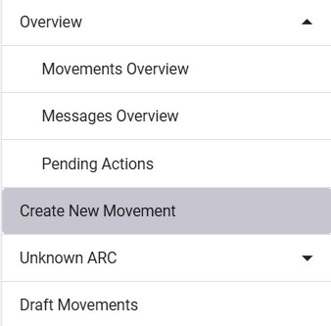
Figure 2: IE815 Message Menu Button
By selecting Create New Movement in the menu, the following form appears:
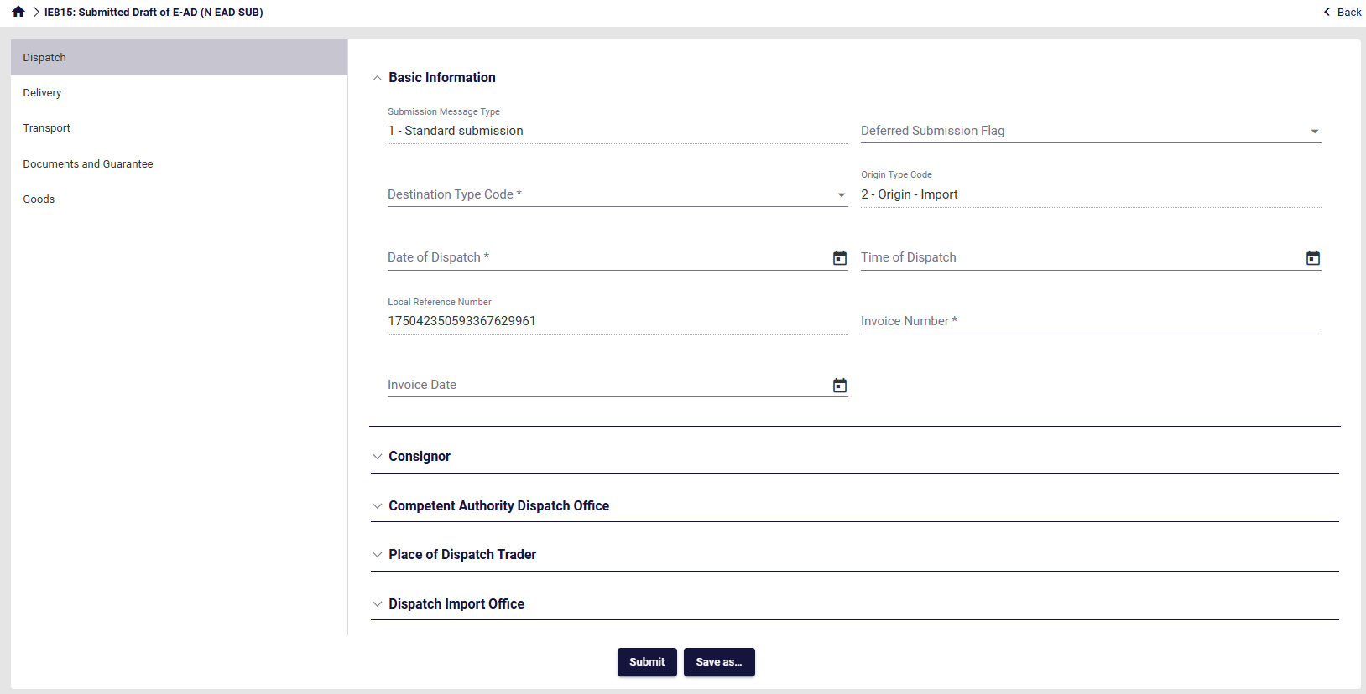
Figure 3: Screen Submission of an IE815 Message
Complete the necessary information for each section that can be seen on the left.
These sections are:
- Dispatch
- Delivery
- Transport
- Documents and Guarantees
- Goods
Finally click Submit.
Be aware it is possible to save an IE815 as a draft by clicking on “Save as”.
Please refer to 3.4 Draft Declarations for more details.

Required and Validated data elements
All required fields within the declaration dataset are indicated by an asterisk in the respective field description.
A number of declaration data elements are also validated upon declaration submission against specific business rules.
The behaviour of the system is different in these two cases:
- If any required fields (i.e. fields that require a value and cannot be left blank) are not completed, the submit button will not result in declaration submission and validation. However, the section(s) descriptor(s) where the required fields are left blank will be dsplayed in red, as in the example shown in the image below:
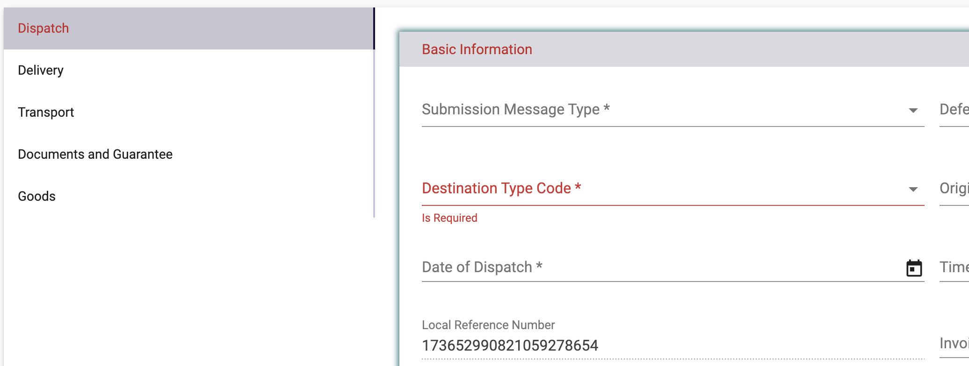
Figure 4: Declaration drafting - marking of missing required fields
- If all required fields contain values, the declaration will be submitted to EMCS and the validation will be performed. If any validation rules are violated, in addition to the visual indication above, the system will display a pop-up box with the list of the validation errors that had been detected.
The following screen shows an example of a validation error list, which is included on the top part of the screen: 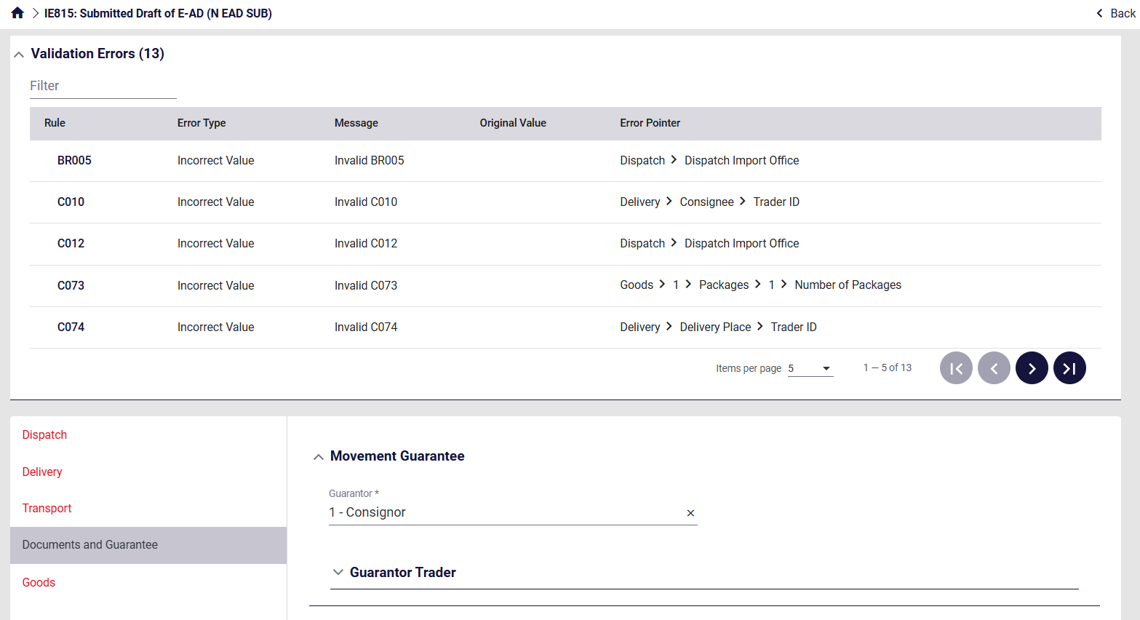
Figure 5: Validation errors - example
Click on each validation in order to see the details.
- Clicking on the Error Pointer will redirect the user to the incorrect field within the form, so that it can be corrected.
- Clicking on the Business Rule will generate a popup window (as in the example shown below) indicating the definition of the business rule that has not been satisfied.
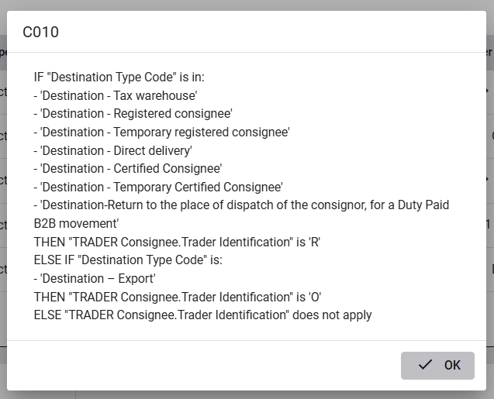
Figure 6: Validation errors - popup window with business rule
The sections that have errors are also marked in red. Click on each sections and see the detailed error message(s). An example is shown in the image below:
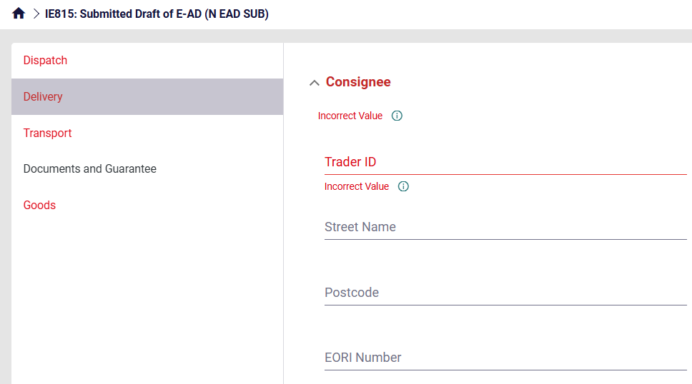
Figure 7: Validation errors - markup on the screen
Next to the error message (which is shown under the data element) there is an info icon ( ), Click on it to see the details of the associated business rule.

Validation errors
All validation errors contain the following information:
- Rule: Violated business rule (BRxxxx or Rxxxx) or condition (Cxxxx) code ID
- Message: Error description
- Original Value: The value contained in the data element
- Error Pointer: Indication on the location (field) of the error in the declaration

Consignee
Based on the user's selection in the Destination Type Code field, the Consignee behaves as follows:
The user should first select the Destination Type Code in the Dispatch section:
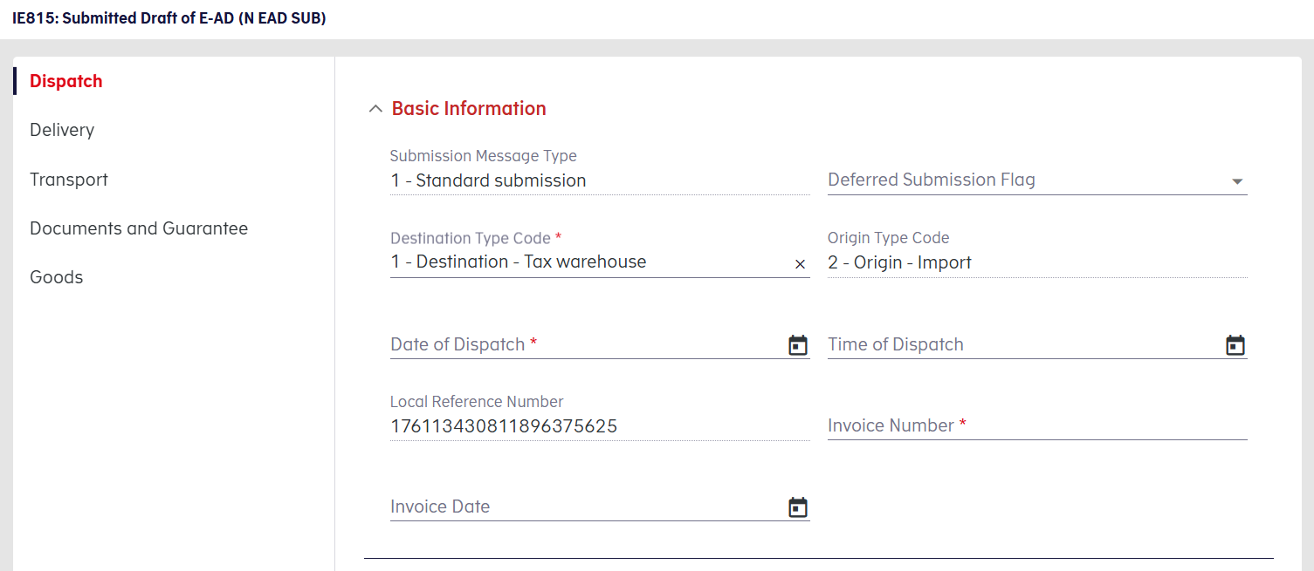
Figure 8: Consignee – Destination Type Code

For destination types where the Consignee's ID is an Excise Number, a field labelled "Excise Number" (Punktafgiftsnummer) is displayed.
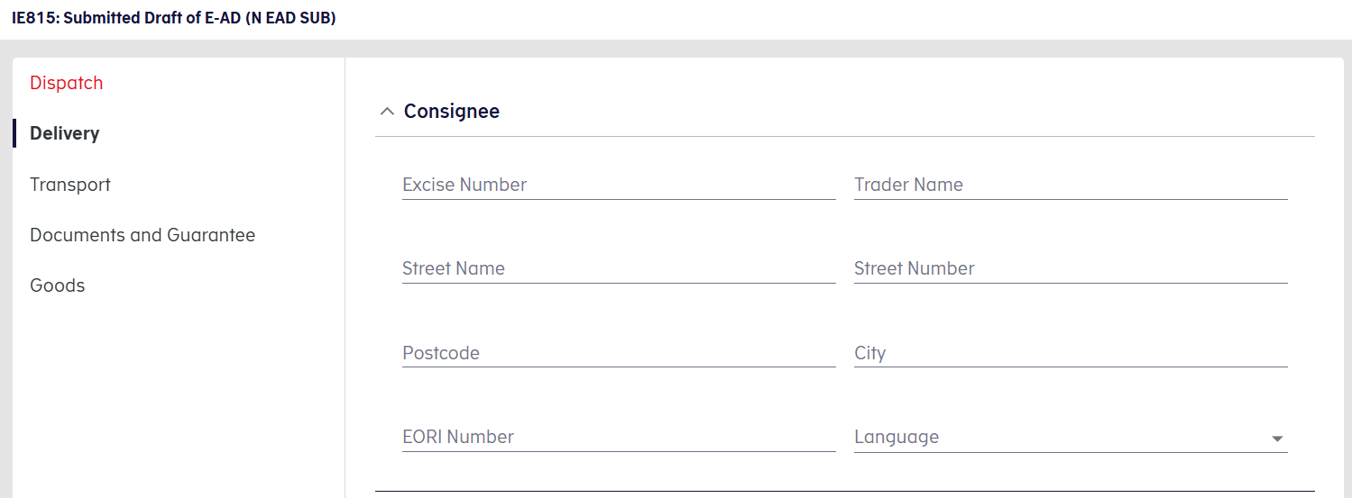
Figure 9: Consignee – Excise Number

The user must enter the Consignee's Excise Number in this field. If the Excise Number is valid, the Consignee’s details are automatically populated by the system. These fields remain editable in case the user wishes to modify them.
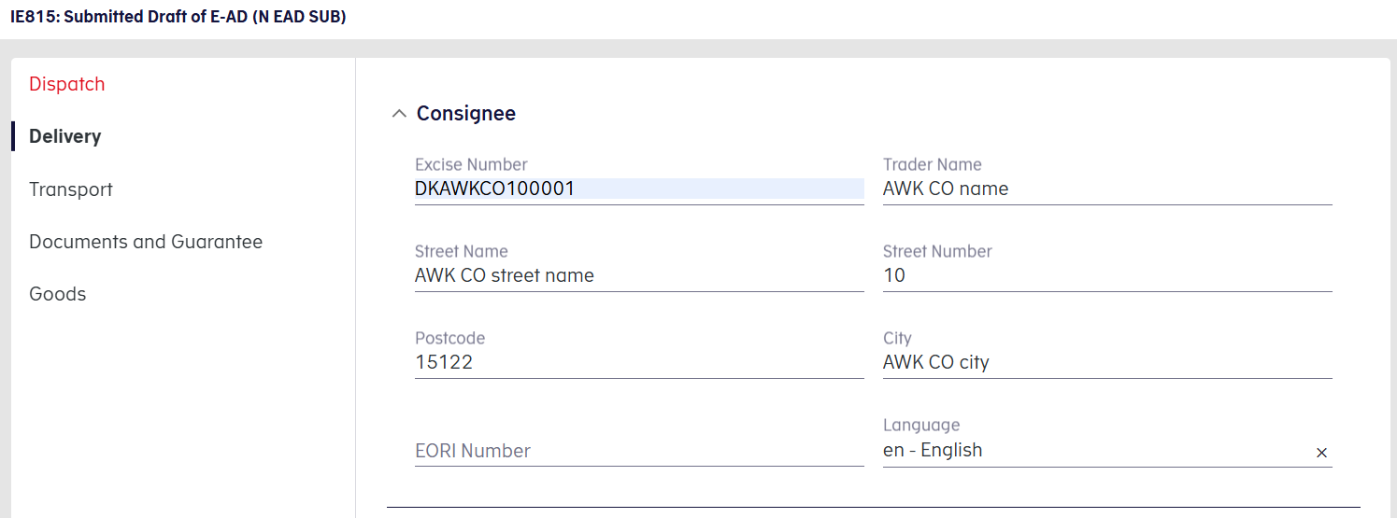
Figure 10: Consignee – Consignee Details

If the Trader Excise Number is invalid, the following error message is be displayed:
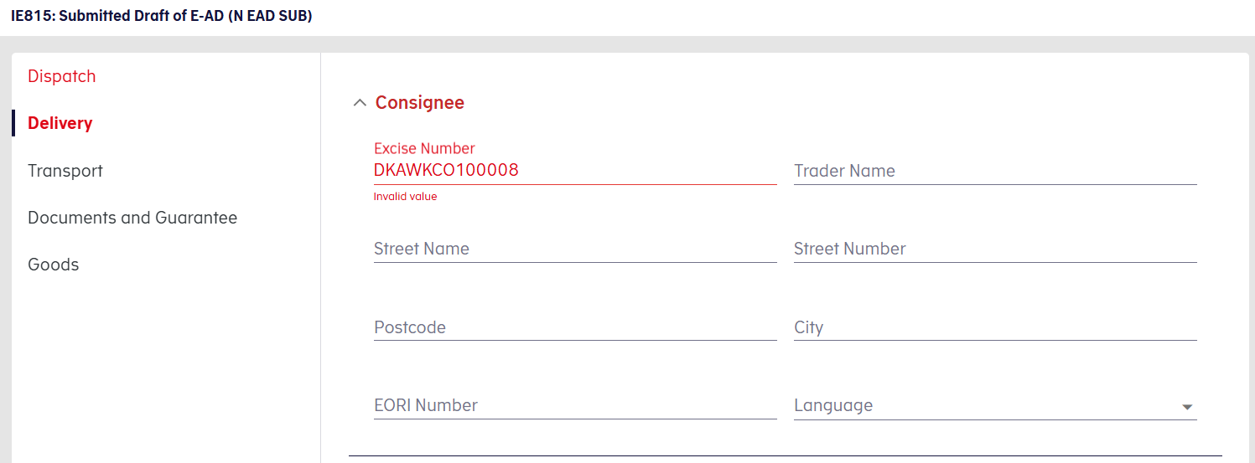
Figure 11: Consignee – Consignee Error

For destination types where the Consignee is identified differently, a field labelled "Trader ID" (Virksomhedsnummer) is shown instead. This is a free-text field with no additional system functionality.
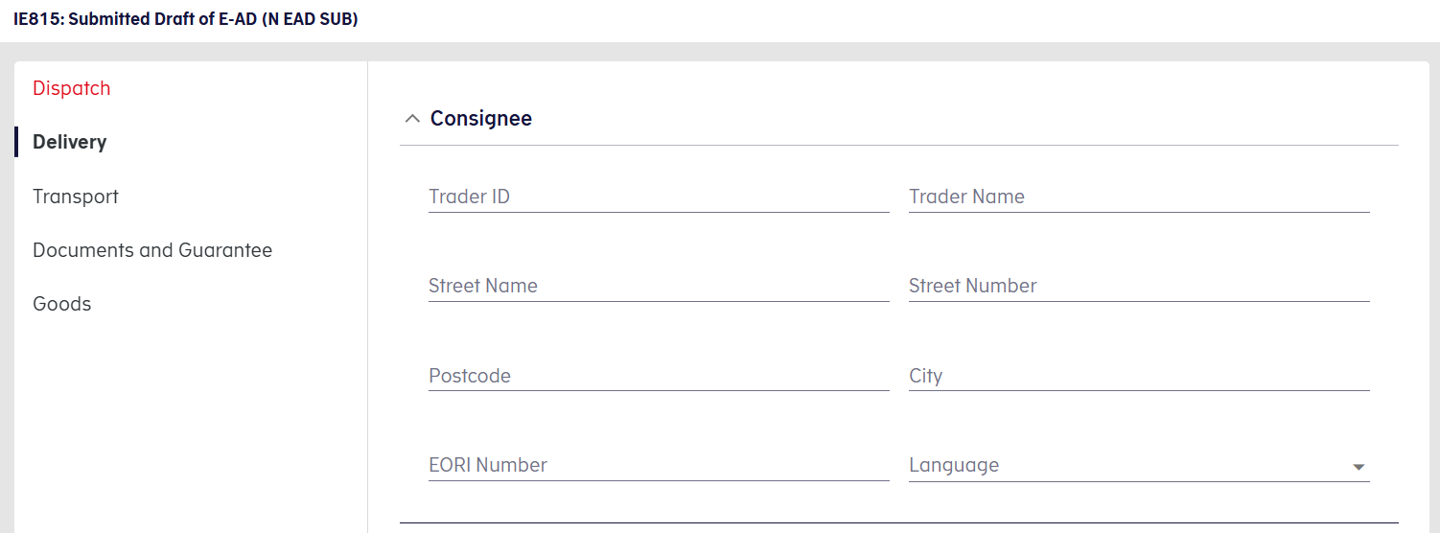
Figure 12: Consignee – Trader ID

Note: Every time the user changes the Destination Type Code, the Consignee section is cleared.

Delivery Place
Based on the user's selection in the Destination Type Code field, the Delivery Place behaves as follows:
The user should first select the Operator Type Code in the Dispatch section.
Figure 13: Delivery Place – Destination Type Code

Then the user must enter the Consignee's Excise Number in the Consignee section.
Figure 14: Delivery Place – Consignee Details

For Destination Type 1 (Tax Warehouse), a field labelled "Tax Warehouse" (Afgiftsoplag) is displayed in the Delivery Place Section.
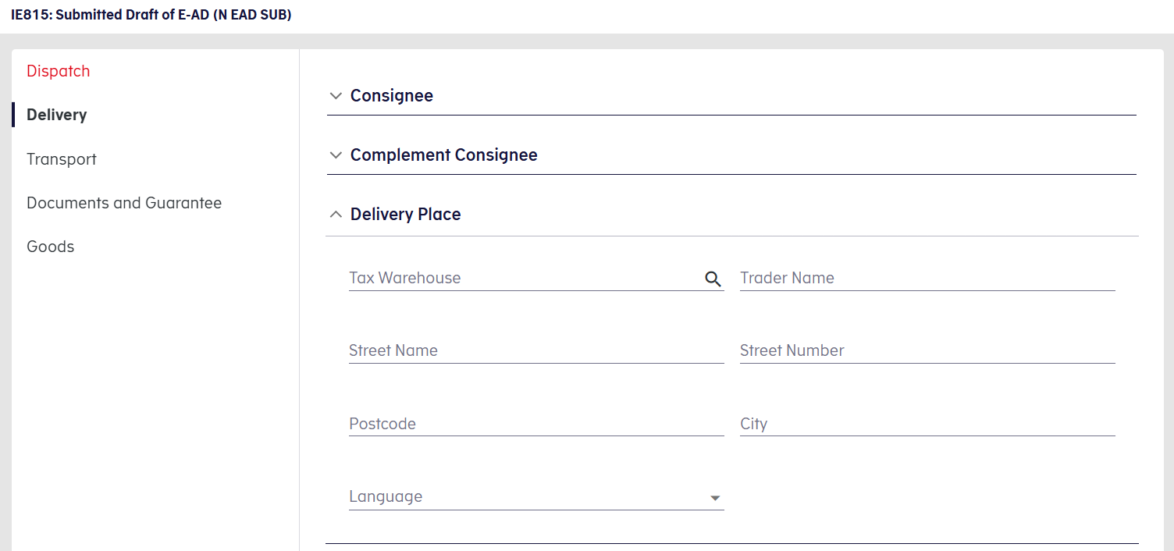
Figure 15: Delivery Place – Tax Warehouse

The user must enter the Tax Warehouse's Excise Number. If the Excise Number is valid, the warehouse details are automatically populated by the system. These remain editable for manual changes.
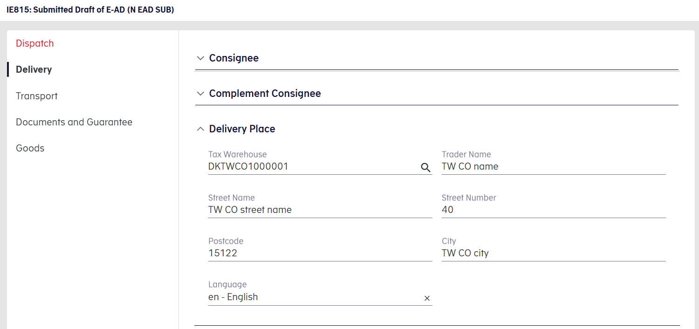
Figure 16: Delivery Place – Tax Warehouse Details

This field also includes a search button, allowing the user to search among the Consignee’s registered Tax Warehouses.
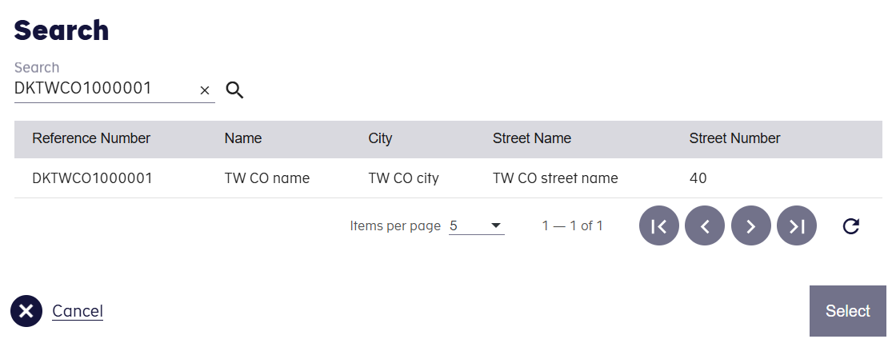
Figure 17: Delivery Place – Search

If no Consignee has been selected prior to clicking the search button, the following pop-up appears:
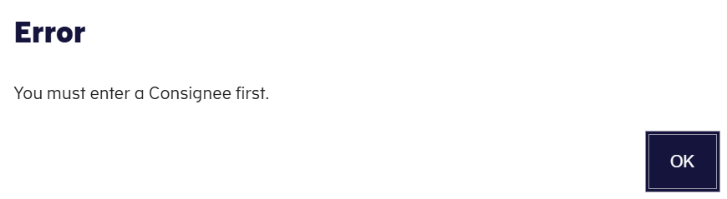
Figure 18: Delivery Place – Consignee Error

For all other destination types (e.g. 2, 3, 6 etc.) in the Dispatch section, a field labelled "Trader ID" (Virksomhedsnummer) is shown in the Delivery Place section. This is a free-text field with no additional system functionality.
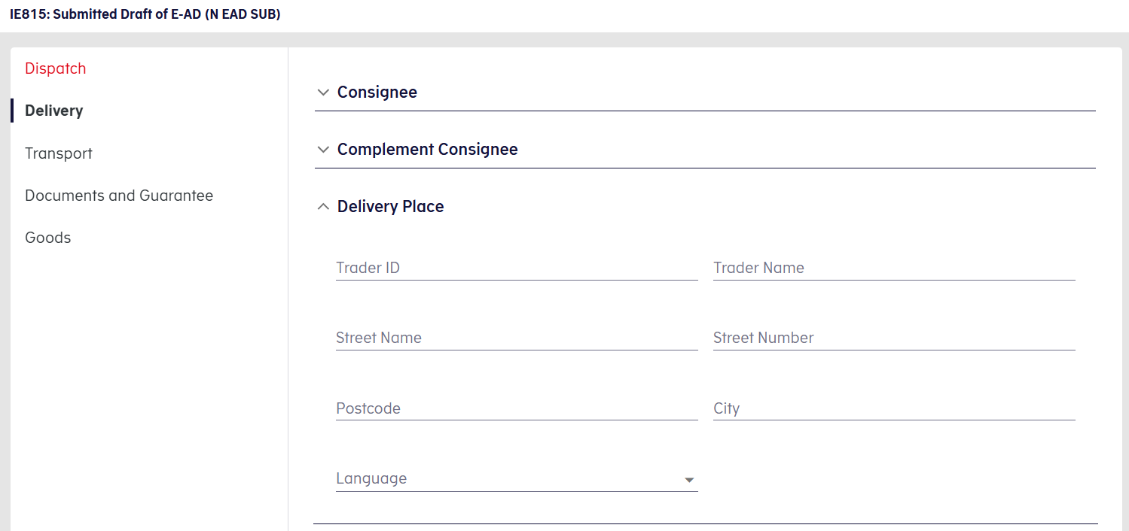
Figure 19: Delivery Place – Trader ID

Note: Every time the user changes the Destination Type Code, both the Consignee and Delivery Place sections are cleared.

Overview

Open Movements
This section lists all open movements submitted by the logged-in user as shown in the following screen:

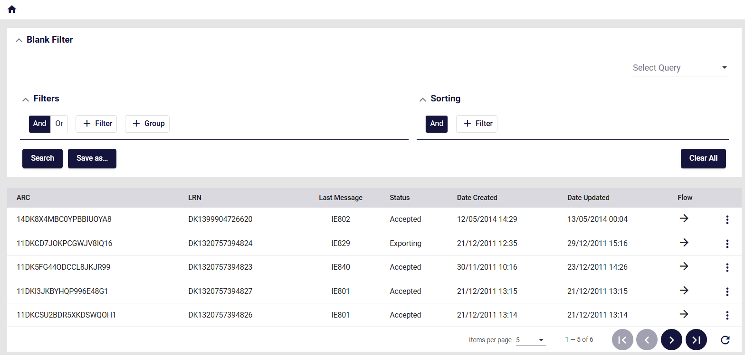
Figure 20: Open Movements grid
A movement is considered as Open when its status is not final.
Therefore, this screen is identical to Movements Overview (3.2.2) while excluding Closed (i.e. finalised) movements.
Click on the action selector on the right side of the grid to View the movement (for further detail please refer to 3.2.2.2).

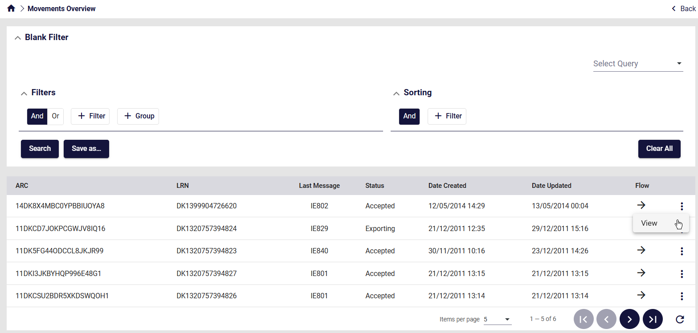
Figure 21: Open Movements Actions
By clicking on View, the previously Movement Details grid will be displayed (for further detail please refer to 3.2.2.3).
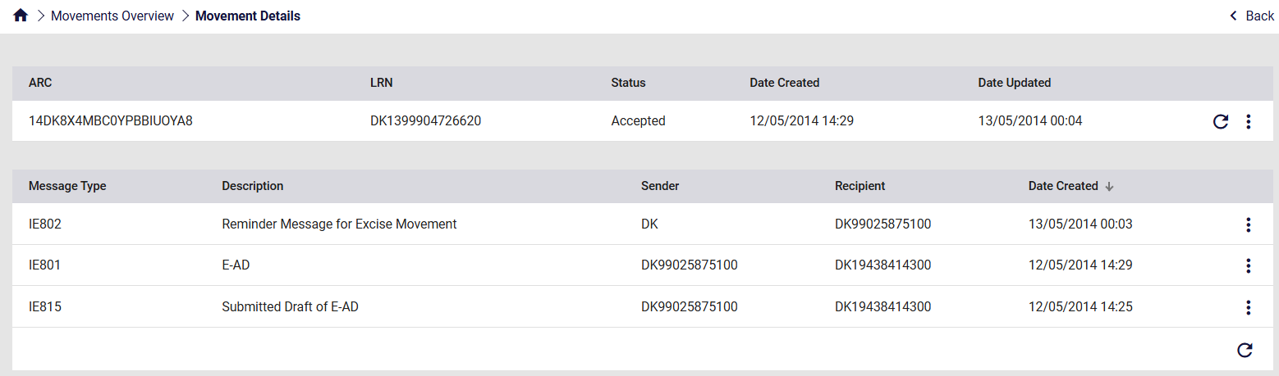
Figure 22: Open Movements View

Movements Overview
This section lists all movements submitted by the logged-in user as shown in the following screen:
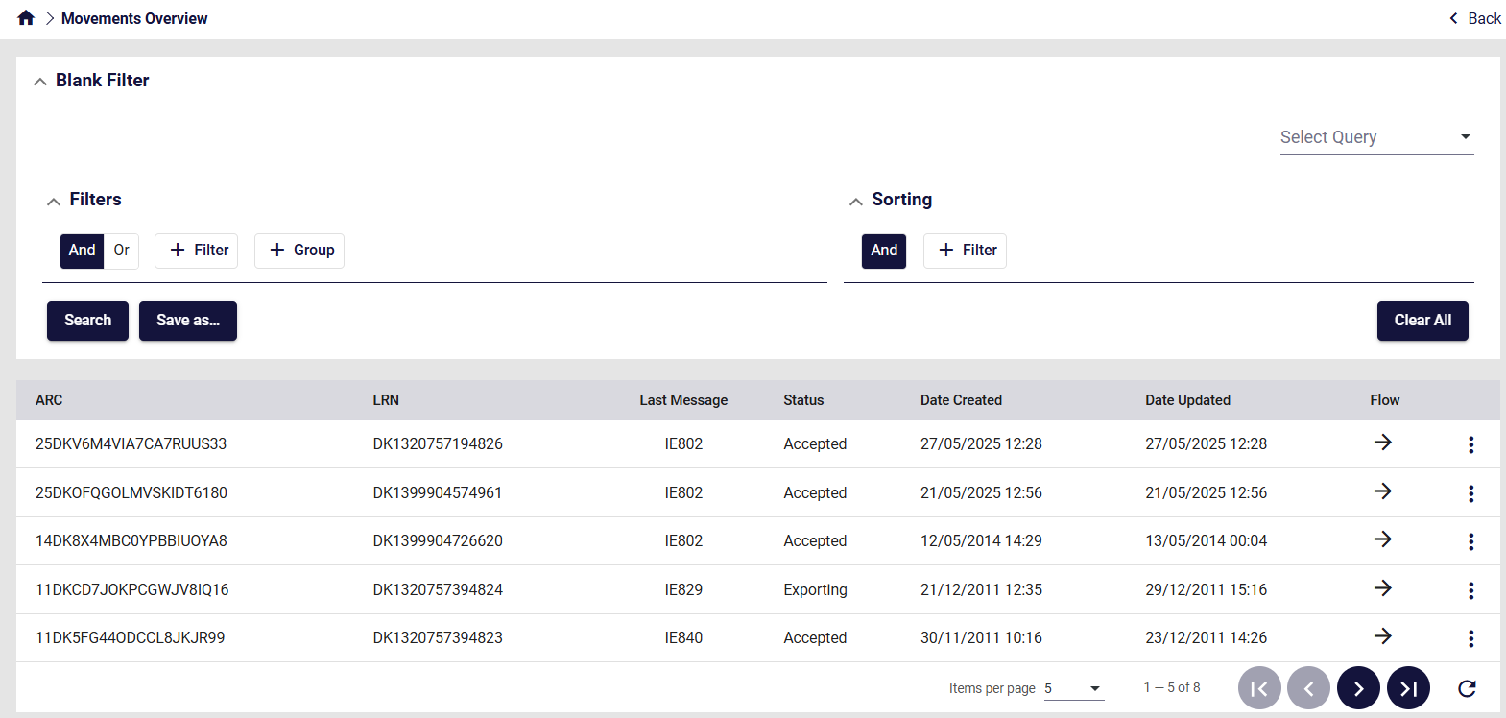
Figure 23: Movement Overview grid – example

Grid columns
The following columns are displayed in the Movements grid:
Column name | Description
ARC | The ARC of the entry
LRN | The LRN of the entry (LRN = Local Reference Number)
Last message | The last message of the movement (e.g. IE801)
Status | Movement Status
Date Created | The date the movement was created
Date Updated | The date the last message referencing the movement ARC was registered in the system
Flow | The flow of the last message exchanged.  - Incoming: indicated by a left pointing arrow  - Outbound: indicated by a right pointing arrow.
Table 1: Movement Overview grid - fields

Menu with the available actions
The actions selector in the Overview grid (icon) will display the available Movement Actions, depending on the type and status of the corresponding movement.
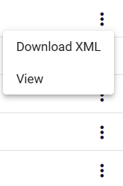
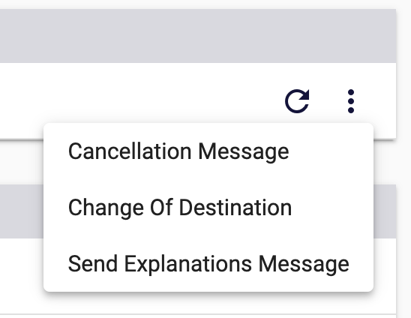
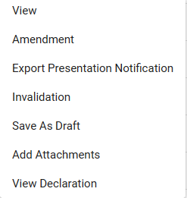
Examples of the “Action” menus are shown in the images below:
Figure 24: "Actions" menu - examples

View movement details
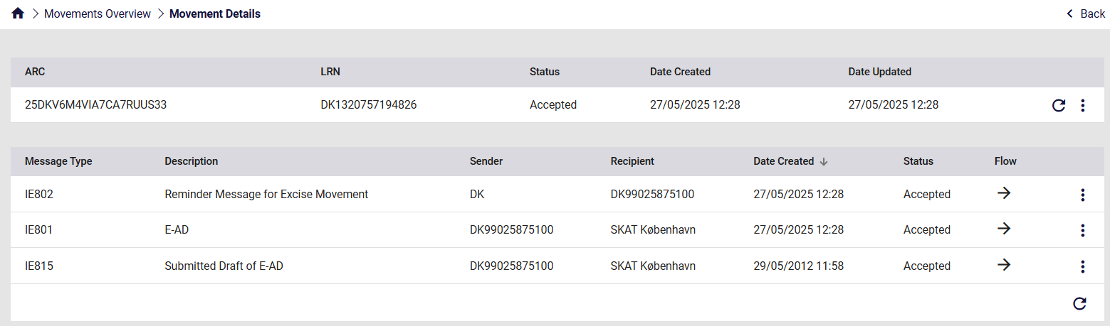When selecting “View” from the “Actions” menu, the “Movement details” data grid is displayed.
Figure 25: Movement Details screen
The “Movement details” grid has the following sections:
- Header element; the Header element contains the following columns for the movement:
  - ARC
  - LRN
  - Status (Movement status)
  - Date Created
  - Date Updated

Figure 26: Movement details header
You can refresh the screen by clicking on the refresh button which is located on the right side of the container.
- Movement message history: it contains all messages that reference the movement’s ARC.
The following columns are displayed:
- Message type (The message code)
- Description (Message name)
- Sender
- Recipient
- Date created
- Action selector for the entry (“View” is the only available action here)
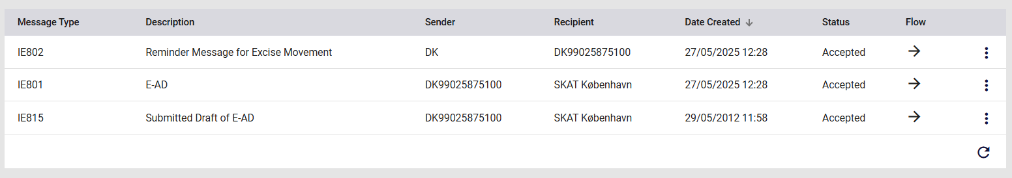
Figure 27: Movement messages grid
To view the contents of an individual entry from the movement message history section, double-click the selected row, or click on the action selector and click on “View”.

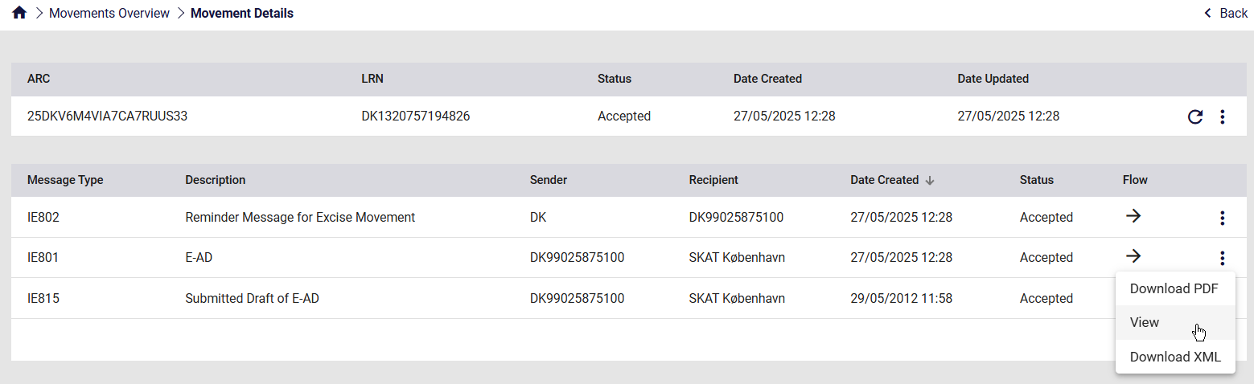
Figure 28: Movement messages grid View
In order to download any message in XML format, click on the action selector and then on “Download XML”.
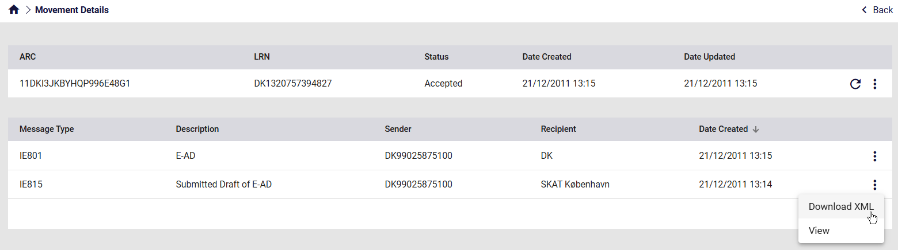
Figure 29: Movement messages grid Download XML
In order to download IE801 messages in PDF format, click on the action selector and then on “Download PDF”.
Note: This is only available for IE801 messages
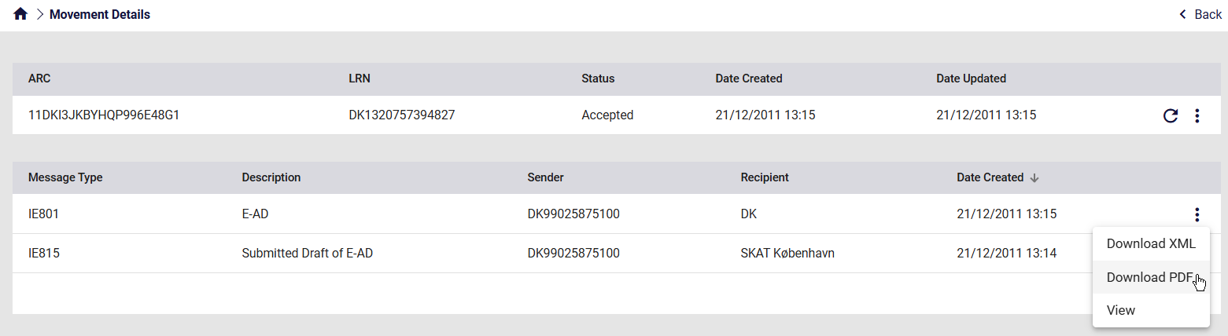
Figure 30: Movement messages grid Download PDF

View declaration
The following shows the “View Declaration” screen layout:
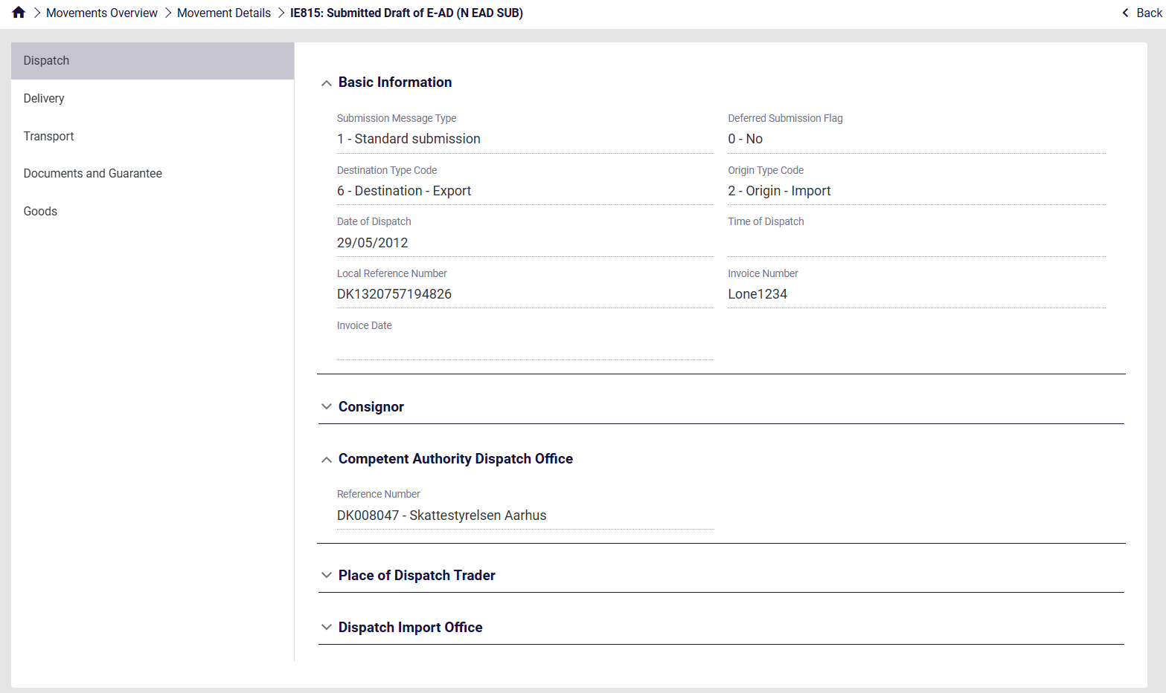
Figure 31: View Declaration screen - example
The following declaration sections are displayed on the left in this screenshot:
Section Name | Description
Dispatch | Contains all the information related to the consignor
Delivery | Contains information for the recipient and the place of delivery of the movement.
Transport | Basic information and details of movement. The duration of movement can be expressed either in hours or days. Moreover, the time corresponding to the days of the movement of goods taking into account the duration of the movement, must not exceed one week.
Documents and Guarantee | Includes all documents certificates and movement guarantees information that was submitted for that movement.
Goods | The EMCS goods
Table 2: View Declaration Message - sections

Messages Overview
This section lists all messages exchanged between the logged-in user and the application, as shown in the following screen:
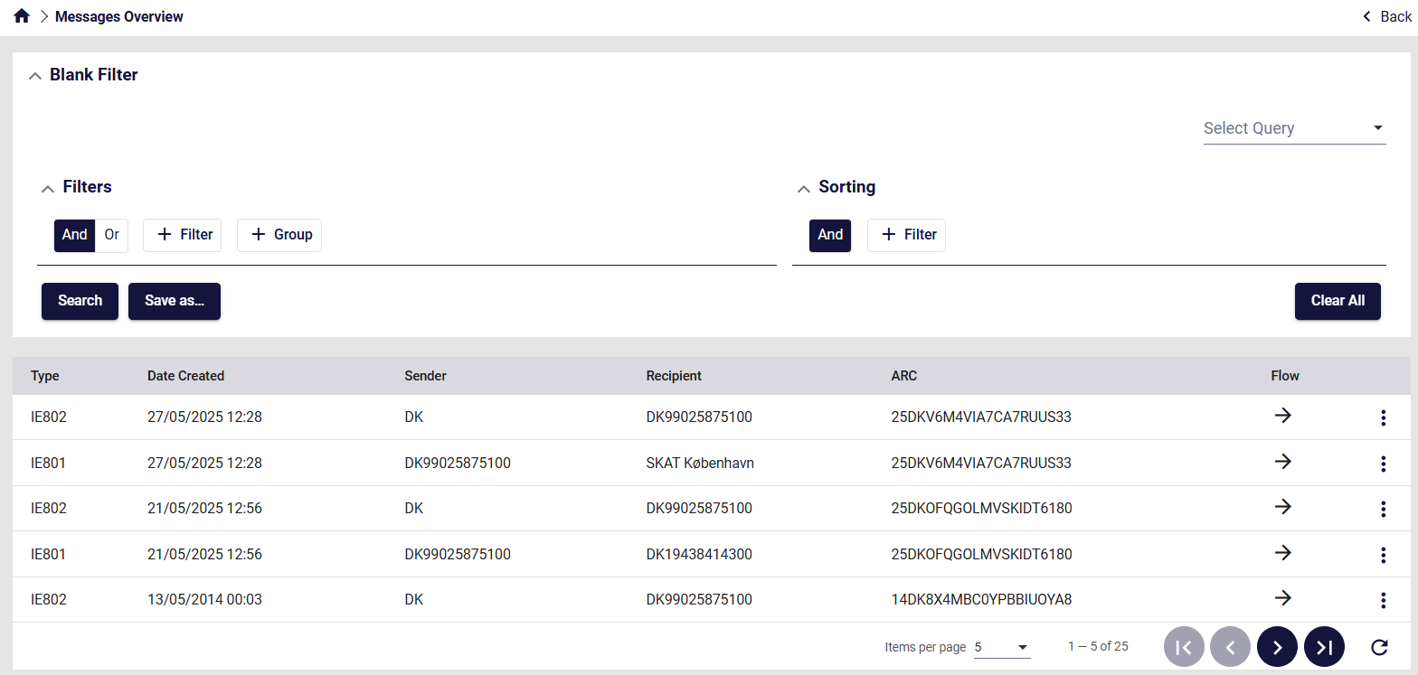
Figure 32: Message Overview grid – example

Grid columns
The following columns are displayed in the Messages grid:
Column name | Description
Type | The type of message exchanged (eg IE801)
Date Created | The date of the message exchange
Sender | Indicates who generated the message
Recipient | Indicates who received the message
ARC | The ARC of the entry
Flow | The flow of the last message exchanged.  - Incoming: indicated by a left pointing arrow  - Outbound: indicated by a right pointing arrow.
Table 3: Message Overview grid - fields

Pending Actions
This section lists all movements that require an action to be completed by the logged-in user, as shown in the following screen:
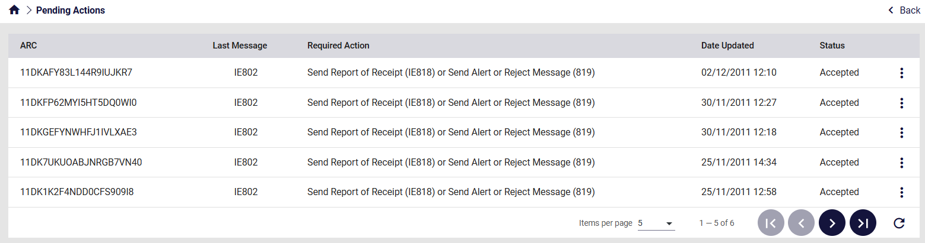
Figure 33: Pending Actions – example

Grid columns
The following columns are displayed in the Actions grid:
Column name | Description
ARC | The ARC of the entry
Last message | The last message of the movement (eg IE801)
Required Action | Description of the action that the logged-in user should complete
Date Updated | The date of the last message exchange or action completed
Status | Movement Status
Table 4: Pending Actions grid – fields
Be selecting to view the movement, the necessary pending action can be completed.

Unknown ARC
This function can be used if the Consignee cannot see the reported ARC – message IE801 - in their own EMCS application.
If the Consignee submits an IE818 for an unknown ARC, i.e. no movement exists with the submitted ARC number, the Pending message remains in the Unknown ARC – Overview screen.

Overview
Through the following screen, the Overview of the Unknown ARC’s can be accessed.
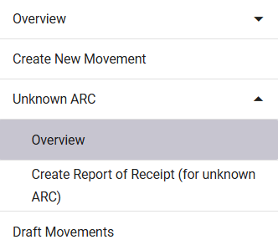
Figure 34: Unknown ARC – Overview button
By selecting Overview in the menu, the following grid appears:
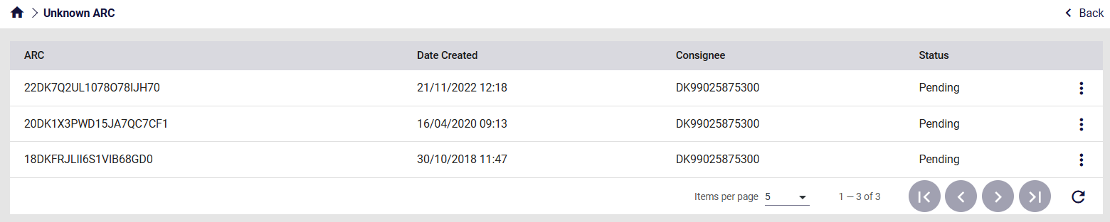
Figure 35: Unknown ARC – Overview
Please refer to 3.2.2.2 Menu with the available actions for more details regarding the action selector (three dots).

Grid columns
The following columns are displayed in the grid:
Column name | Description
ARC | The ARC of the entry
Date Created | Date of creation of the entry
Consignee | Consignee of the movement
Status | Movement Status
Table 5: Unknown ARC - Overview grid - fields

Menu with the available actions
The actions selector in the Overview grid (icon) will display the available Actions, depending on the type and status of the corresponding movement.
Examples of the “Action” menus are shown in the images below:
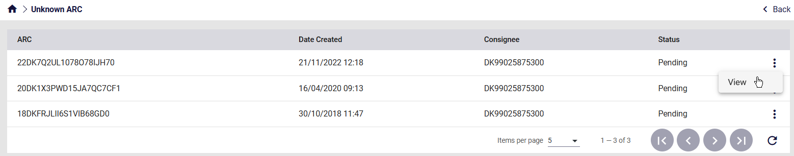
Figure 36: Unknown ARC – Overview Actions

Create Report of Receipt
The Create Report of Receipt (for unknown ARC) screen allows the user to submit a IE818 message for an unknown ARC.
This screen can only be used in cases where an IE801 message has not been received through the system. In all other cases, use the normal procedure to submit a Receipt of Receipt (IE818) through an already created movement.
A Report of Receipt (IE818) for an unknown ARC can be submitted through the following screen.
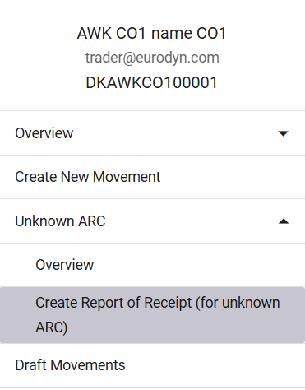
Figure 37: IE818 Message Menu Button
By selecting Create Report of Receipt in the menu, the following form appears:
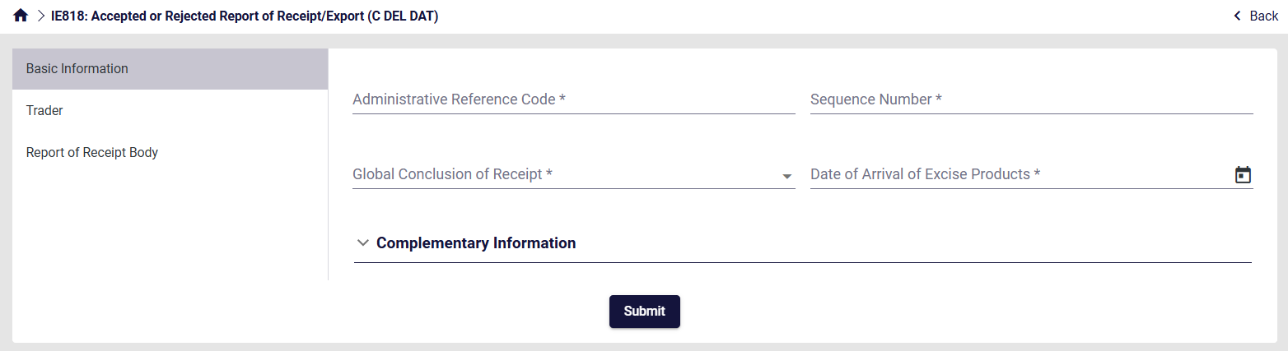
Figure 38: Screen Submission of an IE818 Message

Draft Declarations
The “Draft declarations” grid displays all the unfinished declarations that had been saved during the drafting process or already submitted declarations that had been “Saved as Draft” using the corresponding action of the declaration in the “Declarations” overview.
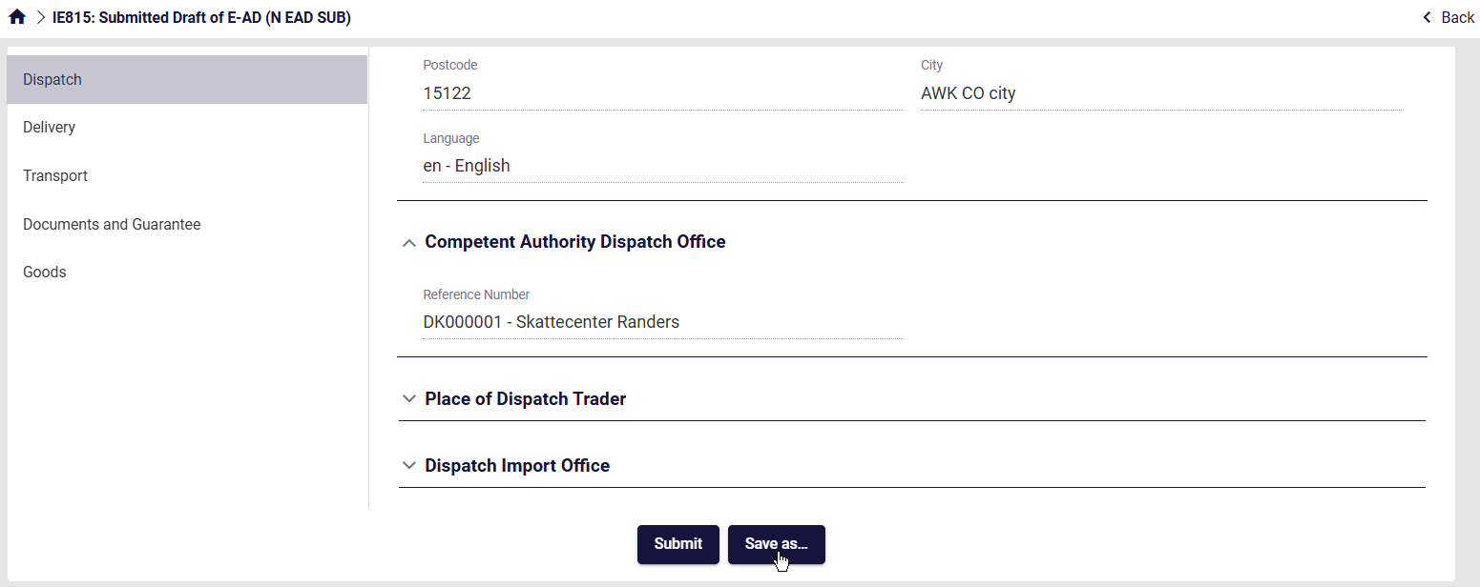
Figure 39: Drafting Process
To resume work on a draft dataset, select “Edit” from the available actions on the draft entry.
Users can create a copy of an existing draft declaration using the “Copy” action button or even completely remove a draft declaration using the “Delete” action button.
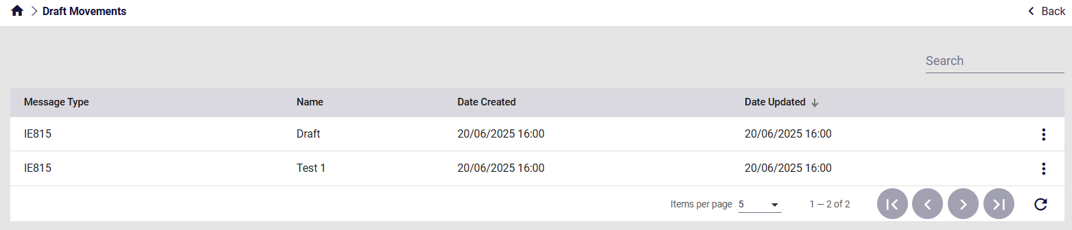
Figure 40: Draft Declarations overview

Import
The Import section is exclusive to Registered Consignors. It displays submitted messages that relate to Import procedures.
These are essentially IE815 messages with Origin Type Code equal to “2 - Origin – Import”.
As explained in further detail below, they are either:
- Pending approval by the Customs Authorities (3.5.1)
- Have already been rejected (3.5.2)
No ARC has been generated for these IE815 messages yet.
If accepted by the Customs Authorities, these will no longer be visible in the Import section but can be found in the Overview screens (3.1.2).

Pending Messages
The Import Pending Messages screen displays IE815 messages that have been submitted and are pending approval by the Customs Authorities.
Through the following screen, the Import Pending Messages can be accessed.
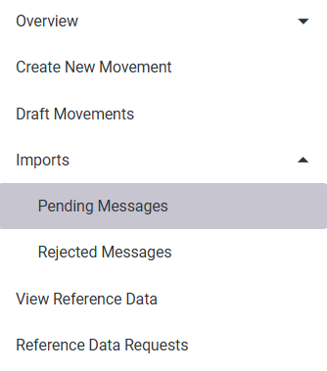
Figure 41: Import – Pending Messages Button

By selecting Pending Messages in the menu, the following screen appears:
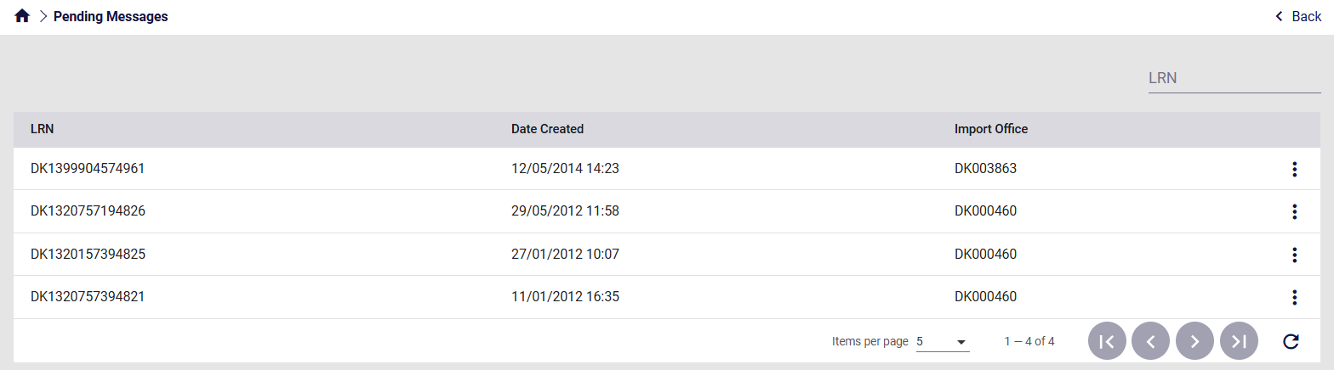
Figure 42: Import – Pending Messages Screen
In the grid above, the following are displayed:
- LRN: Local Reference Number of the IE815 message
- Date Created: Submission date of the IE815 message
- Import Office: Dispatch Import Office referenced in the IE815 message
A specific message can be found by searching its LRN on the top right.
Input the LRN and press Enter. The results will appear as seen below.
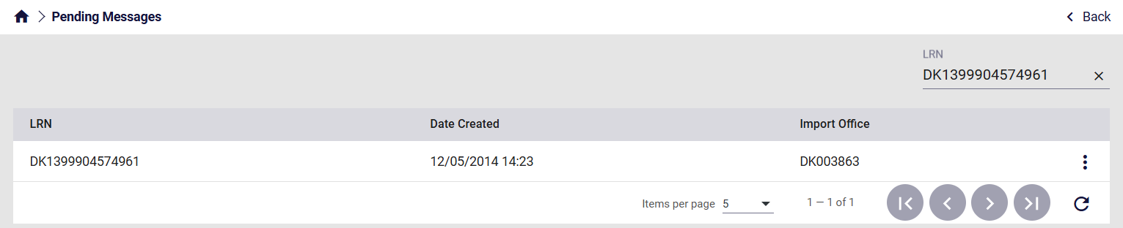
Figure 43: Import – Pending Messages LRN Search

Click on the action selector on the right side of the grid to View the message.
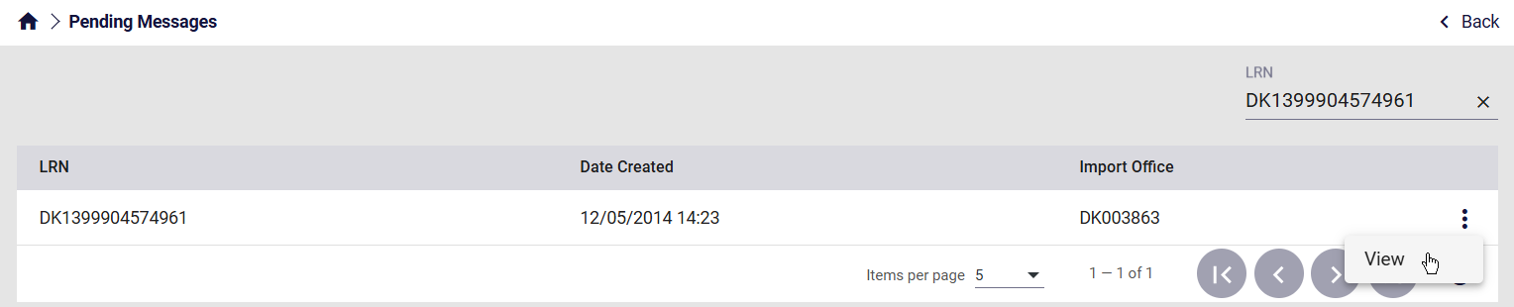
Figure 44: Import – Pending Messages Actions
By clicking on View, the previously submitted IE815 will be displayed.
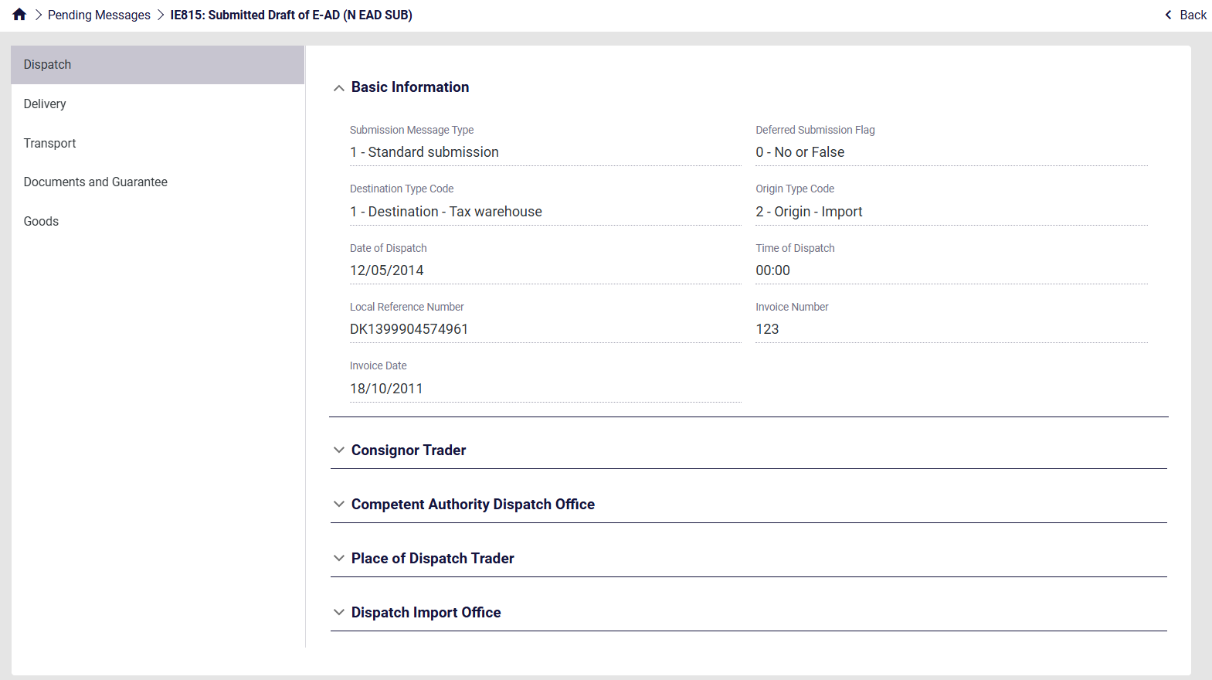
Figure 45: Import – Pending Messages Submitted form

Rejected Messages
The Import Rejected Messages screen displays IE815 messages that have been submitted and rejected by the Customs Authorities.
Through the following screen, the Import Rejected Messages can be accessed.
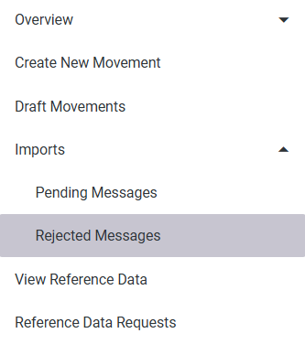
Figure 46: Import – Rejected Messages Button
By selecting Rejected Messages in the menu, the following screen appears:
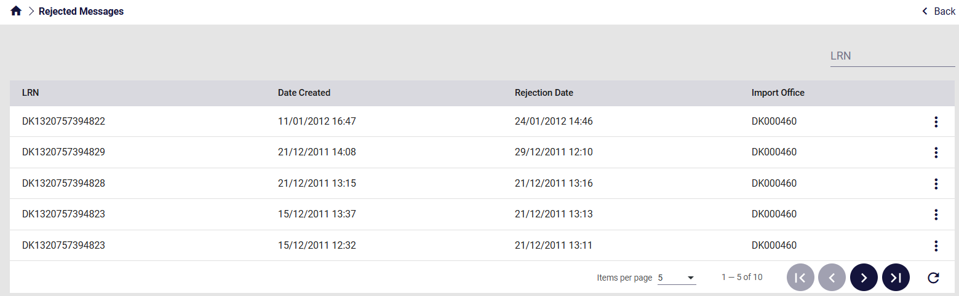
Figure 47: Import – Rejected Messages Screen
In the grid above, the following are displayed:
- LRN: LRN of the IE815 message
- Date Created: Submission date and time of the IE815 message
- Rejection Date: Date and time of the rejection by the Customs Authorities
- Import Office: Dispatch Import Office referenced in the IE815 message
A specific message can be found by searching its LRN on the top right.
Input the LRN and press Enter. The results will appear as seen below.
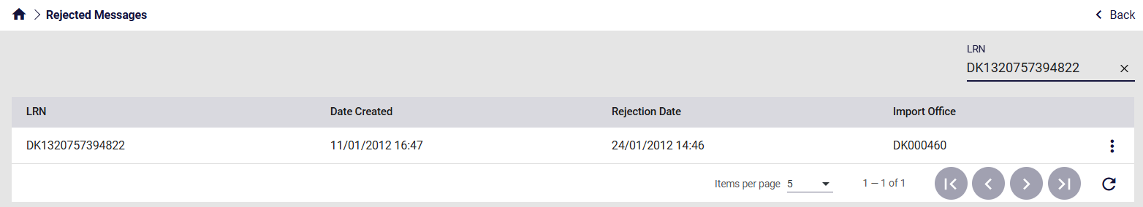
Figure 48: Import – Rejected Messages LRN Search
Click on the action selector on the right side of the grid to either:
- View: Displays the previously submitted IE815 message
- View Rejection: Displays the rejection message by the Custom Authorities

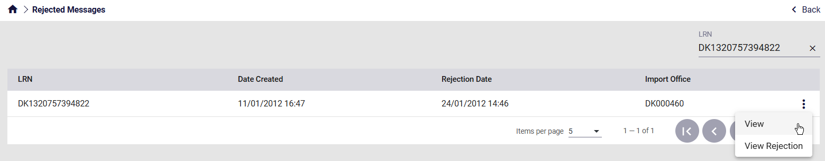
Figure 49: Import – Rejected Messages Actions

By clicking on View, the previously submitted IE815 will be displayed.
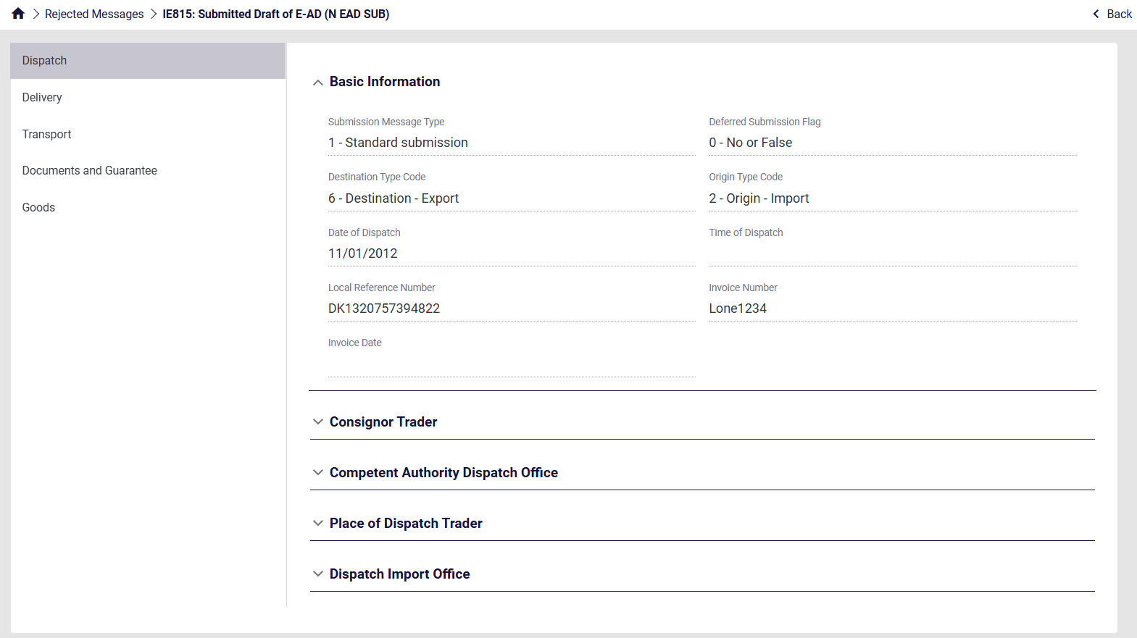
Figure 50: Import – Rejected Messages Submitted IE815
By clicking on View Rejection, the rejection message by the Custom Authorities will be displayed.
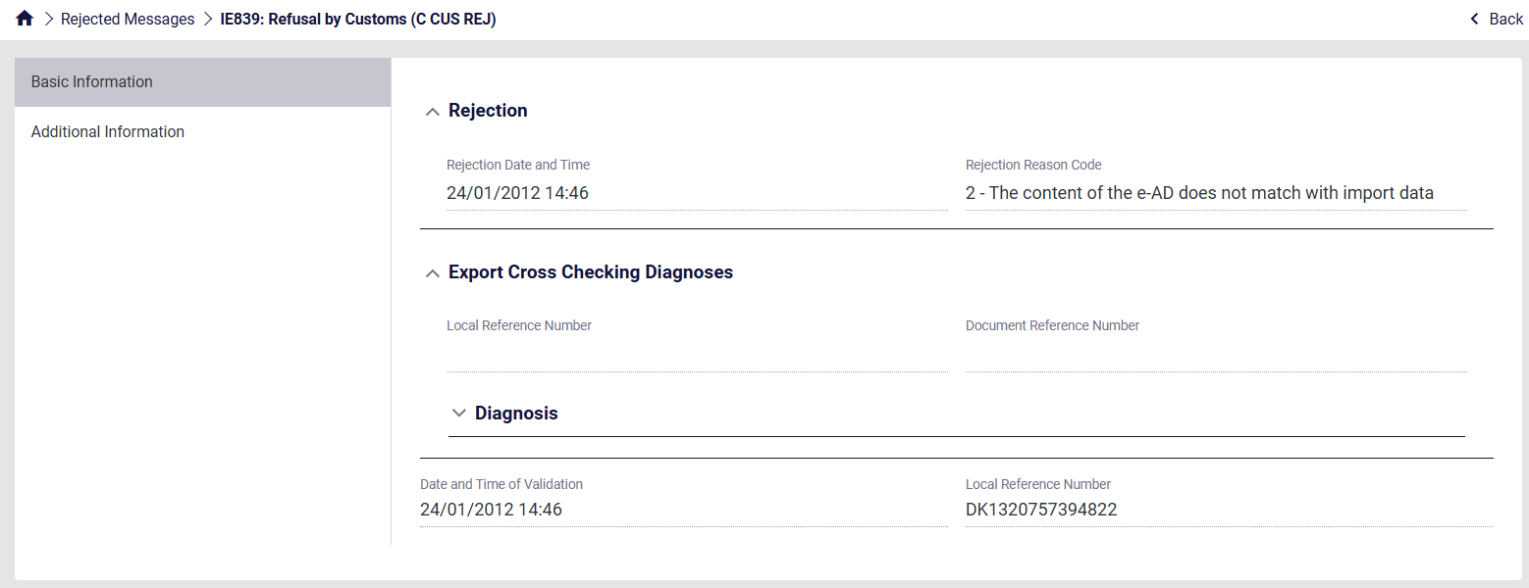
Figure 51: Import – Rejected Messages Rejection

Reference Data
This function aims to facilitate any query the user might have regarding the contents of the reference data.

View Reference Data
Through the following screen, the Reference data can be accessed.
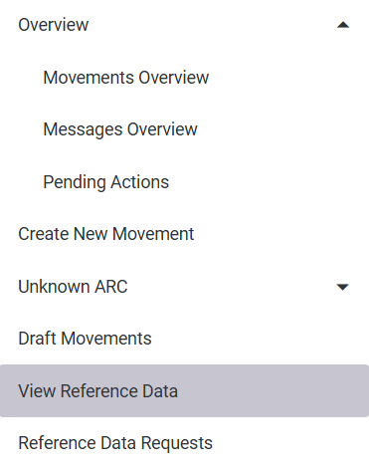
Figure 52: View Reference Data Button
By selecting View Reference Data in the menu, the following screen appears:
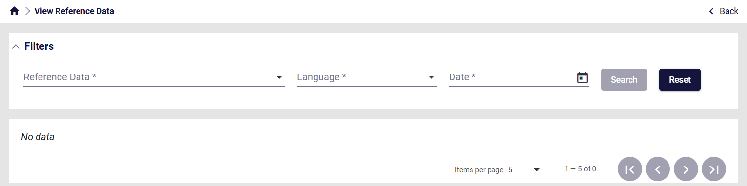
Figure 53: View Reference Data Screen
The following filters can be applied to narrow down the search:
- Reference Data: The name of reference data list
- Language: The language of the description
- Date: The validity date of the list. The lists can be updated and therefore can change depending on the date selected
Select the required filters and click Search.
Note: All three filters are mandatory
The results will appear as seen below.
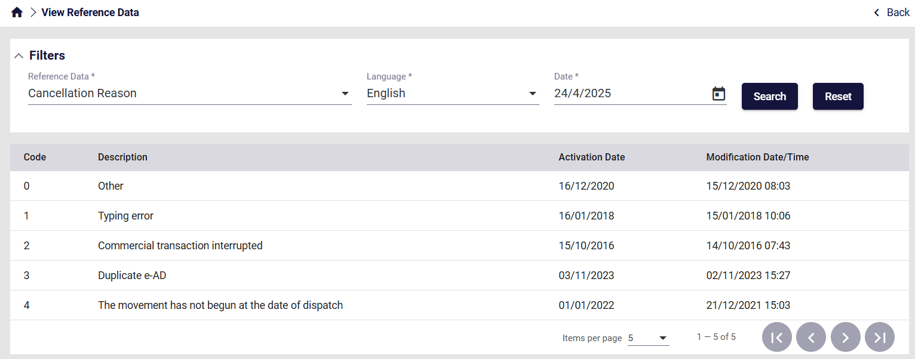
Figure 54: View Reference Data Results

Grid columns
The following columns are displayed in the View Reference Data Results:
Column name | Description
Code | The values of the list
Description | Text description of each value
Activation Date | Date when the value was introduced to the list
Modification Date/Time | Date/Time of the latest change applied to the value
Table 6: View Reference Data Results grid - fields

Reference Data Requests
Through the following screen, the past Reference Data Requests can be accessed.
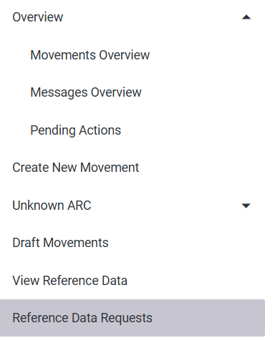
Figure 55: Reference Data Requests Button
By selecting Reference Data Requests in the menu, the following screen appears:
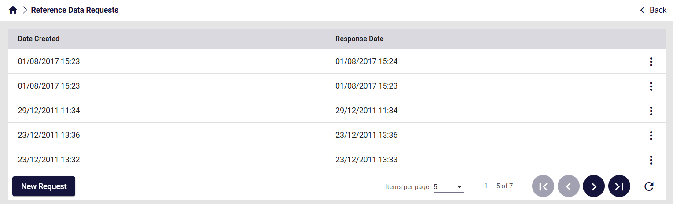
Figure 56: Reference Data Requests Screen
In the grid above, the following are displayed:
- Date Created: Date/Time of the request
- Response Date: Date/Time of the response

By clicking on New Request at the bottom left of the grid, the user can complete a request form.
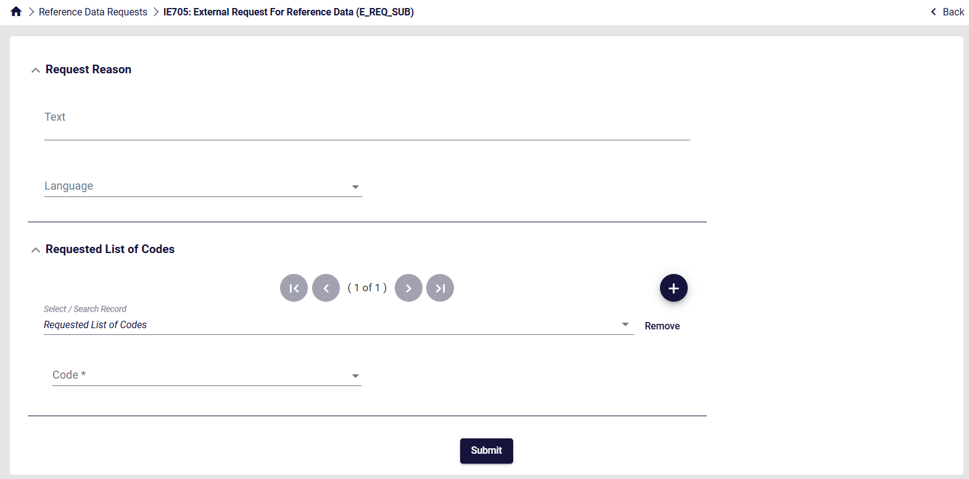
Figure 57: View Reference Data New Request
The following fields are mandatory and need to be completed:
- Text: Explanatory request reason description
- Language: Language of the results
- Code: Which Reference Data list is required by the user
Complete the form and click Submit.
The request will be displayed on the Reference Data Requests Screen, and its results will be available upon reception.
Click on the action selector on the right side of the grid to either:
- View: Displays the completed form of the request
- Download Data: Downloads the results in XML Format
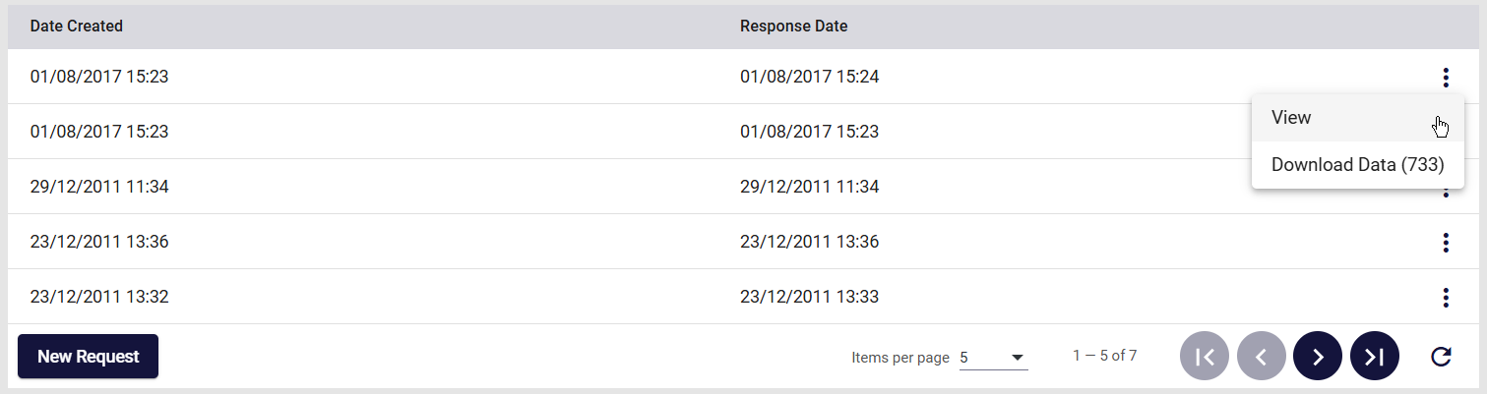
Figure 58: View Reference Data Request actions
The completed request form can be seen below.
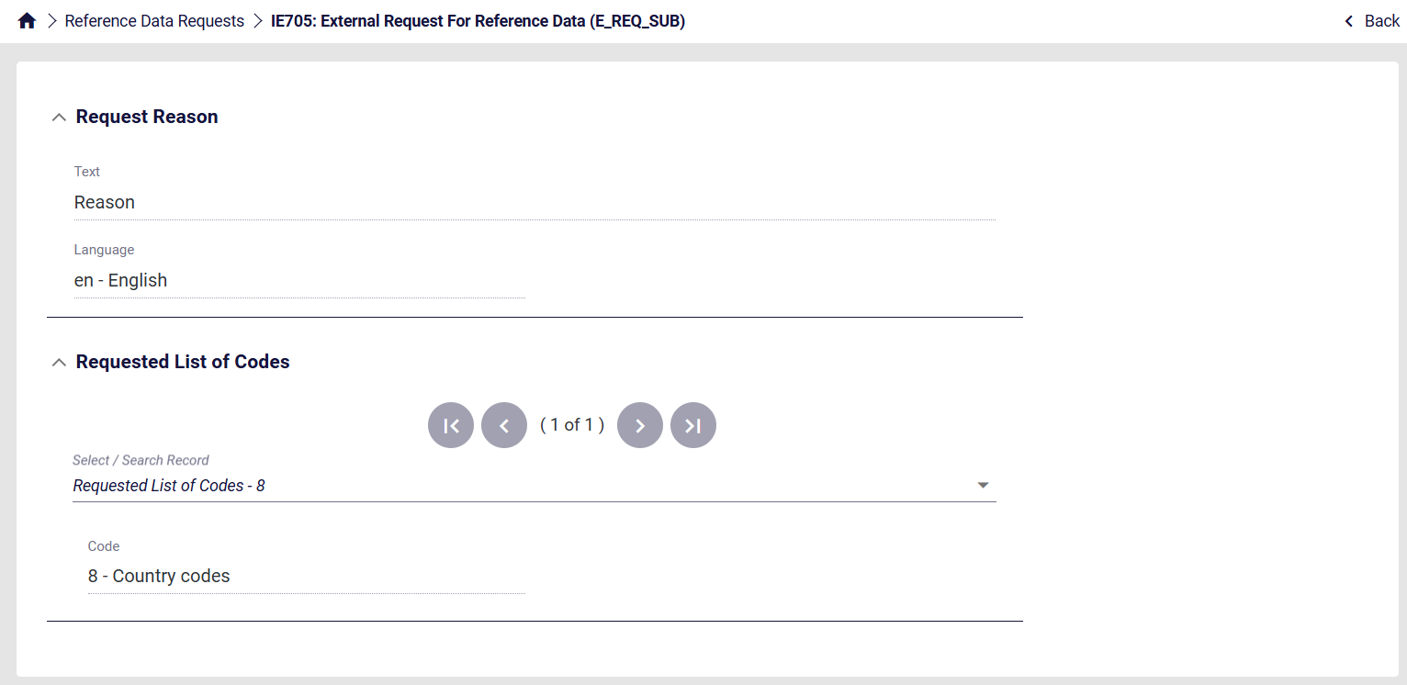
Figure 59: View Reference Data Request form

SEED Authorisation
This function aims to display the SEED Authorisation associated with the logged-in user.
Through the following screen, the authorisation can be accessed.
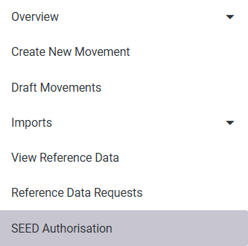
Figure 60: SEED Authorisation Button
By selecting SEED Authorisation in the menu, the following screen appears:
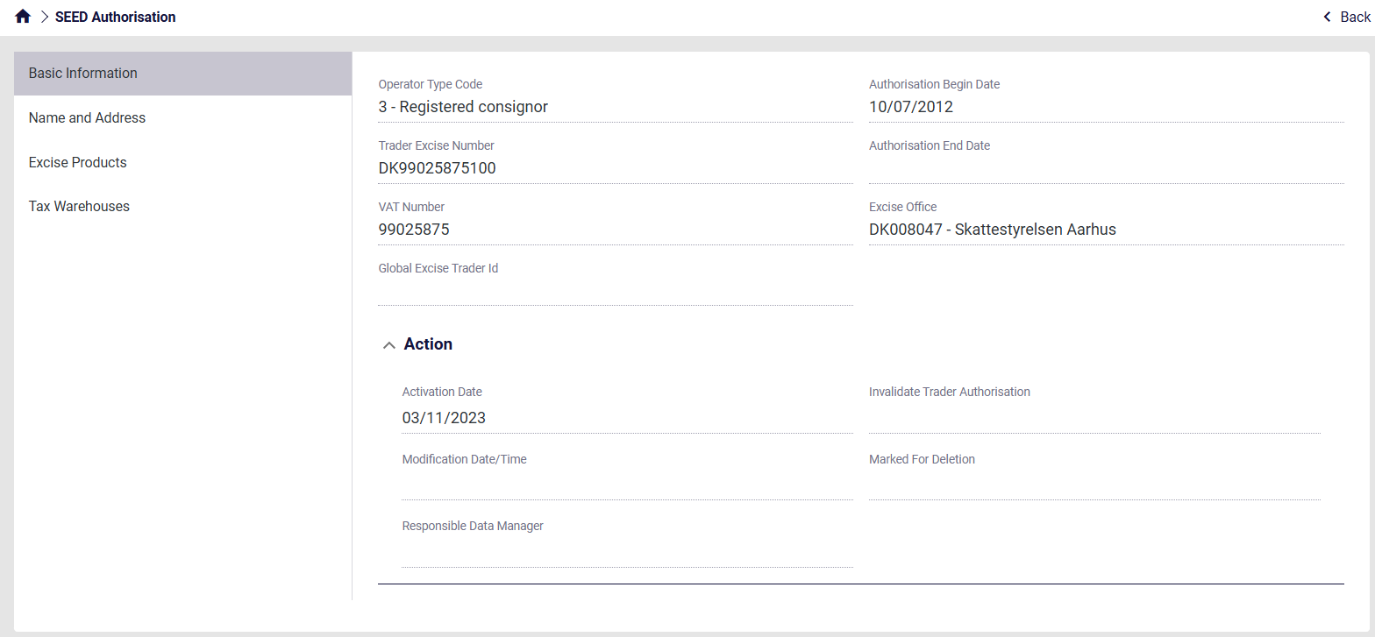
Figure 61: SEED Authorisation Screen
The contents of the SEED Authorisation can be accessed by navigating the different sections on the left side.

Business-related Actions on Movements

Change of destination (IE813)
The IE813 consists of an update message to change the Member State of Destination.
The consignor can change the destination of a movement at any time before receiving a receipt (IE818). If the receipt status is partially rejected or completely rejected, the destination must always be changed.
In order to submit it, click on the action selector in the movement details.
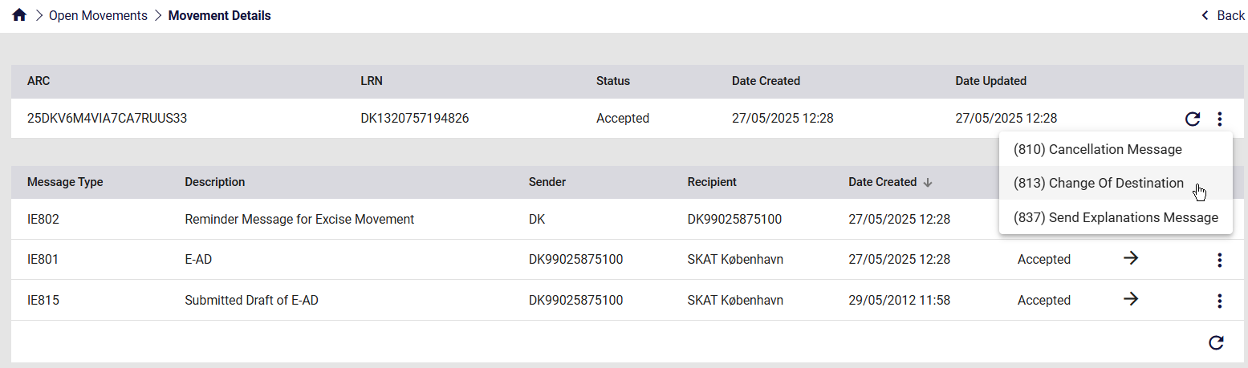
Figure 62: Change of destination (IE813)
The following form appears:
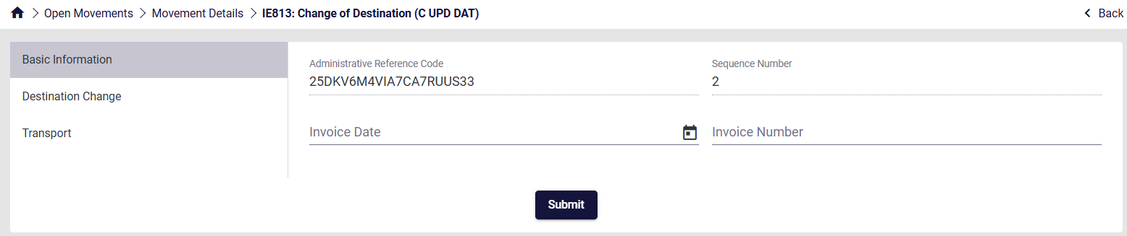
Figure 63: Screen Submission of an IE813 Message
Complete the necessary information for each section that can be seen on the left and finally click Submit.

Destination Change

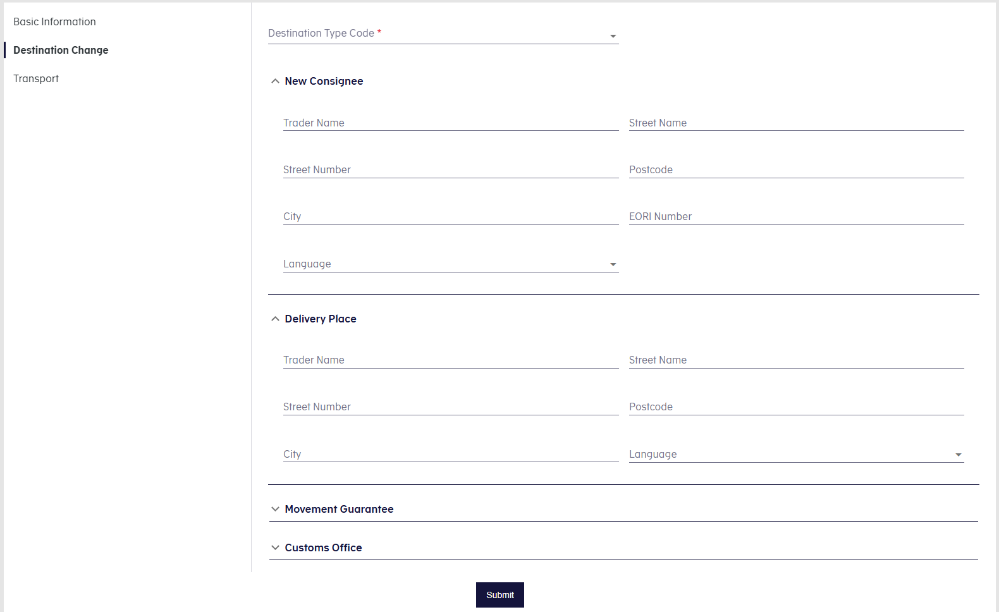
Figure 64: Destination Change

The sections “New Consignee” and “Delivery Place” respond dynamically based on the selected Destination Type Code, following the same rules as described in:
- 3.1.2 Consignee
- 3.1.3 Delivery Place

Cancelation of declaration (IE810)
The IE810 consists of a cancellation message in cases where a consignment has not left the Place of Dispatch.
Cancellation of a movement (IE810) can only take place when the goods have not left the consignor's tax warehouse.
In order to submit it, click on the action selector in the movement details.
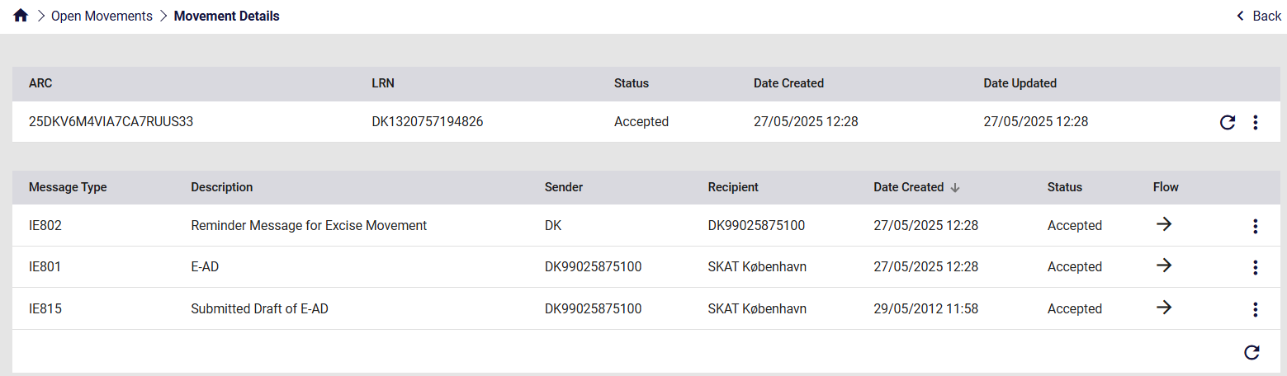
Figure 65: Cancelation of declaration (IE810)
The following form appears:
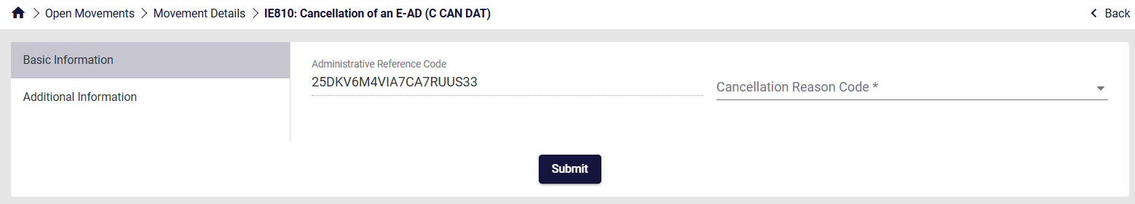
Figure 66: Screen Submission of an IE810 Message
Complete the necessary information for each section that can be seen on the left and finally click Submit.

Report of Receipt (IE818)
The IE818 consists of a report of receipt message, submitted by the Consignee, indicating that the goods have arrived at their destination.
When the goods arrive, the Consignee must check whether the movement is intact or if there are any discrepancies (excess quantity or shortage) and report the result in a receipt. The Consignee can thus accept the movement as satisfactory or unsatisfactory or reject the consignment in whole or in part.
If the Consignee rejects the entire consignment, the Consignor must change the destination of the shipment, both when he wants the goods returned or if the goods are redirected to another Consignee. When returning, the Consignor must state himself as the Consignee.
In the event of a partial rejection of the consignment, the Consignee must state the rejected quantity for each item separately in the receipt.
In order to submit it, click on the action selector in the movement details.
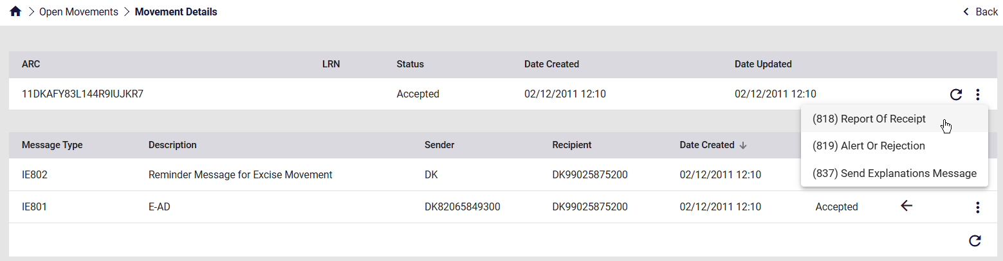
Figure 67: Report of Receipt (IE818)
The following form appears:
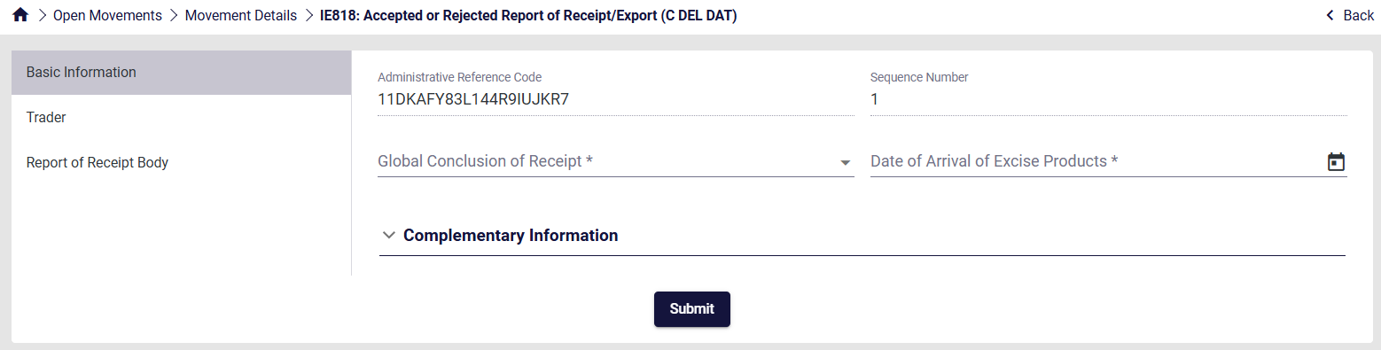
Figure 68: Screen Submission of an IE818 Message
Complete the necessary information for each section that can be seen on the left and finally click Submit.

Alert or Rejection of an E-AD (IE819)
The IE819 consists of an alert or rejection message submitted by the Consignee before the goods arrive at their destination. This message can only be sent by the Consignee and the status of the shipment will change accordingly, either remaining Accepted or changing to Rejected.
In order to submit it, click on the action selector in the movement details.
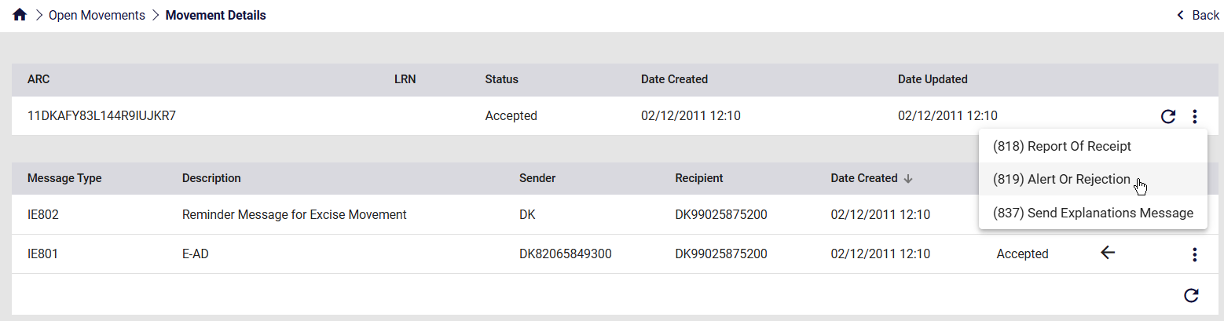
Figure 69: Alert or Rejection of an E-AD (IE819)
The following form appears:
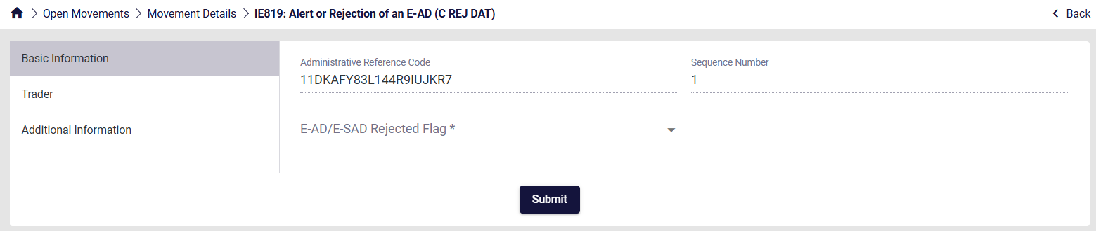
Figure 70: Screen Submission of an IE819 Message
Complete the necessary information for each section that can be seen on the left and finally click Submit.

Explanations on Delay (IE837)
The IE837 consists of an explanation message submitted by the Consignor and/or the Consignee. This message can be used to explain the reason for a delayed receipt submission (IE818) or the reason for a delayed Change of Destination (IE813).
In order to submit it, click on the action selector in the movement details.
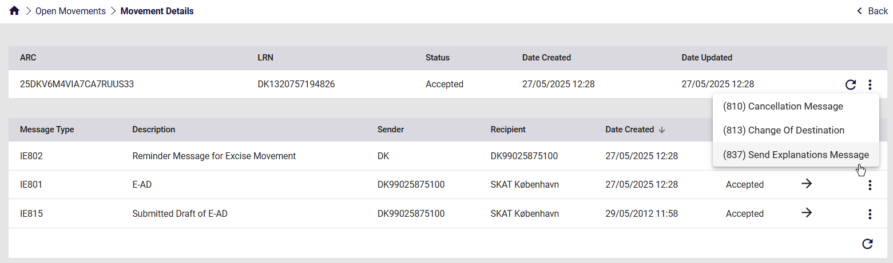
Figure 71: Explanations on Delay (IE837)
The following form appears:
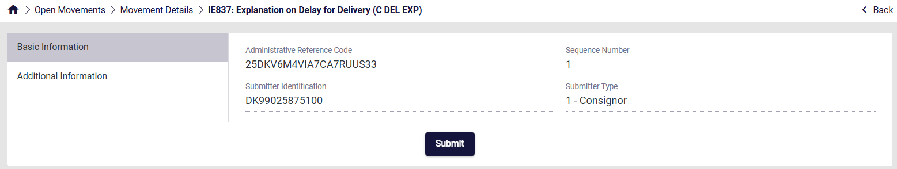
Figure 72: Screen Submission of an IE837 Message
Complete the necessary information for each section that can be seen on the left and finally click Submit.

Submitted Draft of Splitting Operation (IE825)
The IE825 consists of draft splitting operation message submitted by the Consignor.
Consignments of energy products may be split into two or more parts thus replacing the original consignment. The successful completion of a splitting operation causes state transition for the concerned movement to “Replaced” for both Member State of Dispatch and Destination.
The new movements resulting from the splitting operation are registered at the “Accepted” state.
In order to submit it, click on the action selector in the movement details.
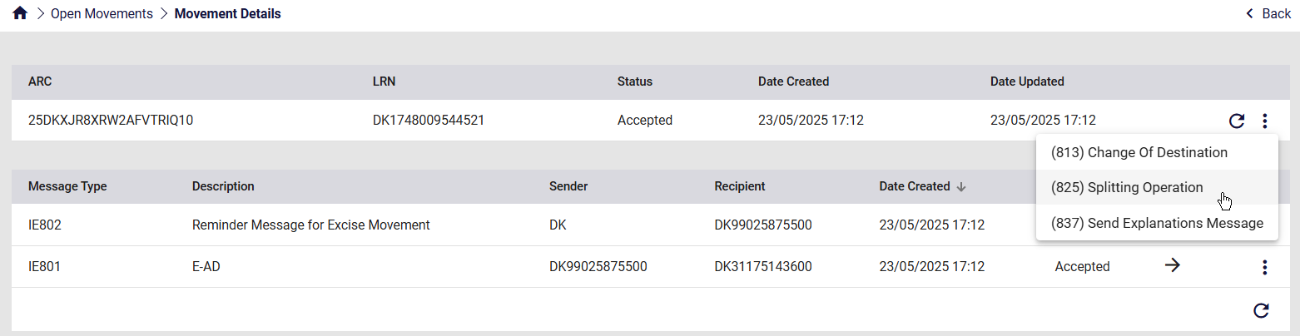
Figure 73: Submitted Draft of Splitting Operation (IE825)
The following form appears:
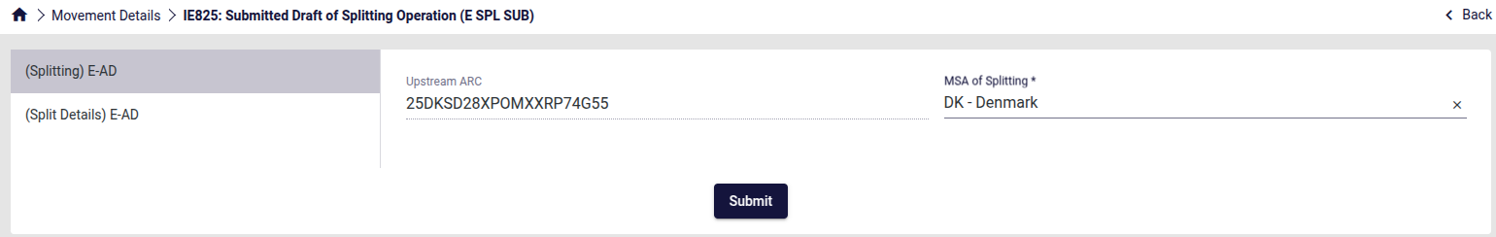
Figure 74: Screen Submission of an IE825 Message 1
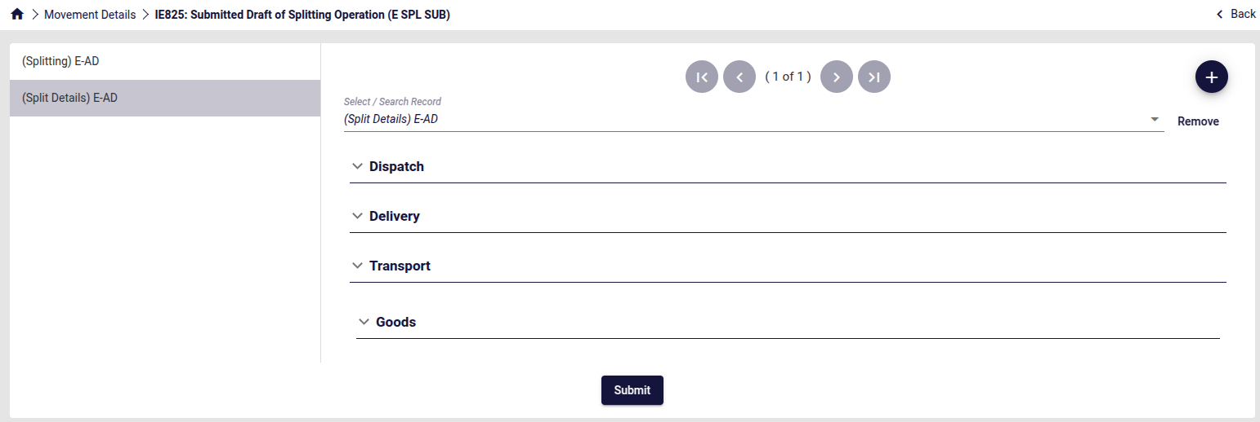
Figure 75: Screen Submission of an IE825 Message 2
Complete the necessary information for each section that can be seen on the left and finally click Submit.

IE825 Submission Guide
The Splitting Operation separates the initial IE815 E-AD into multiple ones.
In order to do so, the IE825 message should have at least two instances of “(Split Details) E-AD”. It is important to note that the total quantities and masses of goods declared in the IE825 should equal the initial quantities and masses of the IE815 previously submitted.
Please see an example below. The IE815 message includes the following goods:
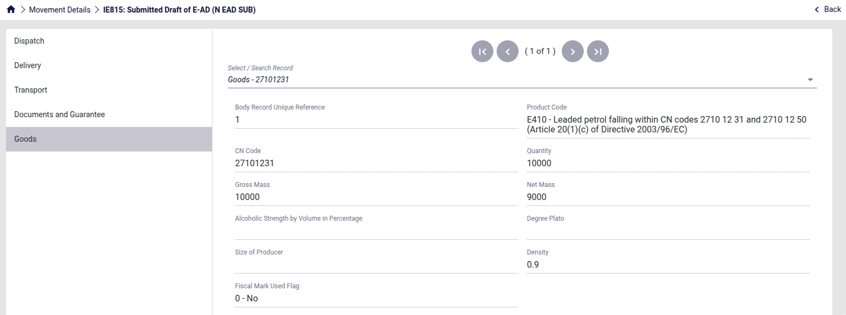
Figure 76: Splitting operation IE815 Message
Therefore, the IE825 should include all of these goods.
Note: The Product Code and CN Code should remain the same.
The first instance of “(Split Details) E-AD” in the IE825 message includes the following goods:
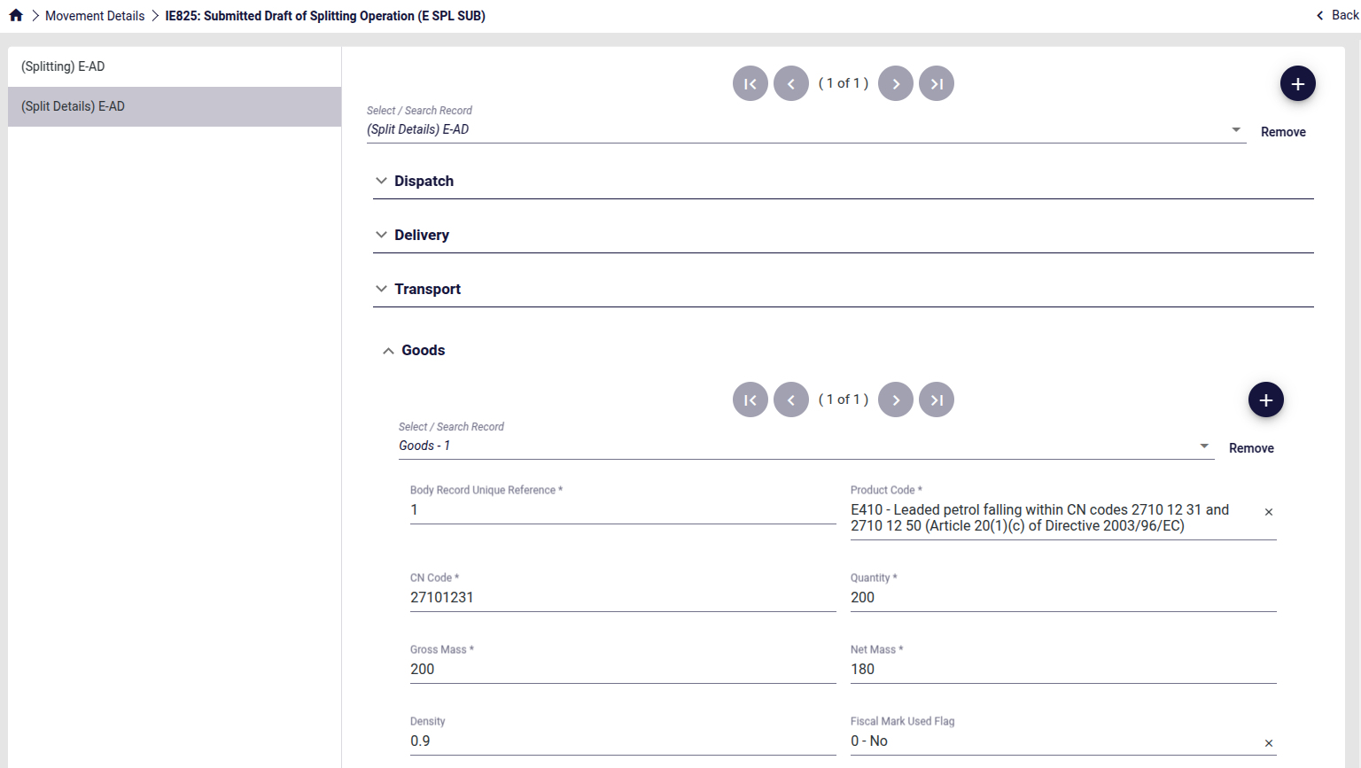
Figure 77: Splitting operation IE825 Message E-AD 1
The second instance of “(Split Details) E-AD” in the IE825 message includes the following goods:
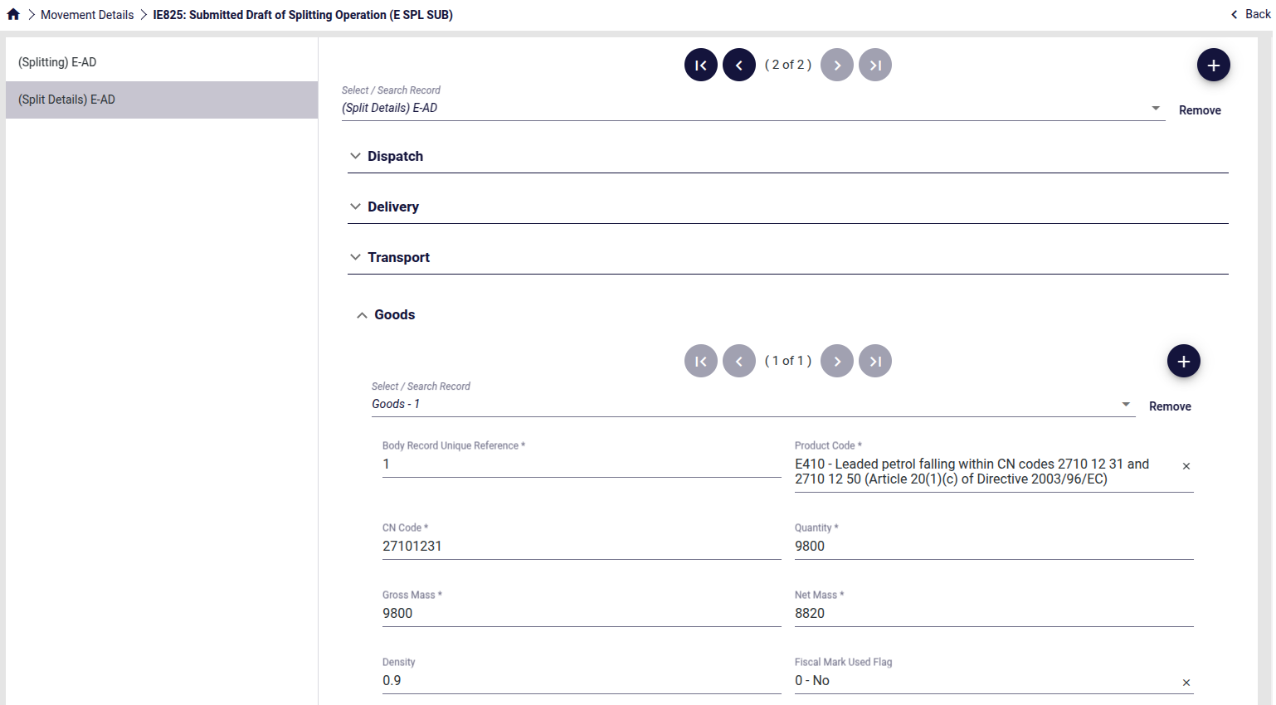
Figure 78: Splitting operation IE825 Message E-AD 2
It can be noted that while the Product Code and CN Code remain the same, the sum of quantities and masses match the ones declared in the initial IE815 message.
Once submitted, the IE825 will appear in the original movement created by the IE815.
Furthermore, the IE803 acceptance message has been generated and the movement status has been set to “Replaced”.
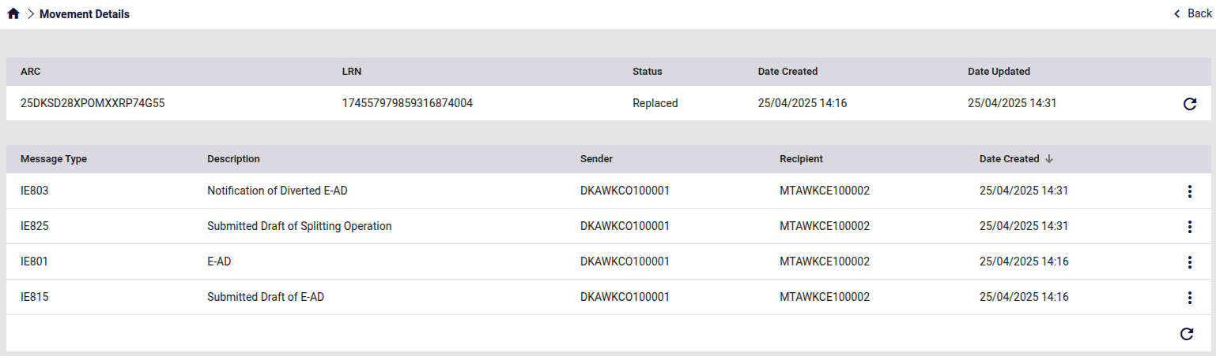
Figure 79: Splitting operation Original Movement

Finally, two new movements with new different ARC’s have been created.
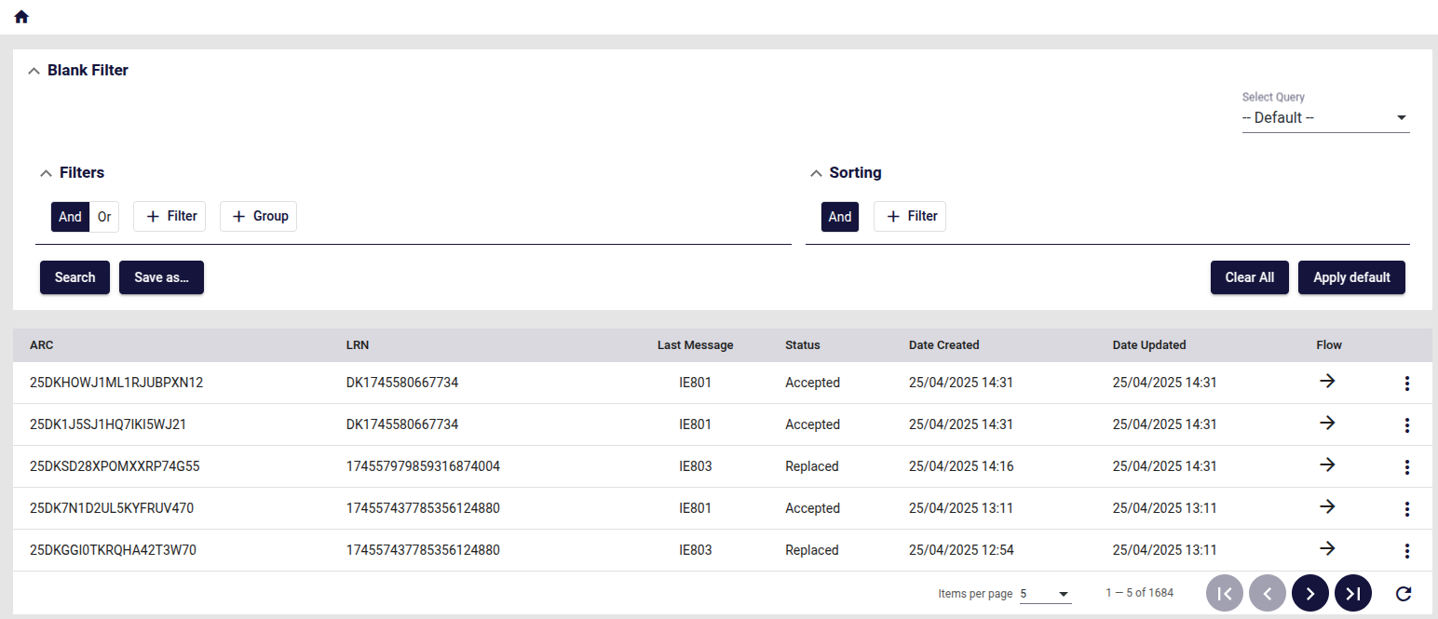
Figure 80: Splitting operation New Movements
These new movements have an IE801 as an initial message which reflects the contents of the corresponding “(Split Details) E-AD” of the IE825 message.
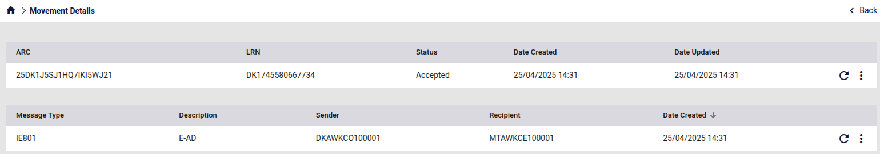
Figure 81: Splitting operation New Movement 1
Thus, the Splitting Operation has successfully been completed.

New Consignee and Delivery Place
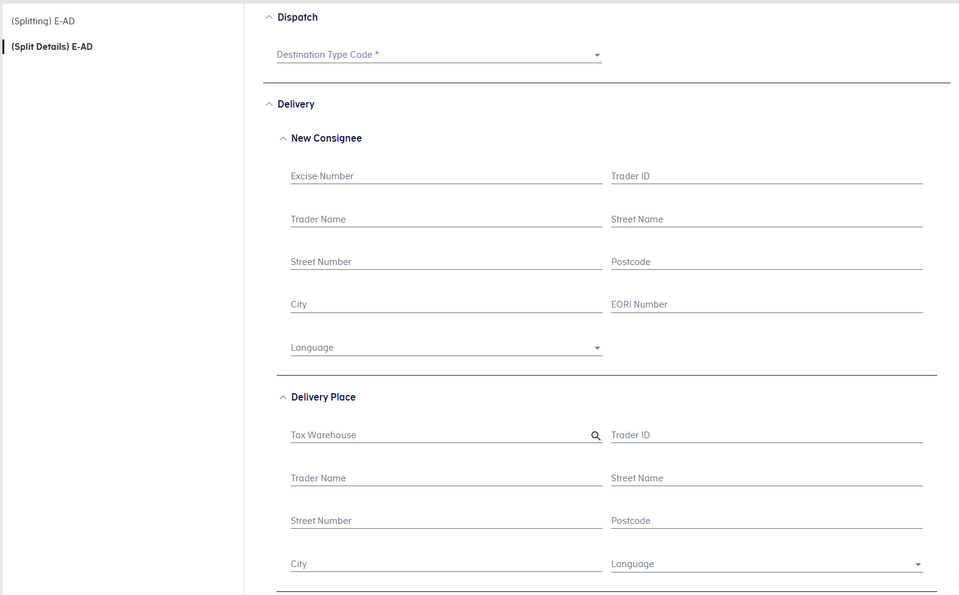
Figure 82: Destination Change

The sections “New Consignee” and “Delivery Place” respond dynamically based on the selected Destination Type Code, following the same rules as described in:
- 3.1.2 Consignee
- 3.1.3 Delivery Place

Explanations on Reason for Shortage (IE871)
The IE871 consists of an explanation message, submitted by the Consignor and/or the Consignee, providing additional information following the submission or reception of IE818 in cases where the Report of Receipt declares shortages or excesses.
IE871 can be submitted multiple times by the same actor.
In order to submit it, click on the action selector in the movement details.
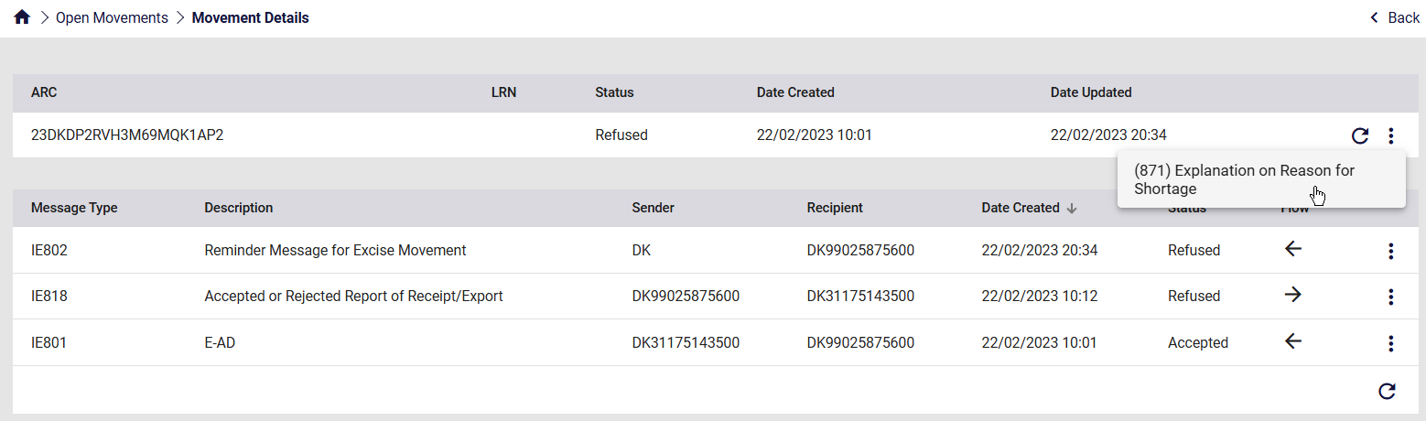
Figure 83: Explanations on Reason for Shortage (IE871)
The following form appears:
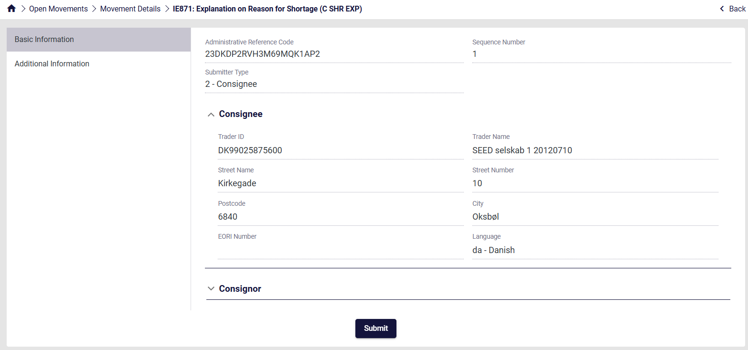
Figure 84: Screen Submission of an IE871 Message
Complete the necessary information for each section that can be seen on the left and finally click Submit.

Common User Interface Components
The following sections describe components that are used as part of the application’s grids and forms and are common to all ECDP-based applications.

Logging-in
Once the credentials are entered, the login screen prompts the user to select an Excise Number associated with the account.
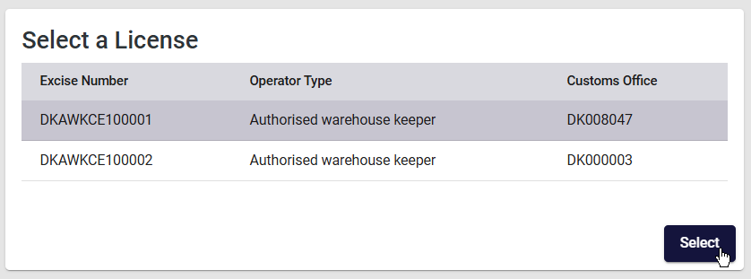
Figure 85: EMCS License Selection Screen
Once the license is selected, the user is redirected to the Movements overview screen where all the relevant movements are displayed.
Note: In cases where only one Excise number is associated with the account, the user is automatically redirected to the Movements Overview Screen.
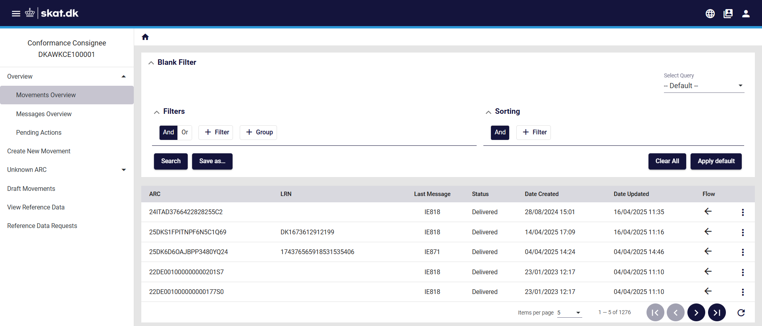
Figure 86: EMCS Movement Overview Screen
On the top right corner of the screen, the user can switch Excise Numbers by clicking on the icon seen below.
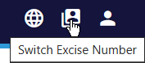
Figure 87: EMCS Switch Excise Number Button

Basic Screen Elements
The interface consists of the following general screen elements as shown below:
- Menu show/hide button (shows / hides the section selector)
- Section Selector (collapsible sections)
- Action Selector (list of available actions depending on selected object)
- Message Alert indicator / Application Selector button / Logout button.
- Grid / Page Navigation Buttons
- Home Button
- Back Button
- Header Area (where applicable)
- Detail Grid Area (where applicable)
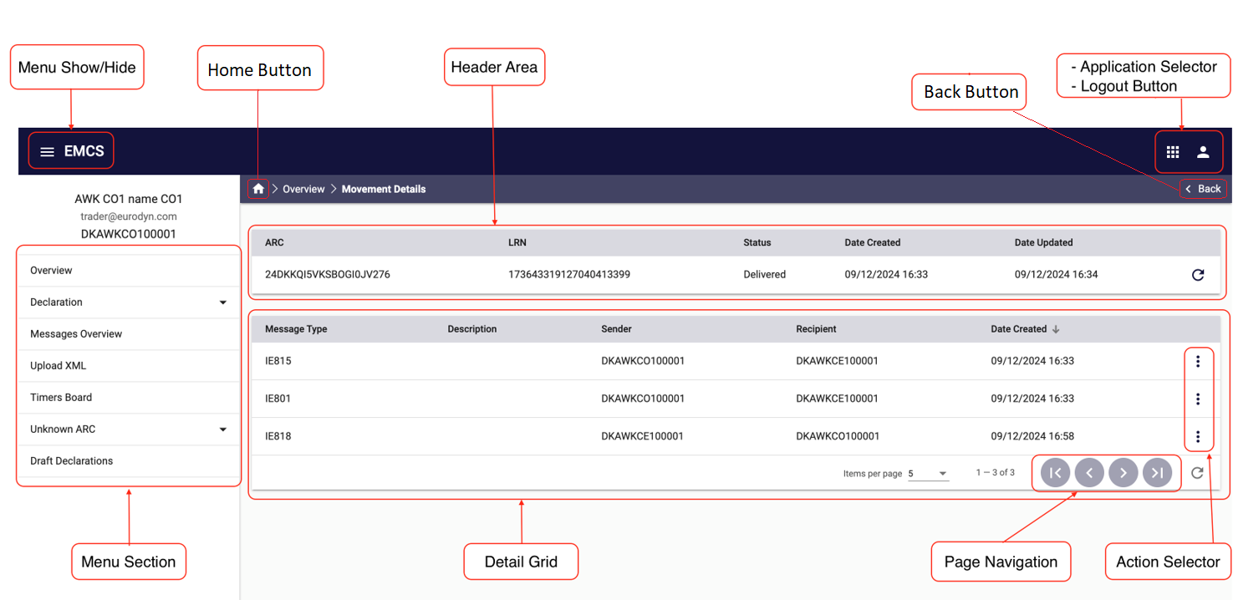

Figure 88: Common screen elements

Data Field indicators
This section describes the special indicators that appear in fields where data entry is expected.
- Mandatory fields a field that is marked with an asterisk icon, as in the image below, is mandatory. All mandatory fields of a form must be completed before the form can be submitted.

- Long search lists a field that is marked with a magnifying lens icon, as in the image below, can be set using the long search list component. See also section 4.9.


- Short search lists a field that is marked with an arrowhead as in the image below can be set using the short search list component. See also section 4.10.


- Date selector; a field that is marked with a calendar icon, as in the image below, can be set using the date selector component. See also section 4.11.

Advanced Search Facility
The advanced search facility is available in almost all the grids that display data entries and provides the following functionalities:
- Apply multiple filters, combined with AND/OR logic
- Sorting criteria using one or more columns
- Saving of the filters and sorting criteria for easy recall and reuse.
The default advanced search facility screen is shown below:
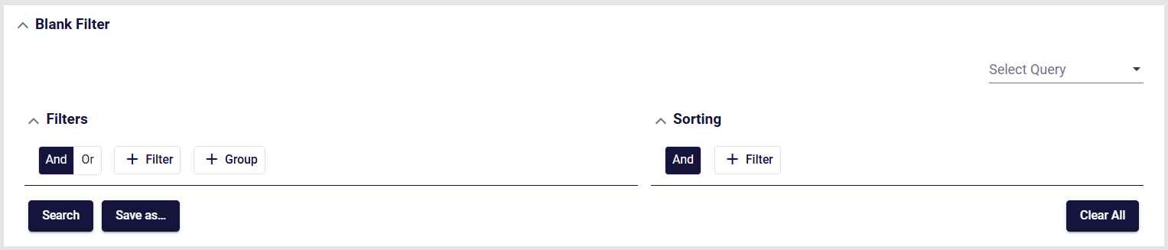
Figure 89: Advanced filter component
The Advanced Search Facility window can collapse or expand, using the arrow buttons and at the right of the top header line.
The Search facility consists of two main sections (Filters and Sorting), a “Select Query” drop-down element, which allows selection of a previously saved search, and four buttons:

This button executes the search, causing the grid below the search section to display any matching data.

This button opens the “Save Criteria” dialog box (please see next section)

This button will clear any entered information in the search facility, essentially resetting the search facility to its initial state.

Adding a search criterion (Rule)
The picture below shows an example of the filtering component of the Advanced Search Facility:
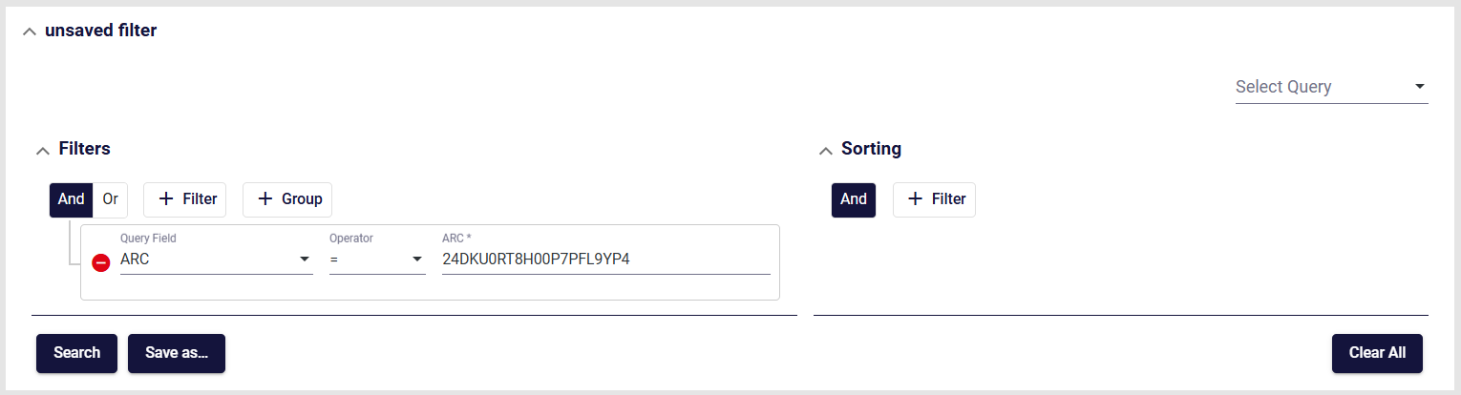
Figure 90: Advanced Search facility - The filtering component

Follow the steps below in order to create a filter:
- Click on the icon.
- Select the search field name from the drop-down list as shown on the right. (The drop-down list in the example is from the “Movements” section).
- Multiple filters can be selected in this manner.
- Additionally, an ‘AND’ / ‘OR’ logic can be selected that will apply to all the configured filters.
- Filters can be removed by clicking on the icon.

- A collection of filters created this way is a “Filter Group”.
- Additional “Filter Groups” can be nested by clicking on the icon.
- Each “Filter Group” has its own logic component and is linked with the (AND/OR) operators.

Configuring the search “Sort Order”
The sort component of the Advanced Search facility is shown in the following picture:
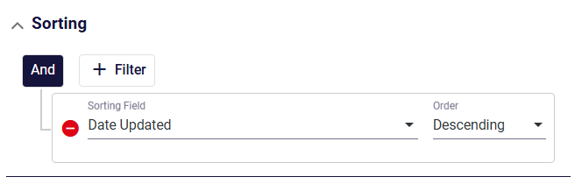
Figure 91: Advanced Search facility - The sorting component
- The same principles apply here as in the Search (filter) section.
- Any number of consecutive sort criteria can be defined, always with an ‘AND’ logic.
- Each sort criterion is accompanied by a ‘Descending / Ascending’ selector.
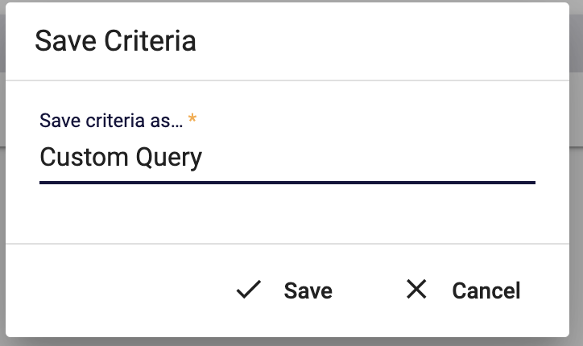

Saving configured search criteria
The configured search, complete with the sorting options selected, can be saved for future use. Provide a unique name and click the button
The “Save as” dialog box is shown on the right.
Figure 92: Save search criteria dialog

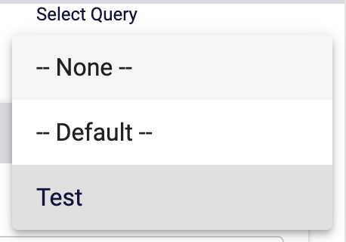
All the saved search criteria names will be available from a drop-down list in the “Select Query” (as shown on the right).

The saved search can be deleted by clicking on the button, which appears when selecting a saved search.
Figure 93: Use saved search criteria

Search Results
The search results are shown in the grid as in the following example:
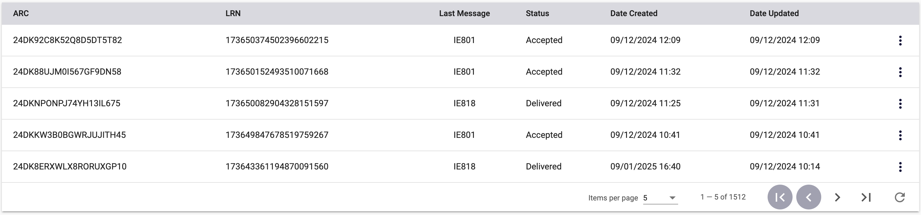
Figure 94: Search results
The displayed results correspond to the applied filters and sorting criteria.
The three-dots button at the right of each displayed entry provides the list of available actions for that specific entry. The list of available actions depends on the type of the entry and the access rights of the user.

Grid Footer
The footer element of a data grid is displayed as in the following example:
Figure 95: Grid footer
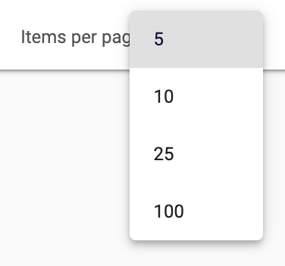
Each footer consists of three sections:
- Items per page:
This section displays the number of items displayed (default is 5).
Clicking on the arrow next to the number of items indicator, reveals a drop-down list with the option to display 10, 25, or 100 items per page as shown on the right.
Figure 96: Selection of shown results
The range of items displayed and the total number of items in the grid is displayed next to the “Items per page” part of the footer (e.g., 1 – 5 of 384).
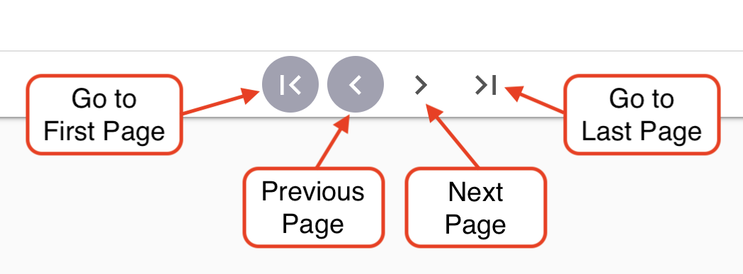
- Page navigation controls
The page navigation controls, contain four action arrows as shown on the right.
Figure 97: Page navigation controls

- Refresh Icon
The refresh icon refreshes (reloads) the displayed grid data, without having to do a complete reload from the browser.

Export Functionality
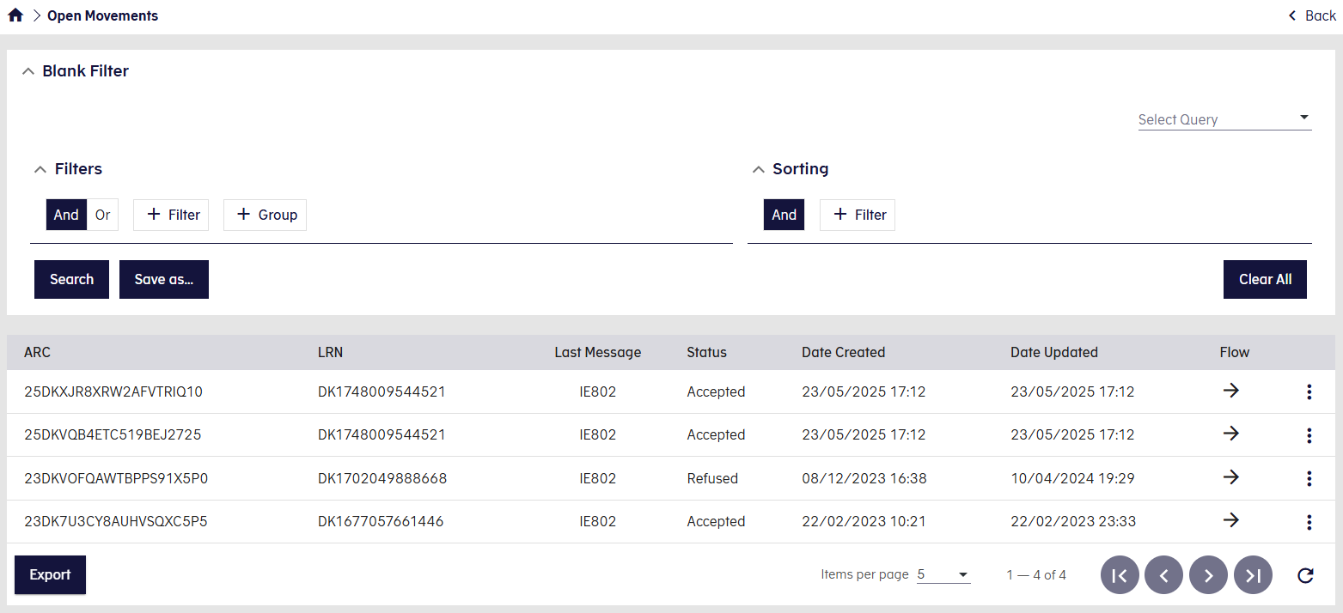
Figure 98: Export Functionality

Some application screens with search functionality also provide an Export feature.
When available, an Export button appears at the bottom-left corner of the results grid (see Figure).
Note: If there are no search results, the Export button is disabled.
How It Works:
- Click the Export button to generate an .xlsx file containing the latest search results.
- The file will automatically download to your device once generated.
Result Limits
- If the total number of search results exceeds 3,000, only the first 3,000 entries are included in the export.
- In this case, an informational pop-up will be displayed to notify you of the limit.

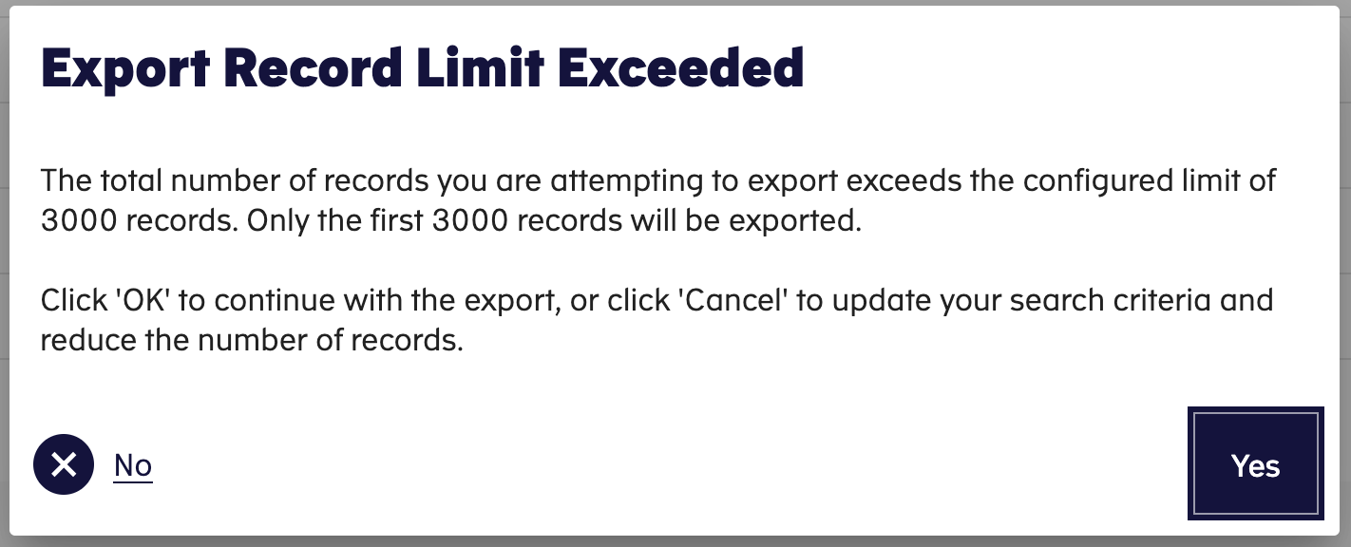
Figure 99: Export record limit

Form Tab
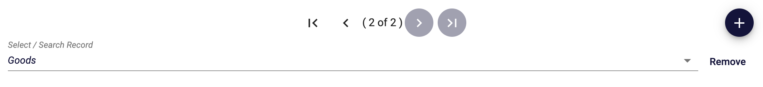
Figure 100: Form tabs
The component allows the user to add, remove and navigate tabs. Each tab represents a record that can be repeated in the enclosing section of a form.
The component includes the following parts:
- The Tab navigation control. The control includes the following parts:
  - The First Tab [ |< ] button navigates to the first tab of the component
  - The Previous Tab [ < ] button navigates to the previous tab of the component
  - The Next Tab [ > ] button navigates to the next tab of the component
  - The Last Tab [ >|] button navigates to the last tab of the component
  - The [(# of #)] is the tab index of the component. The first number depicts the numbering of the current tab of the component. The second number depicts the total number of the tabs of the component.
- Quick selection dropdown box. It allows to navigate directly to the desired tab
- The Add Tab [ + ] button add a new tab in the component.
Note: In the example displayed in the figure above, clicking that button will add one instance of Goods to be completed.
- The Remove button removes the current tab from the component

Overview Button
Certain data groups, such as Goods Items, Packages, and Transport Details, may contain multiple list entries. Each entry constitutes a different tab.
The List items Overview functionality facilitates the viewing of all instances within the data group.

Figure 101: Overview Button

The “Overview” button is located on the top right corner of the Data Group:
- When clicked, this button will open a popup displaying a concise overview table of the corresponding list entries.
- This allows users to easily review all items at a glance without navigating through each one individually.

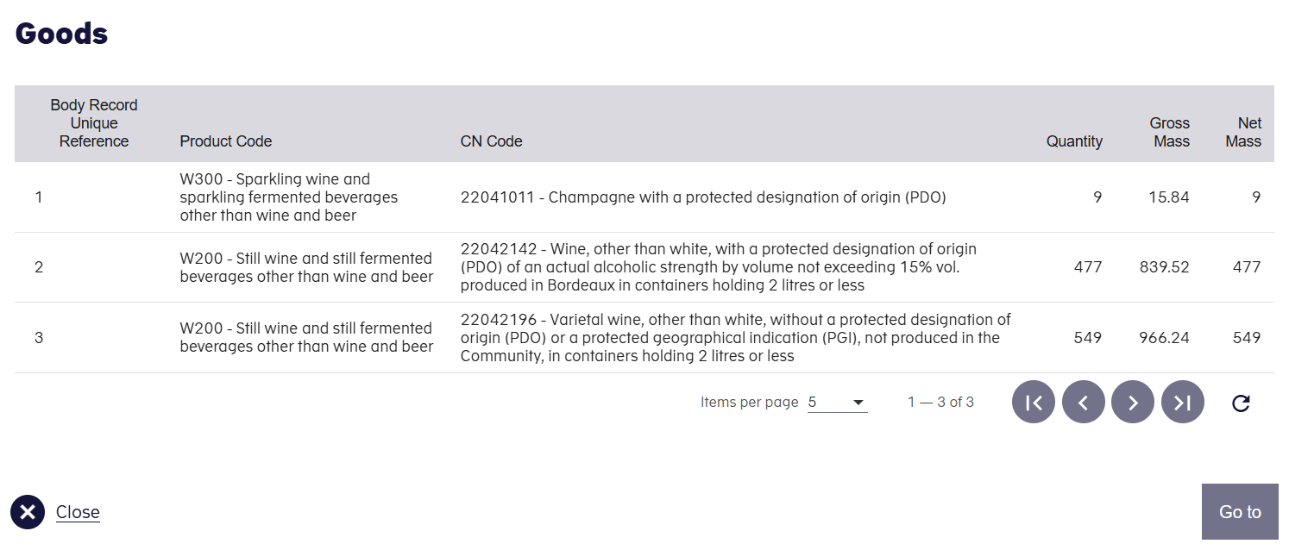
Figure 102: List items Overview

Additionally, by selecting a specific row, the overview table allows us to navigate directly to the corresponding item in the main UI form for detailed viewing or editing.

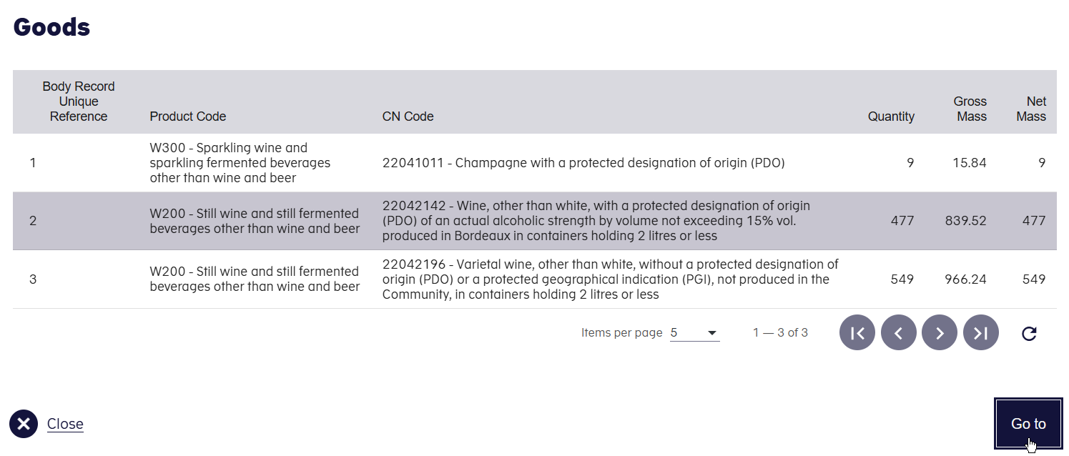
Figure 103: Go to Item

Long Search lists
Long Search list data elements (fields) are populated with a wide number of values. Those elements are implemented with a use of a popup window that displays the available values in pages.
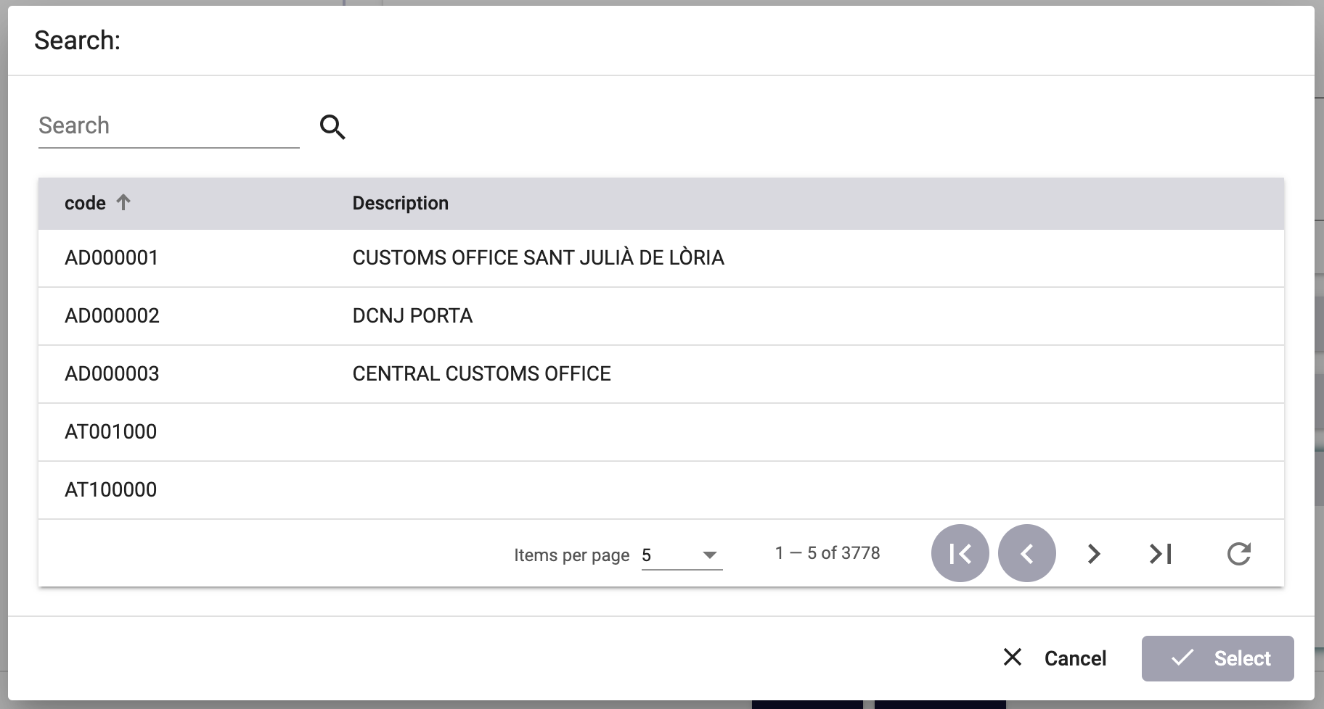
Figure 104: Long search list - example
Long search list popup windows consist of the following parts:
- The searched field. The user can enter a value and then press the ‘magnify lens’ icon to filter the values that are displayed in the values grid.
- The values grid, where all available values for the specific element are displayed. To facilitate the navigation between the available pages, the grid includes the grid footer component. See section 4.5 Grid Footer.
- The ‘Cancel’ button. When the button is pressed, no value is selected, the popup window closes and the value of the element that is associated with the long search list remains unchanged.
- The ‘Select’ button. The button is activated when the user selects a value from the values grid. When the button is pressed, the selected value from the value grid is transferred to the form element that is associated with the long search list.

Short Search lists
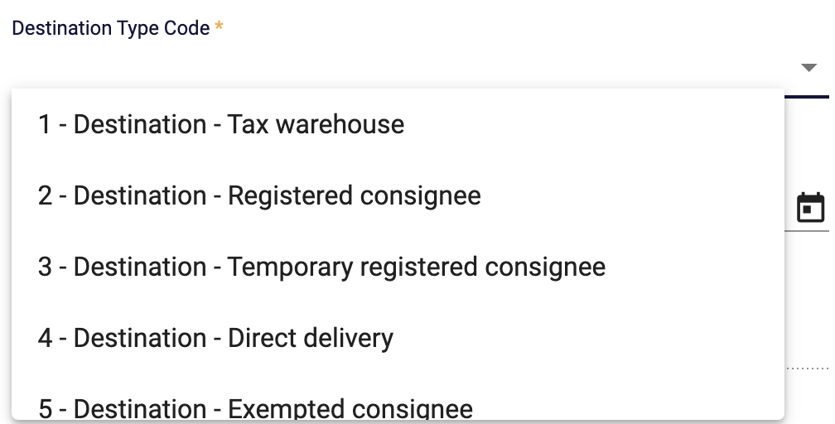
Figure 105: Short search list – example
Short search list data elements (fields) are populated with a limited number of values. They consist of the following parts:
- The data field where the actual value of the data element is displayed/entered
- The drop-down list where all available values for the specific element are displayed
Values from short search lists can be selected by:
- Scrolling the drop-down list and selecting the desired value with a mouse right click
- Entering the desired values in the data field. As the user types in the data field, the component search and display all the entries that match the entered value. The user can select any of the displayed values with a mouse right click. Alternatively, if only one value is displayed in the list it can be selected by hitting the “Enter” key.
When a value is selected in the drop-down list, with any of the above methods, the selected value will automatically populate the data field.

Date Selector
The date selector component facilitates the filling of data elements that require a date value. It consists of the following parts:
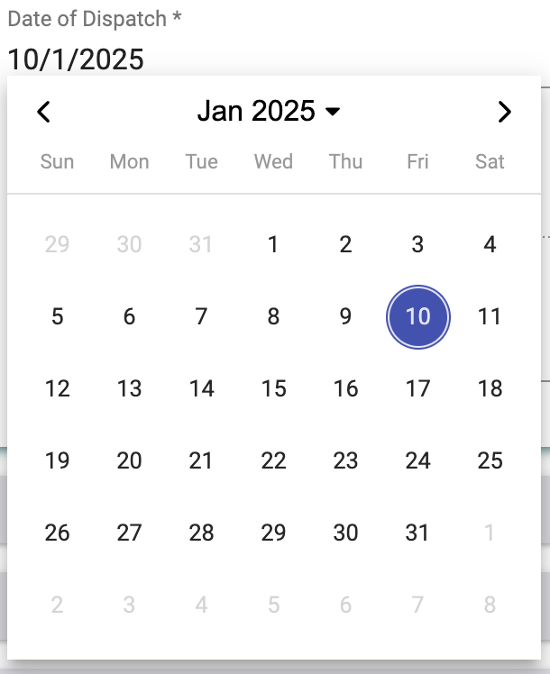
- Year selection short search list. The list allows the selection of a year and a month. Then the days of the week per month list is updated accordingly.
- Previous [ < ] and Next [ > ] month navigation controls.
- The list of days of the week within the selected month and year.
The date is selected by clicking on the desired date. The selected value is then set for that specific data field.
Figure 106: Date selector - example

Interface Scaling (Adaptive Behaviour)
The interface is adaptive to the screen size and resolution. As the screen size is reduced (for example on a smaller monitor screen or when not working on a full-size window) the screen elements (Menu Items, Selected item sections) will automatically adjust to the screen size in three distinct steps, as shown in the paragraphs below.

Full (expanded) size
The screen below shows a full-size display example:
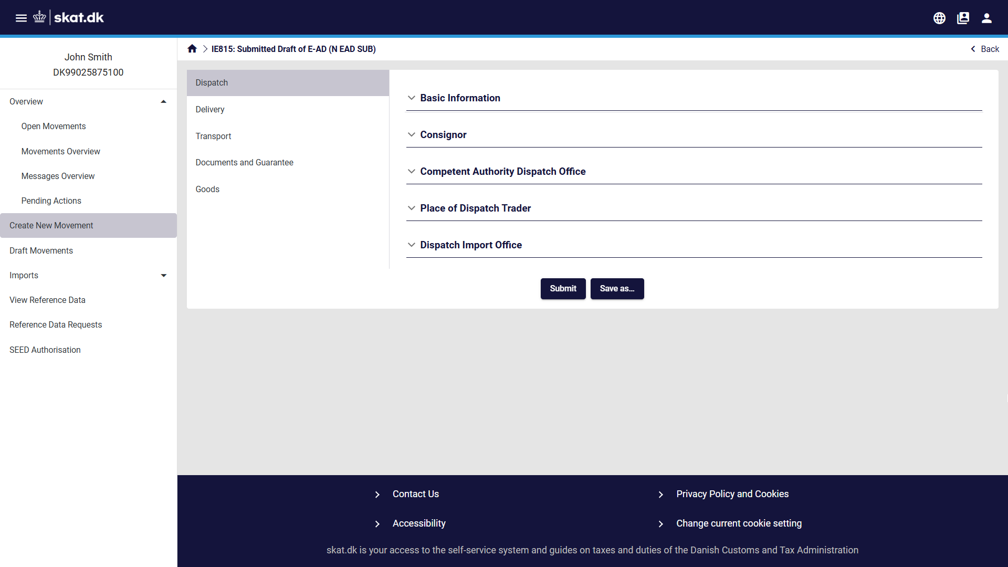
Figure 107: Interface scaling - Full size screen example

Compact size
In this compact screen size, the left panel sections are collapsed into a dropdown menu on top of the page:
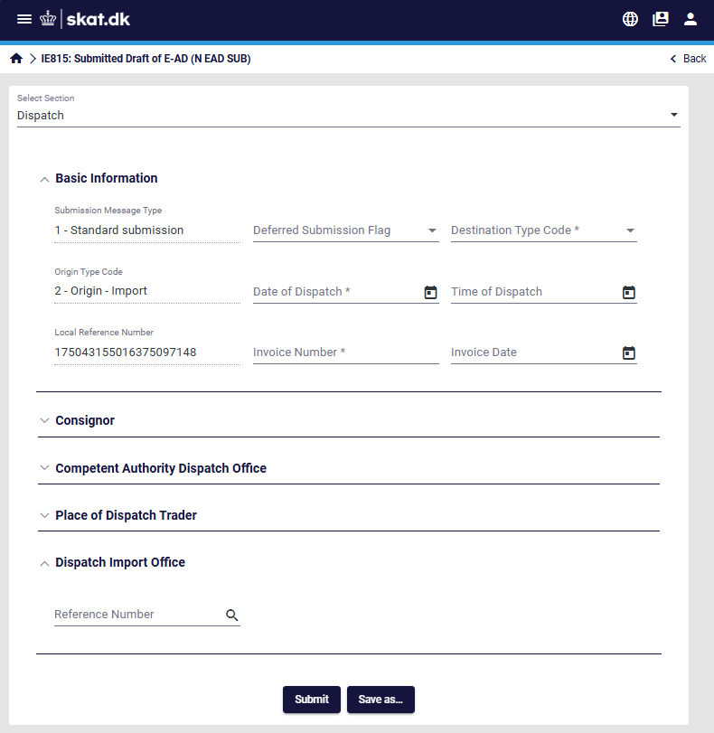
Figure 108: Interface scaling - compact screen example

When clicking on the “Select Section” object, the following section list appears:
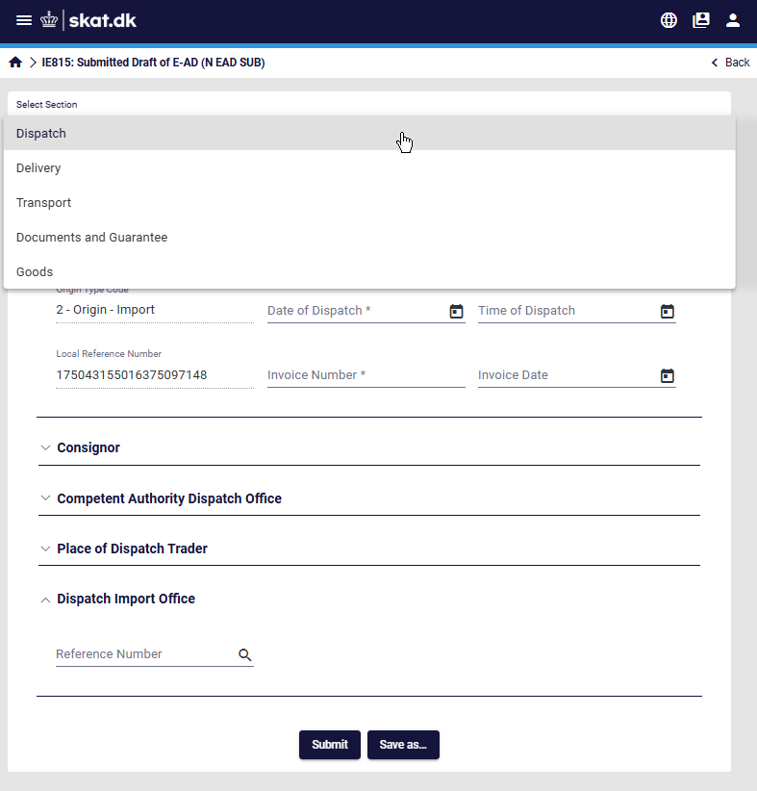
Figure 109: Interface scaling - Select section example

Condensed size
The screen below shows an example of the condensed screen size:
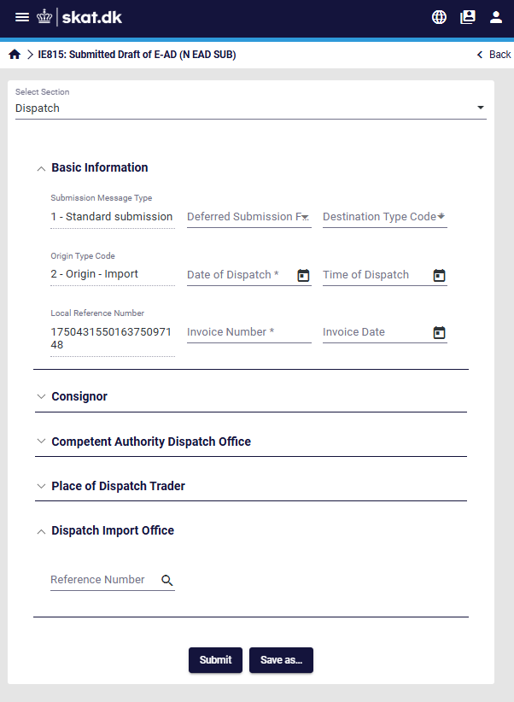
Figure 110: Interface scaling - condensed screen example


In this condensed display size, the EMCS menu can be displayed as an overlay by clicking on the object as shown in the image below:
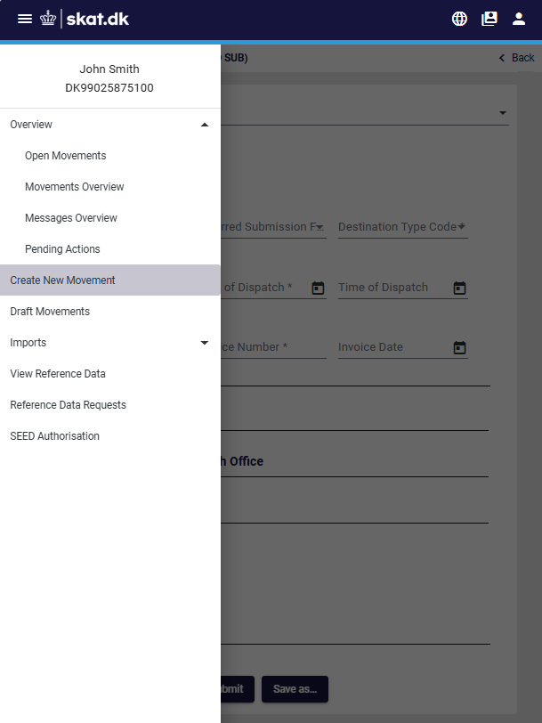
Figure 111: Interface scaling – show menu in condensed screen size

Appendices

Appendix A – Movement Statuses
Status | Description
X01 | Accepted
X02 | Cancelled
X03 | Delivered
X04 | Diverted
X05 | Rejected
X06 | Replaced
X07 | e-AD Manually Closed
X08 | Refused
X10 | Partially Refused
X11 | Exporting
X12 | Accepted for Export
X13 | Stopped
X14 | Accepted Export Declaration
X15 | e-AD Request Accepted for Export
Table 7: Movement statuses

Appendix B – Message Types and Descriptions
Message | Description
IE801 | E-AD
IE802 | Reminder Message for Excise Movement
IE803 | Notification of Diverted E-AD
IE807 | Interruption of Movement
IE810 | Cancellation of an E-AD
IE813 | Change of Destination
IE815 | Submitted Draft of E-AD
IE818 | Accepted or Rejected Report of Receipt/Export
IE819 | Alert or Rejection of an E-AD
IE825 | Submitted Draft of Splitting Operation
IE829 | Notification of Accepted Export
IE837 | Explanation on Delay for Delivery
IE839 | Refusal by Customs
IE840 | Event Report Envelope
IE871 | Explanation on Reason for Shortage
Table 8: Messages Codes and Descriptions

END OF THE DOCUMENT

