Et billede, der indeholder Font/skrifttype, logo, Grafik, hvid

Indhold genereret af kunstig intelligens kan være forkert.

DK-EMCS

User Manual - Trader Portal Guide

**EUROPEAN DYNAMICS   
AUGUST 2025**

|  |  |  |
| --- | --- | --- |
|  | **User Manual - Trader Portal Guide** | DK-EMCS |
| D1.5.UMN - TR  Version 1.1 |

Page **2** of **79**

DK-EMCS-D1.5.UMN-TR.User Manual Traders v1.1

|  |  |  |
| --- | --- | --- |
|  | **User Manual - Trader Portal Guide** | DK-EMCS |
| D1.5.UMN - TR  Version 1.1 |

**Table of Contents**

**1 INTRODUCTION 9**

1.1 Purpose 9

1.2 Minimum System Requirements 9

1.3 Document Structure 10

**2 BASIC CONCEPTS AND TERMS 11**

2.1 Movement 11

2.2 Movement Actions 11

**3 USER INTERFACE 12**

3.1 Create New Movement (Create IE815) 13

3.1.1 Required and Validated data elements 14

3.2 Overview 19

3.2.1 Open Movements 19

3.2.2 Movements Overview 20

3.2.3 Messages Overview 27

3.2.4 Pending Actions 28

3.3 Unknown ARC 30

3.3.1 Overview 30

3.3.2 Create Report of Receipt 32

3.4 Draft Declarations 34

3.5 Import 35

3.5.1 Pending Messages 35

3.5.2 Rejected Messages 38

3.6 Reference Data 41

3.6.1 View Reference Data 41

3.6.2 Reference Data Requests 43

3.7 SEED Authorisation 45

3.8 Business-related Actions on Movements 47

3.9 Change of destination (IE813) 47

3.10 Cancelation of declaration (IE810) 48

3.11 Report of Receipt (IE818) 48

3.12 Alert or Rejection of an E-AD (IE819) 50

3.13 Explanations on Delay (IE837) 51

3.14 Submitted Draft of Splitting Operation (IE825) 51

3.14.1 IE825 Submission Guide 53

3.15 Explanations on Reason for Shortage (IE871) 57

**4 COMMON USER INTERFACE COMPONENTS 59**

4.1 Logging-in 59

4.2 Basic Screen Elements 61

4.3 Data Field indicators 61

4.4 Advanced Search Facility 62

4.4.1 Adding a search criterion (Rule) 64

Page **3** of **79**

DK-EMCS-D1.5.UMN-TR.User Manual Traders v1.1

|  |  |  |
| --- | --- | --- |
|  | **User Manual - Trader Portal Guide** | DK-EMCS |
| D1.5.UMN - TR  Version 1.1 |

4.4.2 Configuring the search “Sort Order” 65

4.4.3 Saving configured search criteria 65

4.4.4 Search Results 66

4.5 Grid Footer 66

4.6 Export Functionality 68

4.7 Form Tab 69

4.8 Long Search lists 70

4.9 Short Search lists 71

4.10 Date Selector 72

4.11 Interface Scaling (Adaptive Behaviour) 72

4.11.1 Full (expanded) size 73

4.11.2 Compact size 74

4.11.3 Condensed size 76

**5 APPENDICES 78**

5.1 Appendix A – Movement Statuses 78

5.2 Appendix B – Message Types and Descriptions 79

Page **4** of **79**

DK-EMCS-D1.5.UMN-TR.User Manual Traders v1.1

|  |  |  |
| --- | --- | --- |
|  | **User Manual - Trader Portal Guide** | DK-EMCS |
| D1.5.UMN - TR  Version 1.1 |

**Table of Figures**

Figure 1: Trader Portal - Main left-menu 12

Figure 2: IE815 Message Menu Button 13

Figure 3: Screen Submission of an IE815 Message 14

Figure 4: Declaration drafting - marking of missing required fields 15

Figure 5: Validation errors - example 16

Figure 6: Validation errors - popup window with business rule 17

Figure 7: Validation errors - markup on the screen 17

Figure 8: Open Movements grid 19

Figure 9: Open Movements Actions 20

Figure 10: Open Movements View 20

Figure 11: Movement Overview grid – example 21

Figure 12: "Actions" menu - examples 22

Figure 13: Movement Details screen 23

Figure 14: Movement details header 23

Figure 15: Movement messages grid 24

Figure 16: Movement messages grid View 25

Figure 17: Movement messages grid Download XML 25

Figure 18: Movement messages grid Download PDF 26

Figure 19: View Declaration screen - example 26

Figure 20: Message Overview grid – example 28

Figure 21: Pending Actions – example 28

Figure 22: Unknown ARC – Overview button 30

Figure 23: Unknown ARC – Overview 30

Figure 24: Unknown ARC – Overview Actions 31

Figure 25: IE818 Message Menu Button 32

Figure 26: Screen Submission of an IE818 Message 33

Figure 27: Drafting Process 34

Figure 28: Draft Declarations overview 34

Figure 29: Import – Pending Messages Button 35

Figure 30: Import – Pending Messages Screen 36

Figure 31: Import – Pending Messages LRN Search 36

Figure 32: Import – Pending Messages Actions 37

Figure 33: Import – Pending Messages Submitted form 37

Figure 34: Import – Rejected Messages Button 38

Figure 35: Import – Rejected Messages Screen 38

Figure 36: Import – Rejected Messages LRN Search 39

Figure 37: Import – Rejected Messages Actions 39

Figure 38: Import – Rejected Messages Submitted IE815 40

Figure 39: Import – Rejected Messages Rejection 40

Figure 40: View Reference Data Button 41

Figure 41: View Reference Data Screen 41

Page **5** of **79**

DK-EMCS-D1.5.UMN-TR.User Manual Traders v1.1

|  |  |  |
| --- | --- | --- |
|  | **User Manual - Trader Portal Guide** | DK-EMCS |
| D1.5.UMN - TR  Version 1.1 |

Figure 42: View Reference Data Results 42

Figure 43: Reference Data Requests Button 43

Figure 44: Reference Data Requests Screen 43

Figure 45: View Reference Data New Request 44

Figure 46: View Reference Data Request actions 45

Figure 47: View Reference Data Request form 45

Figure 48: SEED Authorisation Button 46

Figure 49: SEED Authorisation Screen 46

Figure 50: Change of destination (IE813) 47

Figure 51: Screen Submission of an IE813 Message 47

Figure 52: Cancelation of declaration (IE810) 48

Figure 53: Screen Submission of an IE810 Message 48

Figure 54: Report of Receipt (IE818) 49

Figure 55: Screen Submission of an IE818 Message 49

Figure 56: Alert or Rejection of an E-AD (IE819) 50

Figure 57: Screen Submission of an IE819 Message 50

Figure 58: Explanations on Delay (IE837) 51

Figure 59: Screen Submission of an IE837 Message 51

Figure 60: Submitted Draft of Splitting Operation (IE825) 52

Figure 61: Screen Submission of an IE825 Message 1 52

Figure 62: Screen Submission of an IE825 Message 2 53

Figure 63: Splitting operation IE815 Message 53

Figure 64: Splitting operation IE825 Message E-AD 1 54

Figure 65: Splitting operation IE825 Message E-AD 2 55

Figure 66: Splitting operation Original Movement 55

Figure 67: Splitting operation New Movements 55

Figure 68: Splitting operation New Movement 1 57

Figure 69: Explanations on Reason for Shortage (IE871) 57

Figure 70: Screen Submission of an IE871 Message 58

Figure 71: EMCS License Selection Screen 59

Figure 72: EMCS Movement Overview Screen 60

Figure 73: EMCS Switch Excise Number Button 60

Figure 74: Common screen elements 61

Figure 75: Advanced filter component 63

Figure 76: Advanced Search facility - The filtering component 64

Figure 77: Advanced Search facility - The sorting component 65

Figure 78: Save search criteria dialog 65

Figure 79: Use saved search criteria 65

Figure 80: Search results 66

Figure 81: Grid footer 66

Figure 82: Selection of shown results 67

Figure 83: Page navigation controls 67

Figure 84: Export Functionality 68

Page **6** of **79**

DK-EMCS-D1.5.UMN-TR.User Manual Traders v1.1

|  |  |  |
| --- | --- | --- |
|  | **User Manual - Trader Portal Guide** | DK-EMCS |
| D1.5.UMN - TR  Version 1.1 |

Figure 85: Export record limit 69

Figure 86: Form tabs 69

Figure 87: Long search list - example 70

Figure 88: Short search list – example 71

Figure 87: Date selector - example 72

Figure 90: Interface scaling - Full size screen example 73

Figure 91: Interface scaling - compact screen example 74

Figure 92: Interface scaling - Select section example 75

Figure 93: Interface scaling - condensed screen example 76

Figure 94: Interface scaling – show menu in condensed screen size 77

Page **7** of **79**

DK-EMCS-D1.5.UMN-TR.User Manual Traders v1.1

|  |  |  |
| --- | --- | --- |
|  | **User Manual - Trader Portal Guide** | DK-EMCS |
| D1.5.UMN - TR  Version 1.1 |

**Table of Tables**

Table 1: Movement Overview grid - fields 21

Table 2: View Declaration Message - sections 27

Table 3: Message Overview grid - fields 28

Table 4: Pending Actions grid – fields 29

Table 5: Unknown ARC - Overview grid - fields 31

Table 6: View Reference Data Results grid - fields 42

Table 7: Movement statuses 78

Table 8: Messages Codes and Descriptions 79

Page **8** of **79**

DK-EMCS-D1.5.UMN-TR.User Manual Traders v1.1

|  |  |  |
| --- | --- | --- |
|  | **User Manual - Trader Portal Guide** | DK-EMCS |
| D1.5.UMN - TR  Version 1.1 |

**1 Introduction**

**1.1 Purpose**

The purpose of this document is to describe the Trader functions of the EMCS IT system. It describes the user interface through which Economic Operators will be exchanging information with Customs Authorities to conclude end-to-end business processes for the Goods Under Duties Suspension.

The Excise Movement and Control System (EMCS) is a computerised system for recording and monitoring the movement of excise goods (alcohol, tobacco and energy).

The system allows Member States to monitor consignments of excise goods in real time and to carry out the necessary checks. The procedures are intended to facilitate the secure collection of duties set by Member States in the internal market and to reduce the risk of fraud in this area. The user manual does not describe the business logic of the system but contains detailed instructions that allow users to perform all the functions of the system.

**1.2 Minimum System Requirements**

* One of the following browsers must be installed
* Google Chrome 85+
* Mozilla Firefox 78+
* Microsoft Edge 85+
* Safari 13+
* Javascript must be enabled
* Cookies must be enabled
* Display resolution: Application is responsive and supports mobile devices. For optimal experience a minimum 1024×768 resolution is recommended.

Page **9** of **79**

DK-EMCS-D1.5.UMN-TR.User Manual Traders v1.1

|  |  |  |
| --- | --- | --- |
|  | **User Manual - Trader Portal Guide** | DK-EMCS |
| D1.5.UMN - TR  Version 1.1 |

**Note:** This guide is not intended for and does not describe the B2B (Business to Business) communication between Traders, their agents or representatives and Customs Authorities. However, any messages submitted via the B2B interface will be visible in the Trader Portal as well.

This document is not the Trader EMCS Technical Specification and as such it does not contain any technical related information e.g. authorisation, authentication, end points, etc.

**1.3 Document Structure**

This document is divided into the following sections:

* Basic Concepts and Terms
* User Interface
* Business-related Actions on Movements

Page **10** of **79**

DK-EMCS-D1.5.UMN-TR.User Manual Traders v1.1

|  |  |  |
| --- | --- | --- |
|  | **User Manual - Trader Portal Guide** | DK-EMCS |
| D1.5.UMN - TR  Version 1.1 |

**2 Basic Concepts and Terms**

**2.1 Movement**

A Movement starts with the submission of an initial declaration (IE815).

*Note: All messages exchanged within the system are noted as “IE” (Information Exchange).* Within the context of the EMCS, the e-AD/e-SAD (duty suspension/duty paid) is a message containing information about the movement; namely the origin, the destination, the Economic Operators that are involved in the movement and the product codes along with their quantities being moved.

The declaration is validated, processed and an ARC (Administrative Reference Code), is generated. This ARC is common to all messages exchanged for that particular movement. For example, when a declaration has been successfully submitted and validated, it acquires the status ACCEPTED which, in turn, is communicated to the EMCS system (and becomes visible in the Trader Portal) as message IE801.

The possible status for a movement is detailed in Appendix A – Movement Statuses. Their transitions are triggered by exchanged messages.

**2.2 Movement Actions**

Depending on the status of the movement and other factors, a number of actions are available

for the Traders.

For a complete list of available actions that a trader can perform on a movement please see

Business-related Actions on Movements.

Page **11** of **79**

DK-EMCS-D1.5.UMN-TR.User Manual Traders v1.1

|  |  |  |
| --- | --- | --- |
|  | **User Manual - Trader Portal Guide** | DK-EMCS |
| D1.5.UMN - TR  Version 1.1 |

**3 User Interface**

The left-menu user interface is shown in the image below:

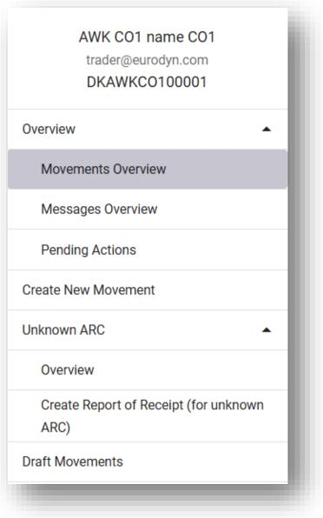

Figure 1: Trader Portal - Main left-menu

Each section is further explained in more details in the paragraphs that follow.

Page **12** of **79**

DK-EMCS-D1.5.UMN-TR.User Manual Traders v1.1

|  |  |  |
| --- | --- | --- |
|  | **User Manual - Trader Portal Guide** | DK-EMCS |
| D1.5.UMN - TR  Version 1.1 |

**3.1 Create New Movement (Create IE815)**

Please note that only an authorized Consignor can create an e-SAD shipment for an authorized

Consignee or temporary authorised Consignee.

This is the beginning of the process of sending excise goods.

The Consignor must meet the following requirements in order to proceed with the shipment

submission:

* be registered and authorized
* be authorized to submit an e-AD / e-SAD (untaxed/taxed). This means that one must be a registered Consignor, authorized Consignor or authorized warehouse keeper.

Through the following screen, a new movement can be created by submitting a new draft e-AD (IE815).

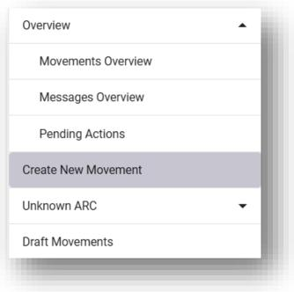

Figure 2: IE815 Message Menu Button

By selecting *Create New Movement* in the menu, the following form appears:

Page **13** of **79**

DK-EMCS-D1.5.UMN-TR.User Manual Traders v1.1

|  |  |  |
| --- | --- | --- |
|  | **User Manual - Trader Portal Guide** | DK-EMCS |
| D1.5.UMN - TR  Version 1.1 |

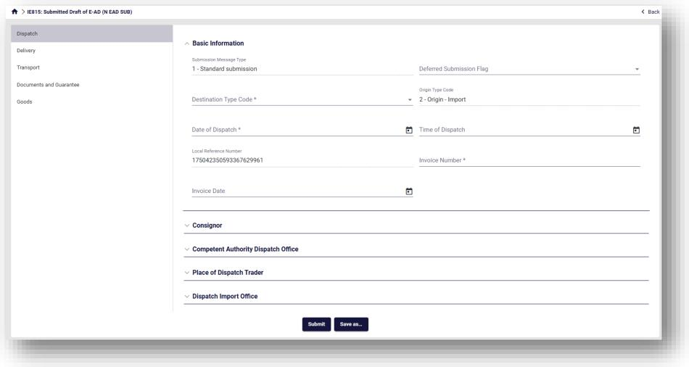

Figure 3: Screen Submission of an IE815 Message

Complete the necessary information for each section that can be seen on the left. These sections are:

* Dispatch
* Delivery
* Transport
* Documents and Guarantees
* Goods

Finally click Submit.

Be aware it is possible to save an IE815 as a draft by clicking on “Save as”. Please refer to 3.4 Draft Declarations for more details.

**3.1.1 Required and Validated data elements**

All required fields within the declaration dataset are indicated by an asterisk in the respective

field description.

Page **14** of **79**

DK-EMCS-D1.5.UMN-TR.User Manual Traders v1.1

|  |  |  |
| --- | --- | --- |
|  | **User Manual - Trader Portal Guide** | DK-EMCS |
| D1.5.UMN - TR  Version 1.1 |

A number of declaration data elements are also validated upon declaration submission against

specific business rules.

The behavior of the system is different in these two cases:

* If any required fields (i.e. fields that require a value and cannot be left blank) are not completed, the submit button will not result in declaration submission and validation. However, the section(s) descriptor(s) where the required fields are left blank will be displayed in red, as in the example shown in the image below:

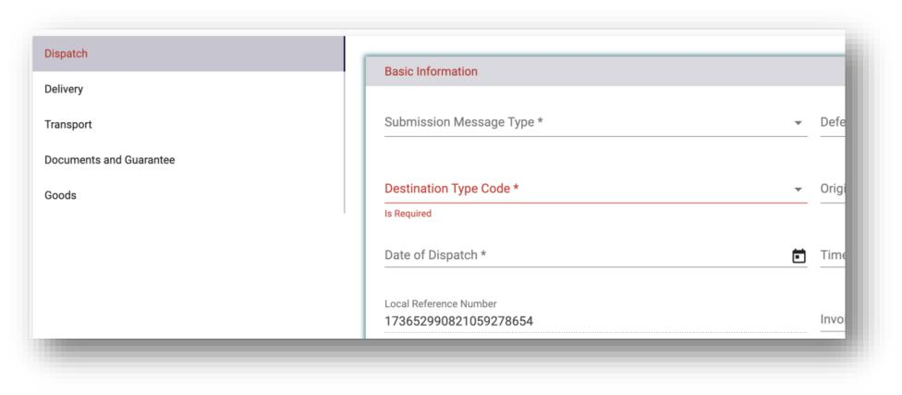

Figure 4: Declaration drafting - marking of missing required fields

* If all required fields contain values, the declaration will be submitted to EMCS and the validation will be performed. If any validation rules are violated, in addition to the visual indication above, the system will display a pop-up box with the list of the validation errors that had been detected.

Page **15** of **79**

DK-EMCS-D1.5.UMN-TR.User Manual Traders v1.1

|  |  |  |
| --- | --- | --- |
|  | **User Manual - Trader Portal Guide** | DK-EMCS |
| D1.5.UMN - TR  Version 1.1 |

The following screen shows an example of a validation error list, which is included on the top part of the screen:

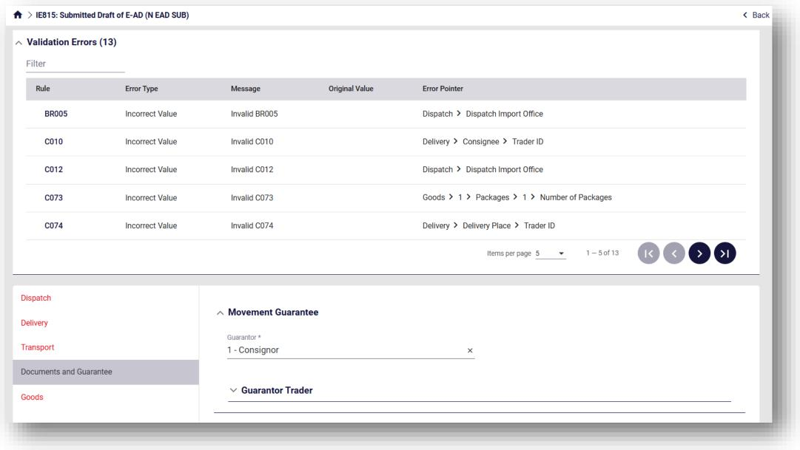

Figure 5: Validation errors - example

Click on each validation in order to see the details.

* Clicking on the Error Pointer will redirect the user to the incorrect field within the form, so that it can be corrected.
* Clicking on the Business Rule will generate a popup window (as in the example shown below) indicating the definition of the business rule that has not been satisfied.

Page **16** of **79**

DK-EMCS-D1.5.UMN-TR.User Manual Traders v1.1

|  |  |  |
| --- | --- | --- |
|  | **User Manual - Trader Portal Guide** | DK-EMCS |
| D1.5.UMN - TR  Version 1.1 |

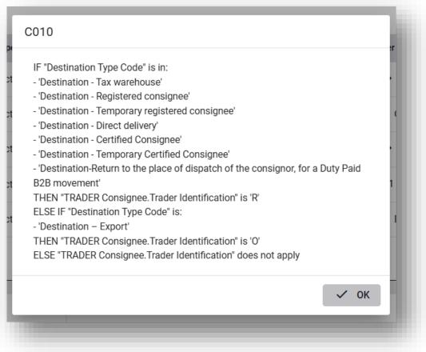

Figure 6: Validation errors - popup window with business rule

The sections that have errors are also marked in red. Click on each sections and see the detailed error message(s). An example is shown in the image below:

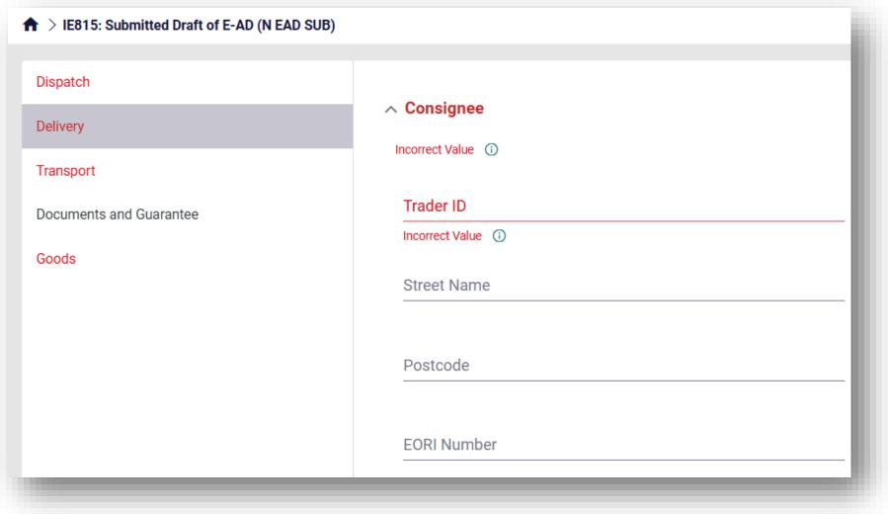

Figure 7: Validation errors - markup on the screen

Page **17** of **79**

DK-EMCS-D1.5.UMN-TR.User Manual Traders v1.1



|  |  |  |
| --- | --- | --- |
|  | **User Manual - Trader Portal Guide** | DK-EMCS |
| D1.5.UMN - TR  Version 1.1 |

Next to the error message (which is shown under the data element) there is an info icon ( ), Click on it to see the details of the associated business rule.

**3.1.1.1 Validation errors**

All validation errors contain the following information:

* Rule: Violated business rule (BRxxxx or Rxxxx) or condition (Cxxxx) code ID
* Message: Error description
* Original Value: The value contained in the data element
* Error Pointer: Indication on the location (field) of the error in the declaration

Page **18** of **79**

DK-EMCS-D1.5.UMN-TR.User Manual Traders v1.1

|  |  |  |
| --- | --- | --- |
|  | **User Manual - Trader Portal Guide** | DK-EMCS |
| D1.5.UMN - TR  Version 1.1 |

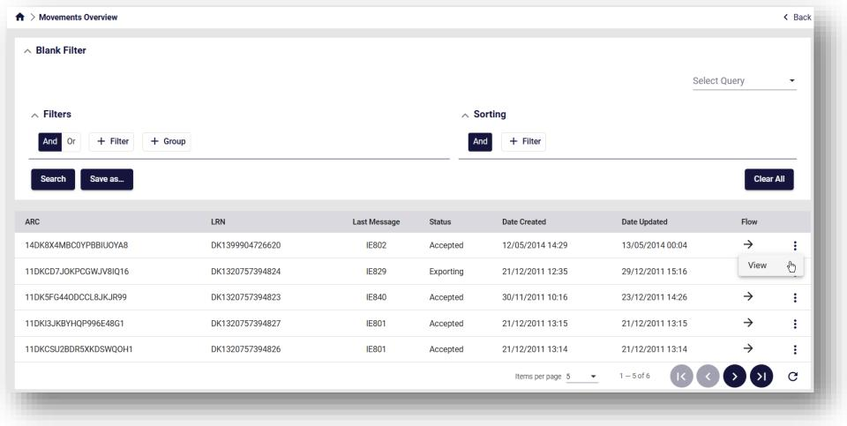

Figure 9: Open Movements Actions

By clicking on *View*, the previously Movement Details grid will be displayed (for further detail please refer to 3.2.2.3).

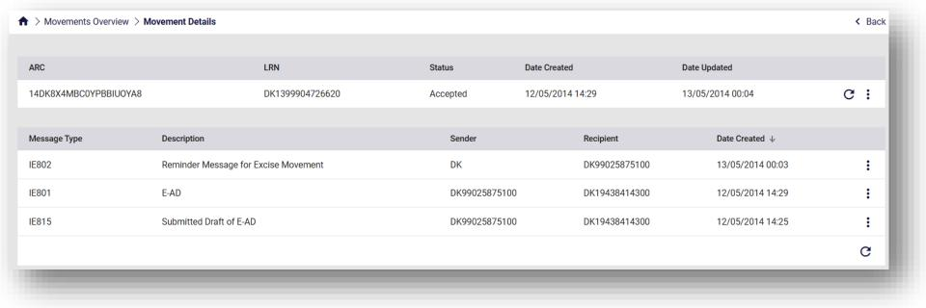

Figure 10: Open Movements View

**3.2.2 Movements Overview**

This section lists all movements submitted by the logged-in user as shown in the following screen:

Page **20** of **79**

DK-EMCS-D1.5.UMN-TR.User Manual Traders v1.1

|  |  |  |
| --- | --- | --- |
|  | **User Manual - Trader Portal Guide** | DK-EMCS |
| D1.5.UMN - TR  Version 1.1 |

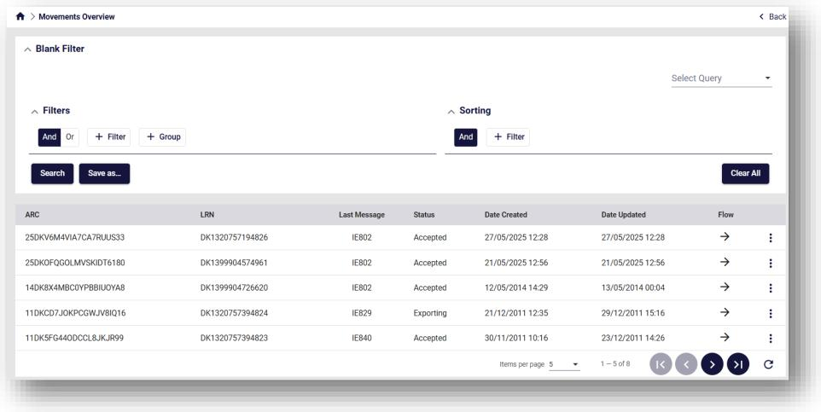

Figure 11: Movement Overview grid – example

**3.2.2.1 Grid columns**

The following columns are displayed in the Movements grid:

|  |  |
| --- | --- |
| **Column name** | **Description** |
| ARC | The ARC of the entry |
| LRN | The LRN of the entry (LRN = Local Reference Number) |
| Last message | The last message of the movement (e.g. IE801) |
| Status | Movement Status |
| Date Created | The date the movement was created |
| Date Updated | The date the last message referencing the movement ARC was registered in the system |
| Flow | The flow of the last message exchanged.   * Incoming: indicated by a left pointing arrow * Outbound: indicated by a right pointing arrow. |

Table 1: Movement Overview grid - fields

Page **21** of **79**

DK-EMCS-D1.5.UMN-TR.User Manual Traders v1.1

|  |  |  |
| --- | --- | --- |
|  | **User Manual - Trader Portal Guide** | DK-EMCS |
| D1.5.UMN - TR  Version 1.1 |

**3.2.2.2 Menu with the available actions**

The actions selector in the Overview grid (icon) will display the available Movement

Actions, depending on the type and status of the corresponding movement.

Examples of the “Action” menus are shown in the images below:

Figure 12: "Actions" menu - examples

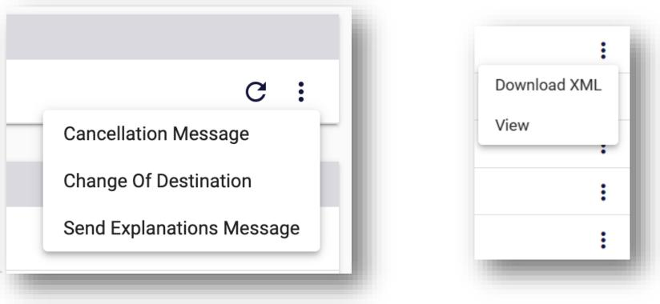

Page **22** of **79**

DK-EMCS-D1.5.UMN-TR.User Manual Traders v1.1

|  |  |  |
| --- | --- | --- |
|  | **User Manual - Trader Portal Guide** | DK-EMCS |
| D1.5.UMN - TR  Version 1.1 |

**3.2.2.3 View movement details**

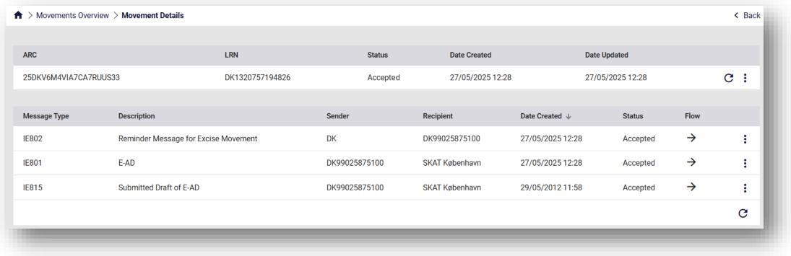

Figure 13: Movement Details screen

When selecting “View” from the “Actions” menu, the “Movement details” data grid is displayed. The “Movement details” grid has the following sections:

* **Header element**; the Header element contains the following columns for the movement:
* ARC
* LRN
* Status (Movement status)
* Date Created
* Date Updated

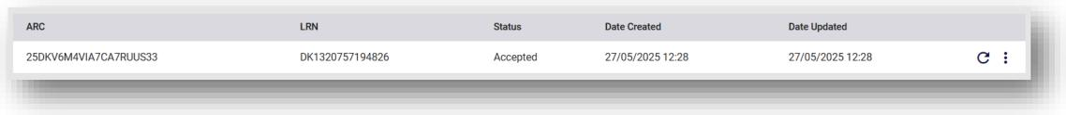

Figure 14: Movement details header

You can refresh the screen by clicking on the refresh button which is located on the right side of the container.

Page **23** of **79**

DK-EMCS-D1.5.UMN-TR.User Manual Traders v1.1

|  |  |  |
| --- | --- | --- |
|  | **User Manual - Trader Portal Guide** | DK-EMCS |
| D1.5.UMN - TR  Version 1.1 |

* **Movement message history**: it contains all messages that reference the movement’s

ARC.

The following columns are displayed:

* Message type (The message code)
* Description (Message name)
* Sender
* Recipient
* Date created
* Action selector for the entry (“View” is the only available action here)

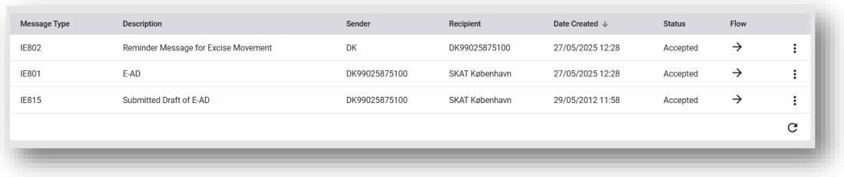

Figure 15: Movement messages grid

To view the contents of an individual entry from the movement message history section, double-

click the selected row, or click on the action selector and click on “View”.

Page **24** of **79**

DK-EMCS-D1.5.UMN-TR.User Manual Traders v1.1

|  |  |  |
| --- | --- | --- |
|  | **User Manual - Trader Portal Guide** | DK-EMCS |
| D1.5.UMN - TR  Version 1.1 |

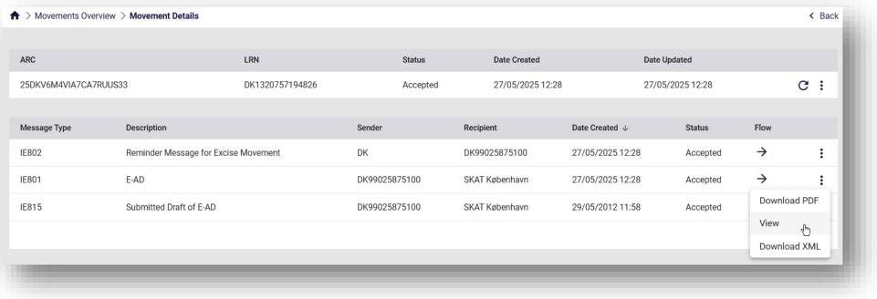

Figure 16: Movement messages grid View

In order to download any message in XML format, click on the action selector and then on “Download XML”.

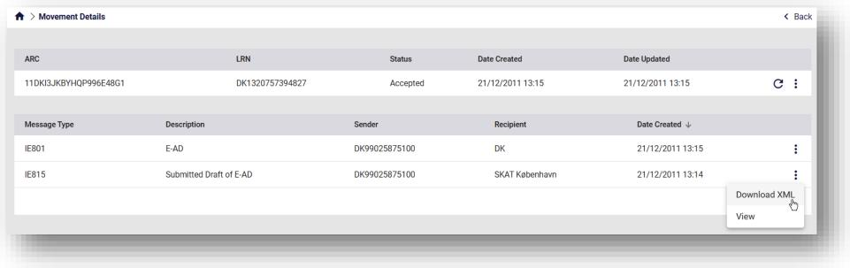

Figure 17: Movement messages grid Download XML

In order to download IE801 messages in PDF format, click on the action selector and then on

“Download PDF”.

*Note: This is only available for IE801 messages*

Page **25** of **79**

DK-EMCS-D1.5.UMN-TR.User Manual Traders v1.1

|  |  |  |
| --- | --- | --- |
|  | **User Manual - Trader Portal Guide** | DK-EMCS |
| D1.5.UMN - TR  Version 1.1 |

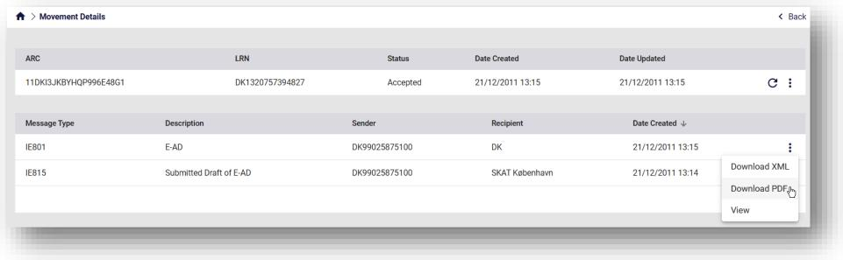

Figure 18: Movement messages grid Download PDF

***3.2.2.3.1 View declaration***

The following shows the “View Declaration” screen layout:

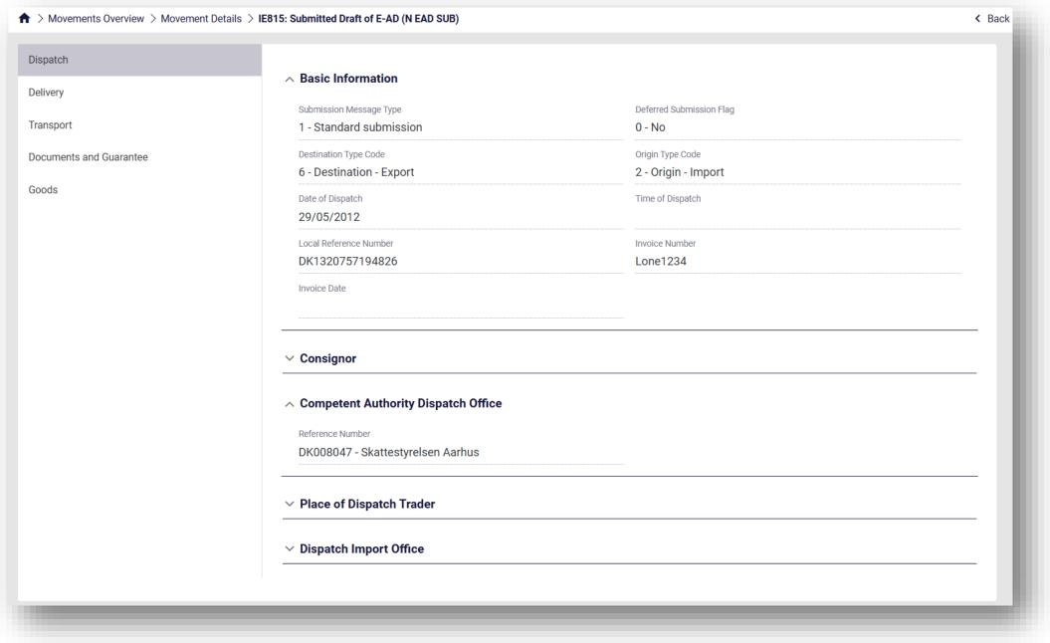

Figure 19: View Declaration screen - example

Page **26** of **79**

DK-EMCS-D1.5.UMN-TR.User Manual Traders v1.1

|  |  |  |
| --- | --- | --- |
|  | **User Manual - Trader Portal Guide** | DK-EMCS |
| D1.5.UMN - TR  Version 1.1 |

The following declaration sections are displayed on the left in this screenshot:

|  |  |
| --- | --- |
| **Section Name** | **Description** |
| Dispatch | Contains all the information related to the consignor |
| Delivery | Contains information for the recipient and the place of delivery of the movement. |
| Transport | Basic information and details of movement. The duration of movement can be expressed either in hours or days. Moreover, the time corresponding to the days of the movement of goods taking into account the duration of the movement, must not exceed one week. |
| Documents and Guarantee | Includes all documents certificates and movement guarantees information that was submitted for that movement. |
| Goods | The EMCS goods |

Table 2: View Declaration Message - sections

**3.2.3 Messages Overview**

This section lists all messages exchanged between the logged-in user and the application, as shown in the following screen:

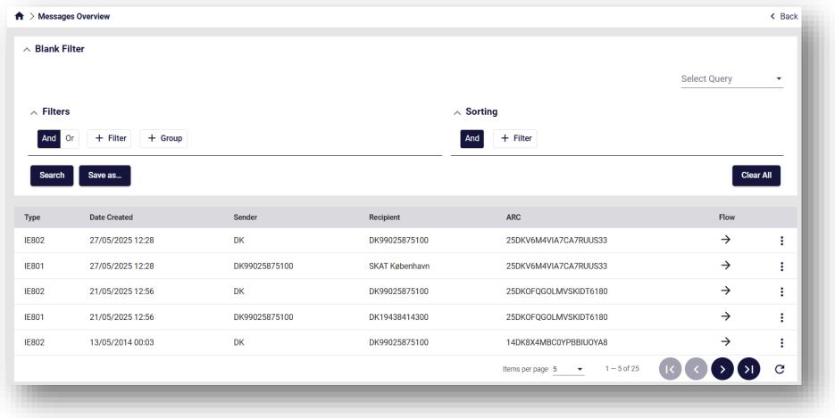

Page **27** of **79**

DK-EMCS-D1.5.UMN-TR.User Manual Traders v1.1

|  |  |  |
| --- | --- | --- |
|  | **User Manual - Trader Portal Guide** | DK-EMCS |
| D1.5.UMN - TR  Version 1.1 |

Figure 20: Message Overview grid – example

**3.2.3.1 Grid columns**

The following columns are displayed in the Messages grid:

|  |  |
| --- | --- |
| **Column name** | **Description** |
| Type | The type of message exchanged (eg IE801) |
| Date Created | The date of the message exchange |
| Sender | Indicates who generated the message |
| Recipient | Indicates who received the message |
| ARC | The ARC of the entry |
| Flow | The flow of the last message exchanged.   * Incoming: indicated by a left pointing arrow * Outbound: indicated by a right pointing arrow. |

Table 3: Message Overview grid - fields

**3.2.4 Pending Actions**

This section lists all movements that require an action to be completed by the logged-in user, as shown in the following screen:

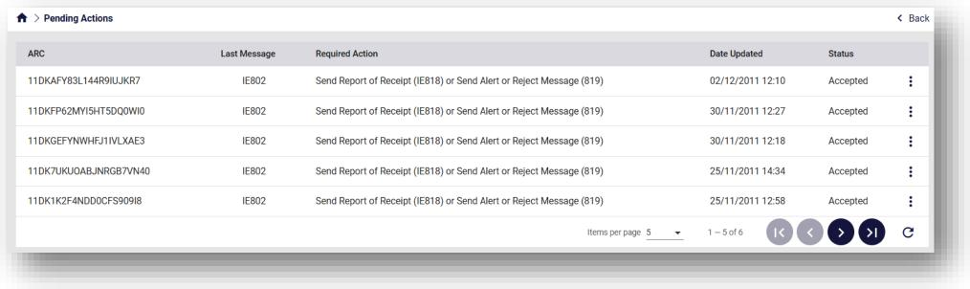

Figure 21: Pending Actions – example

Page **28** of **79**

DK-EMCS-D1.5.UMN-TR.User Manual Traders v1.1

|  |  |  |
| --- | --- | --- |
|  | **User Manual - Trader Portal Guide** | DK-EMCS |
| D1.5.UMN - TR  Version 1.1 |

**3.2.4.1 Grid columns**

The following columns are displayed in the Actions grid:

|  |  |
| --- | --- |
| **Column name** | **Description** |
| ARC | The ARC of the entry |
| Last message | The last message of the movement (eg IE801) |
| Required Action | Description of the action that the logged-in user should complete |
| Date Updated | The date of the last message exchange or action completed |
| Status | Movement Status |

Table 4: Pending Actions grid – fields

Be selecting to view the movement, the necessary pending action can be completed.

Page **29** of **79**

DK-EMCS-D1.5.UMN-TR.User Manual Traders v1.1







|  |  |  |
| --- | --- | --- |
|  | **User Manual - Trader Portal Guide** | DK-EMCS |
| D1.5.UMN - TR  Version 1.1 |

**3.3 Unknown ARC**

This function can be used if the Consignee cannot see the reported ARC – message IE801 - in their own EMCS application.

If the Consignee submits an IE818 for an unknown ARC, i.e. no movement exists with the submitted ARC number, the Pending message remains in the Unknown ARC – Overview screen.

**3.3.1 Overview**

Through the following screen, the *Overview* of the *Unknown ARC*’s can be accessed.



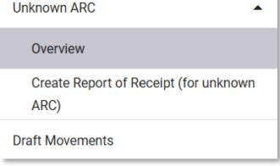

Figure 22: Unknown ARC – Overview button

By selecting *Overview* in the menu, the following grid appears:

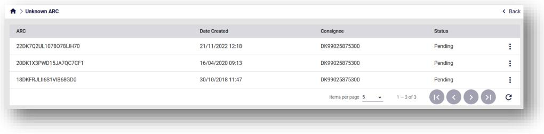

Figure 23: Unknown ARC – Overview

Please refer to 3.2.2.2 Menu with the available actions for more details regarding the action selector (three dots).

Page **30** of **79**

DK-EMCS-D1.5.UMN-TR.User Manual Traders v1.1

|  |  |  |
| --- | --- | --- |
|  | **User Manual - Trader Portal Guide** | DK-EMCS |
| D1.5.UMN - TR  Version 1.1 |

**3.3.1.1 Grid columns**

The following columns are displayed in the grid:

|  |  |
| --- | --- |
| **Column name** | **Description** |
| ARC | The ARC of the entry |
| Date Created | Date of creation of the entry |
| Consignee | Consignee of the movement |
| Status | Movement Status |

Table 5: Unknown ARC - Overview grid - fields

**3.3.1.2 Menu with the available actions**

The actions selector in the Overview grid (icon) will display the available Actions,

depending on the type and status of the corresponding movement.

Examples of the “Action” menus are shown in the images below:

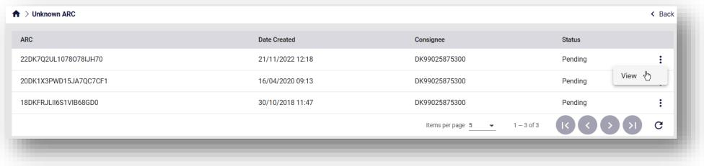

Figure 24: Unknown ARC – Overview Actions

Page **31** of **79**

DK-EMCS-D1.5.UMN-TR.User Manual Traders v1.1

|  |  |  |
| --- | --- | --- |
|  | **User Manual - Trader Portal Guide** | DK-EMCS |
| D1.5.UMN - TR  Version 1.1 |

**3.3.2 Create Report of Receipt**

The Create Report of Receipt (for unknown ARC) screen allows the user to submit a IEB1B message for an unknown ARC.

This screen can only be used in cases where an IEB01 message has not been received through the system. In all other cases, use the normal procedure to submit a Receipt of Receipt (IEB1B) through an already created movement.

A Report of Receipt (IEB1B) for an unknown ARC can be submitted through the following screen.

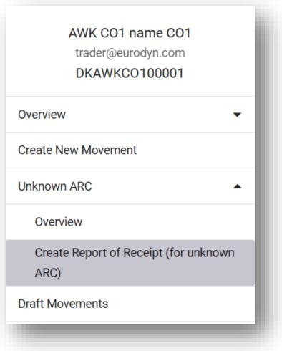

Figure 25: IE818 Message Menu Button

By selecting *Create Report of Receipt* in the menu, the following form appears:

Page **32** of **79**

DK-EMCS-D1.5.UMN-TR.User Manual Traders v1.1

|  |  |  |
| --- | --- | --- |
|  | **User Manual - Trader Portal Guide** | DK-EMCS |
| D1.5.UMN - TR  Version 1.1 |

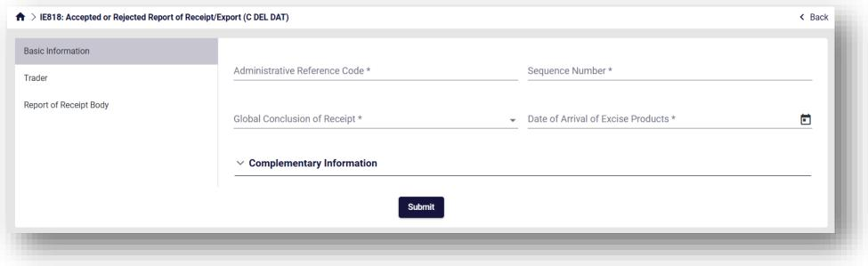

Figure 26: Screen Submission of an IE818 Message

Page **33** of **79**

DK-EMCS-D1.5.UMN-TR.User Manual Traders v1.1

|  |  |  |
| --- | --- | --- |
|  | **User Manual - Trader Portal Guide** | DK-EMCS |
| D1.5.UMN - TR  Version 1.1 |

**3.4 Draft Declarations**

The “Draft declarations” grid displays all the unfinished declarations that had been saved during the drafting process or already submitted declarations that had been “Saved as Draft” using the corresponding action of the declaration in the “Declarations” overview.

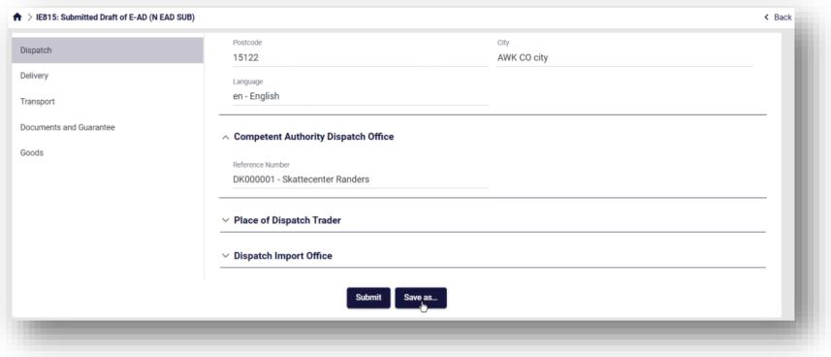

Figure 27: Drafting Process

To resume work on a draft dataset, select “**Edit**” from the available actions on the draft entry.   
Users can create a copy of an existing draft declaration using the “**Copy**” action button or even   
completely remove a draft declaration using the “**Delete**” action button.

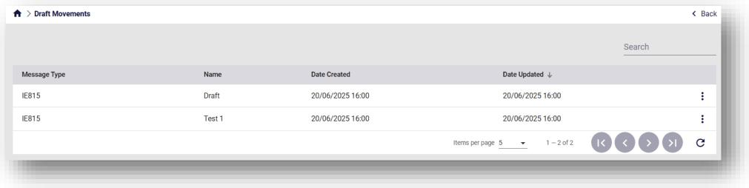

Figure 28: Draft Declarations overview

Page **34** of **79**

DK-EMCS-D1.5.UMN-TR.User Manual Traders v1.1

|  |  |  |
| --- | --- | --- |
|  | **User Manual - Trader Portal Guide** | DK-EMCS |
| D1.5.UMN - TR  Version 1.1 |

**3.5 Import**

The Import section is exclusive to Registered Consignors. It displays submitted messages that

relate to Import procedures.

These are essentially IE815 messages with Origin Type Code equal to “2 - Origin – Import”.

As explained in further detail below, they are either:

* Pending approval by the Customs Authorities (3.5.1)
* Have already been rejected (3.5.2)

No ARC has been generated for these IE815 messages yet.

If accepted by the Customs Authorities, these will no longer be visible in the Import section but

can be found in the Overview screens (3.2).

**3.5.1 Pending Messages**

The Import Pending Messages screen displays IE815 messages that have been submitted and

are pending approval by the Customs Authorities.

Through the following screen, the Import Pending Messages can be accessed.

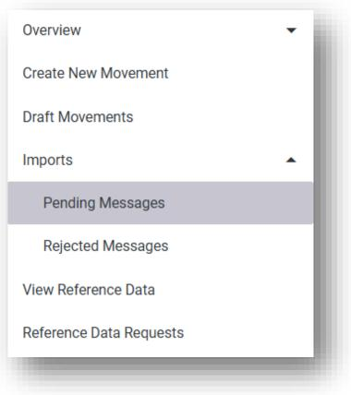

Figure 29: Import – Pending Messages Button

Page **35** of **79**

DK-EMCS-D1.5.UMN-TR.User Manual Traders v1.1

|  |  |  |
| --- | --- | --- |
|  | **User Manual - Trader Portal Guide** | DK-EMCS |
| D1.5.UMN - TR  Version 1.1 |

By selecting *Pending Messages* in the menu, the following screen appears:

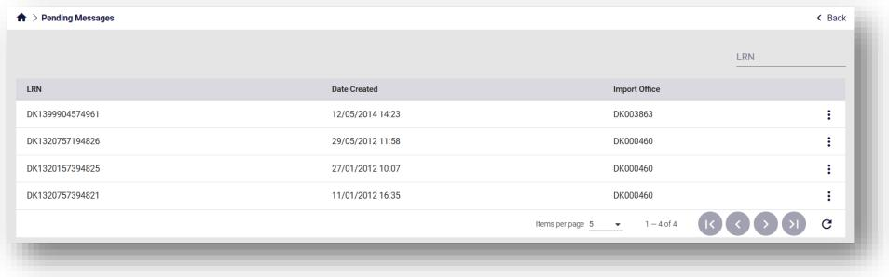

Figure 30: Import – Pending Messages Screen

In the grid above, the following are displayed:

* LRN: Local Reference Number of the IE815 message
* Date Created: Submission date of the IE815 message
* Import Office: Dispatch Import Office referenced in the IE815 message

A specific message can be found by searching its LRN on the top right.   
Input the LRN and press Enter. The results will appear as seen below.

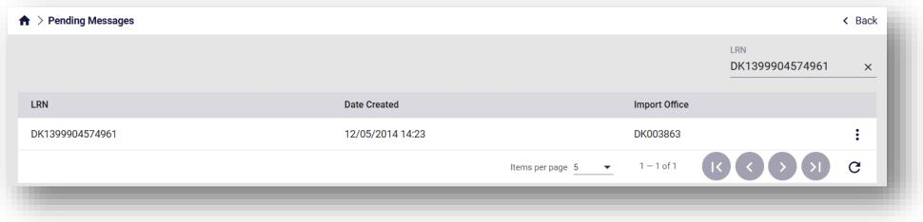

Figure 31: Import – Pending Messages LRN Search

Page **36** of **79**

DK-EMCS-D1.5.UMN-TR.User Manual Traders v1.1

|  |  |  |
| --- | --- | --- |
|  | **User Manual - Trader Portal Guide** | DK-EMCS |
| D1.5.UMN - TR  Version 1.1 |

Click on the action selector on the right side of the grid to *View* the message.

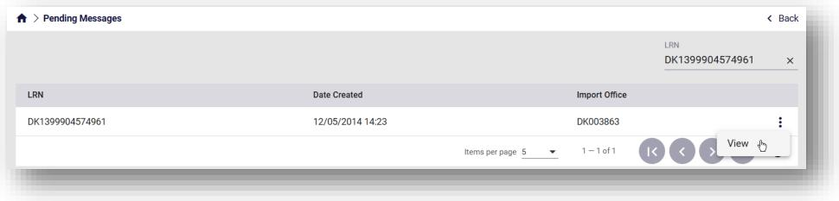

Figure 32: Import – Pending Messages Actions

By clicking on *View*, the previously submitted IE815 will be displayed.

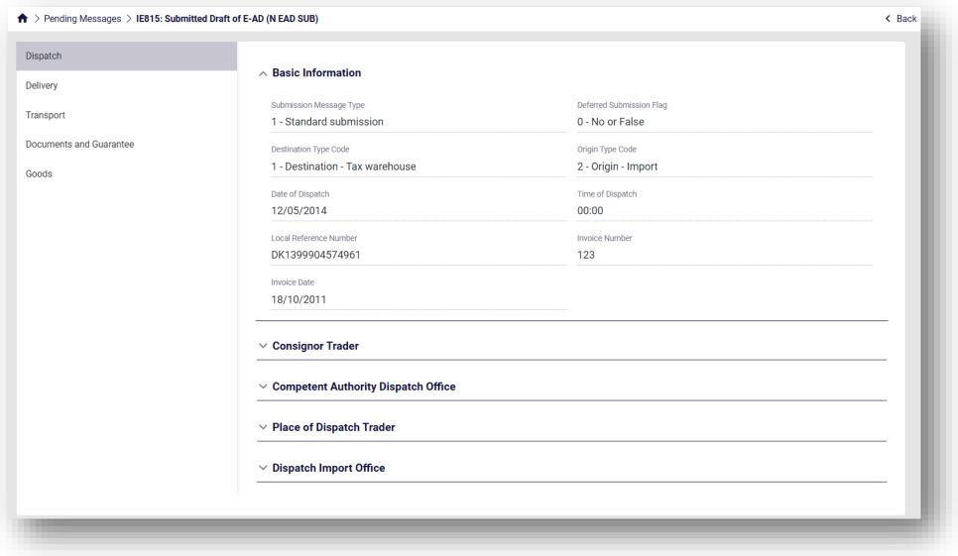

Figure 33: Import – Pending Messages Submitted form

Page **37** of **79**

DK-EMCS-D1.5.UMN-TR.User Manual Traders v1.1

|  |  |  |
| --- | --- | --- |
|  | **User Manual - Trader Portal Guide** | DK-EMCS |
| D1.5.UMN - TR  Version 1.1 |

**3.5.2 Rejected Messages**

The Import Rejected Messages screen displays IE815 messages that have been submitted and

rejected by the Customs Authorities.

Through the following screen, the Import Rejected Messages can be accessed.

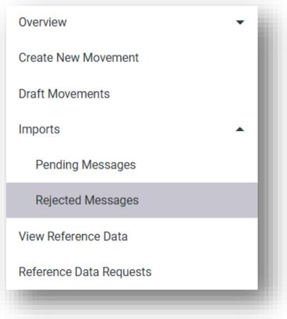

Figure 34: Import – Rejected Messages Button

By selecting *Rejected Messages* in the menu, the following screen appears:

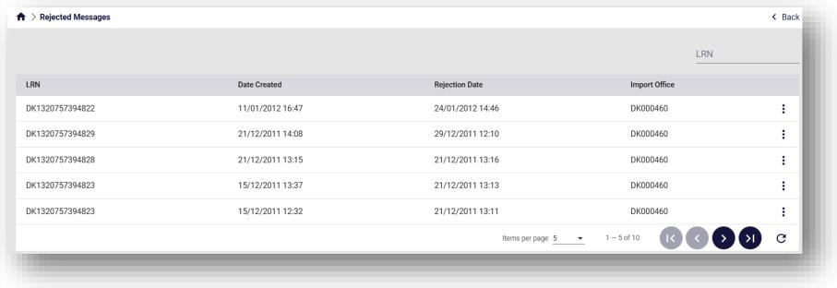

Figure 35: Import – Rejected Messages Screen

In the grid above, the following are displayed:

* LRN: LRN of the IE815 message
* Date Created: Submission date and time of the IE815 message

Page **38** of **79**

DK-EMCS-D1.5.UMN-TR.User Manual Traders v1.1

|  |  |  |
| --- | --- | --- |
|  | **User Manual - Trader Portal Guide** | DK-EMCS |
| D1.5.UMN - TR  Version 1.1 |

* Rejection Date: Date and time of the rejection by the Customs Authorities
* Import Office: Dispatch Import Office referenced in the IE815 message

A specific message can be found by searching its LRN on the top right.   
Input the LRN and press Enter. The results will appear as seen below.

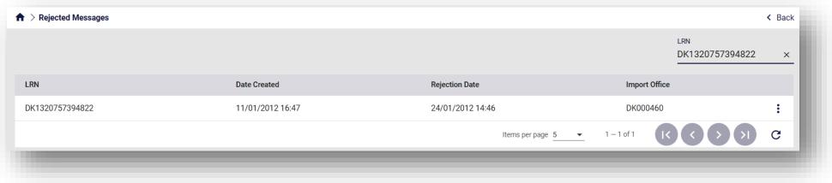

Figure 36: Import – Rejected Messages LRN Search

Click on the action selector on the right side of the grid to either:

* *View*: Displays the previously submitted IE815 message
* *View Rejection*: Displays the rejection message by the Custom Authorities

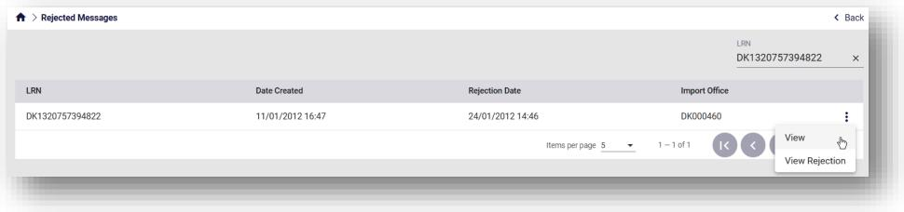

Figure 37: Import – Rejected Messages Actions

Page **39** of **79**

DK-EMCS-D1.5.UMN-TR.User Manual Traders v1.1

|  |  |  |
| --- | --- | --- |
|  | **User Manual - Trader Portal Guide** | DK-EMCS |
| D1.5.UMN - TR  Version 1.1 |

By clicking on *View*, the previously submitted IE815 will be displayed.

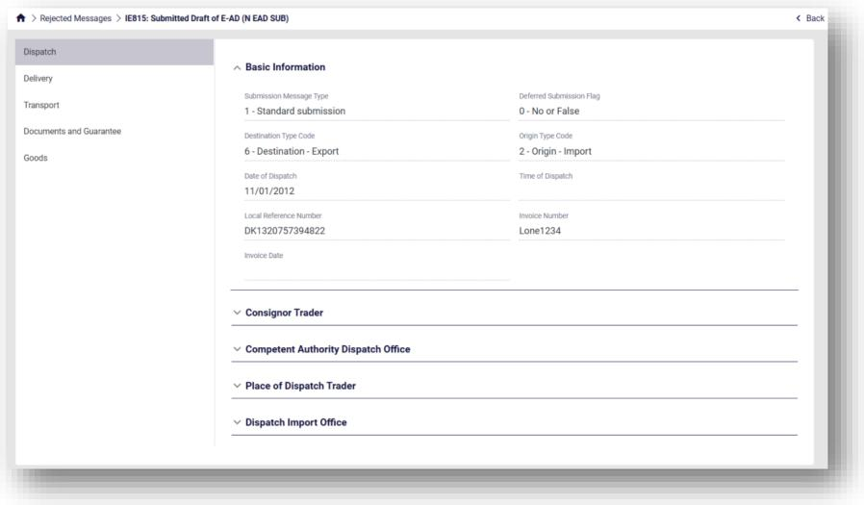

Figure 38: Import – Rejected Messages Submitted IE815

By clicking on *View Rejection*, the rejection message by the Custom Authorities will be displayed.

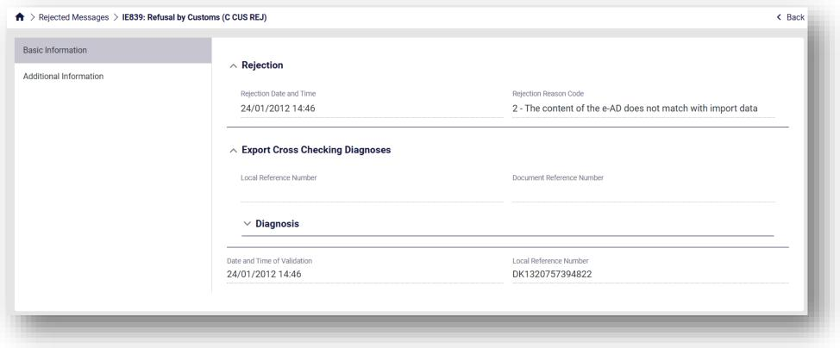

Figure 39: Import – Rejected Messages Rejection

Page **40** of **79**

DK-EMCS-D1.5.UMN-TR.User Manual Traders v1.1

|  |  |  |
| --- | --- | --- |
|  | **User Manual - Trader Portal Guide** | DK-EMCS |
| D1.5.UMN - TR  Version 1.1 |

**3.6 Reference Data**

This function aims to facilitate any query the user might have regarding the contents of the

reference data.

**3.6.1 View Reference Data**

Through the following screen, the Reference data can be accessed.

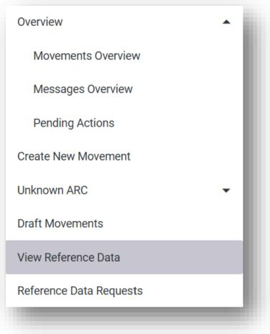

Figure 40: View Reference Data Button

By selecting *View Reference Data* in the menu, the following screen appears:

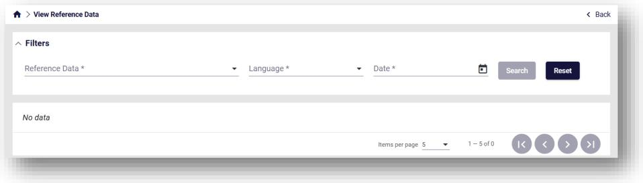

Figure 41: View Reference Data Screen

The following filters can be applied to narrow down the search:

Page **41** of **79**

DK-EMCS-D1.5.UMN-TR.User Manual Traders v1.1

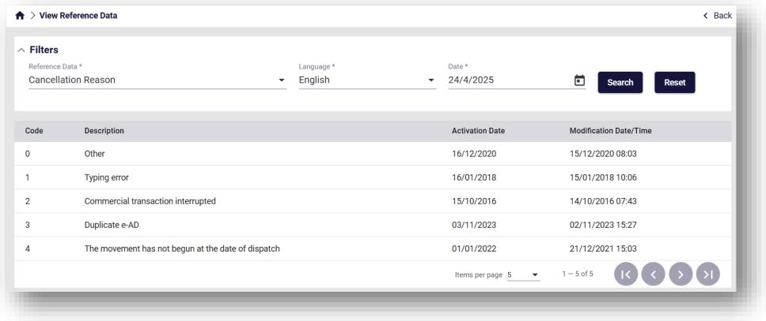

|  |  |  |
| --- | --- | --- |
|  | **User Manual - Trader Portal Guide** | DK-EMCS |
| D1.5.UMN - TR  Version 1.1 |

* Reference Data: The name of reference data list
* Language: The language of the description
* Date: The validity date of the list. The lists can be updated and therefore can change

depending on the date selected

Select the required filters and click Search.

*Note: All three filters are mandatory*

The results will appear as seen below.

Figure 42: View Reference Data Results

**3.6.1.1 Grid columns**

The following columns are displayed in the View Reference Data Results:

|  |  |
| --- | --- |
| **Column name** | **Description** |
| Code | The values of the list |
| Description | Text description of each value |
| Activation Date | Date when the value was introduced to the list |
| Modification Date/Time | Date/Time of the latest change applied to the value |

Table 6: View Reference Data Results grid - fields

Page **42** of **79**

DK-EMCS-D1.5.UMN-TR.User Manual Traders v1.1

|  |  |  |
| --- | --- | --- |
|  | **User Manual - Trader Portal Guide** | DK-EMCS |
| D1.5.UMN - TR  Version 1.1 |

**3.6.2 Reference Data Requests**

Through the following screen, the past Reference Data Requests can be accessed.

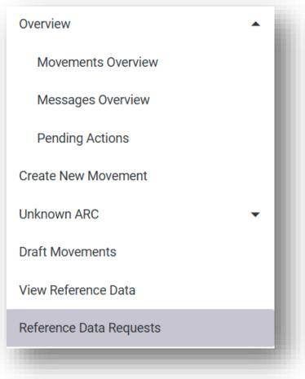

Figure 43: Reference Data Requests Button

By selecting *Reference Data Requests* in the menu, the following screen appears:

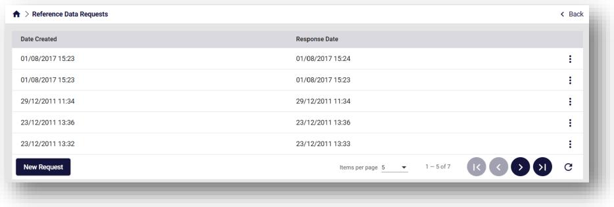

Figure 44: Reference Data Requests Screen

In the grid above, the following are displayed:

* Date Created: Date/Time of the request
* Response Date: Date/Time of the response

Page **43** of **79**

DK-EMCS-D1.5.UMN-TR.User Manual Traders v1.1

|  |  |  |
| --- | --- | --- |
|  | **User Manual - Trader Portal Guide** | DK-EMCS |
| D1.5.UMN - TR  Version 1.1 |

By clicking on New Request at the bottom left of the grid, the user can complete a request form.

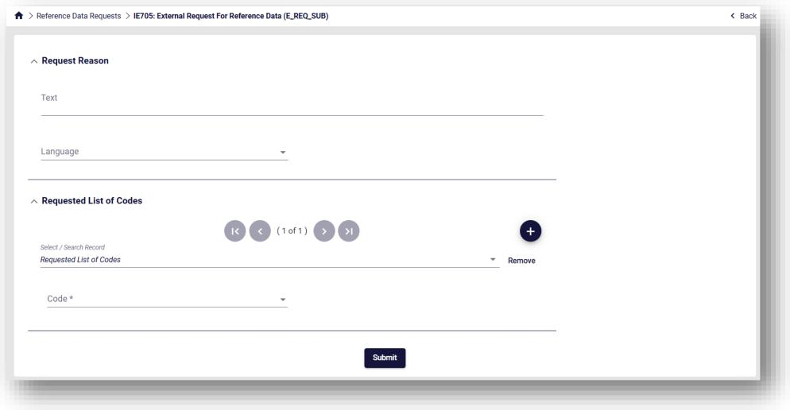

Figure 45: View Reference Data New Request

The following fields are mandatory and need to be completed:

* Text: Explanatory request reason description
* Language: Language of the results
* Code: Which Reference Data list is required by the user

Complete the form and click Submit.

The request will be displayed on the Reference Data Requests Screen, and its results will be

available upon reception.

Click on the action selector on the right side of the grid to either:

* *View*: Displays the completed form of the request
* *Download Data*: Downloads the results in XML Format

Page **44** of **79**

DK-EMCS-D1.5.UMN-TR.User Manual Traders v1.1

|  |  |  |
| --- | --- | --- |
|  | **User Manual - Trader Portal Guide** | DK-EMCS |
| D1.5.UMN - TR  Version 1.1 |

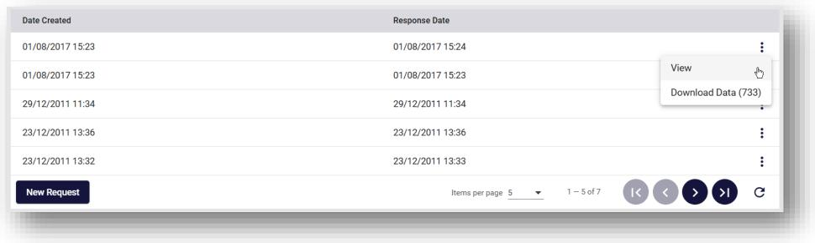

Figure 46: View Reference Data Request actions

The completed request form can be seen below.

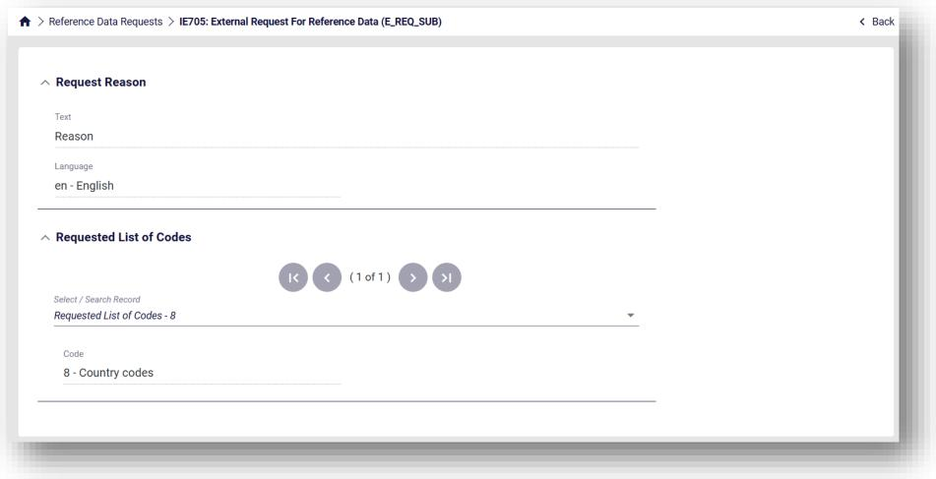

Figure 47: View Reference Data Request form

**3.7 SEED Authorisation**

This function aims to display the SEED Authorisation associated with the logged-in user.

Through the following screen, the authorisation can be accessed.

Page **45** of **79**

DK-EMCS-D1.5.UMN-TR.User Manual Traders v1.1

|  |  |  |
| --- | --- | --- |
|  | **User Manual - Trader Portal Guide** | DK-EMCS |
| D1.5.UMN - TR  Version 1.1 |

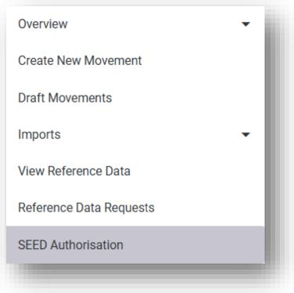

Figure 48: SEED Authorisation Button

By selecting *SEED Authorisation* in the menu, the following screen appears:

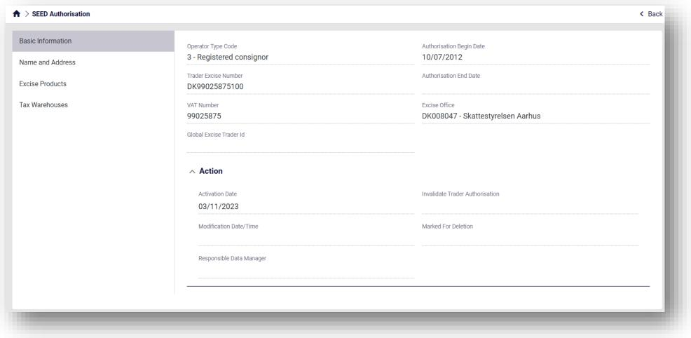

Figure 49: SEED Authorisation Screen

The contents of the SEED Authorisation can be accessed by navigating the different sections on the left side.

Page **46** of **79**

DK-EMCS-D1.5.UMN-TR.User Manual Traders v1.1

|  |  |  |
| --- | --- | --- |
|  | **User Manual - Trader Portal Guide** | DK-EMCS |
| D1.5.UMN - TR  Version 1.1 |

**3.8 Business-related Actions on Movements**

**3.9 Change of destination (IE813)**

The IE813 consists of an update message to change the Member State of Destination.

The consignor can change the destination of a movement at any time before receiving a

receipt (IE818). If the receipt status is partially rejected or completely rejected, the destination

must always be changed.

In order to submit it, click on the action selector in the movement details.

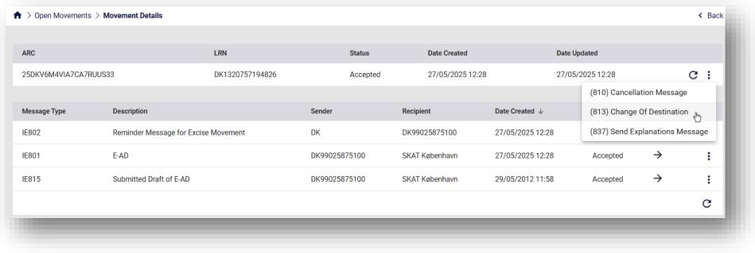

Figure 50: Change of destination (IE813)

The following form appears:

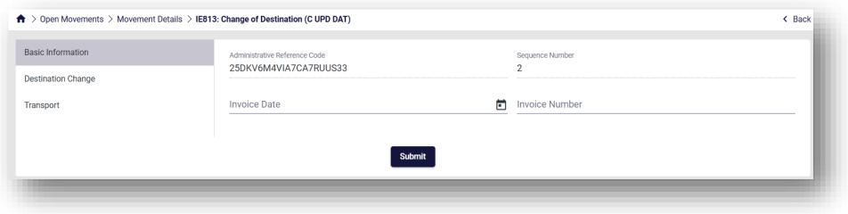

Figure 51: Screen Submission of an IE813 Message

Complete the necessary information for each section that can be seen on the left and finally click Submit.

Page **47** of **79**

DK-EMCS-D1.5.UMN-TR.User Manual Traders v1.1

|  |  |  |
| --- | --- | --- |
|  | **User Manual - Trader Portal Guide** | DK-EMCS |
| D1.5.UMN - TR  Version 1.1 |

**3.10 Cancelation of declaration (IE810)**

The IE810 consists of a cancellation message in cases where a consignment has not left the

Place of Dispatch.

Cancellation of a movement (IE810) can only take place when the goods have not left the

consignor's tax warehouse.

In order to submit it, click on the action selector in the movement details.

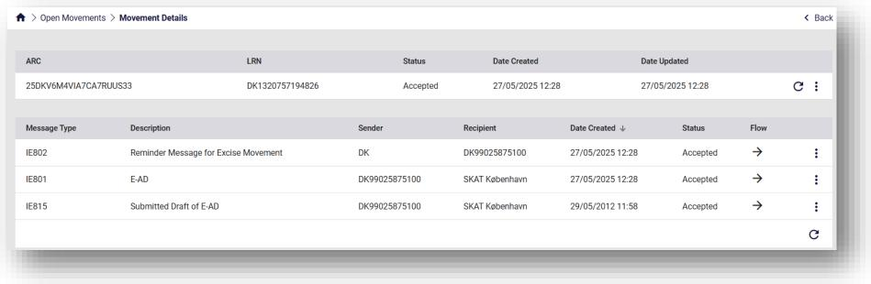

Figure 52: Cancelation of declaration (IE810)

The following form appears:

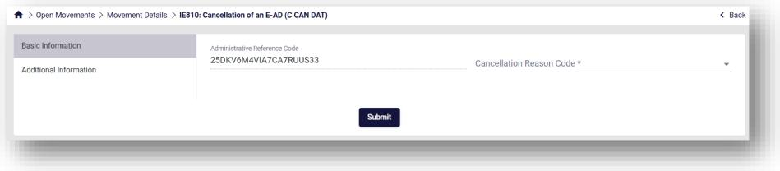

Figure 53: Screen Submission of an IE810 Message

Complete the necessary information for each section that can be seen on the left and finally click Submit.

**3.11 Report of Receipt (IE818)**

The IE818 consists of a report of receipt message, submitted by the Consignee, indicating that

the goods have arrived at their destination.

Page **48** of **79**

DK-EMCS-D1.5.UMN-TR.User Manual Traders v1.1

|  |  |  |
| --- | --- | --- |
|  | **User Manual - Trader Portal Guide** | DK-EMCS |
| D1.5.UMN - TR  Version 1.1 |

When the goods arrive, the Consignee must check whether the movement is intact or if there are any discrepancies (excess quantity or shortage) and report the result in a receipt. The Consignee can thus accept the movement as satisfactory or unsatisfactory or reject the consignment in whole or in part.

If the Consignee rejects the entire consignment, the Consignor must change the destination of the shipment, both when he wants the goods returned or if the goods are redirected to another Consignee. When returning, the Consignor must state himself as the Consignee. In the event of a partial rejection of the consignment, the Consignee must state the rejected quantity for each item separately in the receipt.

In order to submit it, click on the action selector in the movement details.

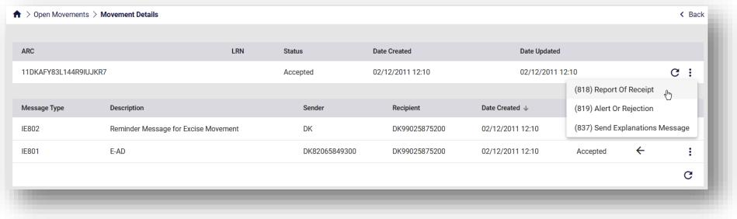

Figure 54: Report of Receipt (IE818)

The following form appears:

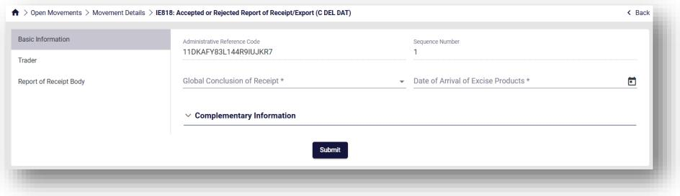

Figure 55: Screen Submission of an IE818 Message

Complete the necessary information for each section that can be seen on the left and finally click Submit.

Page **49** of **79**

DK-EMCS-D1.5.UMN-TR.User Manual Traders v1.1

|  |  |  |
| --- | --- | --- |
|  | **User Manual - Trader Portal Guide** | DK-EMCS |
| D1.5.UMN - TR  Version 1.1 |

**3.12 Alert or Rejection of an E-AD (IE819)**

The IE819 consists of an alert or rejection message submitted by the Consignee before the goods arrive at their destination. This message can only be sent by the Consignee and the status of the shipment will change accordingly, either remaining Accepted or changing to Rejected.

In order to submit it, click on the action selector in the movement details.

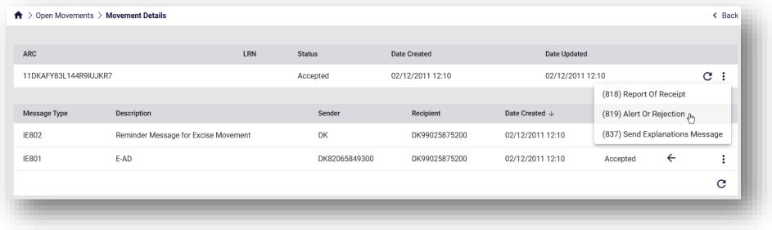

Figure 56: Alert or Rejection of an E-AD (IE819)

The following form appears:

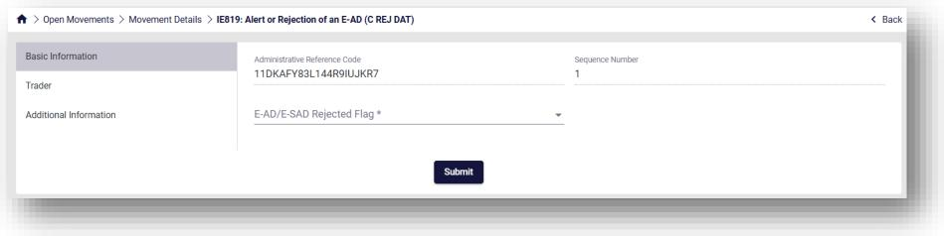

Figure 57: Screen Submission of an IE819 Message

Complete the necessary information for each section that can be seen on the left and finally click Submit.

Page **50** of **79**

DK-EMCS-D1.5.UMN-TR.User Manual Traders v1.1

|  |  |  |
| --- | --- | --- |
|  | **User Manual - Trader Portal Guide** | DK-EMCS |
| D1.5.UMN - TR  Version 1.1 |

**3.13 Explanations on Delay (IE837)**

The IE837 consists of an explanation message submitted by the Consignor and/or the

Consignee. This message can be used to explain the reason for a delayed receipt submission

(IE818) or the reason for a delayed Change of Destination (IE813).

In order to submit it, click on the action selector in the movement details.

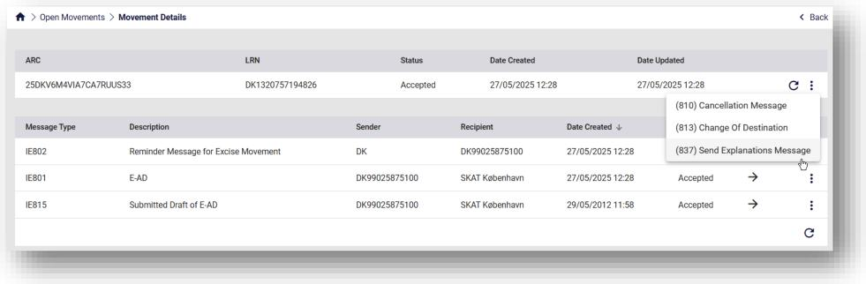

Figure 58: Explanations on Delay (IE837)

The following form appears:

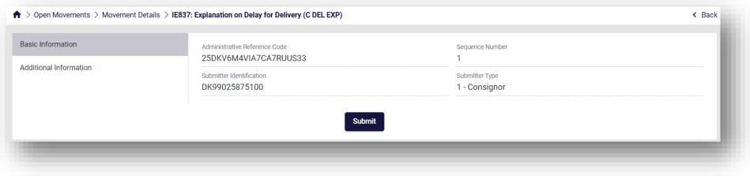

Figure 59: Screen Submission of an IE837 Message

Complete the necessary information for each section that can be seen on the left and finally click Submit.

**3.14 Submitted Draft of Splitting Operation (IE825)**

The IE825 consists of draft splitting operation message submitted by the Consignor. Consignments of energy products may be split into two or more parts thus replacing the

original consignment. The successful completion of a splitting operation causes state transition

Page **51** of **79**

DK-EMCS-D1.5.UMN-TR.User Manual Traders v1.1

|  |  |  |
| --- | --- | --- |
|  | **User Manual - Trader Portal Guide** | DK-EMCS |
| D1.5.UMN - TR  Version 1.1 |

for the concerned movement to “Replaced” for both Member State of Dispatch and

Destination.

The new movements resulting from the splitting operation are registered at the “Accepted”

state.

In order to submit it, click on the action selector in the movement details.

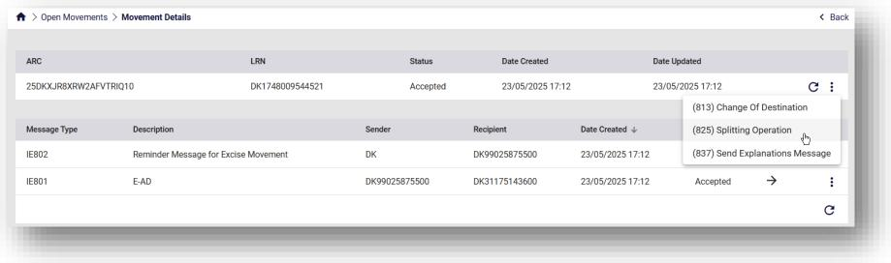

Figure 60: Submitted Draft of Splitting Operation (IE825)

The following form appears:

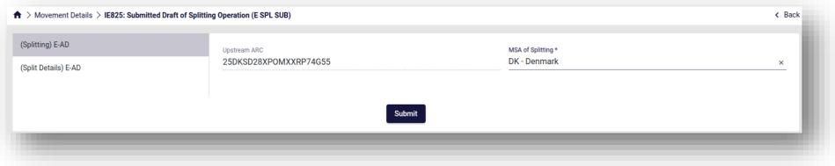

Figure 61: Screen Submission of an IE825 Message 1

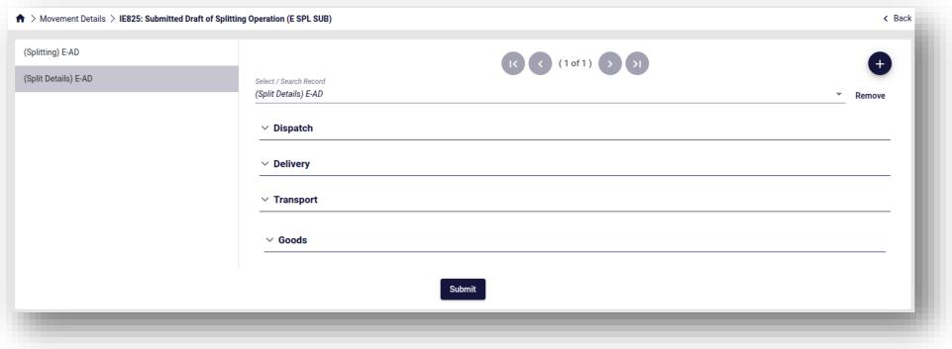

Page **52** of **79**

DK-EMCS-D1.5.UMN-TR.User Manual Traders v1.1

|  |  |  |
| --- | --- | --- |
|  | **User Manual - Trader Portal Guide** | DK-EMCS |
| D1.5.UMN - TR  Version 1.1 |

Figure 62: Screen Submission of an IE825 Message 2

Complete the necessary information for each section that can be seen on the left and finally click Submit.

**3.14.1 IE825 Submission Guide**

The Splitting Operation separates the initial IE815 E-AD into multiple ones.

In order to do so, the IE825 message should have at least two instances of “(Split Details) E-

AD”. It is important to note that the total quantities and masses of goods declared in the IE825

should equal the initial quantities and masses of the IE815 previously submitted.

Please see an example below. The IE815 message includes the following goods:

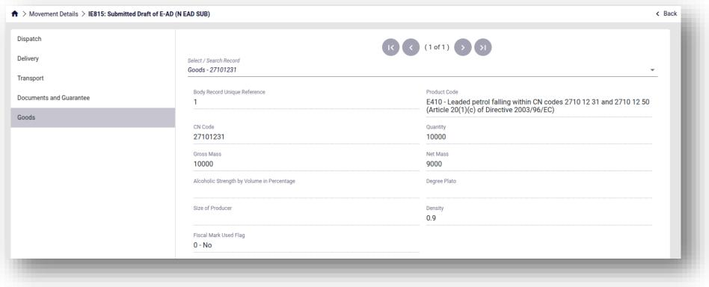

Figure 63: Splitting operation IE815 Message

Therefore, the IE825 should include all of these goods.

*Note: The Product Code and CN Code should remain the same.*

The first instance of “(Split Details) E-AD” in the IE825 message includes the following goods:

Page **53** of **79**

DK-EMCS-D1.5.UMN-TR.User Manual Traders v1.1

|  |  |  |
| --- | --- | --- |
|  | **User Manual - Trader Portal Guide** | DK-EMCS |
| D1.5.UMN - TR  Version 1.1 |

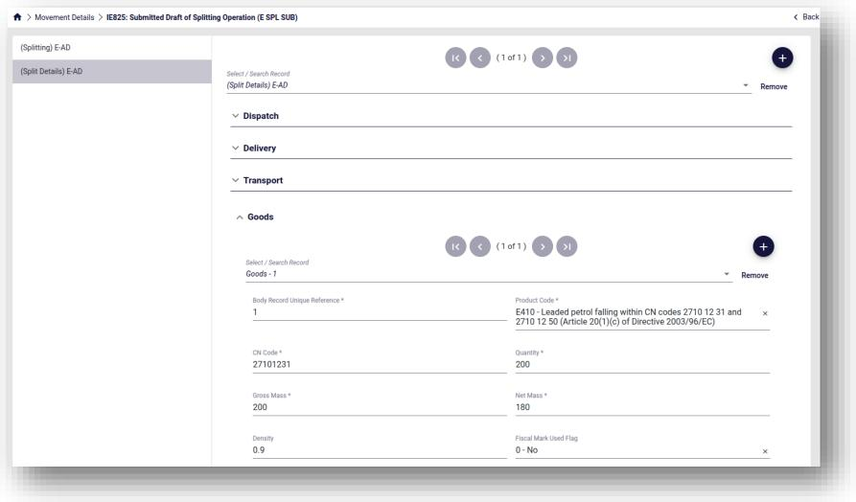

Figure 64: Splitting operation IE825 Message E-AD 1

The second instance of “(Split Details) E-AD” in the IE825 message includes the following goods:

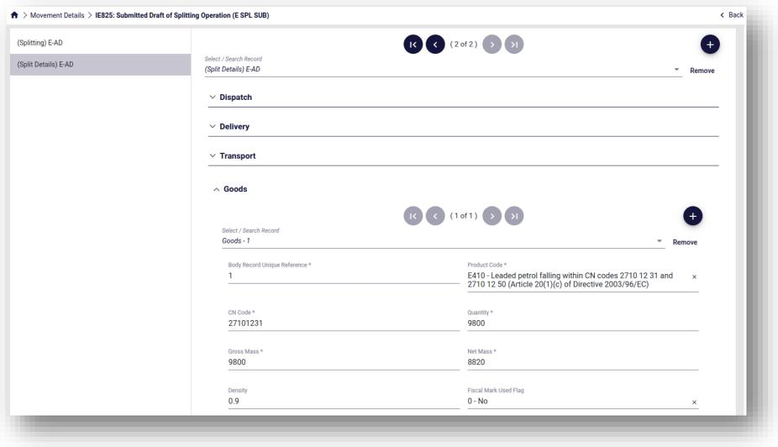

Page **54** of **79**

DK-EMCS-D1.5.UMN-TR.User Manual Traders v1.1

|  |  |  |
| --- | --- | --- |
|  | **User Manual - Trader Portal Guide** | DK-EMCS |
| D1.5.UMN - TR  Version 1.1 |

Figure 65: Splitting operation IE825 Message E-AD 2

It can be noted that while the Product Code and CN Code remain the same, the sum of quantities and masses match the ones declared in the initial IE815 message.

Once submitted, the IE825 will appear in the original movement created by the IE815. Furthermore, the IE803 acceptance message has been generated and the movement status has been set to “Replaced”.

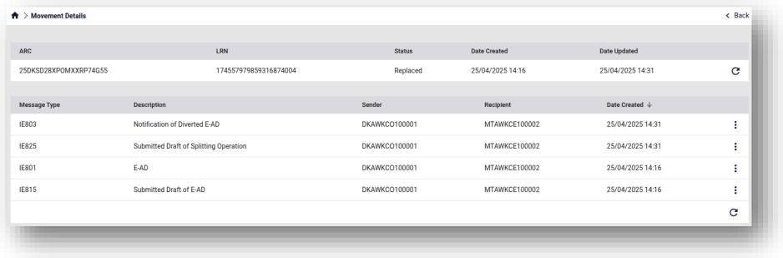

Figure 66: Splitting operation Original Movement

Finally, two new movements with new different ARC’s have been created.

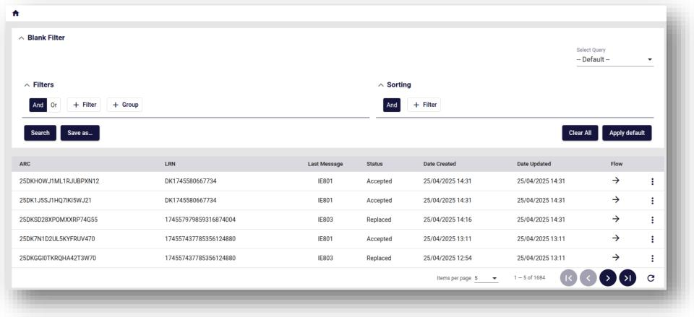

Figure 67: Splitting operation New Movements

Page **55** of **79**

DK-EMCS-D1.5.UMN-TR.User Manual Traders v1.1

|  |  |  |
| --- | --- | --- |
|  | **User Manual - Trader Portal Guide** | DK-EMCS |
| D1.5.UMN - TR  Version 1.1 |

Page **56** of **79**

DK-EMCS-D1.5.UMN-TR.User Manual Traders v1.1

|  |  |  |
| --- | --- | --- |
|  | **User Manual - Trader Portal Guide** | DK-EMCS |
| D1.5.UMN - TR  Version 1.1 |

These new movements have an IE801 as an initial message which reflects the contents of the corresponding “(Split Details) E-AD” of the IE825 message.

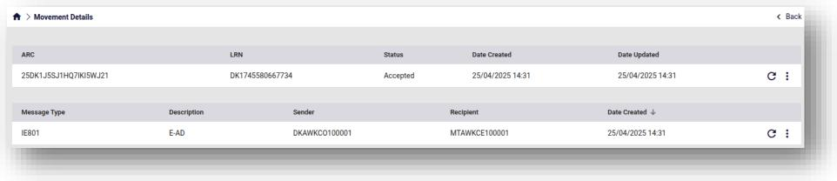

Figure 68: Splitting operation New Movement 1

Thus, the Splitting Operation has successfully been completed.

**3.15 Explanations on Reason for Shortage (IE871)**

The IE871 consists of an explanation message, submitted by the Consignor and/or the

Consignee, providing additional information following the submission or reception of IE818 in

cases where the Report of Receipt declares shortages or excesses.

IE871 can be submitted multiple times by the same actor.

In order to submit it, click on the action selector in the movement details.

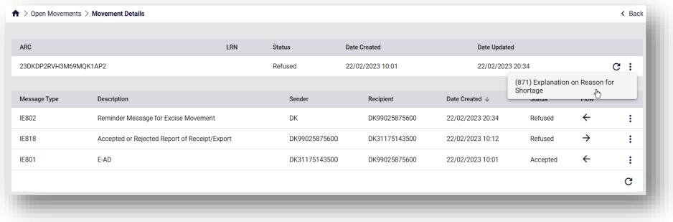

Figure 69: Explanations on Reason for Shortage (IE871)

The following form appears:

Page **57** of **79**

DK-EMCS-D1.5.UMN-TR.User Manual Traders v1.1

|  |  |  |
| --- | --- | --- |
|  | **User Manual - Trader Portal Guide** | DK-EMCS |
| D1.5.UMN - TR  Version 1.1 |

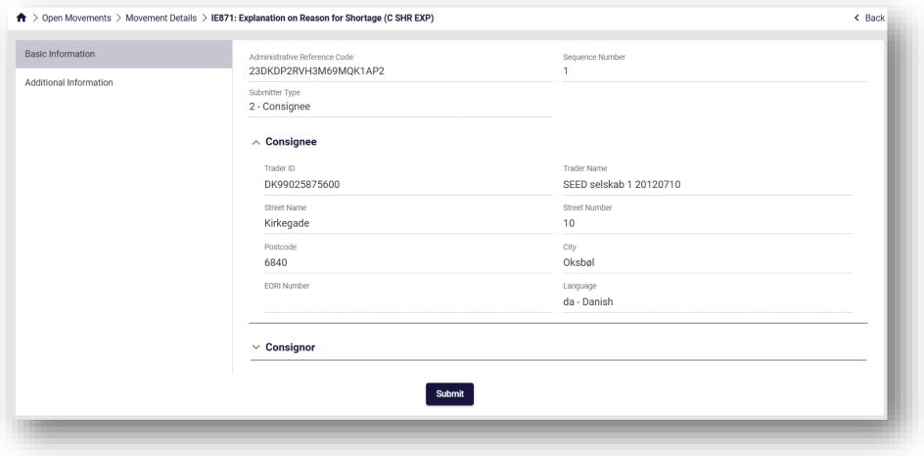

Figure 70: Screen Submission of an IE871 Message

Complete the necessary information for each section that can be seen on the left and finally click *Submit*.

Page **58** of **79**

DK-EMCS-D1.5.UMN-TR.User Manual Traders v1.1

|  |  |  |
| --- | --- | --- |
|  | **User Manual - Trader Portal Guide** | DK-EMCS |
| D1.5.UMN - TR  Version 1.1 |

**4 Common User Interface Components**

The following sections describe components that are used as part of the application’s grids and forms and are common to all ECDP-based applications.

**4.1 Logging-in**

Once the credentials are entered, the login screen prompts the user to select an Excise

Number associated with the account.

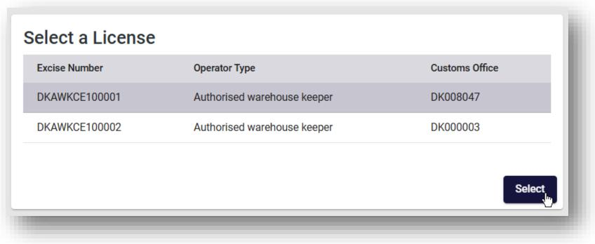

Figure 71: EMCS License Selection Screen

Once the license is selected, the user is redirected to the Movements overview screen where all the relevant movements are displayed.

*Note: In cases where only one Excise number is associated with the account, the user is automatically redirected to the Movements Overview Screen.*

Page **59** of **79**

DK-EMCS-D1.5.UMN-TR.User Manual Traders v1.1

|  |  |  |
| --- | --- | --- |
|  | **User Manual - Trader Portal Guide** | DK-EMCS |
| D1.5.UMN - TR  Version 1.1 |

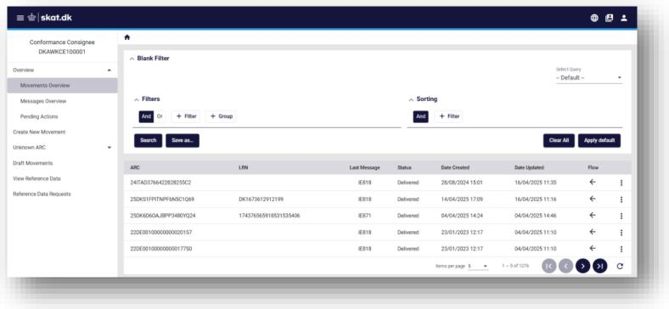

Figure 72: EMCS Movement Overview Screen

On the top right corner of the screen, the user can switch Excise Numbers by clicking on the icon seen below.

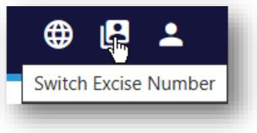

Figure 73: EMCS Switch Excise Number Button

Page **60** of **79**

DK-EMCS-D1.5.UMN-TR.User Manual Traders v1.1

|  |  |  |
| --- | --- | --- |
|  | **User Manual - Trader Portal Guide** | DK-EMCS |
| D1.5.UMN - TR  Version 1.1 |

**4.2 Basic Screen Elements**

The interface consists of the following general screen elements as shown below:

* Menu show/hide button (shows / hides the section selector)
* Section Selector (collapsible sections)
* Action Selector (list of available actions depending on selected object)
* Message Alert indicator / Application Selector button / Logout button.
* Grid / Page Navigation Buttons
* Home Button
* Back Button
* Header Area (where applicable)
* Detail Grid Area (where applicable)

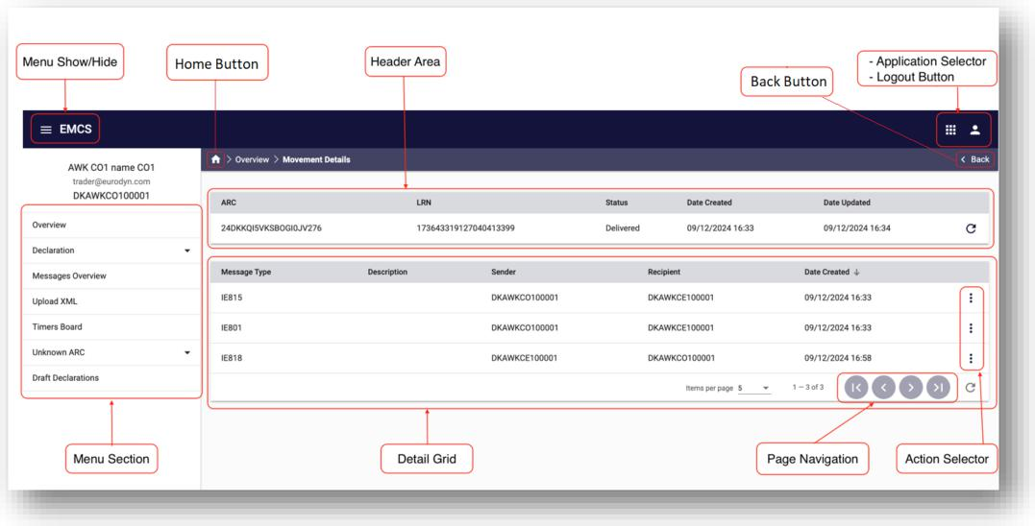

Figure 74: Common screen elements

**4.3 Data Field indicators**

This section describes the special indicators that appear in fields where data entry is expected.

Page **61** of **79**

DK-EMCS-D1.5.UMN-TR.User Manual Traders v1.1

|  |  |  |
| --- | --- | --- |
|  | **User Manual - Trader Portal Guide** | DK-EMCS |
| D1.5.UMN - TR  Version 1.1 |

* **Mandatory fields** a field that is marked with an asterisk icon, as in the image below, is mandatory. All mandatory fields of a form must be completed before the form can be submitted.

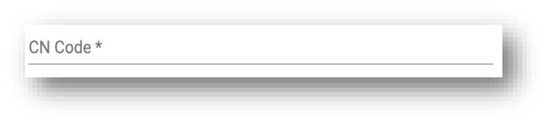

* **Long search lists** a field that is marked with a magnifying lens icon, as in the image below, can be set using the long search list component. See also section 4.8.

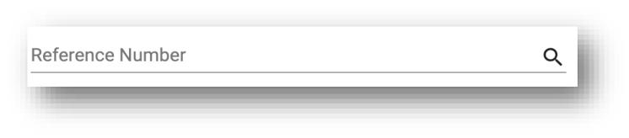

* **Short search lists** a field that is marked with an arrowhead as in the image below can be set using the short search list component. See also section 4.9.

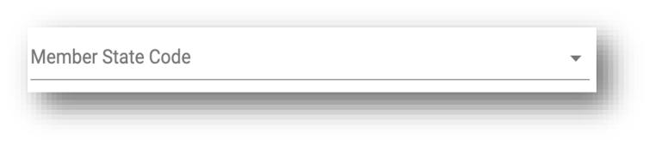

* **Date selector**; a field that is marked with a calendar icon, as in the image below, can be set using the date selector component. See also section 4.10.



**4.4 Advanced Search Facility**

The advanced search facility is available in almost all the grids that display data entries and

provides the following functionalities:

Page **62** of **79**

DK-EMCS-D1.5.UMN-TR.User Manual Traders v1.1

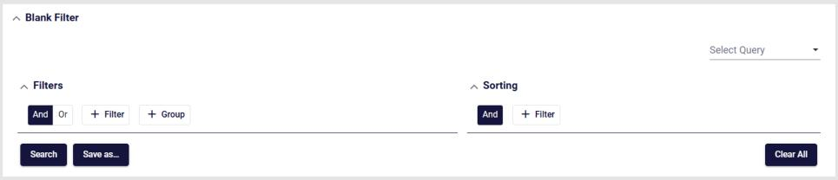

|  |  |  |
| --- | --- | --- |
|  | **User Manual - Trader Portal Guide** | DK-EMCS |
| D1.5.UMN - TR  Version 1.1 |

* Apply multiple filters, combined with AND/OR logic
* Sorting criteria using one or more columns
* Saving of the filters and sorting criteria for easy recall and reuse.

The default advanced search facility screen is shown below:

Figure 75: Advanced filter component

The Advanced Search Facility window can collapse or expand, using the arrow buttons and

at the right of the top header line.



The Search facility consists of two main sections (Filters and Sorting), a “Select Query” drop-

down element, which allows selection of a previously saved search, and four buttons:





This button executes the search, causing the grid below the search section to display any matching data.



This button opens the “Save Criteria” dialog box (please see next section)

This button will clear any entered information in the search facility, essentially resetting the search facility to its initial state.

Page **63** of **79**

DK-EMCS-D1.5.UMN-TR.User Manual Traders v1.1

|  |  |  |
| --- | --- | --- |
|  | **User Manual - Trader Portal Guide** | DK-EMCS |
| D1.5.UMN - TR  Version 1.1 |

**4.4.1 Adding a search criterion (Rule)**

The picture below shows an example of the filtering component of the Advanced Search Facility:

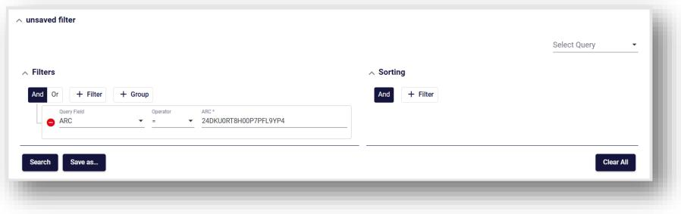

Figure 76: Advanced Search facility - The filtering component

Follow the steps below in order to create a filter:

|  |  |  |
| --- | --- | --- |
| * Click on the |  | icon. |

1. Select the search field name from the drop-down list as shown on the right. (The drop-down list in the example is from the “Movements” section).
2. Multiple filters can be selected in this manner.
3. Additionally, an ‘AND’ / ‘OR’ logic can be selected that will apply to all the configured

filters.

1. Filters can be removed by clicking on the icon.
2. A collection of filters created this way is a “Filter Group”.

* Additional “Filter Groups” can be nested by clicking on the
* Each “Filter Group” has its own logic component and is linked with the (AND/OR) operators.

|  |  |
| --- | --- |
|  | icon. |

Page **64** of **79**

DK-EMCS-D1.5.UMN-TR.User Manual Traders v1.1

|  |  |  |
| --- | --- | --- |
|  | **User Manual - Trader Portal Guide** | DK-EMCS |
| D1.5.UMN - TR  Version 1.1 |

**4.4.2 Configuring the search “Sort Order”**

The sort component of the Advanced Search facility is shown in the following picture:

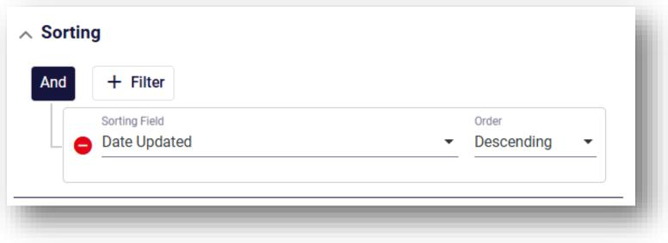

Figure 77: Advanced Search facility - The sorting component

* The same principles apply here as in the Search (filter) section.
* Any number of consecutive sort criteria can be defined, always with an ‘AND’ logic.
* Each sort criterion is accompanied by a ‘Descending / Ascending’ selector.

**4.4.3 Saving configured search criteria**

The configured search, complete with the sorting options selected, can be saved for future use. Provide a

unique name and click the

The “Save as” dialog box is shown on the right.

All the saved search criteria names will be available from a drop-down list in the “Select Query” (as shown on the right).

The saved search can be deleted by clicking on the

button, which appears when selecting a

saved search.

Page **65** of **79**

DK-EMCS-D1.5.UMN-TR.User Manual Traders v1.1

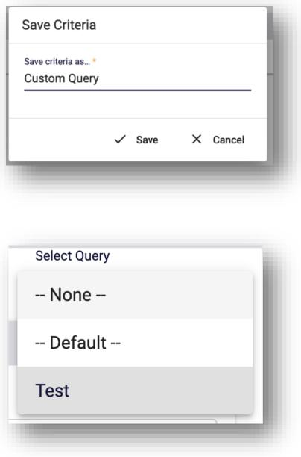

Figure 78: Save search criteria dialog

Figure 79: Use saved search criteria

|  |  |
| --- | --- |
|  | button |



|  |  |  |
| --- | --- | --- |
|  | **User Manual - Trader Portal Guide** | DK-EMCS |
| D1.5.UMN - TR  Version 1.1 |

**4.4.4 Search Results**

The search results are shown in the grid as in the following example:

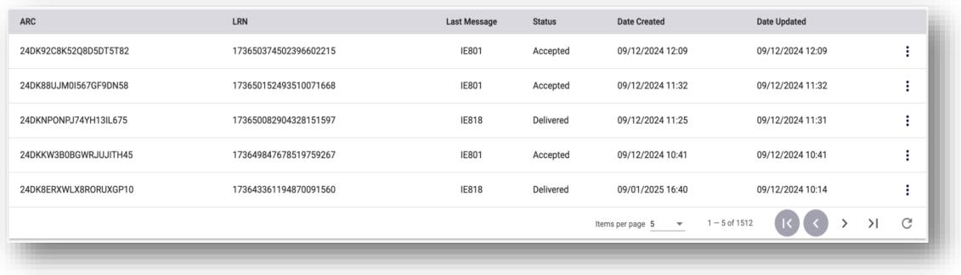

Figure 80: Search results

The displayed results correspond to the applied filters and sorting criteria.

The three-dots button at the right of each displayed entry provides the list of available actions for that specific entry. The list of available actions depends on the type of the entry and the access rights of the user.

**4.5 Grid Footer**

The footer element of a data grid is displayed as in the following example:

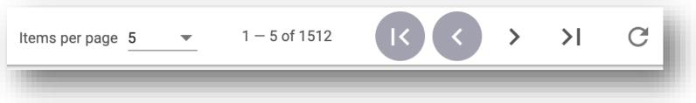

Figure 81: Grid footer

Page **66** of **79**

DK-EMCS-D1.5.UMN-TR.User Manual Traders v1.1

|  |  |  |
| --- | --- | --- |
|  | **User Manual - Trader Portal Guide** | DK-EMCS |
| D1.5.UMN - TR  Version 1.1 |

Each footer consists of three sections:

* **Items per page:**

This section displays the number of items displayed (default is 5). Clicking on the arrow next to the number of items indicator, reveals a drop-down list with the option to display 10, 25, or 100 items per page as shown on the right.

The range of items displayed and the total number of items in

the grid is displayed next to the “Items per page” part of the footer (e.g., 1 – 5 of 384).

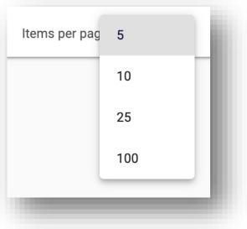

Figure 82: Selection of shown results

|  |  |
| --- | --- |
| * **Page navigation controls**   The page navigation controls, contain four  action arrows as shown on the right. |  |
|  | Figure 83: Page navigation controls |

|  |  |  |
| --- | --- | --- |
| * **Refresh Icon** The refresh icon |  | refreshes (reloads) the displayed grid data, without having to do a |

complete reload from the browser.

Page **67** of **79**

DK-EMCS-D1.5.UMN-TR.User Manual Traders v1.1

|  |  |  |
| --- | --- | --- |
|  | **User Manual - Trader Portal Guide** | DK-EMCS |
| D1.5.UMN - TR  Version 1.1 |

**4.6 Export Functionality**

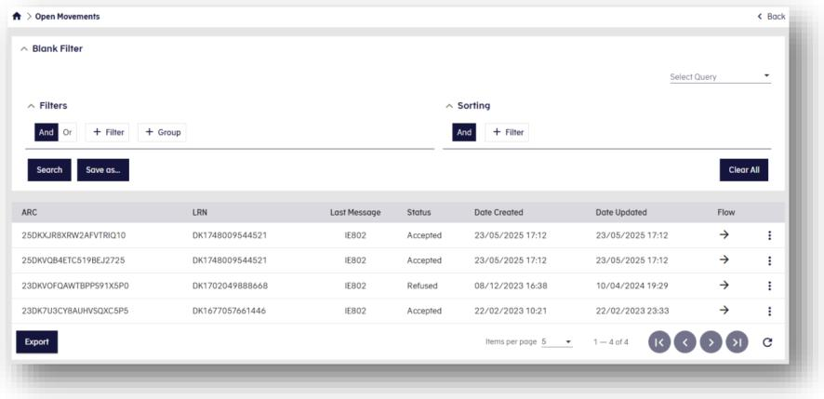

Figure 84: Export Functionality

Some application screens with search functionality also provide an Export feature.

When available, an Export button appears at the **bottom-left corner** of the results grid (see

Figure).

*Note: If there are no search results, the Export button is disabled.*

**How It Works:**

* Click the Export button to generate an .xlsx file containing the latest search results.
* The file will automatically download to your device once generated. **Result Limits**
* If the total number of search results exceeds 3,000, only the first 3,000 entries are included in the export.
* In this case, an informational pop-up will be displayed to notify you of the limit.

Page **68** of **79**

DK-EMCS-D1.5.UMN-TR.User Manual Traders v1.1

|  |  |  |
| --- | --- | --- |
|  | **User Manual - Trader Portal Guide** | DK-EMCS |
| D1.5.UMN - TR  Version 1.1 |

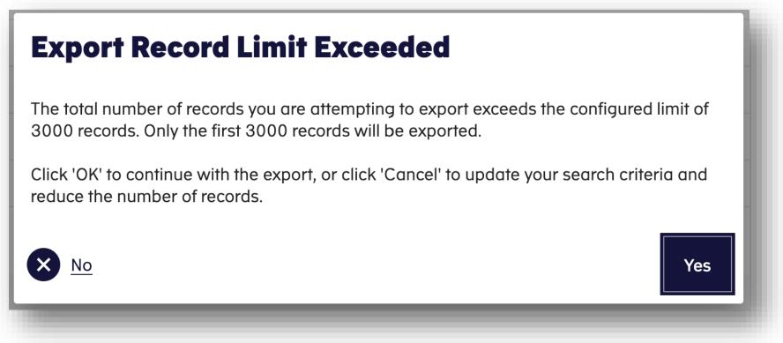

Figure 85: Export record limit

**4.7 Form Tab**

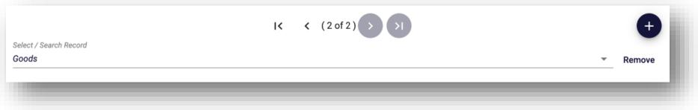

Figure 86: Form tabs

The component allows the user to add, remove and navigate tabs. Each tab represents a record

that can be repeated in the enclosing section of a form.

The component includes the following parts:

* The Tab navigation control. The control includes the following parts:
* The **First Tab** [ **|<** ] button navigates to the first tab of the component
* The **Previous Tab** [ **<** ] button navigates to the previous tab of the component
* The **Next Tab** [ **>** ] button navigates to the next tab of the component
* The **Last Tab [ >|**] button navigates to the last tab of the component

Page **69** of **79**

DK-EMCS-D1.5.UMN-TR.User Manual Traders v1.1

|  |  |  |
| --- | --- | --- |
|  | **User Manual - Trader Portal Guide** | DK-EMCS |
| D1.5.UMN - TR  Version 1.1 |

o The [**(# of #)]** is the tab index of the component. The first number depicts the numbering of the current tab of the component. The second number depicts the total number of the tabs of the component.

* Quick selection dropdown box. It allows to navigate directly to the desired tab
* The **Add Tab** [ **+** ] button add a new tab in the component.

*Note: In the example displayed in the figure above, clicking that button will add one*

*instance of Goods to be completed.*

* The **Remove** button removes the current tab from the component

**4.8 Long Search lists**

Long Search list data elements (fields) are populated with a wide number of values. Those elements are implemented with a use of a popup window that displays the available values in pages.

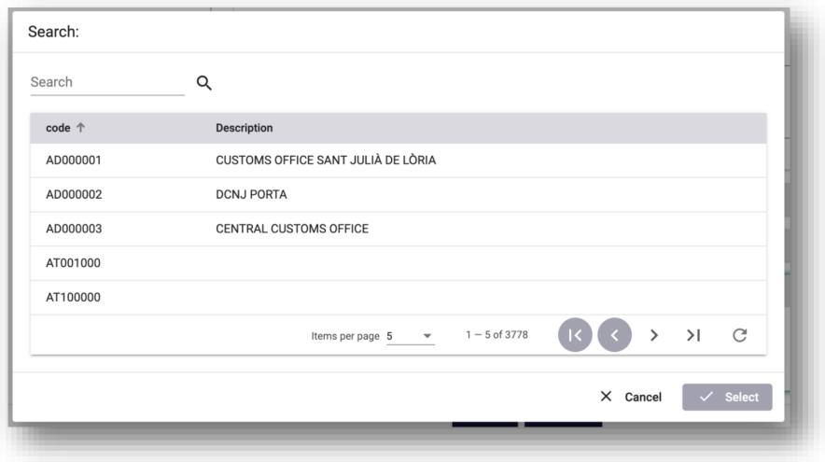

Figure 87: Long search list - example

Long search list popup windows consist of the following parts:

* The searched field. The user can enter a value and then press the ‘magnify lens’ icon to filter the values that are displayed in the values grid.

Page **70** of **79**

DK-EMCS-D1.5.UMN-TR.User Manual Traders v1.1

|  |  |  |
| --- | --- | --- |
|  | **User Manual - Trader Portal Guide** | DK-EMCS |
| D1.5.UMN - TR  Version 1.1 |

* The values grid, where all available values for the specific element are displayed. To facilitate the navigation between the available pages, the grid includes the grid footer component. See section 4.5 Grid Footer.
* The ‘Cancel’ button. When the button is pressed, no value is selected, the popup window closes and the value of the element that is associated with the long search list remains unchanged.
* The ‘Select’ button. The button is activated when the user selects a value from the values grid. When the button is pressed, the selected value from the value grid is transferred to the form element that is associated with the long search list.

**4.9 Short Search lists**

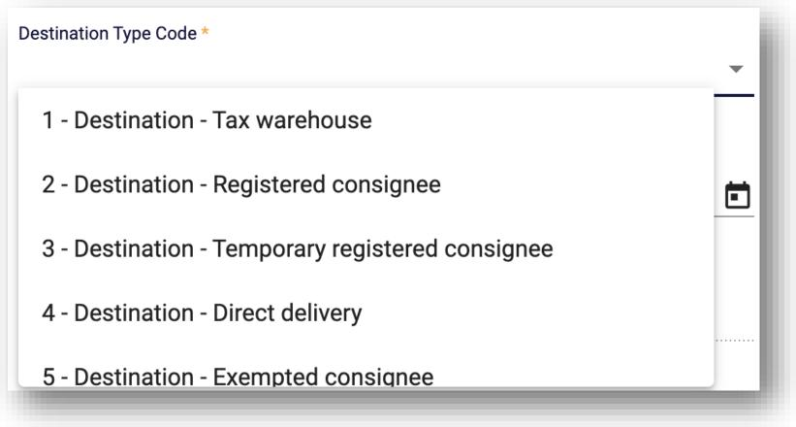

Figure 88: Short search list – example

Short search list data elements (fields) are populated with a limited number of values. They consist of the following parts:

* The data field where the actual value of the data element is displayed/entered
* The drop-down list where all available values for the specific element are displayed Values from short search lists can be selected by:

Page **71** of **79**

DK-EMCS-D1.5.UMN-TR.User Manual Traders v1.1

|  |  |  |
| --- | --- | --- |
|  | **User Manual - Trader Portal Guide** | DK-EMCS |
| D1.5.UMN - TR  Version 1.1 |

* Scrolling the drop-down list and selecting the desired value with a mouse right click
* Entering the desired values in the data field. As the user types in the data field, the component search and display all the entries that match the entered value. The user can select any of the displayed values with a mouse right click. Alternatively, if only one value is displayed in the list it can be selected by hitting the “Enter” key.

When a value is selected in the drop-down list, with any of the above methods, the selected value will automatically populate the data field.

**4.10 Date Selector**

The date selector component facilitates the filling of data elements that require a date value. It

consists of the following parts:

|  |  |
| --- | --- |
| * Year selection short search list. The list allows the selection of a year and a month. Then the days of the week per month list is updated accordingly. * Previous [ **<** ] and Next [ **>** ] month navigation controls. * The list of days of the week within the selected month and year.   The date is selected by clicking on the desired date. The selected value is then set for that specific data field. |  |
|  | Figure 89: Date selector - example |

**4.11 Interface Scaling (Adaptive Behaviour)**

The interface is adaptive to the screen size and resolution. As the screen size is reduced (for example on a smaller monitor screen or when not working on a full-size window) the screen elements (Menu Items, Selected item sections) will automatically adjust to the screen size in three distinct steps, as shown in the paragraphs below.

Page **72** of **79**

DK-EMCS-D1.5.UMN-TR.User Manual Traders v1.1

|  |  |  |
| --- | --- | --- |
|  | **User Manual - Trader Portal Guide** | DK-EMCS |
| D1.5.UMN - TR  Version 1.1 |

**4.11.1 Full (expanded) size**

The screen below shows a full-size display example:

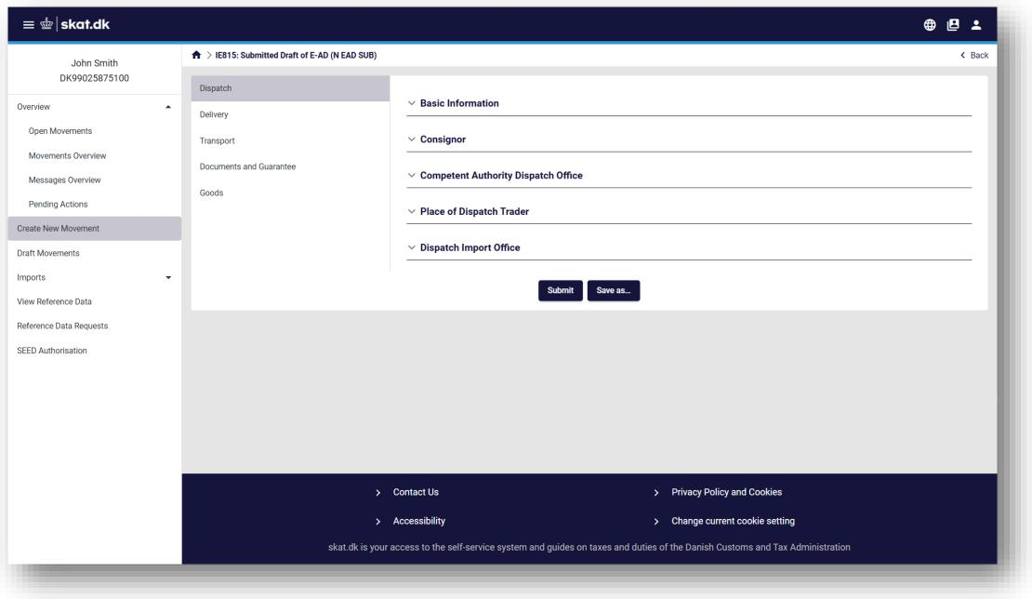

Figure 90: Interface scaling - Full size screen example

Page **73** of **79**

DK-EMCS-D1.5.UMN-TR.User Manual Traders v1.1

|  |  |  |
| --- | --- | --- |
|  | **User Manual - Trader Portal Guide** | DK-EMCS |
| D1.5.UMN - TR  Version 1.1 |

**4.11.2 Compact size**

In this compact screen size, the left panel sections are collapsed into a dropdown menu on top

of the page:

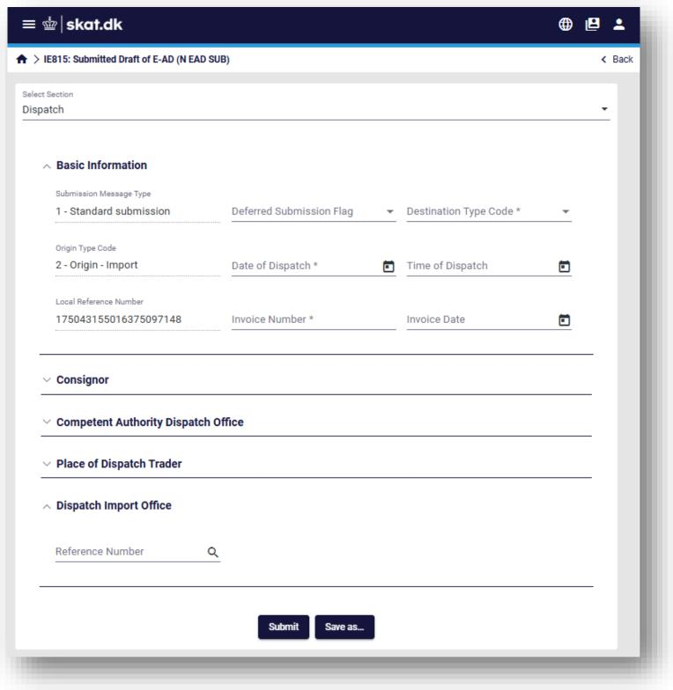

Figure 91: Interface scaling - compact screen example

Page **74** of **79**

DK-EMCS-D1.5.UMN-TR.User Manual Traders v1.1

|  |  |  |
| --- | --- | --- |
|  | **User Manual - Trader Portal Guide** | DK-EMCS |
| D1.5.UMN - TR  Version 1.1 |

When clicking on the “Select Section” object, the following section list appears:

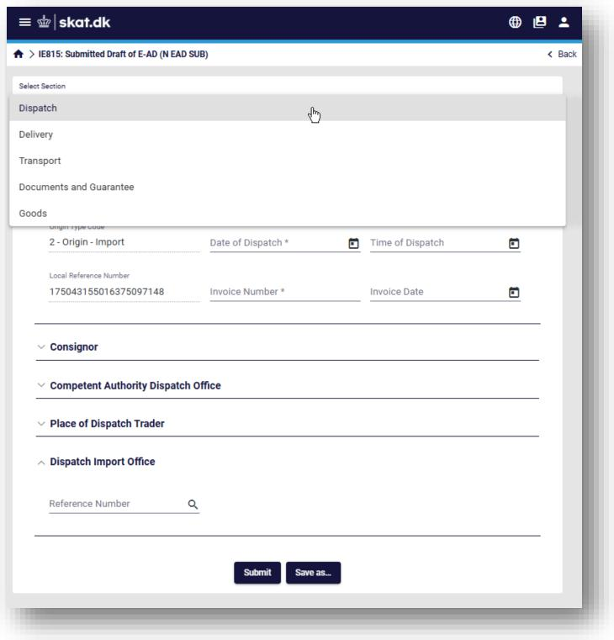

Figure 92: Interface scaling - Select section example

Page **75** of **79**

DK-EMCS-D1.5.UMN-TR.User Manual Traders v1.1

|  |  |  |
| --- | --- | --- |
|  | **User Manual - Trader Portal Guide** | DK-EMCS |
| D1.5.UMN - TR  Version 1.1 |

**4.11.3 Condensed size**

The screen below shows an example of the condensed screen size:

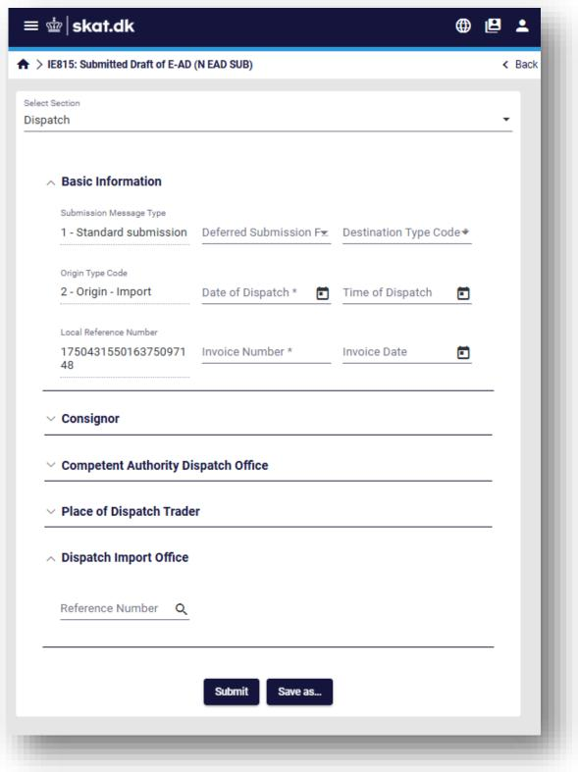

Figure 93: Interface scaling - condensed screen example

Page **76** of **79**

DK-EMCS-D1.5.UMN-TR.User Manual Traders v1.1

|  |  |  |
| --- | --- | --- |
|  | **User Manual - Trader Portal Guide** | DK-EMCS |
| D1.5.UMN - TR  Version 1.1 |

In this condensed display size, the EMCS menu can be displayed as an overlay by clicking on the

|  |  |  |
| --- | --- | --- |
| object |  | as shown in the image below: |

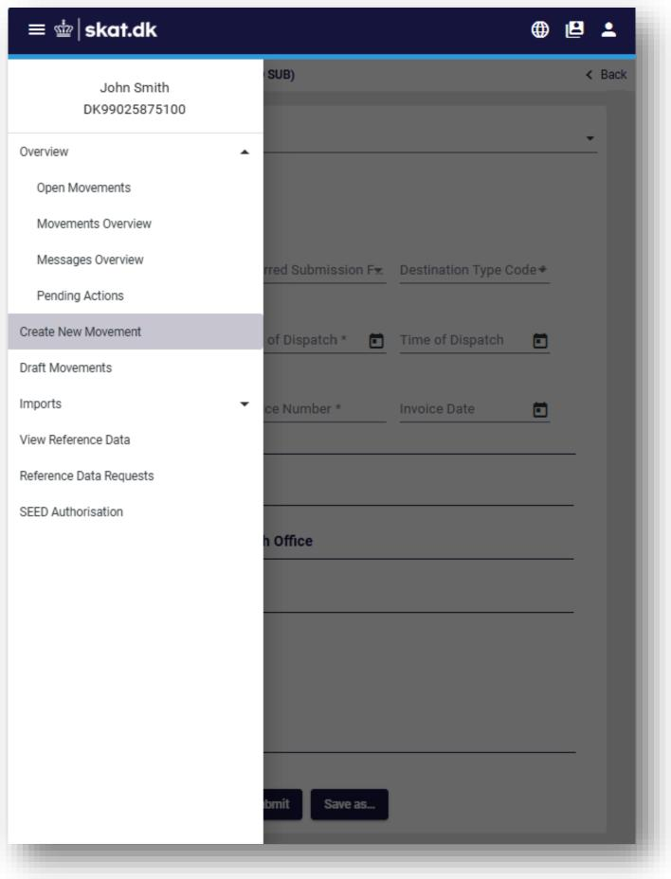

Figure 94: Interface scaling – show menu in condensed screen size

Page **77** of **79**

DK-EMCS-D1.5.UMN-TR.User Manual Traders v1.1

|  |  |  |
| --- | --- | --- |
|  | **User Manual - Trader Portal Guide** | DK-EMCS |
| D1.5.UMN - TR  Version 1.1 |

**5 Appendices**

**5.1 Appendix A – Movement Statuses**

|  |  |
| --- | --- |
| **Status** | **Description** |
| X01 | Accepted |
| X02 | Cancelled |
| X03 | Delivered |
| X04 | Diverted |
| X05 | Rejected |
| X06 | Replaced |
| X07 | e-AD Manually Closed |
| X08 | Refused |
| X10 | Partially Refused |
| X11 | Exporting |
| X12 | Accepted for Export |
| X13 | Stopped |
| X14 | Accepted Export Declaration |
| X15 | e-AD Request Accepted for Export |

Table 7: Movement statuses

Page **78** of **79**

DK-EMCS-D1.5.UMN-TR.User Manual Traders v1.1

|  |  |  |
| --- | --- | --- |
|  | **User Manual - Trader Portal Guide** | DK-EMCS |
| D1.5.UMN - TR  Version 1.1 |

**5.2 Appendix B – Message Types and Descriptions**

|  |  |
| --- | --- |
| **Message** | **Description** |
| IE801 | E-AD |
| IE802 | Reminder Message for Excise Movement |
| IE803 | Notification of Diverted E-AD |
| IE807 | Interruption of Movement |
| IE810 | Cancellation of an E-AD |
| IE813 | Change of Destination |
| IE815 | Submitted Draft of E-AD |
| IE818 | Accepted or Rejected Report of Receipt/Export |
| IE819 | Alert or Rejection of an E-AD |
| IE825 | Submitted Draft of Splitting Operation |
| IE829 | Notification of Accepted Export |
| IE837 | Explanation on Delay for Delivery |
| IE839 | Refusal by Customs |
| IE840 | Event Report Envelope |
| IE871 | Explanation on Reason for Shortage |

Table 8: Messages Codes and Descriptions

**END OF THE DOCUMENT**

Page **79** of **79**

DK-EMCS-D1.5.UMN-TR.User Manual Traders v1.1