Technical description
Danish SAF-T format for Cash Register data, version 1.2



November 2023

Table of contents

Introduction to the Danish SAF-T format for Cash

Register data, technical description. 4
  - XML and XML elements 4
  - Encoding of the SAF-T Cash Register data 6
  - Empty elements 6
  - Description of each XML element 6
  - Digital Cash Register Act specific requirements 8
- XML elements in auditfile and auditfileSender 10
  - auditfile 11
  - header 11
  - auditfileSender 14
  - streetAddress (auditfileSender) 15
  - postalAddress (auditfileSender) 17
- XML elements in company 19
  - company 20
  - streetAddress (company) 23
  - postalAddress (company) 25
  - customersSuppliers 26
  - customerSupplier 27
  - streetAddress (customerSupplier) 29
  - postalAddress (customerSupplier) 31
  - generalLedger 32
  - ledgerAccount 33
  - vatCodeDetails 34
  - vatCodeDetail 34
  - periods 36
  - period 36
  - employees 38
  - employee 38
  - employeeRole 39
  - articles 40
  - article 41
  - basics 42
  - basic 43
- XML elements in location and cashregister 45
  - location 46
  - streetAddress (location) 47
  - cashregister 48
- XML elements in event and eventReport 51
  - event 52
  - eventReport 53
  - reportTotalCashSales 61
  - reportArtGroups 62
  - reportArtGroup 63
  - reportEmpArtGroups 64
  - reportEmpArtGroup 65
  - reportPayments 66
  - reportPayment 67
  - reportEmpPayments 68
  - reportEmpPayment 69
  - reportTip 70
  - reportCashSalesVat 71
  - reportCashSaleVat 72
  - reportEmpOpeningChangeFloats 73
  - reportEmpOpeningChangeFloat 74
  - reportCorrLines 75
  - reportCorrLine 76
  - reportPriceInquiries 77
  - reportPriceInquiry 78
  - reportOtherCorrs 79
  - reportOtherCorr 80
  - reportCreditSales 81
  - reportCreditMemos 82
  - reportPayIns 83
  - reportPayIn 83
  - reportPayOuts 85
  - reportPayOut 85
- XML elements in cashtransaction 87
  - cashtransaction 88
  - ctLine 92
  - vat (cashtransaction) 96
  - savings (cashtransaction) 97
  - discount (cashtransaction) 98
  - raise (cashtransaction) 100
  - rounding 101
  - payment 102
  - vat (ctLine) 103
  - savings (ctLine) 105
  - discount (ctLine) 106
  - raise (ctLine) 107

Introduction to the Danish SAF-T format for Cash Reg- ister data, technical description.
1
The logical structure of the Danish SAF-T:
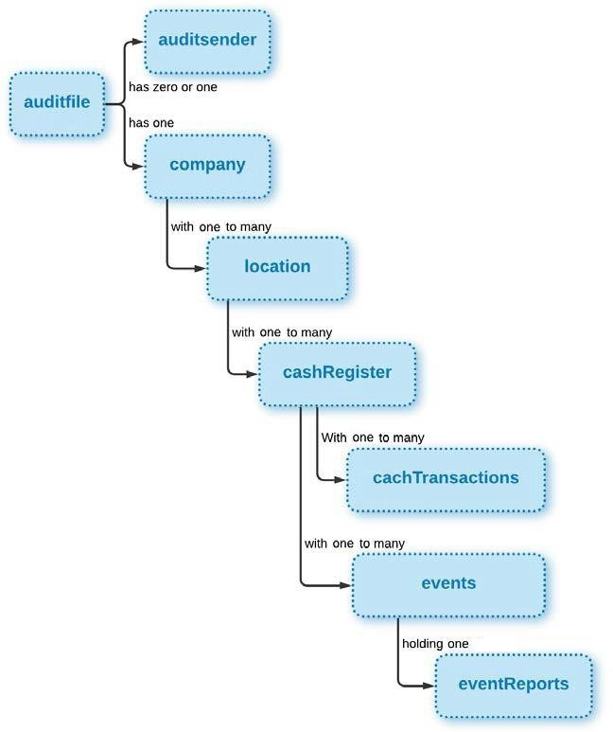
The logical elements are described in section 2 - 6 of this document.

XML and XML elements

The Danish SAF-T format is a standard XML tree that initiates at a root XML- element and branches from the root to child XML elements. The terms parent and child are used to describe the relationships between XML elements. Parents have one or more children. A child always have one parent.
The format contains simple XML-elements and complex XML-elements:

Simple XML elements
A simple XML element can only contain data, and NOT other XML-elements. In the for- mat all XML elements have restrictions on format or length or might be required to match a specific pattern.
A simple XML element is always a child of a complex XML element, and it can never act as a parent to other XML elements. In this description, each simple XML element is described in the section following the complex XML element, of which it is a child.
“xsd:date” is an example where the text must adhere to a specific pattern, the date must be valid, and the text must follow this pattern:
“YYYY-MM-DD” (example: 2015-10-31)

YYYY indicates the year, MM indicates the month and DD indicates the date.
It is also possible to enter a date in UTC time by adding a “Z” behind the date. Exam- ple:

<element>2015-10-31Z</element>

Or with an offset from the UTC time by adding a positive or negative time behind the date, like this:

<element>2015-10-31-06:00</element>
<element>2015-10-31+06:00</element>

For more information, see: https://www.w3.org/TR/xmlschema-2/#date

“xsd:time” is another example where the text must adhere to a specific pattern. The time is in 24 hour format, and the time must be in Danish time and adjusted for daylight saving time (summer time):

“HH:MM:SS” Example: “23:59:59”

HH indicates the hour, MM indicates the minutes and SS indicates the seconds. If sec- onds are not available in the system, please set seconds to “00”. An unlimited number of additional digits can be used to increase the precision of fractional seconds if de- sired, but not considered necessary.

It is optional to use a time zone indicator “Z” who equals Coordinated Universal Time (UTC), but not preferred or necessary to do so. Examples when included additional dig- its and time zone indicator are:

“HH:MM:SS.SSS+Z” Example: “23:59:59.9999999+05:00”

For more information, see: https://www.w3.org/TR/xmlschema-2/#time

Furthermore, a simple XML element can contain additional and specific constraints about the values that can be used in the element. This is known as a "simple type". “Coun- trycode” is a simple type based upon the simple XML element “xsd:string” and with the additional constraint that the text must be 2 letters long.

Complex XML elements
An element that is not a simple XML element is, in this description, handled as a complex XML element.
A complex XML element contains from one to many other XML elements, and is there- fore always a parent. These other XML elements can be either simple XML elements or other complex XML elements. With the exception of the ROOT XML element, a complex XML element is always a child of another complex XML element. A complex XML ele- ment therefore contains a structure of other XML elements, and are in the following de- scription also referred to as <structure type>.
In this description, each complex XML element is described in its own section, see section 2 to 6.

Encoding of the SAF-T Cash Register data
The encoding of the file must be in UTF-8. This is the default character encoding for XML.

Empty elements
If no data is available for optional elements, those elements should be excluded from the file. Empty elements might be considered a mistake, and automatic field validation of e.g. dates and numeric elements might fail due to format restrictions.

Description of each XML element
Below is a detailed description of how the SAF-T file XML elements are described in the following sections of this document.
Each complex XML element is described in its own section. Each simple XML element is described in the section following the complex XML element, of which it is a child.

Parent refers to the parent of the described complex XML element. Children refers to the children of the described complex element. Children are listed in tables with this format:

XML Element | Description | Type | Req | Rep. | Example

XML Element refers to the name of the child of the described complex XML element.
Description provides a detailed description of the content, usage or purpose of the item.
Type can either be different types of a simple XML element or a complex XML element (structure type).

Required (Req) states if the element is:
M | Mandatory
(M) | Mandatory if available
O | Optional

Difference between Mandatory, Mandatory if available and Optional data elements
The data stored in the database of a cash register varies between the various ven- dors, model and even software versions. For this reason, several data elements are stated as optional. It is important to emphasize that if the optional data ele- ments are available in the cash registers database, it must be written to the XML file. For elements where this is of increased importance, or where the element is only relevant in certain cases, the term “mandatory if available” is used to indicate this.
The SAF-T Cash Register data format will not extend the documentation require- ments beyond the Cash Register Systems Act.
Mandatory data elements cannot be left empty, and might have formatting require- ments e.g. enumerated values (as listed in the XML schema).
The mandatory elements represent the minimum data necessary to fulfil the legis- lated requirements. In addition, some essential data in the XML file must by nature be mandatory, such as the header data elements.
Enumerated values are also restricted by code lists, which are not strictly enforced in the schema itself. Code lists must be used as enumerated values for the data element.

Data not available in mandatory fields
The fields dateOfEntry and timeOfEntry represent the date and time for when the master data entry was created in the system for the first time. If the Cash Register System does not contain this information, the following values must be used:
- dateOfEntry: 0001-01-01
- timeOfEntry: 00:00:00

Repetitions (Rep) states how many times the element can or must be repeated.
    - 0..1: The element can be used once.
    - 1..1: The element must be used once.

    - 0..U: The element can be used from none to an unbounded amount of times.
    - 1..U: The element must be used at least once, and can be used to an unbounded amount of times

  - Danish Cash Register Act specific requirements

The Danish Cash register Act comprises of several specific requirements to both data elements and functionality within the digital cash register system. This section describes the legal requirements to functionalities not covered by the XML data model itself.

Export/extract functionality:
- The digital cash register system must be able to produce an XML file containing the electronic journal in SAF-T format directly within the system software.
- The electronic journal from the digital cash register system must be transferable to generally available electronic media or otherwise be able to be digitally transferred to the authorities upon request.

Receipt generating and distribution functionality:
- The digital cash register system must at all times be able to produce/print a physical receipt in accordance with the danish requirements to simplified receipts. While the aforementioned functionality is mandatory, the client/supplier can, prior to the transaction, agree to receive the receipt digitally if the system supports this.

Data deletion and editing restrictions:
- The digital cash register system must not contain options to delete or alter transactional data once a transaction has been concluded. This also prohibits the integration of third party software which makes it possible to add, edit or delete information within the electronic journal.

Cash payment prerequisites
- In order to comply with the general rules regarding payments in Denmark, the digital cash register system must be compatible with a cash drawer for currency storage. Furthermore it should support the inclusion of a change/float box, if desired. Note i.e. the mandatory element within "5.2 - eventReport" relating to cashdrawer openings.

Generating a file containing an electronic journal for control purposes
- The digital cash register system must be able to produce a complete electronic journal upon request by the Danish Tax Authorities. The packaged electronic journal (XML) must have all transactions digitally signed utilizing an OCES- certificat issued to the owner of the company in question or the supplier of the system, if the latter is responsible for generating the file. This is required to secure the integrity of the electronic journal as a whole.
- The signature shall sign all data reported in the element cashtransaction (6.1) in addition to the company's CVR number and be logged in the electronic journal upon finalization of each transaction.
It is mandatory to include the relevant signature information in the SAF-T Cash Register XML (see 6.1 "signature", "keyVersion" and "certificateData").
Further details regarding the requirements and implementation of the digital signature on transactions can be found in the document "Danish Cash Register Act - Guideline for implementing digital signature"

File naming standard for the electronic journal
Danish SAF-T files must generally comply with the name standard below, so that the necessary information is included in the file names. The purpose of the name standard is to ensure which data the file contains, data owner, time and to ensure a unique name for each file.

Each element in the name is separated by "_" [underscore];
Name_ID_Date_Filenumber
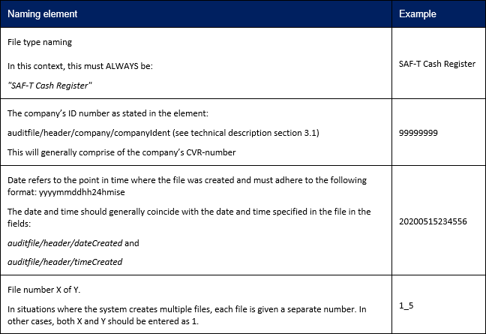

The complete filename in accordance to the example offered above is:
SAF-T Cash Register_99999999_20200515234556_1_5.xml

XML elements in auditfile and auditfileSender
The structure of the "auditfile" and "auditfileSender" can be illustrated as follow:

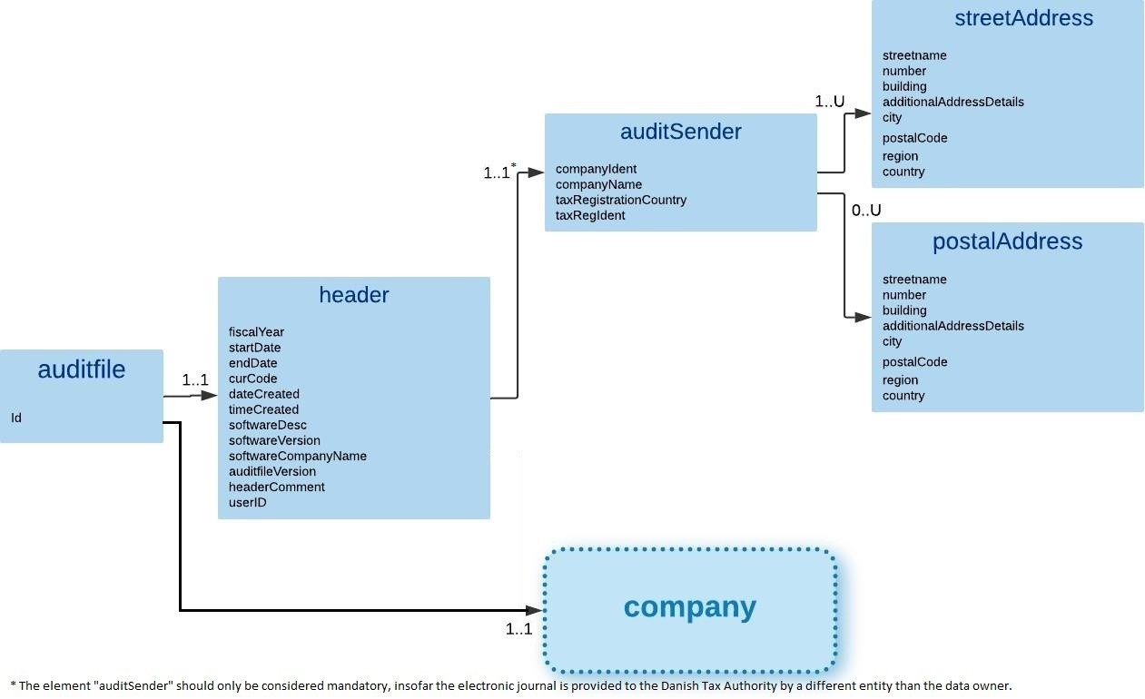
In section 1, the logical structure of the Danish SAF-T format is illustrated.

auditfile
Mandatory, Repetitions: 1..1

Parent: ROOT/

Children:

XML Element | Description | Type | Req | Rep. | Example
header | Overall information about this Standard Audit file. | <Structure type> | M | 1..1 | Section: 2.2
company | Contains the data of the entity that has provided the data in the present audit file. | <Structure type> | M | 1..1 | Section: 3.1

header
Description: Overall information about this Standard Audit file.

Mandatory, Repetitions: 1..1

Parent: auditfile/ (section 0)

Children:

XML Element | Description | Type | Req | Rep. | Example
fiscalYear | Fiscal year YYYY.  A split fiscal year must be as format: YYYY-YYYY. | String9 | M | 1..1 | 2019 or 2018-2019
startDate | First day of the financial year as: YYYY-MM-DD | xsd:date | M | 1..1 | 2019-01-01
endDate | Last day of the financial year as: YYYY-MM-DD | xsd:date | M | 1..1 | 2019-12-31
curCode | Three letter Currency Code (ISO 42171) of local currency which is the default for the audit file. | Currencycode | M | 1..1 | DKK
dateCreated | The date of when the audit file is created. | xsd:date | M | 1..1 | 2020-05-15
timeCreated | The time of when the audit file is created. The time must be in danish time and adjusted for daylight saving time (summer time). | xsd:time | M | 1..1 | 23:45:56
softwareDesc | Name and description of the software that generated the audit file. | String100 | M | 1..1 | Kasseapparatet
softwareVersion | Version of the software that generated the audit file. | String20 | M | 1..1 | 6.4.12
softwareCompany- Name | Name of the software company whose product created the audit file. | String100 | M | 1..1 | Kasseapparatet ApS
auditfileVersion | Version of standard audit file being used. The version number to be used is displayed in an XML annotation in top of the XSD schema file. | IdentificationString36 | M | 1..1 | 1.0

1 https://www.iso.org/iso-4217-currency-codes.html

XML Element | Description | Type | Req | Rep. | Example
headerComment | Space for any further generic comments on the audit file. For example selection criteria other than date and time. | String999 | O | 0..1 | Kasseapparat ved døren
userID | ID of the user that generated the audit file.  Description of the code MUST be stated in the table "Basics" (section: 3.19) with BasicType= 15 or in employees (empID). | IdentificationString36 | O | 0..1 | 1234
auditfileSender | Information about the sender of the audit file if the sender is not the company that owns the data. This can be an account- ing office, a parent company, etc. If the sender is not the company owning the data, this field becomes mandatory | <Structure type> | M | 1..1 | Section: 2.3

Example:
<d1:header>
<d1:fiscalYear>2019</d1:fiscalYear>
<d1:startDate>2019-01-01</d1:startDate>
<d1:endDate>2019-12-31</d1:endDate>
<d1:curCode>DKK</d1:curCode>
<d1:dateCreated>2020-05-15</d1:dateCreated>
<d1:timeCreated>23:45:56</d1:timeCreated>
<d1:softwareDesc>Kasseapparatet</d1:softwareDesc>
<d1:softwareVersion>6.4.12</d1:softwareVersion>
<d1:softwareCompanyName>Kasseapparatet ApS</d1:softwareCompanyName>
<d1:auditfileVersion>1.0</n1:auditfileVersion>
<d1:headerComment>Kasseapparat ved døren</d1:headerComment>
<d1:userID>1234</d1:userID>
<d1:auditfileSender>
…
</d1:auditfileSender>
</d1:header>

auditfileSender
Description: Information about the sender of the audit file if the sender is not the company that owns the data. This can be an accounting office, auditor or a parent company, etc.

Mandatory if sender is not data owning company, Repetitions: 0..1

Parent: auditfile/header/ (section: 2.2)

Children:

XML Element | Description | Type | Req | Rep. | Example
companyIdent | Danish CVR-number of the auditfileSender | IdentificationString36 | O | 0..1 | 99999999
companyName | The name of the company that acts as auditfileSender. | String 100 | M | 1..1 | Selskabet ApS
taxRegistrationCountry | Two-letter country code according to ISO 3166-1 alpha 2 standard. | Countrycode | M | 1..1 | DK
taxRegIdent | If taxRegistrationCountry is DK: Danish CVR-number.  Else use national Tax identifier according to taxRegistra- tionCountry | String50 | M | 1..1 | 99999999
streetAddress | Official business register address of auditfileSender according to address in the tax registration country (taxRegistra- tionCountry). | <Structure type> | M | 1..U | Section: 2.4

XML Element | Description | Type | Req | Rep. | Example
postalAddress | Address used for postal interaction with auditfileSender. | <Structure type> | O | 0..U | Section: 2.5

Example:
<d1:auditfileSender>
<d1:companyIdent>99999999</n1:companyIdent>
<d1:companyName>Selskabet ApS</n1:companyName>
<d1:taxRegistrationCountry>DK</n1:taxRegistrationCountry>
<d1:taxRegIdent>99999999</n1:taxRegIdent>
<d1:streetAddress>
…
</d1:streetAddress>
<d1:postalAddress>
…
</d1:postalAddress>
</d1:auditfileSender>

streetAddress (auditfileSender)
Description: Official business register address of "auditfileSender" according to address in the tax registration country.

Mandatory, Repetitions: 1..U

Parent: auditfile/header/auditfileSender/ (section:2.3)

Children:

XML Element | Description | Type | Req | Rep. | Example
streetname | Normally street name. | String100 | M | 1..1 | Vejen
number | House number | String20 | M | 1..1 | 13
building | Building and letter in addition to house number | String20 | (M) | 1..1 | B
additionalAddressDetails | Floor, door etc. | String20 | O | 0..1 | 2. th.
city | Name of the city/post district | String50 | M | 1..1 | Nørreby
postalCode | Postal code for the relevant city/post district. | String20 | M | 1..1 | 7913
region | Country specific code to indicate regions / provinces within the tax authority. | String50 | O | 0..1 | Mellemregionen
country | Two-letter country code according to ISO 3166-1 alpha 2 standard. | Countrycode | M | 1..1 | DK

Example:
<d1:streetAddress>
<d1:streetname>Vejen</d1:streetname>
<d1:number>13</d1:number>
<d1:building>B</d1:building>
<d1:additionalAddressDetails>2. th.</ n1:additionalAddressDetails> <d1:city>Nørreby</d1:city>
<d1:postalCode>7913</d1:postalCode>
<d1:country>DK</d1:country>
</d1:streetAddress>

postalAddress (auditfileSender)
Description: Address used for postal interaction with auditfileSender.

Optional, Repetitions: 0..U

Parent: auditfile/header/auditfileSender/ (section:2.3)

Children:

XML Element | Description | Type | Req | Rep. | Example
streetname | Normally street name. | String100 | O | 0..1 | Vejen
number | House number | String20 | O | 0..1 | 13
building | Building and letter in addition to house number | String20 | O | 0..1 | B
additionalAddressDetails | Floor, door etc. | String20 | O | 0..1 | 2. th.
city | Name of the city/post district | String50 | M | 1..1 | Nørreby
postalCode | Postal code for the relevant city/post district. | String20 | M | 1..1 | 7913

XML Element | Description | Type | Req | Rep. | Example
region | Country specific code to indicate regions / provinces within the tax authority. | String50 | O | 0..1 | Mellemregionen
country | Two-letter country code according to ISO 3166-1 alpha 2 standard. | Countrycode | O | 0..1 | DK

Example:
<d1:postalAddress>
<d1:streetname>Vejen</d1:streetname>
<d1:number>13</d1:number>
<d1:building>DK</d1:building>
<d1:additionalAddressDetails>2. th.</n1:additionalAddressDetails>
<d1:city>Nørreby</d1:city>
<d1:postalCode>7913</d1:postalCode>
<d1:country>DK</d1:country>
</d1:postalAddress>

XML elements in company
The structure of the "company" can be illustrated as follow:
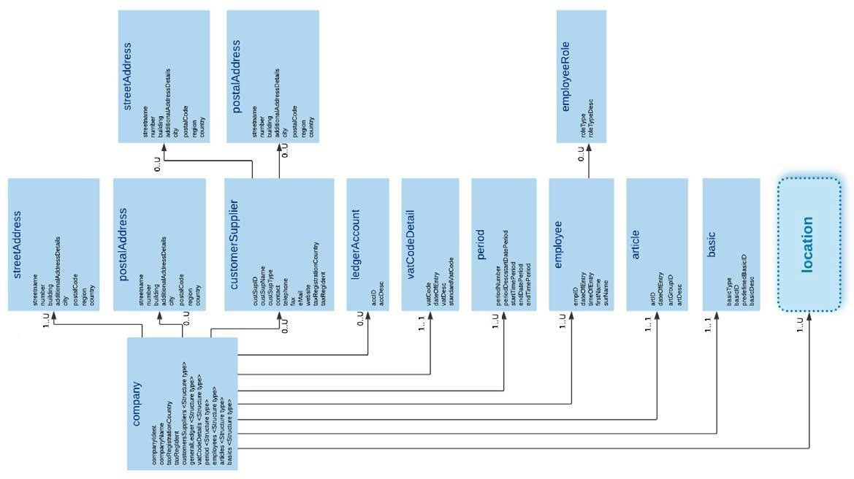
In section 1, the logical structure of the Danish SAF-T format is illustrated.

company
Description: Contains the data of the entity that has provided the data in the present audit file.

Mandatory, Repetitions: 1..1

Parent: auditfile/ (section: 2.2)

Children:

XML Element | Description | Type | Req | Rep. | Example
companyIdent | Danish CVR-number | IdentificationString36 | M | 1..1 | 99999999
companyName | The name of the company | String 100 | M | 1..1 | Selskabet ApS
taxRegistrationCountry | Two-letter country code according to ISO 3166-1 alpha 2 standard. | Countrycode | M | 1..1 | DK
taxRegIdent | If taxRegistrationCountry is DK: Danish CVR-number.  Else use national Tax identifier according to taxRegistra- tionCountry | String50 | O | 0..1 | 99999999

-
XML Element | Description | Type | Req | Rep. | Example
streetAddress | Official business register address of the entity that owns the provided the data in the present audit file according to  the address provided in the tax registration country. | <Structure type> | M | 1..U | Section: 3.2
postalAddress | Address used for postal interaction with of the entity that has provided the data in the present audit file. | <Structure type> | O | 0..U | Section: 3.3
customersSuppliers | Contains the data on all known customers and suppliers. | <Structure type> | O | 0..1 | Section: 3.4
generalLedger | Lists ledger accounts mapped to the company's general ledger (kontoplan). | <Structure type> | O | 0..1 | Section: 3.8
vatCodeDetails | List of mappings of vat codes to be used within a cashtrans- action (section: 6.1) and/or ctLine (section: 6.2) | <Structure type> | M | 1..1 | Section: 3.10
periods | List of periods used in the auditfile. | <Structure type> | M | 1..1 | Section: 3.12
employees | List of employees that, as users, are present in event and cash transactions for the selected period. | <Structure type> | M | 1..1 | Section: 3.14
articles | List of articles in ctLine (section 6.2) for the selection period of the audit file. | <Structure type> | M | 1..1 | Section: 3.17
basics | List of basics element, which are used to define various master data, and translate system specific codes into pre- defined standard codes. | <Structure type> | M | 1..1 | Section: 3.19
Location | The location element contains data on the physical location of the cash register, and all data elements holding ALL data in the audit file related to it | <Structure type> | M | 1..U | Section: 4.1

Example:
<d1:company>
<d1:companyIdent>99999999</d1:companyIdent>
<d1:companyName>Selskabet ApS</d1:companyName>
<d1:taxRegistrationCountry>DK<d1:taxRegistrationCountry>
<d1:taxRegIdent>99999999</n1:taxRegIdent>
<d1:streetAddress>
…
</d1:streetAddress>
<d1:postalAddress>
…
</d1:postalAddress>
<d1:customersSuppliers>
<d1:customerSupplier>
…
</d1:customerSupplier>
</d1:customersSuppliers>
<d1:generalLedger>
<d1:ledgerAccount>
…
</d1:ledgerAccount>
</d1:generalLedger>
<d1:vatCodeDetails>
<d1:vatCodeDetail>
…
</d1:vatCodedetail>
</d1:vatCodeDetails>
<d1:periods>
<d1:period>
…
</d1:period>
</d1:periods>
<d1:employees>
<d1:employee>
…
</d1:employee>
</d1:employees>
<d1:articles>

<d1:article>
…
</d1:article>
</d1:articles>
<d1:basics>
<d1:basic>
…
</d1:basic>
</d1:basics>
<d1:locations>
…
</d1:locations>
</d1:company>

streetAddress (company)
Description: Official business register address of the entity that owns the data in the present audit file according to the address provided in the tax registration country element.

Mandatory, Repetitions: 1..U

Parent: auditfile/company/
(section:3.1)

Children:

XML Element | Description | Type | Req | Rep. | Example
streetname | Normally street name. | String100 | M | 1..1 | Vejen
number | House number | String20 | M | 1..1 | 13
building | Building and letter in addition to house number | String20 | (M) | 1..1 | B
additionalAddressDetails | Floor, door etc. | String20 | O | 0..1 | 2. th.
city | Name of the city/post district | String50 | M | 1..1 | Nørreby
postalCode | Postal code for the relevant city/post district. | String20 | M | 1..1 | 7913
region | Country specific code to indicate regions / provinces within the tax authority. | String50 | O | 0..1 | Mellemregionen
country | Two-letter country code according to ISO 3166-1 alpha 2 standard. | Countrycode | M | 1..1 | DK

Example:
<d1:streetAddress>
<d1:streetname>Vejen</d1:streetname>
<d1:number>13</d1:number>
<d1:building>B</d1:building>
<d1:additionalAddressDetails>2. th.</n1:additionalAddressDetails>
<d1:city>Nørreby</d1:city>
<d1:postalCode>7913</d1:postalCode>
<d1:country>DK</d1:country>
</d1:streetAddress>

postalAddress (company)
Description: Address used for postal interaction with the entity that has provided the data in the present audit file.

Optional, Repetitions: 0..U

Parent: auditfile/company/
(section: 3.1)

Children:

XML Element | Description | Type | Req | Rep. | Example
streetname | Normally street name. | String100 | O | 0..1 | Vejen
number | House number | String20 | O | 0..1 | 13
building | Building and letter in addition to house number | String20 | O | 0..1 | B
additionalAddressDetails | Floor, door etc. | String20 | O | 0..1 | 2. th.
city | Name of the city/post district | String50 | M | 1..1 | Nørreby
postalCode | Postal code for the relevant city/post district. | String20 | M | 1..1 | 7913
region | Country specific code to indicate regions / provinces within the tax authority. | String50 | O | 0..1 | Mellemregionen

XML Element | Description | Type | Req | Rep. | Example
country | Two-letter country code according to ISO 3166-1 alpha 2 standard. | Countrycode | O | 0..1 | DK

Example:
<d1:postalAddress>
<d1:streetname>Vejen</d1:streetname>
<d1:number>13</d1:number>
<d1:building>B</d1:building>
<d1:additionalAddressDetails>2. th.</n1:additionalAddressDetails>
<d1:city>Nørreby</d1:city>
<d1:postalCode>7913</d1:postalCode>
<d1:country>DK</d1:country>
</d1:postalAddress>

customersSuppliers
Description: Contains the data on all known customers and suppliers.

Optional, Repetitions: 0..1

Parent: auditfile/company/
(section: 3.1)

Children:

XML Element | Description | Type | Req | Rep. | Example
customerSupplier | Data on a specific customers or suppliers | <Structure type> | O | 0..U | Section: 3.5

customerSupplier
Description: Data on a specific customers or suppliers.

Optional, Repetitions: 0..U

Parent: auditfile/company/customersSuppliers/ (section: 3.4)

Children:

XML Element | Description | Type | Req | Rep. | Example
custSupID | Unique number og code for the customer/supplier  Identifier used at element "cashtransaction", section 6.1 | IdentificationString36 | M | 1..1 | 100
custSupName | Name of customer/supplier | String100 | O | 0..1 | Kunden ApS

XML Element | Description | Type | Req | Rep. | Example
custSupType | Identifies whether this is a "Customer" og "Supplier".  The following enumerations are accepted:  - Customer  - Supplier | custSupType | M | 1..1 | Customer
contact | Contect person at customer/supplier | String50 | O | 0..1 | Jens Hansen
telephone | Telephone number | String50 | O | 0..1 | 12345678
fax | Fax number | String50 | O | 0..1 | 12345678
eMail | E-mail address | xsd:token | O | 0..1 | name@namename.com
website | Website | xsd:token | O | 0..1 | www.namename.com
taxRegistrationCountry | Two-letter country code according to ISO 3166-1 alpha 2 standard. | Countrycode | O | 0..1 | DK
taxRegIdent | If taxRegistrationCountry is DK: Danish CVR-number of customer/Supplier.  Else use national Tax identifier according to taxRegistra- tionCountry | String50 | O | 0..1 | 88888888
streetAddress | Official business register address of customer/supplier ac- cording to address in the tax registration country (taxRegis- trationCountry). | <Structure type> | O | 0..U | Section: 3.6
postalAddress | Address used for postal interaction with customer/supplier. | <Structure type> | O | 0..U | Section: 3.7

Example:
<d1:customerSupplier>

<d1:custSupID>Kunden ApS</d1:custSupID>
<d1:custSupName>Kunden ApS</d1:custSupName>
<d1:custSupType>Customer</d1:custSupType>
<d1:contact>Jens Hansen</d1:contact>
<d1:taxRegistrationCountry>DK</n1:taxRegistrationCountry>
<d1:taxRegIdent>88888888</d1:taxRegIdent>
<d1:streetAddress>
…
</d1:streetAddress>
<d1:postalAddress>
…
</d1:postalAddress>
</d1:customerSupplier>

streetAddress (customerSupplier)
Description: Official business register address of on a specific customers or suppliers.

Optional, Repetitions: 0..U

Parent: auditfile/company/customersSuppliers/customerSupplier/ (section: 3.5)
Children:

XML Element | Description | Type | Req | Rep. | Example
streetname | Normally street name. | String100 | O | 0..1 | Vejen
number | House number | String20 | O | 0..1 | 13
building | Building and letter in addition to house number | String20 | O | 0..1 | B
additionalAddressDetails | Floor, door etc. | String20 | O | 0..1 | 2. th.
city | Name of the city/post district | String50 | O | 0..1 | Nørreby
postalCode | Postal code for the relevant city/post district. | String20 | O | 0..1 | 7913
region | Country specific code to indicate regions / provinces within the tax authority. | String50 | O | 0..1 | Mellemregionen
country | Two-letter country code according to ISO 3166-1 alpha 2 standard. | Countrycode | O | 0..1 | DK

Example:
<d1:streetAddress>
<d1:streetname>Vejen</d1:streetname>
<d1:number>13</d1:number>
<d1:building>DK</d1:building>
<d1:additionalAddressDetails>2. th.</n1:additionalAddressDetails>
<d1:city>Nørreby</d1:city>
<d1:postalCode>7913</d1:postalCode>
<d1:country>DK</d1:country>
</d1:streetAddress>

postalAddress (customerSupplier)
Description: Address used for postal interaction with a specific customers or suppliers.

Optional, Repetitions: 0..U

Parent: auditfile/company/customersSuppliers/customerSupplier/ (section: 3.5)

Children:

XML Element | Description | Type | Req | Rep. | Example
streetname | Normally street name. | String100 | O | 0..1 | Vejen
number | House number | String20 | O | 0..1 | 13
building | Building and letter in addition to house number | String20 | O | 0..1 | B
additionalAddressDetails | Floor, door etc. | String20 | O | 0..1 | 2. th.
city | Name of the city/post district | String50 | M | 1..1 | Nørreby
postalCode | Postal code for the relevant city/post district. | String20 | M | 1..1 | 7913
region | Country specific code to indicate regions / provinces within the tax authority. | String50 | O | 0..1 | Mellemregionen

XML Element | Description | Type | Req | Rep. | Example
country | Two-letter country code according to ISO 3166-1 alpha 2 standard. | Countrycode | O | 0..1 | DK

Example:
<d1:postalAddress>
<d1:streetname>Vejen</d1:streetname>
<d1:number>13</d1:number>
<d1:building>DK</d1:building>
<d1:additionalAddressDetails>2. th.</n1:additionalAddressDetails>
<d1:city>Nørreby</d1:city>
<d1:postalCode>7913</d1:postalCode>
<d1:country>DK</d1:country>
</d1:postalAddress>

generalLedger
Description: Lists ledger accounts mapped to the company's general ledger (kontoplan). Optional, Repetitions: 0..1

Parent: auditfile/company/
(section: 3.1)

Children:

XML Element | Description | Type | Req | Rep. | Example
ledgerAccount | Accounts mapped to the company's general ledger (kon- toplan). | <Structure type> | O | 0..U | Section: 3.9

ledgerAccount
Description: Ledger accounts mapped to the company's general ledger (kontoplan). This element describes general ledger accounts which can corresponds with elements in ctLine (section 6.2). All the corresponding elements are optional.

Optional, Repetitions: 0..U

Parent: auditfile/company/generalLedger/ (section: 3.8)

Children:

XML Element | Description | Type | Req | Rep. | Example
accID | General ledger account number (identification) | IdentificationString36 | M | 1..1 | 1010
accDesc | General ledger account description | String999 | M | 1..1 | Salg af varer og ydelser m/moms

Example:

<d1:ledgerAccount>
<d1:accID>1010</d1:accID>
<d1:accDesc>Salg af varer og ydelser m/moms</d1:accDesc>
</d1:ledgerAccount>

vatCodeDetails
Description: List of mappings of vat codes to be used within a cashtransaction (section: 6.1) and/or ctLine (section: 6.2)
Mandatory, Repetitions: 1..1

Parent: auditfile/company/
(section: 3.1)

Children:

XML Element | Description | Type | Req | Rep. | Example
vatcodeDetail | Mapping of vat code | <Structure type> | M | 1..1 | Section: 3.11

vatCodeDetail
Description of the mapping of vat codes to be used within a cashtransaction (section: 6.1) and/or ctLine (section: 6.2). The element dateOfEntry are used to keep track of from what point in time the codes first were present in the system.

The standard VAT code list are valid regardless of changes in VAT percentage, as the code list will be changed if types are added/deleted not rates changed within a code. Future change of standard VAT code list will include versioning with valid periods.
If however several system specific codes (vatCode) are valid to the same standard code (standardVatCode), they should be listed one by one.

Mandatory, Repetitions: 1..1

Parent: auditfile/company/vatCodeDetails/ (section: 3.10)

Children:

XML Element | Description | Type | Req | Rep. | Example
vatCode | Internal VAT code used by the cash register system. | String20 | M | 1..1 | 1
dateOfEntry | Date of entry of the first time use of the VAT code by the cash register system. | Xsd:date | M | 1..1 | 2020-01-01
vatDesc | VAT code description used by the cash register system. | String100 | O | 0..1 | Salgsmoms varer og ydelser, 25 %
standardVatCode | Corresponding VAT code according to the overview of standard codes. | String9 | M | 1..1 | 1

Example:
<d1:vatCodeDetail>
<d1:vatCode>1</d1:vatCode>
<d1:dateOfEntry>2020-01-01</d1:dateOfEntry>
<d1:vatDesc>Salgsmoms varer og ydelser, 25 %</d1:vatDesc>

<d1:standardVatCode>1</d1:StandardVatCode>
</d1:vatCodeDetail>

periods
Description: List of periods used in the auditfile.
Mandatory, Repetitions: 1..U

Parent: auditfile/company/
(section: 3.1)

Children:

XML Element | Description | Type | Req | Rep. | Example
period | List of periods | <Structure type> | M | 1..U | Section: 3.13

period
Description: Period used in the auditfile.
Mandatory, Repetitions: 1..U

Parent: auditfile/company/periods/ (section: 3.12)

Children:

XML Element | Description | Type | Req | Rep. | Example
periodNumber | Period number of the defined period. | Nonnegativeinteger3 | O | 1..1 | 1
periodDesc | Description of the defined period. | String50 | O | 0..1 | Januar
startDatePeriod | Start date of the defined period. | xsd:date | M | 1..1 | 2020-01-01
startTimePeriod | Start time of the defined period. | xsd:time | M | 1..1 | 06:53:44
endDatePeriod | End date of the defined period. | xsd:date | M | 1..1 | 2020-01-31
endTimePeriod | End time of the defined period. | xsd:time | M | 1..1 | 23:50:50

Example:
<d1:period>
<d1:periodNumber>1</d1:periodNumber>
<d1:periodDesc>Januar</d1:periodDesc>
<d1:startDatePeriod>2020-01-01</d1:startDatePeriod>
<d1:startTimePeriod>06:53:44</d1:startTimePeriod>
<d1:endDatePeriod>2020-01-31</d1:endDatePeriod>
<d1:endTimePeriod>23:50:50</d1:endTimePeriod>
</d1:period>

employees
Description: List of employees that, as users, are present in event and cash transactions for the

selected period. Mandatory, Repetitions: 1..U
Parent: auditfile/company/
(section: 3.1) Children:
XML Element | Description | Type | Req | Rep. | Example
employee | List of employees | <Structure type> | M | 1..U | Section: 3.15

employee
Description: Employee that, as users, are present in event and cash transactions for the selected period in the auditfile.

Mandatory, Repetitions: 1..U

Parent: auditfile/company/employees/ (section: 3.14)

Children:

XML Element | Description | Type | Req | Rep. | Example
empID | Unique employee ID | IdentificationString36 | M | 1..1 | 1001
dateOfEntry | Date of entry | xsd:date | M | 1..1 | 2019-05-20
timeOfEntry | Time of entry | xsd:time | M | 1..1 | 14:05:35
firstName | Employee first name. | String50 | M | 1..1 | Lene
surName | Employee last name. | String100 | M | 1..1 | Nielsen
employeeRole | Role of the employee | <Structure type> | O | 0..U | Section: 3.16

Example:
<d1:period>
<d1:empID>1001</d1:empID>
<d1:dateOfEntry>2019-05-20</d1:dateOfEntry>
<d1:timeOfEntry>14:05:35</d1:timeOfEntry>
<d1:firstName>Lene</d1:firstName>
<d1:surName>Nielsen</d1:surName>
<d1:employeeRole>
….
</d1:employeeRole>
</d1:period>

employeeRole
Description: Role of the employee.
Optional, Repetitions: 0..U

Parent: auditfile/company/employees/employee/ (section: 3.15)

Children:

XML Element | Description | Type | Req | Rep. | Example
roleType | Role of the employee | String50 | M | 1..1 | Manager
roleTypeDesc | Description of the role type, rights and function | String100 | O | 0..1 | Butikschef

Example:
<d1:employeeRole>
<d1:roleType>Manager</d1:roleType>
<d1:roleTypeDesc>Butikschef</d1:roleTypeDesc>
</d1:employeeRole>

articles
Description: List of articles in ctLine (section 6.2) for the selection period of the audit file.

Mandatory, Repetitions: 1..1

Parent: auditfile/company/
(section: 3.1)

Children:

XML Element | Description | Type | Req | Rep. | Example
article | List of articles | <Structure type> | M | 1..U | Section: 3.18

article
Description: Articles in ctLine (Section 6.2) for the selection period of the audit file. It is not necessary to include all articles present in the cash register system. If several articles are combined in one ctLine use artGroupID if appropriate. In addition, cashTransLineDescr can be used to describe the article in the ctLine.

Mandatory, Repetitions: 1..U

Parent: auditfile/company/articles/ (section: 3.17)

Children:

XML Element | Description | Type | Req | Rep. | Example
artID | Article ID | IdentificationString36 | M | 1..1 | 22654
dateOfEntry | Article date of Entry. | xsd:date | M | 1..1 | 2019-01-08

XML Element | Description | Type | Req | Rep. | Example
artGroupID | Article group ID. Refers to the group. Description of the code MUST be stated in "basics" (section 3.20) | IdentificationString36 | O | 0..1 | 100
artDesc | Description of the article | String999 | M | 1..1 | Mørkt rugbrød, 750 g

Example:
<d1:article>
<d1:artID>22654</d1:artID>
<d1:dateOfEntry>2019-01-08</d1:dateOfEntry>
<d1:artGroupID>100</d1:artGroupID>
<d1:artDesc>Mørkt rugbrød, 750 g</d1:artDesc>
</d1:article>

basics
Description: List of basics element, which are used to define various master data, and translate system specific codes into predefined standard codes.

Mandatory Repetitions: 1..1

Parent: auditfile/company/
(section: 3.1)

Children:

XML Element | Description | Type | Req | Rep. | Example
basic | List of basic element | <Structure type> | M | 1..U | Section: 3.20

basic
Description: The Basics element is used to define various master data, and translate system specific codes into predefined standard codes. Master data relevant to the Danish SAF-T Cash Register are primarily the transaction codes, codes for mode of payment, codes of events and codes for raise.

In recording the various transactions and events in a cash register, the system specific codes are written to the Danish SAF-T Cash Register datafile. There should ALWAYS be a corresponding basics element for each (system specific) code included in a Danish SAF-T Cash Register datafile.

Mandatory, Repetitions: 1..U

Parent: auditfile/company/basics/

(section: 3.19)

Children:

XML Element | Description | Type | Req | Rep. | Example
basicType | Two digits code indicating the type of master data that the element describes.  See attachment for list of enumerated values. | String9 | M | 1..1 | 11
basicID | Unique code for the individual structure (typical system specific) | IdentificationString36 | M | 1..1 | 100
predefinedBasicID | Predefined 5 digits code that is included in addition to the company’s own (system specific) basicID.  When using this code, a mapping can be done between system specific basicID with standard defined codes listed in basicType 10, 11, 12 and 13. This element is mandatory for registering these basicType codes.  See attachment for list of enumerated values. | String9 | (M) | 1..1 | 11001
basicDesc | System specific description of the master structure. | String999 | M | 1..1 | kontantsalg

Example:
<d1:basic>
<d1:basicType>11</d1:basicType>
<d1:basicID>100</d1:basicID>
<d1:predefinedBasicID>11001</d1:predefinedBasicID>
<d1:basicDesc>Kontantsalg</d1:basicDesc>
</d1:basic>

XML elements in location and cashregister
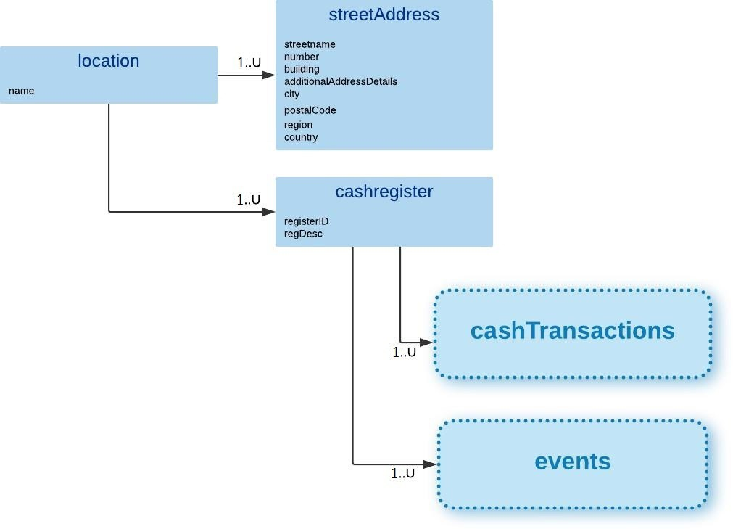
The structure of the "location" and "cashregister" can be illustrated as follow:

In section 1, the logical structure of the Danish SAF-T format is illustrated.

location
Description: The location element contains data on the physical location of the cash register, for instance the address of a certain establishment, and all data elements holding ALL data in the audit file related to it.

Mandatory, Repetitions: 1..U

Parent: auditfile/company/
(section: 3.1)

Children:

XML Element | Description | Type | Req | Rep. | Example
name | Name of the location. | String100 | O | 0..1 | Din lokale butik
streetAddress | Address of the location | <Structure type> | M | 1..U | Section: 4.2
cashregister | The cash register element contains all data of each point of sale (cash register). | <Structure type> | M | 1..U | Section: 4.3

Example:
<d1:location>
<d1:name>Din lokale butik</d1:name>
<d1:streetAddress>
…
</d1:streetAddress>
<d1:cashregister>

…
</d1:cashregister>
</d1:location>

streetAddress (location)
Description: Address of the location

Mandatory, Repetitions: 1..U

Parent: auditfile/company/location/ (section: 4.1)

Children:

XML Element | Description | Type | Req | Rep. | Example
streetname | Normally street name. | String100 | M | 1..1 | Vejen
number | House number | String20 | M | 1..1 | 13
building | Building and letter in addition to house number | String20 | (M) | 1..1 | B
additionalAddressDetails | Floor, door etc. | String20 | O | 0..1 | 2. th.
city | Name of the city/post district | String50 | M | 1..1 | Nørreby

XML Element | Description | Type | Req | Rep. | Example
postalCode | Postal code for the relevant city/post district. | String20 | M | 1..1 | 7913
region | Country specific code to indicate regions / provinces within the tax authority. | String50 | O | 0..1 | Mellemregionen
Country | Two-letter country code according to ISO 3166-1 alpha 2 standard. | Countrycode | M | 1..1 | DK

Example:
<d1:streetAddress>
<d1:streetname>Vejen</d1:streetname>
<d1:number>13</d1:number>
<d1:building>B</d1:building>
<d1:additionalAddressDetails>2. th.</n1:additionalAddressDetails>
<d1:city>Nørreby</d1:city>
<d1:postalCode>7913</d1:postalCode>
<d1:country>DK</d1:country>
</d1:streetAddress>

cashregister
Description: The cashregister element contains all data of each point of sale (cash register).

Mandatory, Repetitions: 1..U

Parent: auditfile/company/location/ (section: 4.1)

Children:

XML Element | Description | Type | Req | Rep. | Example
registerID | The ID number of the cash register (the same as the num- ber that must be printed on the receipt). See also "moms- bekendtgørelsen", §63a, 2d.  This must be a unique description of the point of sale. There are no specific regulations on how to represent this. As a minimum it must be unique on each location, and preferably within a company.  Examples are a combination of the licence ID and soft- wareversion. Other industry standard unique numbering systems can be used. When appropriate, unique hardware identification (serial nr) can be used. | String100 | M | 1..1 | 123.45678-A
regDesc | Logical description of the cash register or point of sale. | String999 | O | 0..1 | Ved indgangen til butikken.
event | Stores activity not represented as a cash register transac- tion (cashtransaction) or transaction line (ctline). | <Structure type> | M | 1..U | Section: 5.1
cashtransaction | The cash transaction element contains data about a trans- action for which the cash register is used. | <Structure type> | M | 1..U | Section: 6.1
Example:
<d1:cashregister>
<d1:registerID>123.45678-A</d1:registerID>
<d1:regDesc>Ved indgangen til butikken</d1:regDesc>
<d1:event>

….
</d1:event>
<d1:cashtransaction>
….
</d1:cashtransaction>
</d1:cashregister>

XML elements in event and eventReport
The structure of the "event" and "eventReport" can be illustrated as follow:
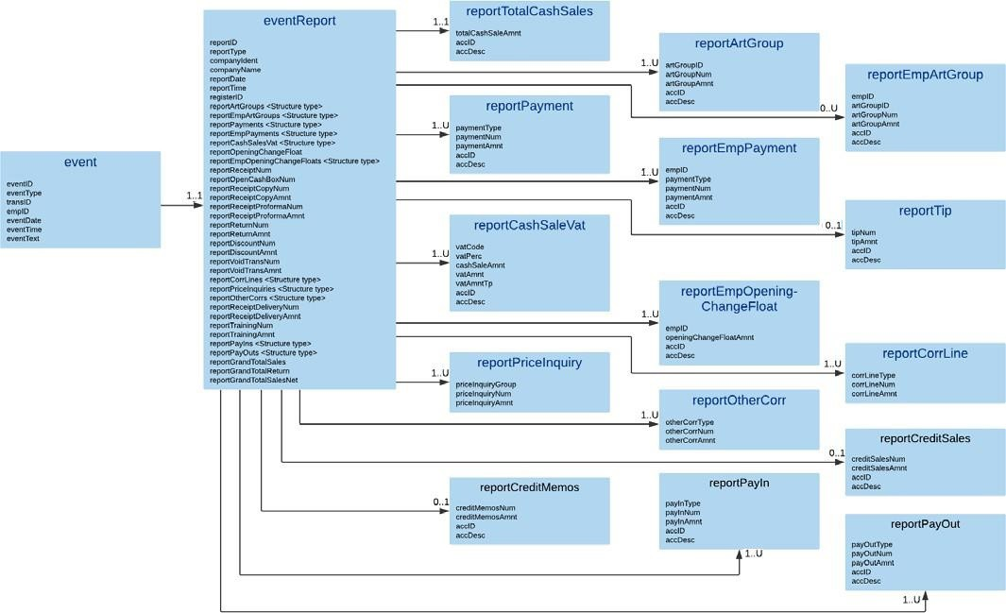
In section 1, the logical structure of the Danish SAF-T format is illustrated.

event
Description: The event element stores activity not represented as a cash register transaction (cashtransaction) or transaction line (ctline).

Mandatory, Repetitions: 1..U

Parent: auditfile/company/location/cashregister/ (section: 4.3)

Children:

XML Element | Description | Type | Req | Rep. | Example
eventID | Unique system specific identification of this event. | IdentificationString36 | M | 1..1 | 500
eventType | Reference to the type of event. Description of the system specific code MUST be stated in the table 'Basics' (basicType 6, 13 or 14). | IdentificationString36 | M | 1..1 | DRAWOPEN
transID | Transaction ID. Should be used as a reference to the cash transaction ID. (Section: 6.1). This element is mandatory when registering an event code that relates to a cashtransaction. | IdentificationString36 | (M) | 1..1 | 11334455
empID | Reference to the employee. Employee MUST be included in the table "employees", Section: 3.15 | IdentificationString36 | M | 1..1 | 1001
eventDate | Date of the event. | xsd:date | M | 1..1 | 2020-01-20
eventTime | Time of the event. | xsd:time | M | 1..1 | 10:13:45

XML Element | Description | Type | Req | Rep. | Example
eventText | Event text | String9999 | O | 0..1 | Dette er en tekst
eventReport | A structure for Z and X report in accordance with moms- bekendtgørelsen" §63a para 5-6. It is mandatory to use this structure when representing the X/Z-report for reports taken for the selection period, using PredefinedBasicID 13008 or 13009.  For mandatory elements that has no instances for the report period, please use 0 – numeric value zero – for the element. | <Structure type> | (M) | 1..1 | Section: 5.2

Example:
<d1:event>
<d1:eventID>500</d1:eventID>
<d1:eventType>DRAWOPEN</d1:eventType>
<d1:transID>11334455</d1:transID>
<d1:empID>500</d1:empID>
<d1:eventDate>2020-01-20</d1:eventDate>
<d1:eventTime>10:13:45</d1:eventTime>
<d1:eventReport>
….
</d1:eventReport>
</d1:event>

eventReport
Description: A structure for Z and X report in accordance with "momsbekendtgørelsen" § 63 para 5-6. It is mandatory to use this structure when representing the X/Z-report for reports taken for the selection period, using PredefinedBasicID 13008 or 13009.
For mandatory elements that has no instances for the report period, please use 0 – numeric value zero – for the element.

Mandatory if available, Repetitions: 0..U

Parent: auditfile/company/location/cashregister/event/ (section: 0)

Children:

XML Element | Description | Type | Req | Rep. | Example
reportID | The number of the Z/X report.  The Z report must be numbered consecutively with se- quential number.  The X report can be numbered consecutively with sequen- tial number, but there are no obligation. As a minimum there must be a value present. | IdentificationString36 | M | 1..1 | 123
reportType | An inscription that the report is an Z/X report. This field is enumerated and the only values allowed is “Z report” or “X report”. | Reporttypestring | M | 1..1 | Z report
companyIdent | Danish CVR-number  See also Section: 3.1 | IdentificationString36 | M | 1..1 | 99999999
companyName | The name of the company. | String100 | M | 1..1 | Selskabet ApS
reportDate | Date of the Z report/X report. | xsd:date | M | 1..1 | 2020-01-10
reportTime | Time of the Z report/X report. | xsd:time | M | 1..1 | 23:58:10

XML Element | Description | Type | Req | Rep. | Example
registerID | The ID number of the cash register (the same as the num- ber that must be printed on the receipt). See also "moms- bekendtgørelsen", §62a, 2d.  This must be a unique description of the point of sale. There are no specific regulatory demands on how to represent this. As a minimum it must be unique on each location, and preferably within a company.  Examples are a combination of the licence ID and soft- ware version. Other industry standard unique numbering systems can be used. When appropriate, unique hardware identification (serial nr) can be used.  See Section: 4.3 | String100 | M | 1..1 | 123.45678-A
reportTotalCashSales | Total cash sales. | <Structure type> | M | 1..1 | Section: 5.3
reportArtGroups | List of numbers of cash sales and amounts broken down at minimum by main article groups. | <Structure type> | M | 1..1 | Section: 5.4
reportEmpArtGroups | List of numbers of cash sales and amounts broken down at minimum by main article groups, and for each individual operator if the cash register system has functionality for this. | <Structure type> | O | 0..1 | Section: 5.6
reportPayments | List of numbers of cash sales and amounts broken down by different means of payment. | <Structure type> | M | 1..1 | Section: 5.8
reportEmpPayments | List of numbers of cash sales and amounts broken down by different means of payment, and for each individual. | <Structure type> | M | 1..1 | Section: 5.10
reportTip | The number of tips and amount. | <Structure type> | O | 0..1 | Section: 5.12

XML Element | Description | Type | Req | Rep. | Example
reportCashSalesVat | Cash sales subject to value added tax and cash sales free  from value added tax, as well as value added tax from cash sales subdivided into different value added tax rates. | <Structure type> | M | 1..1 | Section: 5.13
reportOpeningChange- Float | Opening change float | Amount2decimals | M | 1..1 | 1234.00
reportEmpOpen- ingChangeFloats | List of opening change float per employee. | <Structure type> | O | 0..1 | Section: 5.15
reportReceiptNum | The number of cash sales receipts issued. | Nonnegativeinteger10 | M | 1..1 | 54
reportOpenCashBox- Num | The number of cash box openings. | Nonnegativeinteger10 | M | 1..1 | 53
reportReceiptCopyNum | The number of cash sales copy receipts. | Nonnegativeinteger10 | M | 1..1 | 52
reportReceiptCopyAmnt | Amount from copy receipts from cash sales. | Amount2decimals | M | 1..1 | 543.21
reportReceiptProfor- maNum | The number of pro forma cash sales receipts | Nonnegativeinteger10 | M | 1..1 | 51
reportReceiptProfor- maAmnt | Pro forma cash sales receipts amount. | Amount2decimals | M | 1..1 | 543.21
reportReturnNum | The number of returns from cash sales. | Nonnegativeinteger10 | M | 1..1 | 50
reportReturnAmnt | Returns amount from cash sales. | Amount2decimals | M | 1..1 | 123.45
reportDiscountNum | The number of discounts. | Nonnegativeinteger10 | M | 1..1 | 49
reportDiscountAmnt | Discounts amount. | Amount2decimals | M | 1..1 | 234.56

XML Element | Description | Type | Req | Rep. | Example
reportVoidTransNum | The number of non-completed cash sales. | Nonnegativeinteger10 | M | 1..1 | 48
reportVoidTransAmnt | Sum of amounts from non-completed cash sales. | Amount2decimals | M | 1..1 | 456.78
reportCorrLines | List of numbers of line corrections specified by type and amount. | <Structure type> | M | 1..1 | Section: 5.17
reportPriceInquiries | List of numbers of price look-ups specified by product group and amount. | <Structure type> | M | 1..1 | Section: 5.19
reportOtherCorrs | List of numbers of other corrections specified by type and amount. | <Structure type> | M | 1..1 | Section: 5.21
reportReceiptDeliv- eryNum | Number of delivery receipts. | Nonnegativeinteger10 | M | 1..1 | 47
reportReceiptDeliv- eryAmnt | Sum of amounts from delivery receipts. | Amount2decimals | M | 1..1 | 654.32
reportTrainingNum | Number of training mode transactions, both cash and credit sale. | Nonnegativeinteger10 | M | 1..1 | 46
reportTrainingAmnt | Sum of amounts from transactions/receipts in training mode, both cash and credit sale. | Amount2decimals | M | 1..1 | 456.78
reportCreditSales | The number of credit sales and amount. | <Structure type> | O | 0..1 | Section: 5.23
reportCreditMemos | The number of credit memos and amount from credit sales. | <Structure type> | O | 0..1 | Section: 5.24
reportPayIns | List of numbers and amount of pay ins by type.  If credit sales, specify payments regarding this as own type. | <Structure type> | O | 0..1 | Section: 5.25
reportPayOuts | List of numbers and amount of payouts by type. | <Structure type> | O | 0..1 | Section: 5.27

XML Element | Description | Type | Req | Rep. | Example
reportGrandTotalSales | Grand total sales are including cash sales and credit sales if cash register has the functionality for the latter, at the point of sale.  Sales transactions registered in training mode is not to be included.  The amount is including VAT for transactions eligible for VAT.  The total is to be accumulated from “0” on installations done after 2021-07-01 on the cash register system. | Amount2decimals | M | 1..1 | 87654.32
reportGrandTotalReturn | Grand total amount of returns.  Sales transactions registered in training mode is not to be included.  The amount is including VAT for transactions eligible for VAT.  The total is to be accumulated from “0” on installations done after 2021-07-01 on cash register system. | Amount2decimals | M | 1..1 | 12345.67
reportGrandTotal- SalesNet | Grand total net is sales less returns.  Sales transactions registered in training mode is not to be included.  The amount is including VAT for transactions eligible for VAT.  The total is to be accumulated from “0” on installations done after 2021-07-01 on cash register system. | Amount2decimals | M | 1..1 | 75308.65

Example:
<d1:eventReport>
<d1:reportID>123</d1:reportID>
<d1:reportType>Z report</d1:reportType>
<d1:companyIdent>99999999</d1:companyIdent>
<d1:companyName>Selskabet ApS</d1:companyName>
<d1:reportDate>2020-01-20</d1:reportDate>
<d1:reportTime>23:58:10</d1:reportTime>
<d1:registerID>123.45678-A</d1:registerID>
<d1:reportTotalCashSales>
….
</d1:reportTotalCashSales>
<d1:reportArtGroups>
<d1:reportArtGroup>
….
</d1:reportArtGroup>
</d1:reportArtGroups>
<d1:reportEmpArtGroups>
<d1:reportEmpArtGroup>
….
</d1:reportEmpArtGroup>
</d1:reportEmpArtGroups>
<d1:reportPayments>
<d1:reportPayment>
….
</d1:reportPayment>
</d1:reportPayments>
<d1:reportEmpPayments>
<d1:reportEmpPayment>
….
</d1:reportEmpPayment>
</d1:reportEmpPayments>
<d1:reportTip>
….
</d1:reportTip>
<d1:reportCashSalesVat>
<d1:reportCashSaleVat>
….

</d1:reportCashSaleVat>
</d1:reportCashSalesVat>
<d1:reportOpeningChangeFloat>1234.00</d1:reportOpeningChangeFloat>
<d1:reportEmpOpeningChangeFloats>
<d1:reportEmpOpeningChangeFloat>
….
</d1:reportEmpOpeningChangeFloat>
</d1:reportEmpOpeningChangeFloats>
<d1:reportReceiptNum>54</d1:reportReceiptNum>
<d1:reportOpenCashBoxNum>53</d1:reportOpenCashBoxNum>
<d1:reportReceiptCopyNum>52</d1:reportReceiptCopyNum>
<d1:reportReceiptCopyAmnt>543.21</d1:reportReceiptCopyAmnt>
<d1:reportReceiptProformaNum>51</d1:reportReceiptProformaNum>
<d1:reportReceiptProformaAmnt>543.21</d1:reportReceiptProformaAmnt>
<d1:reportReturnNum>50</d1:reportReturnNum>
<d1:reportReturnAmnt>123.45</d1:reportReturnAmnt>
<d1:reportDiscountNum>49</d1:reportDiscountNum>
<d1:reportDiscountAmnt>234.56</d1:reportDiscountAmnt>
<d1:reportVoidTransNum>48</d1:reportVoidTransNum>
<d1:reportVoidTransAmnt>456.78</d1:reportVoidTransAmnt>
<d1:reportCorrLines>
<d1:reportCorrLine>
….
</d1:reportCorrLine>
</d1:reportCorrLines>
<d1:reportPriceInquiries>
<d1:reportPriceInquiry>
….
</d1:reportPriceInquiry>
</d1:reportPriceInquiries>
<d1:reportOtherCorrs>
<d1:reportOtherCorr>
….
</d1:reportOtherCorr>
</d1:reportOtherCorrs>
<d1:reportReceiptDeliveryNum>47</d1:reportReceiptDeliveryNum>
<d1:reportReceiptDeliveryAmnt>654.32</d1:reportReceiptDeliveryAmnt>
<d1:reportTrainingNum>46</d1:reportTrainingNum>
<d1:reportTrainingAmnt>456.78</d1:reportTrainingAmnt>

<d1:reportCreditSales>
….
</d1:reportCreditSales>
<d1:reportCreditMemos>
….
</d1:reportCreditMemos> d1:reportPayIns>
<d1:reportPayIn>
….
</d1:reportPayIn>
</d1:reportPayIns> d1:reportPayOuts>
<d1:reportPayOut>
….
</d1:reportPayOut>
</d1:reportPayOuts>
<d1:reportGrandTotalSales>87654.32</d1:reportGrandTotalSales>
<d1:reportGrandTotalReturn>12345.67</d1:reportGrandTotalReturn>
<d1:reportGrandTotalSalesNet>75308.65</d1:reportGrandTotalSalesNet>
</d1:eventreport>

reportTotalCashSales
Description: Total cash sales.
Mandatory, Repetitions: 1..1

Parent: auditfile/company/location/cashregister/event/eventReport/ (section: 5.2)

Children:

XML Element | Description | Type | Req | Rep. | Example
totalCashSaleAmnt | Total cash sales amount. | Amount2decimals | M | 1..1 | 6543.21
accID | Unique account ID. (section: 3.9) | IdentificationString36 | O | 0..1 | 1010
accDesc | General ledger account description | String999 | O | 0..1 | Salg af varer og ydelser m/moms

Example:
<d1:reportTotalCashSales>
<d1:totalCashSaleAmnt>6543.21</d1:totalCashSaleAmnt>
<d1:accID>1010</d1:accID>
<d1:accDesc>Salg af varer og ydelser m/moms</d1:accDesc>
</d1:reportTotalCashSales>

reportArtGroups
Description: List of numbers of cash sales and amounts broken down at minimum by main article groups. Mandatory, Repetitions: 1..1

Parent: auditfile/company/location/cashregister/event/eventReport/ (section: 5.2)

Children:

XML Element | Description | Type | Req | Rep. | Example
reportArtGroup | List of reportArtGroup element | <Structure type> | M | 1..U | Section: 5.5

reportArtGroup
Description: The numbers of cash sales and amounts broken down at minimum by main article groups.

Mandatory, Repetitions: 1..U
Parent: auditfile/company/location/cashregister/event/eventReport/reportArtGroups/ (section: 5.4)

Children:

XML Element | Description | Type | Req | Rep. | Example
artGroupID | Article group ID. Refers to the group. Description of the code MUST be stated in "basics" (section 3.20) | IdentificationString36 | M | 1..1 | 100
artGroupNum | Number of cash sales in article group. | Amount6decimals | M | 1..1 | 2
artGroupAmnt | Amount from cash sales in article group. | Amount2decimals | M | 1..1 | 1234.56
accID | Unique account ID. (section: 3.9) | IdentificationString36 | O | 0..1

XML Element | Description | Type | Req | Rep. | Example
accDesc | General ledger account description | String999 | O | 0..1

Example:
<d1:reportArtGroup>
<d1:artGroupID>100</d1:artGroupID>
<d1:artGroupNum>2</d1:artGroupNum>
<d1:artGroupAmnt>1234.56</d1:artGroupAmnt>
</d1:reportArtGroup>

reportEmpArtGroups
Description: List of numbers of cash sales and amounts broken down at minimum by main article groups, and for each individual operator if the cash register system has functionality for this.
Use if the Cash Register has this functionality. This requirement is not from Cash Register System Act regulations. This is advisable for industries that need this specification to comply with the book keeping regulations.

Optional, Repetitions: 0..1

Parent: auditfile/company/location/cashregister/event/eventReport/ (section: 5.2)

Children:

XML Element | Description | Type | Req | Rep. | Example
reportEmpArtGroup | List of reportEmpArtGroup element | <Structure type> | M | 0..U | Section: 5.7

reportEmpArtGroup
Description: The number of cash sales and amounts broken down at minimum by main article groups, and for each individual operator if the cash register system has functionality for this.

Optional, Repetitions: 0..U

Parent: auditfile/company/location/cashregister/event/eventReport/reportEmpArtGroups/ (section: 5.6)

Children:

XML Element | Description | Type | Req | Rep. | Example
empID | Unique identification of the employee (refers to the empID of the employee element). Section: 3.15. | IdentificationString36 | M | 1..1 | 1003
artGroupID | Article group ID. Refers to the group. Description of the code MUST be stated in "basics" (section 3.20) | IdentificationString36 | M | 1..1 | 100
artGroupNum | Number of cash sales in article group. | Amount6decimals | M | 1..1 | 2

XML Element | Description | Type | Req | Rep. | Example
artGroupAmnt | Amount from cash sales in article group. | Amount2decimals | M | 1..1 | 1234.56
accID | Unique account ID. (section: 3.9) | IdentificationString36 | O | 0..1
accDesc | General ledger account description | String999 | O | 0..1

Example:
<d1:reportEmpArtGroup>
<d1:empID>1003</d1:empID>
<d1:artGroupID>100</d1:artGroupID>
<d1:artGroupNum>2</d1:artGroupNum>
<d1:artGroupAmnt>1234.56</d1:artGroupAmnt>
</d1:reportEmpArtGroup>

reportPayments
Description: List of numbers of cash sales and amounts broken down by different means of payment. Mandatory, Repetitions: 1..1

Parent: auditfile/company/location/cashregister/event/eventReport/ (section: 5.2)

Children:

XML Element | Description | Type | Req | Rep. | Example
reportPayments | List of reportPayment element | <Structure type> | M | 1..U | Section: 5.9

reportPayment
Description: The number of cash sales and amounts broken down by different means of payment.

Mandatory, Repetitions: 1..U

Parent: auditfile/company/location/cashregister/event/eventReport/reportPayments/ (section: 5.8)

Children:

XML Element | Description | Type | Req | Rep. | Example
paymentType | Reference to the type of payment. Description of the code MUST be stated in the table 'Basics'. BasicType 12 | IdentificationString36 | M | 1..1 | Cash
paymentNum | Number of payments. | Amount6decimals | M | 1..1 | 1
paymentAmnt | Payment amount. | Amount2decimals | M | 1..1 | 765.50
accID | Unique account ID. (section: 3.9) | IdentificationString36 | O | 0..1 | 1910
accDesc | General ledger account description | String999 | O | 0..1 | Kassekonto

Example:
<d1:reportPayment>
<d1:paymentType>Cash</d1:paymentType>
<d1:paymentNum>1</d1:paymentNum>
<d1:paymentAmnt>765.50</d1:paymentAmnt>
<d1:accID>1910</d1:accID>
<d1:accDesc>Kassekonto</d1:accDesc>
</d1:reportPayment>

reportEmpPayments
Description: List of numbers of cash sales and amounts broken down by different means of payment, and for each individual operator.

Mandatory, Repetitions: 1..1

Parent: auditfile/company/location/cashregister/event/eventReport/ (section: 5.2)

Children:

XML Element | Description | Type | Req | Rep. | Example
reportEmpPayment | List of reportEmpPayment element | <Structure type> | M | 1..U | Section: 5.11

reportEmpPayment
Description: The number of cash sales and amounts broken down by different means of payment, and for each individual operator.

Mandatory, Repetitions: 1..U

Parent: auditfile/company/location/cashregister/event/eventReport/reportEmpPayments/ (section: 5.10)

Children:

XML Element | Description | Type | Req | Rep. | Example
empID | Unique identification of the employee (refers to the empID of the employee element). Section: 3.15. | IdentificationString36 | M | 1..1 | 1003
paymentType | Reference to the type of payment. Description of the code MUST be stated in the table 'Basics'. BasicType 12 | IdentificationString36 | M | 1..1 | Cash
paymentNum | Number of payments. | Amount6decimals | M | 1..1 | 1
paymentAmnt | Payment amount. | Amount2decimals | M | 1..1 | 765.50
accID | Unique account ID. (section: 3.9) | IdentificationString36 | O | 0..1 | 1920
accDesc | General ledger account description | String999 | O | 0..1 | Bankkonto

Example:
<d1:reportEmpPayment>
<d1:empID>1003</d1:empID>
<d1:paymentType>Cash</d1:paymentType>
<d1:paymentNum>1</d1:paymentNum>
<d1:paymentAmnt>765.50</d1:paymentAmnt>
<d1:accID>1920</d1:accID>
<d1:accDesc>Bankkonto</d1:accDesc>
</d1:reportEmpPayment>

reportTip
Description: The number of tips and amount. Mandatory to use if the cash register system has functionality for this.

Optional, Repetitions: 0..1

Parent: auditfile/company/location/cashregister/event/eventReport/ (section: 5.2)

Children:

XML Element | Description | Type | Req | Rep. | Example
tipNum | Number of tips. | Amount6decimals | M | 1..1 | 1
tipAmnt | Sum of tips amounts. | Amount2decimals | M | 1..1 | 123.00
accID | Unique account ID. (section: 3.9) | IdentificationString36 | O | 0..1 | 1930

XML Element | Description | Type | Req | Rep. | Example
accDesc | General ledger account description | String999 | O | 0..1 | Bankkonto drikkepenge

Example:
<d1:reportTip>
<d1:tipNum>1</d1:tipNum>
<d1;tipAmnt>123.50</d1:tipAmnt>
<d1:accID>1930</d1:accID>
<d1:accDesc>Bankkonto drikkepenge</d1:accDesc>
</d1:reportTip>

reportCashSalesVat
Description: List of Cash sales subject to value added tax and cash sales free from value added tax, as well as value added tax from cash sales subdivided into different value added tax rates.

Mandatory, Repetitions: 1..1

Parent: auditfile/company/location/cashregister/event/eventReport/ (section: 5.2)

Children:

XML Element | Description | Type | Req | Rep. | Example
reportCashSaleVat | List of reportCashSaleVat element | <Structure type> | M | 1..U | Section: 5.14

reportCashSaleVat
Description: Cash sales subject to value added tax and cash sales free from value added tax, as well as value added tax from cash sales subdivided into different value added tax rates.
Mandatory, Repetitions: 1..U

Parent: auditfile/company/location/cashregister/event/eventReport/reportCashSalesVat/ (section: 5.13)

Children:

XML Element | Description | Type | Req | Rep. | Example
vatCode | Internal VAT code used by the cash register system. | String20 | O | 0..1 | 1
vatPerc | VAT percentage. | Decimal8 | M | 1..1 | 25.00
cashSaleAmnt | Total cash sales amount excluded VAT. | Amount2decimals | M | 1..1 | 100.00
vatAmnt | VAT amount from cash sales. | Amount2decimals | M | 1..1 | 25.00

XML Element | Description | Type | Req | Rep. | Example
vatAmntTp | Indication whether the VAT amount is debit or credit.  Choose from the following enumerated values: C - Credit  D - Debit | Debitcredittype | O | 0..1 | C
accID | Unique account ID. (section: 3.9) | IdentificationString36 | O | 0..1 | 1601
accDesc | General ledger account description | String999 | O | 0..1 | Udgående moms, høj sats

Example:
<d1:reportCashSaleVat>
<d1:vatCode>1</d1:vatCode>
<d1:vatPerc>25.00</d1:vatPerc>
<d1:cashSaleAmnt>100.00</d1:cashSaleAmnt>
<d1:vatAmnt>25.00</d1:vatAmnt>
<d1:vatAmntTp>C</d1:vatAmntTp>
<d1:accID>1601</d1:accID>
<d1:accDesc>Udgående moms, høj sats</d1:accDesc>
</d1:reportCashSaleVat>

reportEmpOpeningChangeFloats
Description: List of opening change float per employee.

Optional, Repetitions: 0..1

Parent: auditfile/company/location/cashregister/event/ eventReport/ (section: 5.2)

Children:

XML Element | Description | Type | Req | Rep. | Example
reportEmpOpen- ingChangeFloat | List of reportEmpOpeningChangeFloat element | <Structure type> | M | 1..U | Section: 5.16

reportEmpOpeningChangeFloat
Description: The opening change float per employee.

Mandatory, Repetitions: 1..U

Parent: auditfile/company/location/cashregister/event/eventReport/reportEmpOpeningChangeFloats/ (section: 5.16)

Children:

XML Element | Description | Type | Req | Rep. | Example
empID | Unique identification of the employee (refers to the empID of the employee element). Section: 3.15. | IdentificationString36 | M | 1..1 | 1003
openingChangeFloat- Amnt | Opening change float amount per employee. | Amount2decimals | M | 1..1 | 1234.00
accID | Unique account ID. (section: 3.9) | IdentificationString36 | O | 0..1 | 1930
accDesc | General ledger account description | String999 | O | 0..1 | Bankkonto, drikkepenge

Example:
<d1:reportEmpOpeningChangeFloat>
<d1:empID>1003</d1:empID>
<d1:openingChangeFloatAmnt>1234.00</d1:openingChangeFloatAmnt>
<d1:accID>1930</d1:accID>
<d1:accDesc>Bankkonto, drikkepenge</d1:accDesc>
</d1:reportEmpOpeningChangeFloat>

reportCorrLines
Description: List of numbers of line corrections specified by type and amount.

Mandatory, Repetitions: 1..1

Parent: auditfile/company/location/cashregister/event/eventReport/ (section: 5.2)

Children:

XML Element | Description | Type | Req | Rep. | Example
reportCorrLine | List of reportCorrLine element | <Structure type> | M | 1..U | Section: 5.18

reportCorrLine
Description: The number of line corrections specified by type and amount. Use for reporting of corrections of lines. If no corrections of lines exist, fill in “NONE” as corrLineType and “0” as corrLineNum and “0.00” as corrLineAmnt.

Mandatory, Repetitions: 1..U

Parent: auditfile/company/location/cashregister/event/eventReport/reportCorrLines/ (section: 5.17)

Children:

XML Element | Description | Type | Req | Rep. | Example
corrLineType | Type of line correction. | IdentificationString36 | M | 1..1 | Ændring af sidste linje

XML Element | Description | Type | Req | Rep. | Example
corrLineNum | Number of line corrections. | Nonnegativeinteger10 | M | 1..1 | 12
corrLineAmnt | Amount from line corrections. | Amount2decimals | M | 1..1 | 456.78

Example:
<d1:reportCorrLine>
<d1:corrLineType>Ændring af sidste linje</d1:corrLineType>
<d1:corrLineNum>12</d1:corrLineNum>
<d1:corrLineAmnt>456.78</d1:corrLineAmnt>
</d1:reportCorrLine>

reportPriceInquiries
Description: List of numbers of price look-ups specified by product group and amount.

Mandatory, Repetitions: 1..1

Parent: auditfile/company/location/cashregister/event/eventReport/ (section: 5.2)

Children:

XML Element | Description | Type | Req | Rep. | Example
reportPriceInquiry | List of reportPriceInquiry element | <Structure type> | M | 1..U | Section: 5.18

reportPriceInquiry
Description: The number of price look-ups specified by product group and amount.

Mandatory, Repetitions: 1..U

Parent: auditfile/company/location/cashregister/event/eventReport/reportPriceInquiries/ (section: 5.19)

Children:

XML Element | Description | Type | Req | Rep. | Example
priceInquiryGroup | Article group ID. Refers to the group. Description of the code MUST be stated in "basics" (section 3.20) | IdentificationString36 | M | 1..1 | 100
priceInquiryNum | The number of price inquiries. | Nonnegativeinteger10 | M | 1..1 | 12
priceInquiryAmnt | Sum of amounts of the inquiries. | Amount2decimals | M | 1..1 | 456.78

Example:

<d1:reportPriceInquiry>
<d1:priceInquiryGroup>100</d1:priceInquiryGroup>
<d1:priceInquiryNum>12</d1:priceInquiryNum>
<d1:priceInquiryAmnt>456.78</d1:priceInquiryAmnt>
</d1:reportPriceInquiry>

reportOtherCorrs
Description: List of numbers of other corrections specified by type and amount. Use for reporting of corrections not specified elsewhere. If no other corrections exist, fill in “NONE” as otherCorrType and “0” as otherCorrNum and “0.00” as otherCorrAmnt.

Mandatory, Repetitions: 1..1

Parent: auditfile/company/location/cashregister/event/eventReport/ (section: 5.2)

Children:

XML Element | Description | Type | Req | Rep. | Example
reportCorrLine | List of reportOtherCorr element | <Structure type> | M | 1..U | Section: 5.22

reportOtherCorr
Description: The number of other corrections specified by type and amount. Mandatory, Repetitions: 1..U

Parent: auditfile/company/location/cashregister/event/eventReport/reportOtherCorrs/ (section: 5.21)

Children:

XML Element | Description | Type | Req | Rep. | Example
otherCorrType | Type of other correction. | IdentificationString36 | M | 1..1 | ABC
otherCorrNum | Number of other corrections. | Nonnegativeinteger10 | M | 1..1 | 12
otherCorrAmnt | Amount from other corrections. | Amount2decimals | M | 1..1 | 456.78

Example:
<d1:reportOtherCorr>
<d1:otherCorrType>ABC</d1:otherCorrType>
<d1:otherCorrNum>12</d1:otherCorrNum>
<d1:otherCorrAmnt>456.78</d1:otherCorrAmnt>
</d1:reportOtherCorr>

reportCreditSales
Description: The number of credit sales and amount.

Optional, Repetitions: 0..1

Parent: auditfile/company/location/cashregister/event/eventReport/ (section: 5.2)

Children:

XML Element | Description | Type | Req | Rep. | Example
creditSalesNum | Number of credit sales. | Nonnegativeinteger10 | M | 1..1 | 12
creditSalesAmnt | Amount from credit sales. | Amount2decimals | M | 1..1 | 1234.56
accID | Unique account ID. (section: 3.9) | IdentificationString36 | O | 0..1 | 3001
accDesc | General ledger account description | String999 | O | 0..1 | Salg, kredit

Example:
<d1:reportCreditSales>
<d1:creditSalesNum>ABC</d1:creditSalesNum>
<d1:creditSalesAmnt>1234.56</d1:creditSalesAmnt>
<d1:accID>3001</d1:accID>
<d1:accDesc>Salg, kredit</d1:accDesc>
</d1:reportCreditSales>

reportCreditMemos
Description: The number of credit memos and amount from credit sales.

Optional, Repetitions: 0..1

Parent: auditfile/company/location/cashregister/event/eventReport/ (section: 5.2)

Children:

XML Element | Description | Type | Req | Rep. | Example
creditMemosNum | Number of credit memos from credit sales. | Nonnegativeinteger10 | M | 1..1 | 12
creditMemosAmnt | Sum of amount of credit memos from credit sales. | Amount2decimals | M | 1..1 | 1234.56
accID | Unique account ID. (section: 3.9) | IdentificationString36 | O | 0..1 | 3001
accDesc | General ledger account description | String999 | O | 0..1 | Salg, kredit

Example:
<d1:reportCreditMemos>
<d1:creditMemosNum>ABC</d1:creditMemosNum>

<d1:creditMemosAmnt>1234.56</d1:creditMemosAmnt>
<d1:accID>3001</d1:accID>
<d1:accDesc>Salg, kredit</d1:accDesc>
</d1:reportCreditMemos>

reportPayIns
Description: List of numbers and amount of payins by type. If credit sales, specify payments regarding this as own type.

Optional, Repetitions: 0..1

Parent: auditfile/company/location/cashregister/event/eventReport/ (section: 5.2)

Children:

XML Element | Description | Type | Req | Rep. | Example
reportPayIn | List of reportPayIn element | <Structure type> | M | 1..U | Section: 5.26

reportPayIn
Description: The number and amount of payins by type. If credit sales, specify payments regarding this as own type.

Mandatory, Repetitions: 1..U

Parent: auditfile/company/location/cashregister/event/eventReport/reportPayIns/ (section: 5.25)

Children:

XML Element | Description | Type | Req | Rep. | Example
payInType | Type of pay ins. | IdentificationString36 | M | 1..1 | Cash refill
payInNum | Number of pay ins per type. | Nonnegativeinteger10 | M | 1..1 | 1
payInAmnt | Amount of pay ins per type. | Amount2decimals | M | 1..1 | 2500.00
accID | Unique account ID. (section: 3.9) | IdentificationString36 | O | 0..1 | 1907
accDesc | General ledger account description | String999 | O | 0..1 | Kasse, indbetalinger

Example:
<d1:reportPayIn>
<d1:payInType>Cash refill</d1:payInType>
<d1:payInNum>1</d1:payInNum>
<d1:payInAmnt>2500.00</d1:payInAmnt>
<d1:accID>1907</d1:accID>
<d1:accDesc>Kasse, indbetalinger</d1:accDesc>
</d1:reportPayIn>

reportPayOuts
Description: List of numbers and amount of payouts by type.

Optional, Repetitions: 0..1

Parent: auditfile/company/location/cashregister/event/eventReport/ (section: 5.2)

Children:

XML Element | Description | Type | Req | Rep. | Example
reportPayOut | List of reportPayOut element | <Structure type> | M | 1..U | Section: 5.28

reportPayOut
Description: The number and amount of payouts by type.

Mandatory, Repetitions: 1..U

Parent: auditfile/company/location/cashregister/event/eventReport/reportPayOuts/ (section: 5.27)

Children:

XML Element | Description | Type | Req | Rep. | Example
payOutType | Type of payout. | IdentificationString36 | M | 1..1 | Cash drop
payOutNum | Number of payouts per type. | Nonnegativeinteger10 | M | 1..1 | 1
payOutAmnt | Amount of payouts per type. | Amount2decimals | M | 1..1 | 1250.50
accID | Unique account ID. (section: 3.9) | IdentificationString36 | O | 0..1 | 1908
accDesc | General ledger account description | String999 | O | 0..1 | Kasse, udtagning af penge

Example:
<d1:reportPayOut>
<d1:payOutType>Cash drop</d1:payOutType>
<d1:payOutNum>1</d1:payOutNum>
<d1:payOutAmnt>1250.50</d1:payOutAmnt>
<d1:accID>1908</d1:accID>
<d1:accDesc>Kasse, udtagning af penge</d1:accDesc>
</d1:reportPayOut>

XML elements in cashtransaction
The structure of the "cashtransaction" can be illustrated as follow:
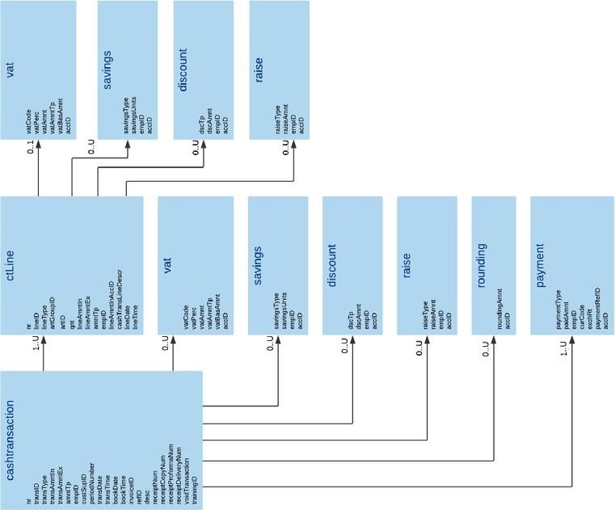
In section 1, the logical structure of the Danish SAF-T format is illustrated.

cashtransaction
Description: The cash transaction element contains data about a transaction for which the cash register is used.
Mandatory, Repetitions: 1..U

Parent: auditfile/company/location/cashregister/ (section: 4.3)

Children:

XML Element | Description | Type | Req | Rep. | Example
nr | Transaction number, also used as reference to the ctLine - nr - element.  This must be a unique, sequential number within a journal. This will be the same as the number stated on the issued receipt. | IdentificationString36 | M | 1..1 | 123456789
transID | Transaction ID. Other unique internal, sequential ID used by the cash register system. This can be the equivalent of the element “nr”. | IdentificationString36 | M | 1..1 | 11334455
transType | Transaction type. Description of the code MUST be de- clared in the 'Basics' table. (basicType 11) | IdentificationString36 | M | 1..1 | CASHSAL
transAmntIn | The amount involved in the transaction, including VAT. | Amount2decimals | M | 1..1 | 1250.00
transAmntEx | The amount involved in the transaction, excluding VAT. | Amount2decimals | M | 1..1 | 1000.00

XML Element | Description | Type | Req | Rep. | Example
amntTp | Amount type. Choose between the following enumera- tions:  D - Debit C – Credit  An increase in revenue (such as sales) is to be marked as C, while a decrease in revenue (such as returns) is to be marked as D | Debitcredittype | M | 1..1 | C
empID | Unique identification of the employee who has performed the transaction (refers to the empID of the employee ele- ment). Section: 3.15. | IdentificationString36 | M | 1..1 | 1003
custSupID | Unique identification of customer or supplier (refers to cus- tomerSupplier table). Section: 3.5 | IdentificationString36 | O | 0..1 | 100
periodNumber | Period number. See table/structure ‘period’. Section: 3.13 | Nonnegativeinteger3 | O | 0..1 | 5
transDate | Date at which the transaction was performed. | xsd;date | M | 1..1 | 2020-01-10
transTime | Time at which the transaction was performed. | xsd:time | M | 1..1 | 12.45.31
bookDate | Booking date of order or e.g. table in a restaurant. | xsd:date | O | 0..1 | 2020-01-10
bookTime | Booking time of order or e.g. table in a restaurant. | xsd:time | O | 0..1 | 11:30:00
invoiceID | The identification of the invoice, if the transaction is a credit sale and the system has the information available. This is used when issuing a delivery receipt for the trans-  action, which must be done when using the cash register system for credit sales. | IdentificationString36 | O | 0..1 | 4567893

XML Element | Description | Type | Req | Rep. | Example
refID | Description on how this transaction can be identified, a system specific reference.  This can also be the table number in a restaurant, or other booking reference. | String9999 | O | 0..1 | Bord 17
desc | Other/further description of the transaction. | String9999 | O | 0..1 | Lirum Larum
ctLine | The ctLine element contains details data of a transaction. If, for instance, the transaction describes a sales slip, the ctLines are the slip lines. The data not described in the cash transaction element, are described in the ctLine. | <Structure type> | M | 1..U | Section: 6.2
vat | Element with VAT data. | <Structure type> | O | 0..U | Section: 6.3
savings | Element with savings data. | <Structure type> | O | 0..U | Section: 6.4
discount | Element with discount data. | <Structure type> | O | 0..U | Section: 6.5
raise | Element with raise data. | <Structure type> | O | 0..U | Section: 6.6
rounding | For recording any rounding of figures. | <Structure type> | O | 0..1 | Section: 6.7
payment | Payment regarding this transaction. | <Structure type> | M | 1..U | Section: 6.8
signature | The digital RSA signature of the cashtransaction. | String999 | M | 1..1 | MIICWgIBAAKBgQCsN…..
keyVersion | The version of the private/secret key used in RSA-SHA512 | String50 | M | 1..1 | 1
certificateData | The OCES certificate without private key  (related to the RSA signature) in PEM X.509 version.  For further description please see document:  Danish Cash Register Act - Guideline for implementing digital signature. | String | M | 1..1 | -----BEGIN CERTIFICATE-----  MIIGfDCCBDCgAwIBAgIUfdkPhr......  -----END CERTIFICATE-----
receiptNum | Number of receipts issued for the transaction. | Nonnegativeinteger3 | O | 0..1 | 1
receiptCopyNum | Number of copy receipts issued from the point of sale/cash register, for this transaction. | Nonnegativeinteger3 | O | 0..1 | 1

XML Element | Description | Type | Req | Rep. | Example
receiptProformaNum | Number of pro forma receipts for the transaction. | Nonnegativeinteger3 | O | 0..1 | 2
receiptDeliveryNum | Number of delivery receipts for the transaction. | Nonnegativeinteger3 | O | 0..1 | 0
voidTransaction | Specifies whether the transaction has been cancelled. Use if cash register has the functionality. | Flag | M | 1..1 | true
 | Boolean, please use: |  |  |  | false
 | Cancelled = true
 | Not cancelled = false
trainingID | Specifies whether this is a training cash transaction or not. Use if cash register has the functionality. | Flag | M | 1..1 | true
 | Boolean, please use: |  |  |  | false
 | Training = true
 | Not training = false

Example:
<d1:cashtransaction>
<d1:nr>123456789</d1:nr>
<d1:transID>11334455</d1:transID>
<d1:transType>CASHSAL</d1:transType>
<d1:transAmntIn>1250.00</d1:transAmntIn>
<d1:transAmntEx>1250.00</d1:transAmntEx>
<d1:amntTp>C</d1:amntTp>
<d1:empID>1003</d1:empID>
<d1:custSupID>100</d1:custSupID>
<d1:periodNumber>1</d1:periodNumber>
<d1:transDate>2020-01-10</d1:transDate>
<d1:transTime>11:30:00</d1:transTime>
<d1:ctLine>
….
</d1:ctLine>
<d1:vat>

…
</d1:vat>
<d1:savings>
…
</d1:saving>
<d1:discount>
…
</d1:discount>
<d1:raise>
…
</d1:raise>
<d1:rounding>
…
</d1:rounding>
<d1:payment>
…
</d1:payment>
<d1:receiptNum>2</d1:receiptNum>
<d1:receiptCopyNum>0</d1:receiptCopyNum>
<d1:trainingID>false</d1:trainingID>
</d1:cashtransaction>

ctLine
Description: The ctLine element contains details data of a transaction. For instance, if the transaction describes a sales slip, the ctLines are the slip lines. The data not described in the cash transaction element, are described in the ctLine.
Mandatory, Repetitions: 1..U

Parent: auditfile/company/location/cashregister/cashtransaction/ (section:6.1)

Children:

XML Element | Description | Type | Req | Rep. | Example
nr | Transaction number, also used as reference to the cash- transaction - nr - element.  This must be a unique, sequential number within a journal. This will be the same as the number stated on the issued receipt. | IdentificationString36 | M | 1..1 | 123456789
lineID | Transaction line number. Should be a unique sequential number within a transaction. | IdentificationString36 | M | 1..1 | 1
lineType | Reference to ticketline codes. Description of the code must be stated in the table 'Basics'. BasicType = 5 | IdentificationString36 | M | 1..1 | Sale, correction, returns, booking, deposit, gift certificate, etc.
artGroupID | Article group ID. Refers to the item group. Description of the code must be stated in the table 'Basics'. BasicType = 4 | IdentificationString36 | O | 0..1 | 100
artID | Unique article ID. Section 3.18. Mandatory when cashtransaction relates to article(s). | IdentificationString36 | (M) | 1..1 | 22654
Qnt | Quantity of an article. Mandatory when cashtransaction relates to article(s). | Amount6decimals | (M) | 1..1 | 1.12
lineAmntIn | Line amount, VAT included. | Amount2decimals | M | 1..1 | 1250.00
lineAmntEx | Line amount, VAT excluded. | Amount2decimals | M | 1..1 | 1000.00

XML Element | Description | Type | Req | Rep. | Example
amntTp | Amount type. Choose between the following enumera- tions:  D - Debit C – Credit  An increase revenue (such as sales) is to be marked as C, while a decrease in revenue (such as returns) is to be marked as D | Debitcredittype | M | 1..1 | C
ppu | Price per unit. | Amount6decimals | O | 0..1
costPrice | Cost price of the article. | Amount2decimals | O | 0..1
costID | Reference to the cost center. Description of the code must be stated in the table 'Basics'.basicType = 1 | IdentificationString36 | O | 0..1
costObjID | Reference to the cost carrier. Description of the code must be stated in the table 'Basics'.basicType = 1 | IdentificationString36 | O | 0..1
projID | Reference to project (instead of cost type and cost center). Description of the code must be stated in the table 'Ba- sics'. basicType = 3 | IdentificationString36 | O | 0..1
empID | Unique identification of the employee who has performed this transaction (refers to the empID of the employee ele- ment). Section 3.15 | IdentificationString36 | O | 0..1 | 1001
lineAmntInAccID | Amount (VAT included) Account ID. Unique ledger account code. (section: 3.9) | IdentificationString36 | O | 0..1
cashTransLineDescr | Cash transaction line description. | String9999 | O | 0..1
lineDate | Line date | xsd:date | O | 0..1 | 2020-01-04
lineTime | Line time | xsd:time | O | 0..1 | 22:34:56

XML Element | Description | Type | Req | Rep. | Example
vat | Element with VAT data. | <Structure type> | O | 0..1 | Section: 6.9
savings | Element with savings data | <Structure type> | O | 0..U | Section: 6.10
discount | Element with discount data. | <Structure type> | O | 0..U | Section: 6.11
raise | Element with raise data. | <Structure type> | O | 0..U | Section: 6.12

Example:
<d1:ctLine>
<d1:nr>123456789</d1:nr>
<d1:lineID>1</d1:lineID>
<d1:lineType>SALE</d1:lineType>
<d1:artGroupID>100</d1:artGroupID>
<d1:artID>22654</d1:artID>
<d1:qnt>1.12</d1:qnt>
<d1:lineAmntIn>1250.00</d1:lineAmntIn>
<d1:lineAmntEx>1000.00</d1:lineAmntEx>
<d1:amntTp>C</d1:amntTp>
<d1:empID>1003</d1:empID>
<d1:lineDate>2020-01-10</d1:lineDate>
<d1:lineTime>11:30:00</d1:lineTime>
<d1:vat>
…
</d1:vat>
<d1:savings>
…
</d1:savings>
<d1:discount>
…
</d1:discount>
<d1:raise>

…
</d1:raise>
</d1:ctLine>

vat (cashtransaction)
Description: Element with VAT data. Optional, Repetitions: 0..U

Parent: auditfile/company/location/cashregister/cashtransaction/ (section:6.1)

Children:

XML Element | Description | Type | Req | Rep. | Example
vatCode | The VAT Codes used by the cash register system. The VAT codes must be stated in vatCodeDetails. Section: 3.11 | String20 | O | 0..1 | 31
vatPerc | VAT percentage. | Decimal8 | O | 0..1 | 25.00
vatAmnt | VAT amount. | Amount2decimals | M | 1..1 | 250.00

XML Element | Description | Type | Req | Rep. | Example
vatAmntTp | Indication whether the VAT amount is debit or credit. Choose from the following enumerated values:  C - Credit D - Debit | Debitcredittype | O | 0..1 | C
vatBasAmnt | Base amount for VAT calculation. | Amount2decimals | O | 0..1 | 1000.00
accID | Unique account ID. (section: 3.9) | IdentificationString36 | O | 0..1

Example:
<d1:vat>
<d1:vatCode>31</d1:vatCode>
<d1:vatPerc>25.00</d1:vatPerc>
<d1:vatAmnt>250.00</d1:vatAmnt>
<d1:vatAmntTp>1250.00</d1:vatAmntTp>
<d1:vatBasAmnt>1250.00</d1:vatBasAmnt>
</d1:vat>

savings (cashtransaction)
Description: Element with savings data.

Optional, Repetitions: 0..U

Parent: auditfile/company/location/cashregister/ cashtransaction/ (section: 6.1)

Children:

XML Element | Description | Type | Req | Rep. | Example
savingsType | Reference to the type of savings system. Description of the code MUST be stated in the table 'Basics' BasicType 7. | IdentificationString36 | M | 1..1 | 3F2
savingsUnits | Number of units. | Nonnegativeinteger10 | M | 1..1 | 1
empID | Unique employee ID. (section: 3.15) | IdentificationString36 | O | 0..1 | 1003
accID | Unique account ID. (section: 3.9) | IdentificationString36 | O | 0..1

Example:
<d1:savings>
<d1:savingsType>3F2</d1:savingsType>
<d1:savingsUnits>1</d1:savingsUnits>
<d1:empID>1003</d1:empID>
</d1:savings>

discount (cashtransaction)
Description: Element with discount data.

Optional, Repetitions: 0..U

Parent: auditfile/company/location/cashregister/cashtransaction/ (section: 6.1)

Children:

XML Element | Description | Type | Req | Rep. | Example
dscTp | Reference to the type of discount. Description of the code MUST be stated in the table 'Basics' BasicType 08. | IdentificationString36 | M | 1..1 | 20DIS
dscAmnt | Discount amount. | Amount2decimals | M | 1..1 | 135.67
empID | Unique employee ID. (section: 3.15) | IdentificationString36 | O | 0..1 | 1003
accID | Unique account ID. (section: 3.9) | IdentificationString36 | O | 0..1

Example:
<d1:discount>
<d1:dscTp>20DIS</d1:dscTp>
<d1:dscAmnt>135.67</d1:dscAmnt>
<d1:empID>1003</d1:empID>
</d1:discount>

raise (cashtransaction)
Description: Element with raise data.

Optional, Repetitions: 0..U

Parent: auditfile/company/location/cashregister/cashtransaction/ (section: 6.1)

Children:

XML Element | Description | Type | Req | Rep. | Example
raiseType | Reference to the type of mark-up. This can be used to rep- resent tip amounts, on transaction level, if the cash regis- ter has the functionality.  The code MUST be stated in the table 'Basics' BasicType 10. | IdentificationString36 | M | 1..1 | TIP
raiseAmnt | Raise amount. | Amount2decimals | M | 1..1 | 50.00
empID | Unique employee ID. (section: 3.15) | IdentificationString36 | O | 0..1 | 1003
accID | Unique account ID. (section: 3.9) | IdentificationString36 | O | 0..1

Example:

<d1:raise>
<d1:raiseType>3F2</d1:raiseType>
<d1:raiseAmnt>50.00</d1:raiseAmnt>
<d1:empID>1003</d1:empID>
</d1:raise>

rounding
Description: For recording any rounding of figures.

Optional, Repetitions: 0..1

Parent: auditfile/company/location/cashregister/cashtransaction/ (section: 6.1)

Children:

XML Element | Description | Type | Req | Rep. | Example
roundingAmnt | Rounding amount. | Amount2decimals | O | 0..1 | 0.11
accID | Unique account ID. (section: 3.9) | IdentificationString36 | O | 0..1

Example:
<d1:rounding>
<d1:roundingAmnt>0.11</d1:roundingAmnt>
</d1:rounding>

payment
Description: Payment regarding this transaction.

Mandatory, Repetitions: 1..U

Parent: auditfile/company/location/cashregister/cashtransaction/ (section: 6.1)

Children:

XML Element | Description | Type | Req | Rep. | Example
paymentType | Reference to the type of payment. Description of the code must be stated in the table 'Basics'. BasicType 12 | IdentificationString36 | M | 1..1 | Cash
paidAmnt | Paid amount. | Amount2decimals | M | 1..1 | 1250.00
empID | Unique employee ID. (section: 3.15) | IdentificationString36 | M | 1..1 | 1003

XML Element | Description | Type | Req | Rep. | Example
curCode | Three-letter currency code according to ISO 4217 stand- ard. | Currencycode | O | 0..1 | DKK
exchRt | Exchange rate. | Amount6decimals | O | 0..1 | 1.000000
paymentRefID | Transaction ID from payment terminal when integrated with the cash register system and transaction ID is stated on the sales receipt. | String999 | O | 1..1 | 123-6543-123
accID | Unique account ID. (section: 3.9) | IdentificationString36 | O | 0..1

Example:
<d1:payment>
<d1:paymentType>Cash</d1:paymentType>
<d1:paidAmnt>1250.00</d1:paidAmnt>
<d1:empID>1003</d1:empID>
<d1:curCode>DKK</d1:curCode>
<d1:exchRt>1.000000</d1:exchRt>
<d1:paymentRefID>123-6543-123</d1:paymentRefID>
</d1:payment>

vat (ctLine)
Description: Element with VAT data.

Optional, Repetitions: 0..1

Parent: auditfile/company/location/cashregister/cashtransaction/ctLine/ (section: 6.2)

Children:

XML Element | Description | Type | Req | Rep. | Example
vatCode | The VAT Codes used by the cash register system. The VAT codes must be stated in vatCodeDetails. Section: 3.11 | String20 | O | 0..1 | 31
vatPerc | VAT percentage. | Decimal8 | O | 0..1 | 25.00
vatAmnt | VAT amount. | Amount2decimals | M | 1..1 | 250.00
vatAmntTp | Indication whether the VAT amount is debit or credit. Choose from the following enumerated values:  C - Credit D - Debit | Debitcredittype | O | 0..1 | C
vatBasAmnt | Base amount for VAT calculation. | Amount2decimals | O | 0..1 | 1000.00
accID | Unique account ID. (section: 3.9) | IdentificationString36 | O | 0..1

Example:
<d1:vat>
<d1:vatCode>31</d1:vatCode>

<d1:vatPerc>25.00</d1:vatPerc>
<d1:vatAmnt>250.00</d1:vatAmnt>
<d1:vatAmntTp>1250.00</d1:vatAmntTp>
<d1:vatBasAmnt>1250.00</d1:vatBasAmnt>
</d1:vat>

savings (ctLine)
Description: Element with savings data.

Optional, Repetitions: 0..U

Parent: auditfile/company/location/cashregister/cashtransaction/ctLine/ (section: 6.2)

Children:

XML Element | Description | Type | Req | Rep. | Example
savingsType | Reference to the type of savings system. Description of the code MUST be stated in the table 'Basics' BasicType 7. | IdentificationString36 | M | 1..1 | 3F2
savingsUnits | Number of units. | Nonnegativeinteger10 | M | 1..1 | 1
empID | Unique employee ID. (section: 3.15) | IdentificationString36 | O | 0..1 | 1003

XML Element | Description | Type | Req | Rep. | Example
accID | Unique account ID. (section: 3.9) | IdentificationString36 | O | 0..1

Example:
<d1:savings>
<d1:savingsType>3F2</d1:savingsType>
<d1:savingsUnits>1</d1:savingsUnits>
<d1:empID>1003</d1:empID>
</d1:savings>

discount (ctLine)
Description: Element with discount data.

Optional, Repetitions: 0..U

Parent: auditfile/company/location/cashregister/cashtransaction/ctLine/ (section: 6.2)

Children:

XML Element | Description | Type | Req | Rep. | Example
dscTp | Reference to the type of discount. Description of the code MUST be stated in the table 'Basics' BasicType 08. | IdentificationString36 | M | 1..1 | 20DIS
dscAmnt | Discount amount. | Amount2decimals | M | 1..1 | 135.67
empID | Unique employee ID. (section: 3.15) | IdentificationString36 | O | 0..1 | 1003
accID | Unique account ID. (section: 3.9) | IdentificationString36 | O | 0..1

Example:
<d1:discount>
<d1:dscTp>20DIS</d1:dscTp>
<d1:dscAmnt>135.67</d1:dscAmnt>
<d1:empID>1003</d1:empID>
</d1:discount>

raise (ctLine)
Description: Element with raise data.

Optional, Repetitions: 0..U
Parent: auditfile/company/location/cashregister/cashtransaction/ctLine/ (section: 6.2)

Children:

XML Element | Description | Type | Req | Rep. | Example
raiseType | Reference to the type of mark-up. This can be used to rep- resent tip amounts, on transaction level, if the cash regis- ter has the functionality.  The code MUST be stated in the table 'Basics' BasicType 10. | IdentificationString36 | M | 1..1 | TIP
raiseAmnt | Raise amount. | Amount2decimals | M | 1..1 | 50.00
empID | Unique employee ID. (section: 3.15) | IdentificationString36 | O | 0..1 | 1003
accID | Unique account ID. (section: 3.9) | IdentificationString36 | O | 0..1
Example:
<d1:raise>
<d1:raiseType>3F2</d1:raiseType>
<d1:raiseAmnt>50.00</d1:raiseAmnt>
<d1:empID>1003</d1:empID>
</d1:raise>

